Supplement to Causes and Consequences of Child Growth Failure in Low- and Middle-income Countries

Andrew Mertens et al.

2023-05-22

Table of Contents

# 1 Directed Acyclic Diagrams (DAGs)

## 1.1 Overview

**Purpose:**  For each exposure, we used the directed acyclic graph (DAG) framework to identify potential confounders from the broader set of exposures used in the analysis. We did not adjust for characteristics that were assumed to be intermediate on the causal path between any exposure and the outcome, because while controlling for mediators may help adjust for unmeasured confounders in some conditions, it can also lead to collider bias. As DAG’s were hand-drawn and are complex for the large number of exposures, we show an example DAG here and then list all potential considered for each exposure in a table below.

**Interpretation:**  The DAG below shows the set of adjusted-for exposures and unadjusted-for exposures for the estimated association between maternal weight and child growth faltering. Grey variables are on the causal pathway and are not adjusted for, while blue variables were considered potential confounders and adjusted for. Note collinear variables like maternal BMI are shown as on the causal pathway in this DAG, which may not be biologically accurate, but they were not adjusted for so are included with the potential mediators.

**Implications:**  Given the exposures measured in each study, we attempted to maximally adjust for confounding without adjusting for mediators on the casual pathway, which would remove part of the effect of the exposure on the outcome. Confounders were not measured in every cohort, so there could be residual confounding in cohort-specific estimates, and actual DAGs will look different across cohort-specific estimates for each study.

## 1.2 Simplified example DAG:

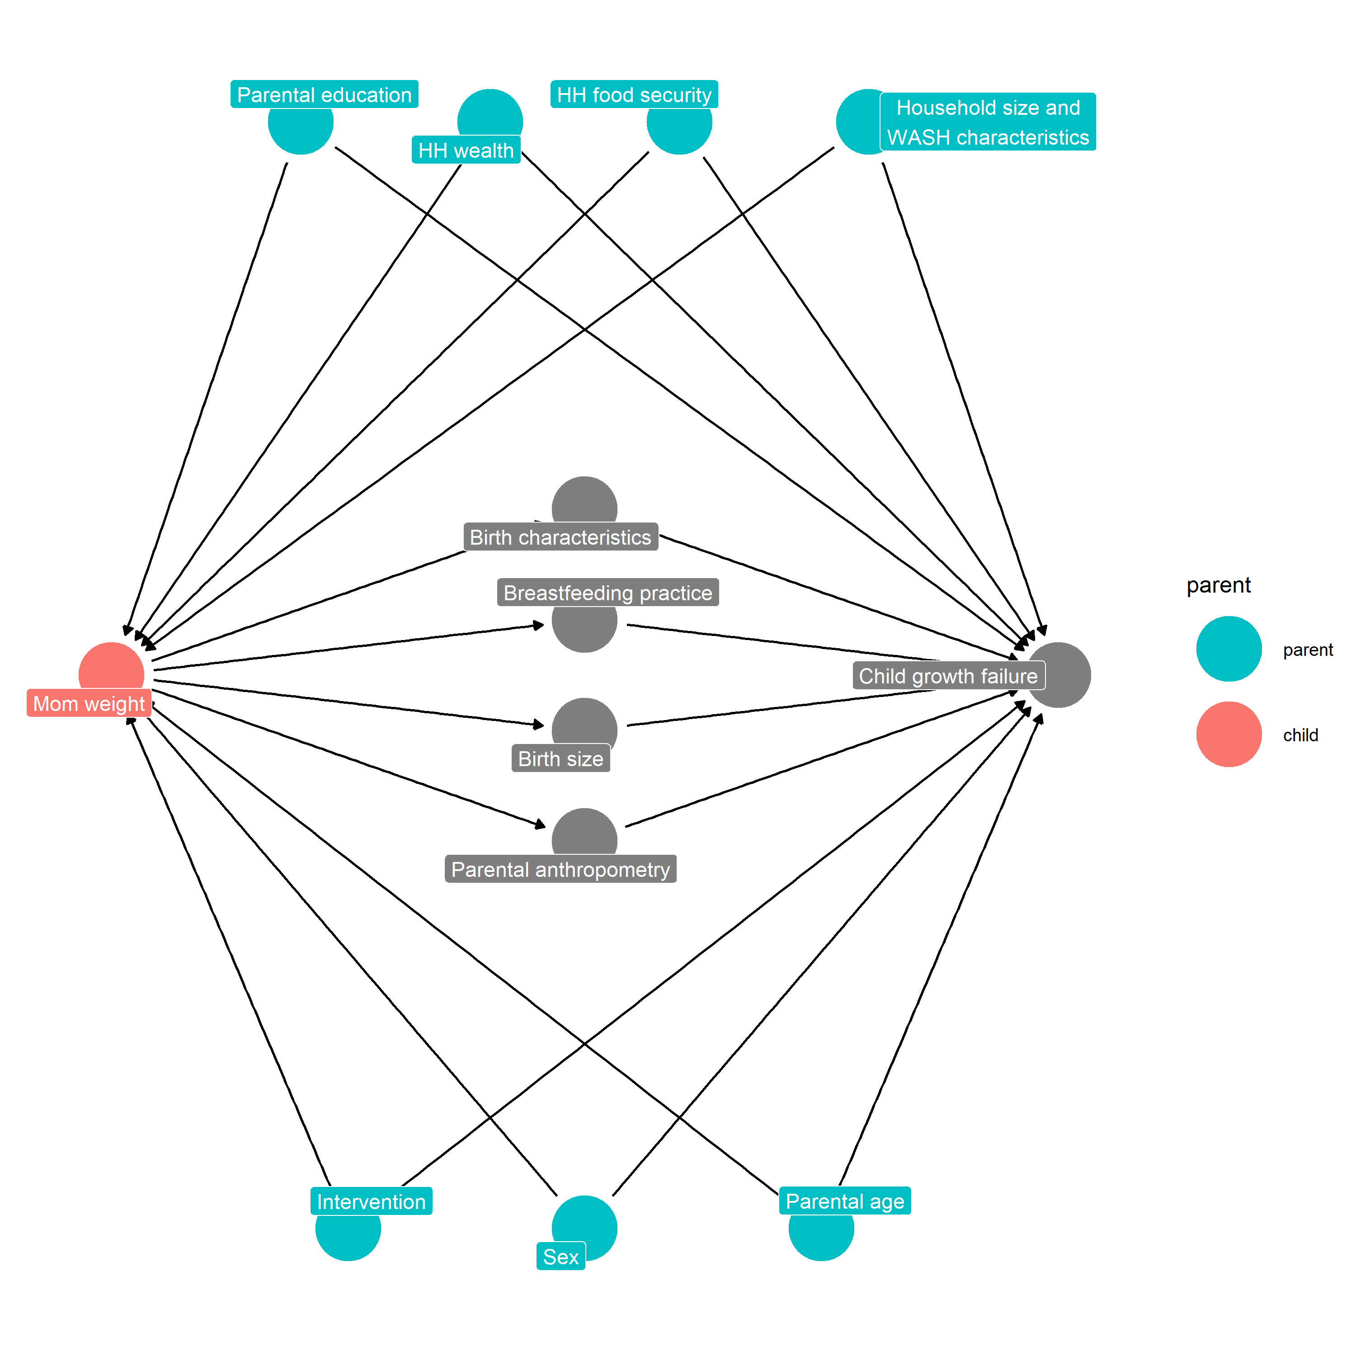

## 1.3 DAG used: Association between maternal weight and child growth faltering

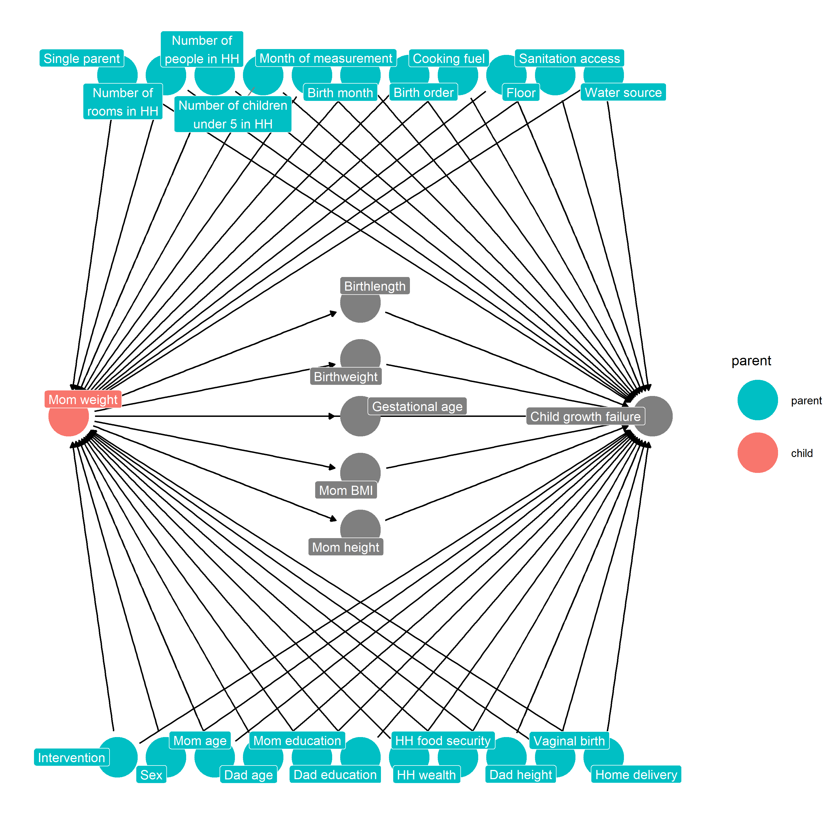

## 1.4 Table of Adjustment Covariates

| Exposure | Potential adjustment covariates |
| --- | --- |
| # of children <5 in HH | Treatment arm , Mother’s age , Father’s age , Mother’s education , Father’s education , HH wealth , HH food security , Mother’s height , Mother’s weight , BMI , Father’s height , Single parent , # of rooms in HH , Birth order , Treats drinking water , Clean cooking fuel usage, Improved floor , Improved sanitation , Safe water source |
| # of people in HH | Treatment arm , Mother’s age , Father’s age , Mother’s education , Father’s education , HH wealth , HH food security , Mother’s height , Mother’s weight , BMI , Father’s height , Single parent , # of rooms in HH , Birth order , Treats drinking water , Clean cooking fuel usage, Improved floor , Improved sanitation , Safe water source |
| # of rooms in HH | Treatment arm , Child sex , Mother’s age , Father’s age , Mother’s education , Father’s education , HH wealth , HH food security , Mother’s height , Mother’s weight , BMI , Father’s height , Single parent , # of people in HH , # of children <5 in HH , Birth order , Treats drinking water , Clean cooking fuel usage, Improved floor , Improved sanitation , Safe water source |
| Any wasting <6 mo. | Treatment arm , Child sex , Mother’s age , Father’s age , Mother’s education , Father’s education , HH wealth , HH food security , Mother’s height , Mother’s weight , BMI , Father’s height , Vaginal birth , Child delivered at home , Single parent , # of rooms in HH , # of people in HH , # of children <5 in HH , Month of measurement , Month of Birth , Birth order , Treats drinking water , Clean cooking fuel usage, Improved floor , Improved sanitation , Safe water source |
| Birth length (cm) | Treatment arm , Child sex , Mother’s age , Father’s age , Mother’s education , Father’s education , HH wealth , HH food security , Mother’s height , Mother’s weight , BMI , Father’s height , Vaginal birth , Child delivered at home , Single parent , # of rooms in HH , # of people in HH , # of children <5 in HH , Month of Birth , Birth order , Treats drinking water , Clean cooking fuel usage, Improved floor , Improved sanitation , Safe water source |
| Birth order | Treatment arm , Mother’s age , Father’s age , Mother’s education , Father’s education , HH wealth , HH food security , Mother’s height , Mother’s weight , BMI , Father’s height , Vaginal birth , Child delivered at home , Single parent , # of rooms in HH , Treats drinking water , Clean cooking fuel usage, Improved floor , Improved sanitation , Safe water source |
| Birthweight (kg) | Treatment arm , Child sex , Mother’s age , Father’s age , Mother’s education , Father’s education , HH wealth , HH food security , Mother’s height , Mother’s weight , BMI , Father’s height , Vaginal birth , Child delivered at home , Single parent , # of rooms in HH , # of people in HH , # of children <5 in HH , Month of Birth , Birth order , Treats drinking water , Clean cooking fuel usage, Improved floor , Improved sanitation , Safe water source |
| Breastfed hour after birth | Treatment arm , Child sex , Mother’s age , Father’s age , Mother’s education , Father’s education , HH wealth , HH food security , Mother’s height , Mother’s weight , BMI , Father’s height , Vaginal birth , Child delivered at home , Gestational age at birth, Birthweight (kg) , Birth length (cm) , Single parent , # of rooms in HH , # of people in HH , # of children <5 in HH , Month of Birth , Birth order , Treats drinking water , Clean cooking fuel usage, Improved floor , Improved sanitation , Safe water source |
| Child delivered at home | Treatment arm , Child sex , Mother’s age , Father’s age , Mother’s education , Father’s education , HH wealth , HH food security , Mother’s height , Mother’s weight , BMI , Father’s height , Single parent , # of rooms in HH , # of people in HH , # of children <5 in HH , Month of Birth , Birth order , Treats drinking water , Clean cooking fuel usage, Improved floor , Improved sanitation , Safe water source |
| Clean cooking fuel usage | Treatment arm , Child sex , Mother’s age , Father’s age , Mother’s education , Father’s education , HH wealth , HH food security , Mother’s height , Mother’s weight , BMI , Father’s height , Single parent , # of rooms in HH , # of people in HH , # of children <5 in HH, Birth order , Treats drinking water , Improved floor , Improved sanitation , Safe water source |
| Diarrhea <24 mo. (% days) | Treatment arm , Child sex , Mother’s age , Father’s age , Mother’s education , Father’s education , HH wealth , HH food security , Mother’s height , Mother’s weight , BMI , Father’s height , Vaginal birth , Child delivered at home , Gestational age at birth, Birthweight (kg) , Birth length (cm) , Single parent , # of rooms in HH , # of people in HH , # of children <5 in HH , Month of measurement , Month of Birth , Birth order , Treats drinking water , Clean cooking fuel usage, Improved floor , Improved sanitation , Safe water source |
| Diarrhea <6 mo. (% days) | Treatment arm , Child sex , Mother’s age , Father’s age , Mother’s education , Father’s education , HH wealth , HH food security , Mother’s height , Mother’s weight , BMI , Father’s height , Vaginal birth , Child delivered at home , Gestational age at birth, Birthweight (kg) , Birth length (cm) , Single parent , # of rooms in HH , # of people in HH , # of children <5 in HH , Month of measurement , Month of Birth , Birth order , Treats drinking water , Clean cooking fuel usage, Improved floor , Improved sanitation , Safe water source |
| Excl/Pred breastfed <6mo. | Treatment arm , Child sex , Mother’s age , Father’s age , Mother’s education , Father’s education , HH wealth , HH food security , Mother’s height , Mother’s weight , BMI , Father’s height , Vaginal birth , Child delivered at home , Gestational age at birth, Birthweight (kg) , Birth length (cm) , Single parent , # of rooms in HH , # of people in HH , # of children <5 in HH , Month of measurement , Month of Birth , Birth order , Treats drinking water , Clean cooking fuel usage, Improved floor , Improved sanitation , Safe water source |
| Father’s age | Treatment arm , Mother’s age , Mother’s education , Father’s education , HH wealth , HH food security , Mother’s height , Mother’s weight , BMI , Father’s height , Single parent , # of rooms in HH , # of people in HH , # of children <5 in HH , Month of Birth , Treats drinking water , Clean cooking fuel usage, Improved floor , Improved sanitation , Safe water source |
| Father’s education | Treatment arm , Mother’s age , Father’s age , Mother’s education , HH wealth , Mother’s height , Mother’s weight , BMI , Father’s height , Gestational age at birth, Birthweight (kg) , Birth length (cm) , Single parent , # of rooms in HH , # of people in HH , # of children <5 in HH , Treats drinking water , Clean cooking fuel usage, Improved floor , Improved sanitation , Safe water source |
| Father’s height | Treatment arm , Mother’s age , Father’s age , Mother’s education , Father’s education , HH wealth , HH food security , Mother’s height , Mother’s weight , BMI , Single parent , # of rooms in HH , Treats drinking water , Clean cooking fuel usage, Improved floor , Improved sanitation , Safe water source |
| Gestational age at birth | Treatment arm , Child sex , Mother’s age , Father’s age , Mother’s education , Father’s education , HH wealth , HH food security , Mother’s height , Mother’s weight , BMI , Father’s height , Single parent , # of rooms in HH , # of people in HH , # of children <5 in HH , Month of Birth , Birth order , Treats drinking water , Clean cooking fuel usage, Improved floor , Improved sanitation , Safe water source |
| HH food security | Treatment arm , Child sex , Mother’s age , Father’s age , Mother’s education , Father’s education , HH wealth , Vaginal birth , Child delivered at home , Single parent , # of rooms in HH , # of people in HH , # of children <5 in HH , Month of Birth , Birth order , Treats drinking water , Clean cooking fuel usage, Improved floor , Improved sanitation , Safe water source |
| HH wealth | Treatment arm , Child sex , Mother’s age , Father’s age , Mother’s education , Father’s education , Gestational age at birth, Birthweight (kg) , Birth length (cm) , Single parent , # of people in HH , # of children <5 in HH , Birth order |
| Improved floor | Treatment arm , Child sex , Mother’s age , Father’s age , Mother’s education , Father’s education , HH wealth , HH food security , Mother’s height , Mother’s weight , BMI , Father’s height , Single parent , # of rooms in HH , # of people in HH , # of children <5 in HH , Birth order , Treats drinking water , Clean cooking fuel usage, Improved sanitation , Safe water source |
| Improved sanitation | Treatment arm , Child sex , Mother’s age , Father’s age , Mother’s education , Father’s education , HH wealth , HH food security , Mother’s height , Mother’s weight , BMI , Father’s height , Single parent , # of rooms in HH , # of people in HH , # of children <5 in HH , Birth order , Treats drinking water , Clean cooking fuel usage, Improved floor , Safe water source |
| Mother’s age | Treatment arm , Father’s age , Mother’s education , Father’s education , HH wealth , HH food security , Mother’s height , Mother’s weight , BMI , Father’s height , Single parent , # of rooms in HH , # of people in HH , # of children <5 in HH , Treats drinking water , Clean cooking fuel usage, Improved floor , Improved sanitation , Safe water source |
| Mother’s BMI | Treatment arm , Mother’s age , Father’s age , Mother’s education , Father’s education , HH wealth , HH food security , Father’s height , Single parent , # of rooms in HH , # of people in HH , # of children <5 in HH , Month of Birth , Birth order , Treats drinking water , Clean cooking fuel usage, Improved floor , Improved sanitation , Safe water source |
| Mother’s education | Treatment arm , Mother’s age , Father’s age , Father’s education , HH wealth , Mother’s height , Mother’s weight , BMI , Father’s height , Gestational age at birth, Birthweight (kg) , Birth length (cm) , Single parent , # of rooms in HH , # of people in HH , # of children <5 in HH , Treats drinking water , Clean cooking fuel usage, Improved floor , Improved sanitation , Safe water source |
| Mother’s height | Treatment arm , Mother’s age , Father’s age , Mother’s education , Father’s education , HH wealth , HH food security , Father’s height , Single parent , # of rooms in HH , Treats drinking water , Clean cooking fuel usage, Improved floor , Improved sanitation , Safe water source |
| Mother’s weight | Treatment arm , Mother’s age , Father’s age , Mother’s education , Father’s education , HH wealth , HH food security , Father’s height , Single parent , # of rooms in HH , # of people in HH , # of children <5 in HH , Month of Birth , Birth order , Treats drinking water , Clean cooking fuel usage, Improved floor , Improved sanitation , Safe water source |
| Persistent wasting <6 mo. | Treatment arm , Child sex , Mother’s age , Father’s age , Mother’s education , Father’s education , HH wealth , HH food security , Mother’s height , Mother’s weight , BMI , Father’s height , Vaginal birth , Child delivered at home , Single parent , # of rooms in HH , # of people in HH , # of children <5 in HH , Month of measurement , Month of Birth , Birth order , Treats drinking water , Clean cooking fuel usage, Improved floor , Improved sanitation , Safe water source |
| Safe water source | Treatment arm , Child sex , Mother’s age , Father’s age , Mother’s education , Father’s education , HH wealth , HH food security , Mother’s height , Mother’s weight , BMI , Father’s height , Single parent , # of rooms in HH , # of people in HH , # of children <5 in HH , Birth order , Treats drinking water , Clean cooking fuel usage, Improved floor , Improved sanitation |
| Single parent | Treatment arm , Mother’s age , Father’s age , Mother’s education , Father’s education , HH wealth , HH food security , Mother’s height , Mother’s weight , BMI , Father’s height , # of rooms in HH , # of people in HH , # of children <5 in HH , Treats drinking water , Clean cooking fuel usage, Improved floor , Improved sanitation , Safe water source |
| Small for gestational age | Treatment arm , Child sex , Mother’s age , Father’s age , Mother’s education , Father’s education , HH wealth , HH food security , Mother’s height , Mother’s weight , BMI , Father’s height , Single parent , # of rooms in HH , # of people in HH , # of children <5 in HH , Month of Birth , Birth order , Treats drinking water , Clean cooking fuel usage, Improved floor , Improved sanitation , Safe water source |
| Treats drinking water | Treatment arm , Child sex , Mother’s age , Father’s age , Mother’s education , Father’s education , HH wealth , HH food security , Mother’s height , Mother’s weight , BMI , Father’s height , Single parent , # of rooms in HH , # of people in HH , # of children <5 in HH , Month of Birth , Birth order , Clean cooking fuel usage, Improved floor , Improved sanitation , Safe water source |

# 2 Complete-Case Sensitivity Analyses

## 2.1 Overview

**Purpose:**  **Interpretation:**  **Implications:**

### 2.1.1 Heatmap of covariate missingness by study

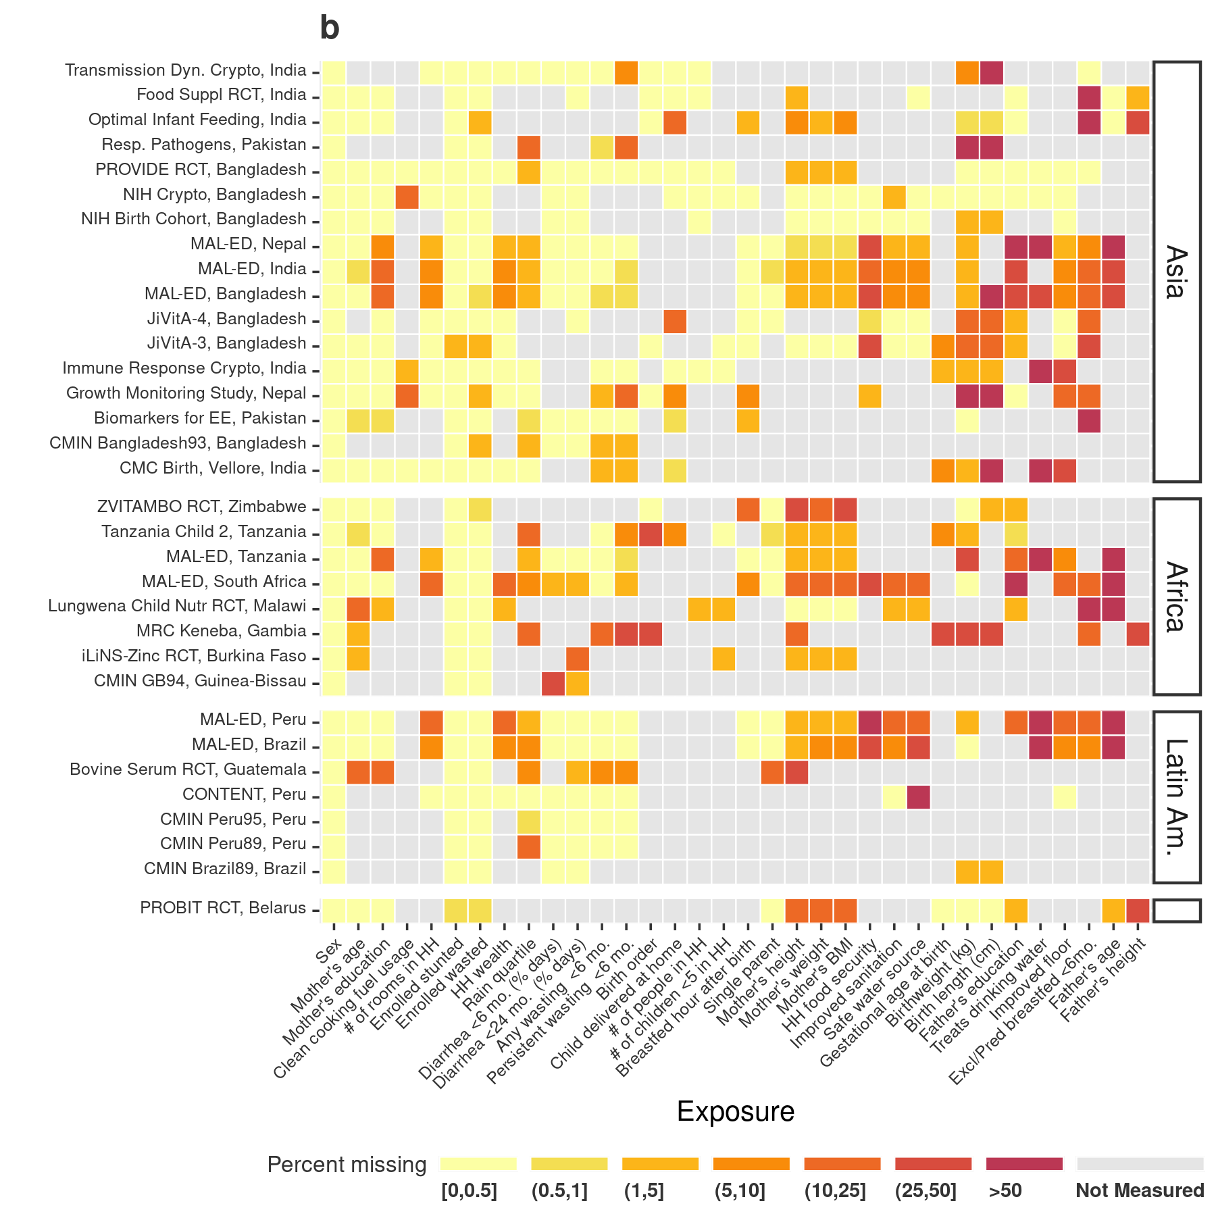

### 2.1.2 Sensitivity analysis to complete case versus median/mode imputed analyses

The median absolute difference in pooled Z-scores was 0.009 and the mean absolute difference was 0.022.

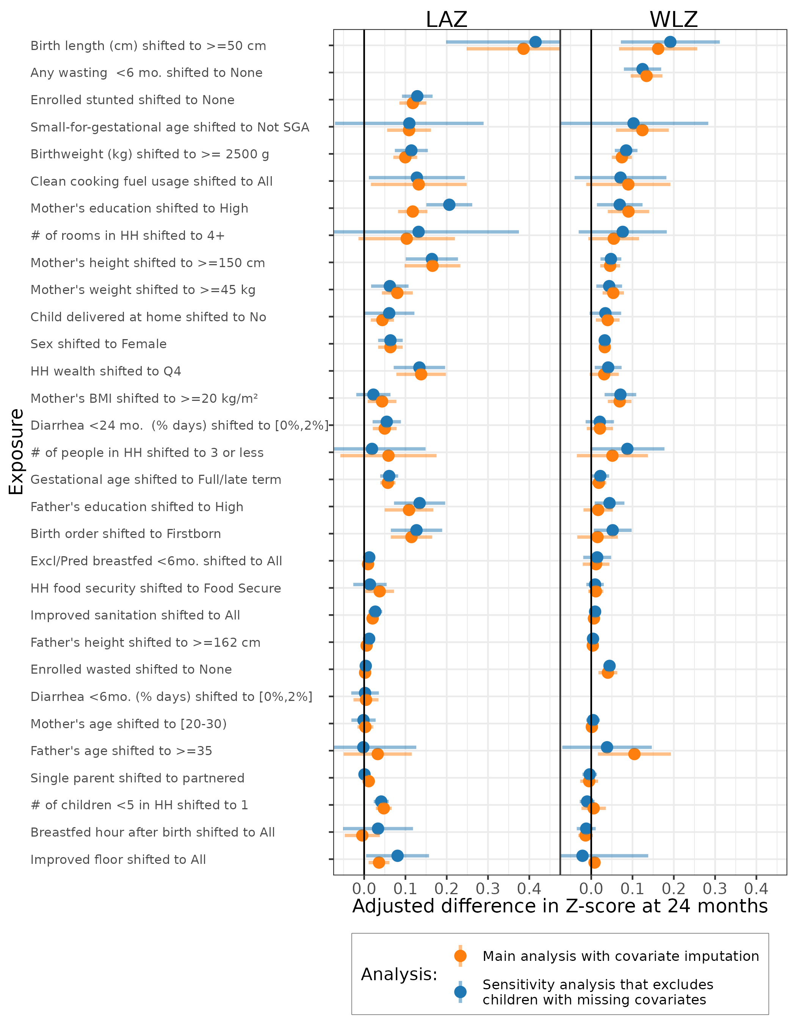

# 3 Sensitivity analysis using fixed effects

## 3.1 Overview

**Purpose:**  In the primary manuscript, we compared estimates pooled across studies using random effects models, which are more conservative in the presence of heterogeneity across studies. Here, we present estimates pooled using fixed effects. Inferences about estimates from fixed effects models are restricted to only the included studies, while random effects estimates assume included studies are sampled from a distribution of hypothetical studies.[^1]

**Interpretation:**

Fixed effect estimates had narrow confidence intervals, and therefore more risk factors had statistically significant PIEs.

**Implications:**

The fixed effect estimates are weighted towards results from larger studies, so are more heavily influenced by the large Jivita-3, Probit, and ZVITAMBO trials. But in general, the key exposures identified from the random-effects estimates were also had the strongest associations when pooled using fixed-effect estimates.

## 3.2 Primary manuscript figures recreated with estimates pooled using fixed effects

More estimates are significant when pooling using fixed effects due to the generally smaller confidence intervals.

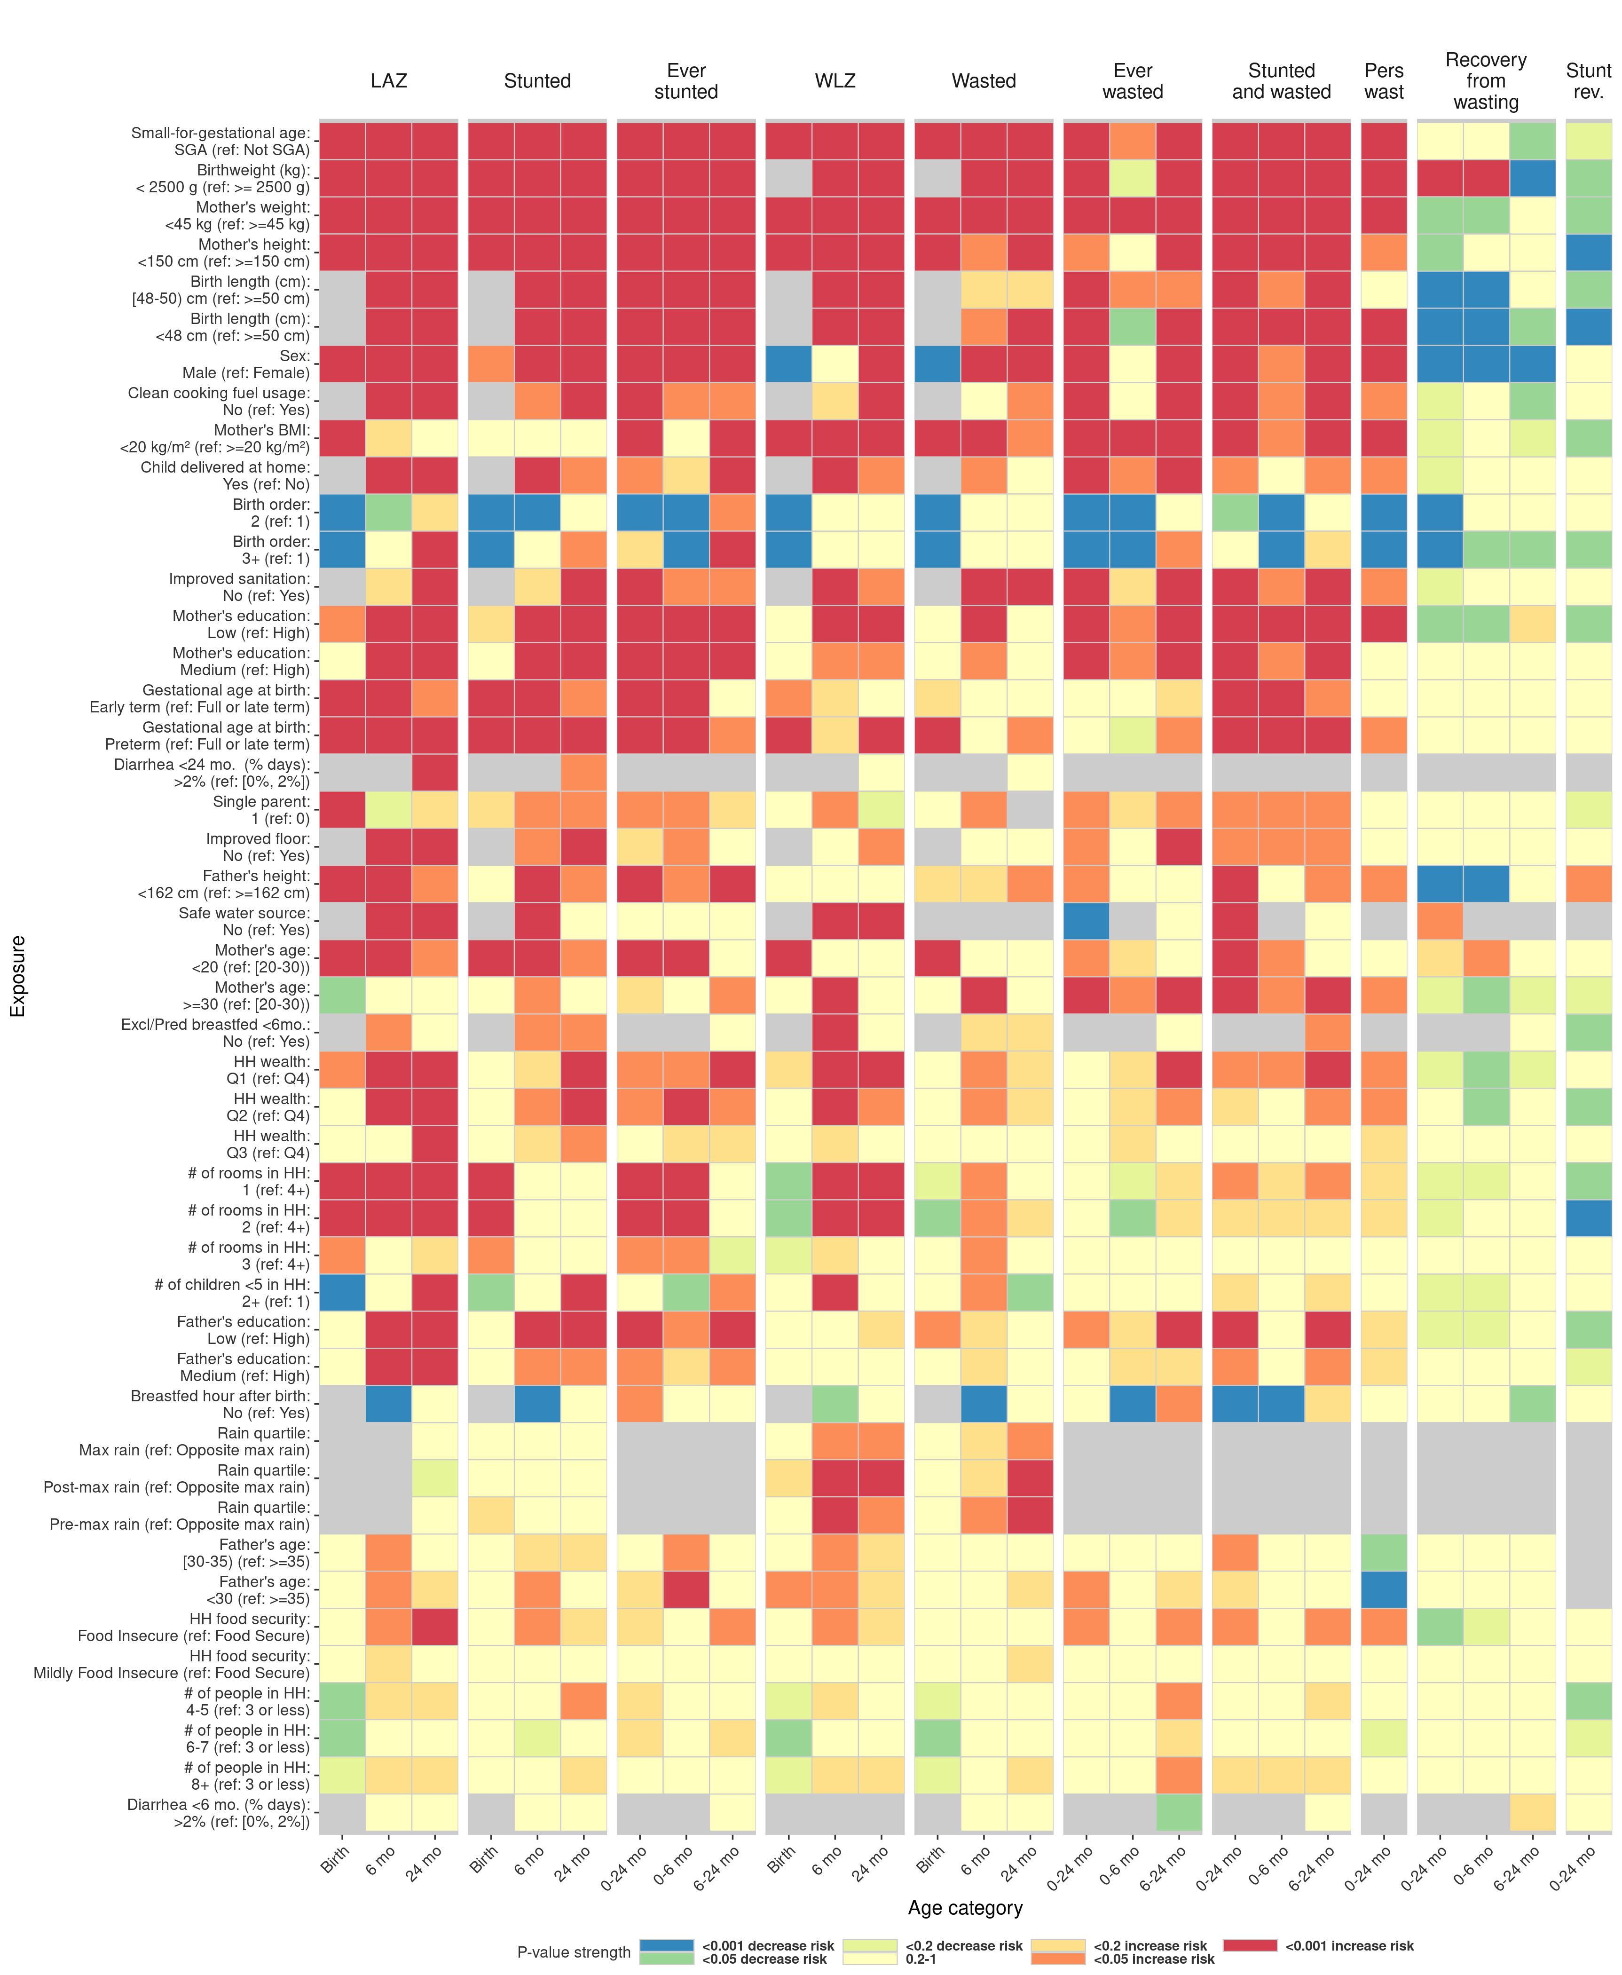 **Figure 1a. Heatmap of significance and direction across exposure-outcome combinations of associations estimated using fixed effects.**

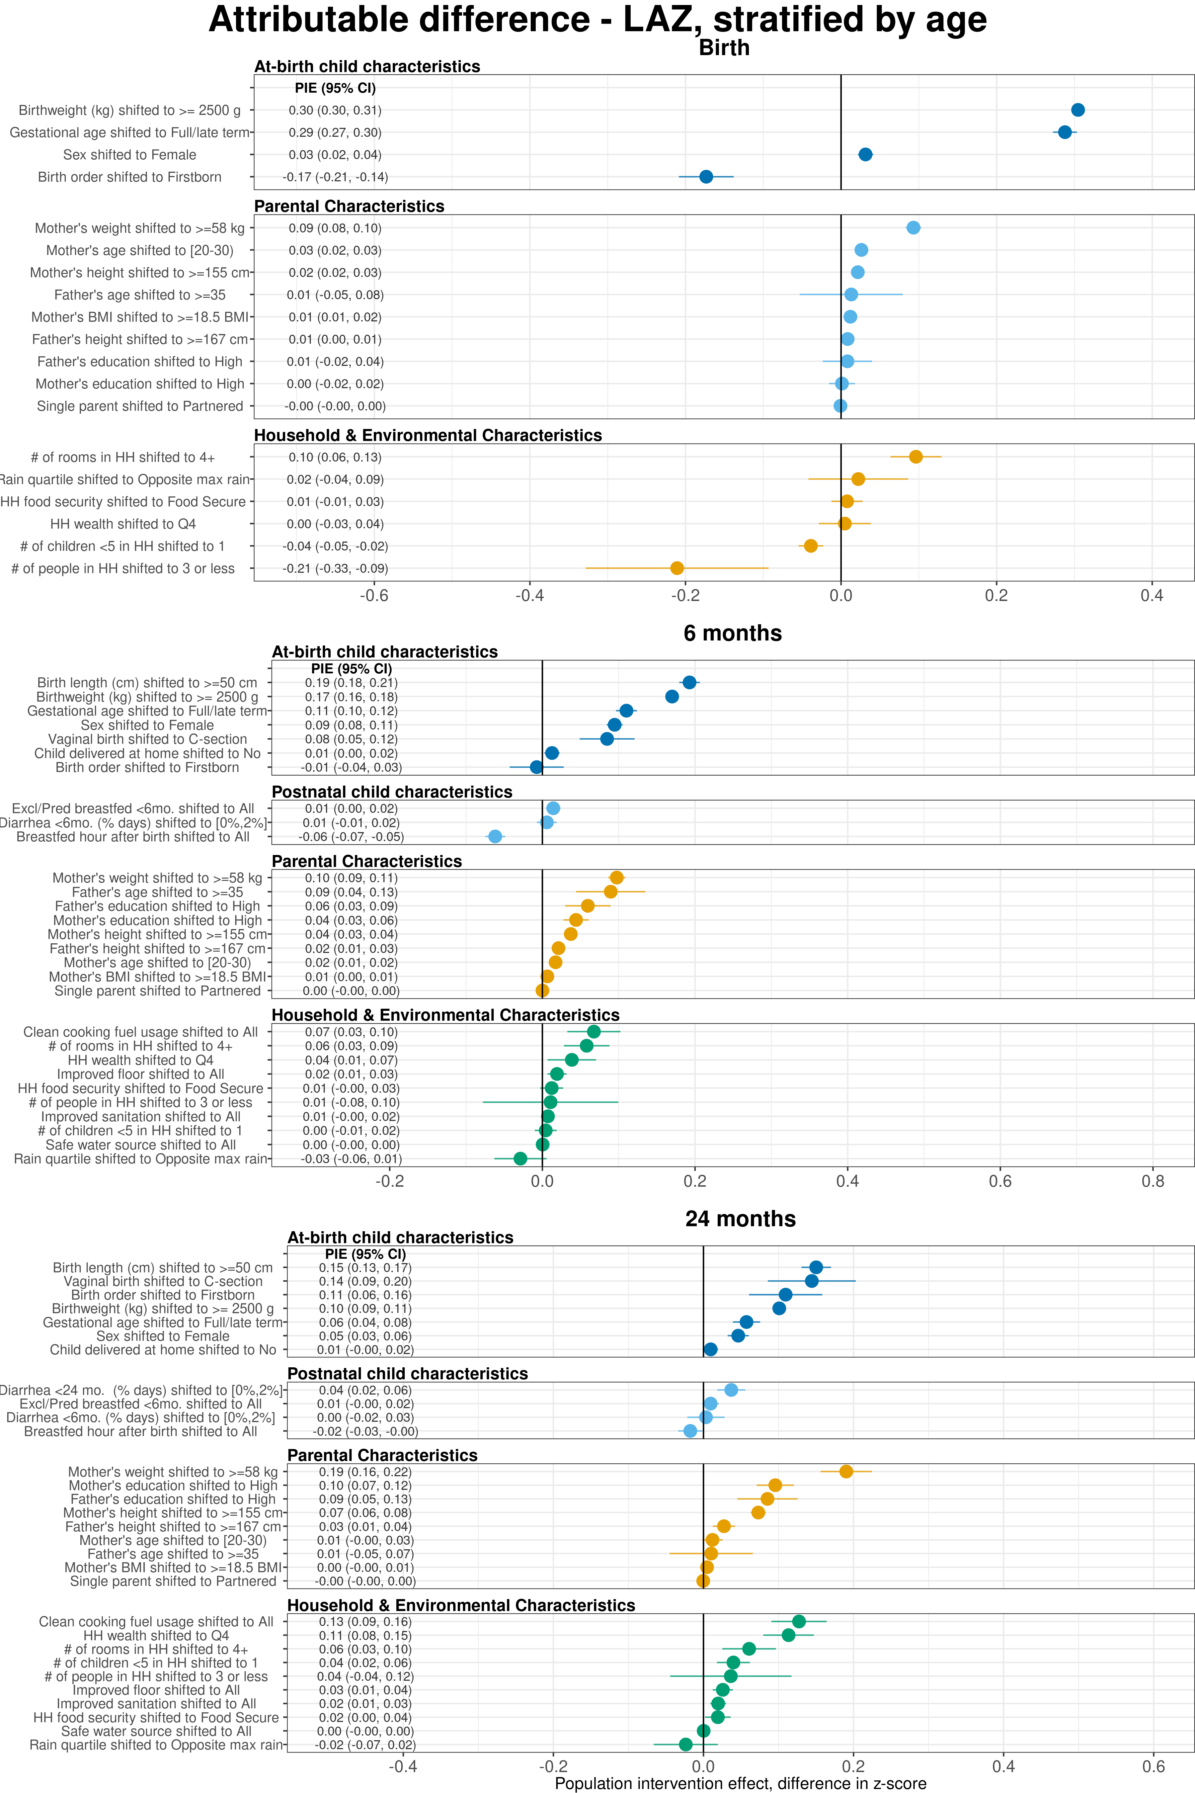 **Extended Data Figure 3 | Age-stratified population attributable differences in length-for-age Z-scores estimated using fixed effects.**

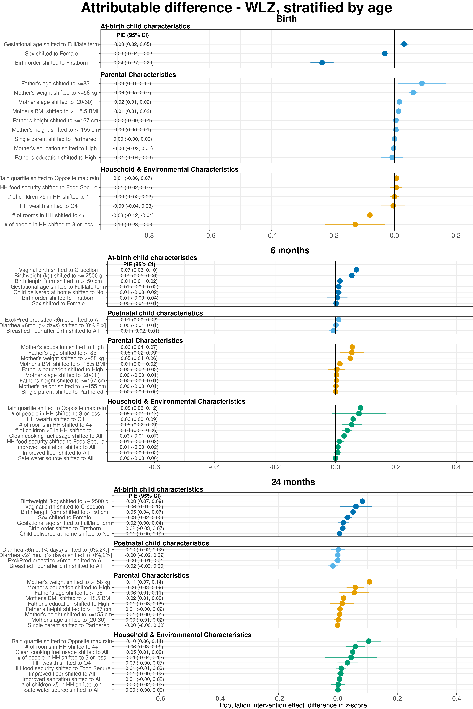 **Extended Data Figure 4 | Age-stratified population attributable differences in weight-for-length Z-scores estimated using fixed effects.**

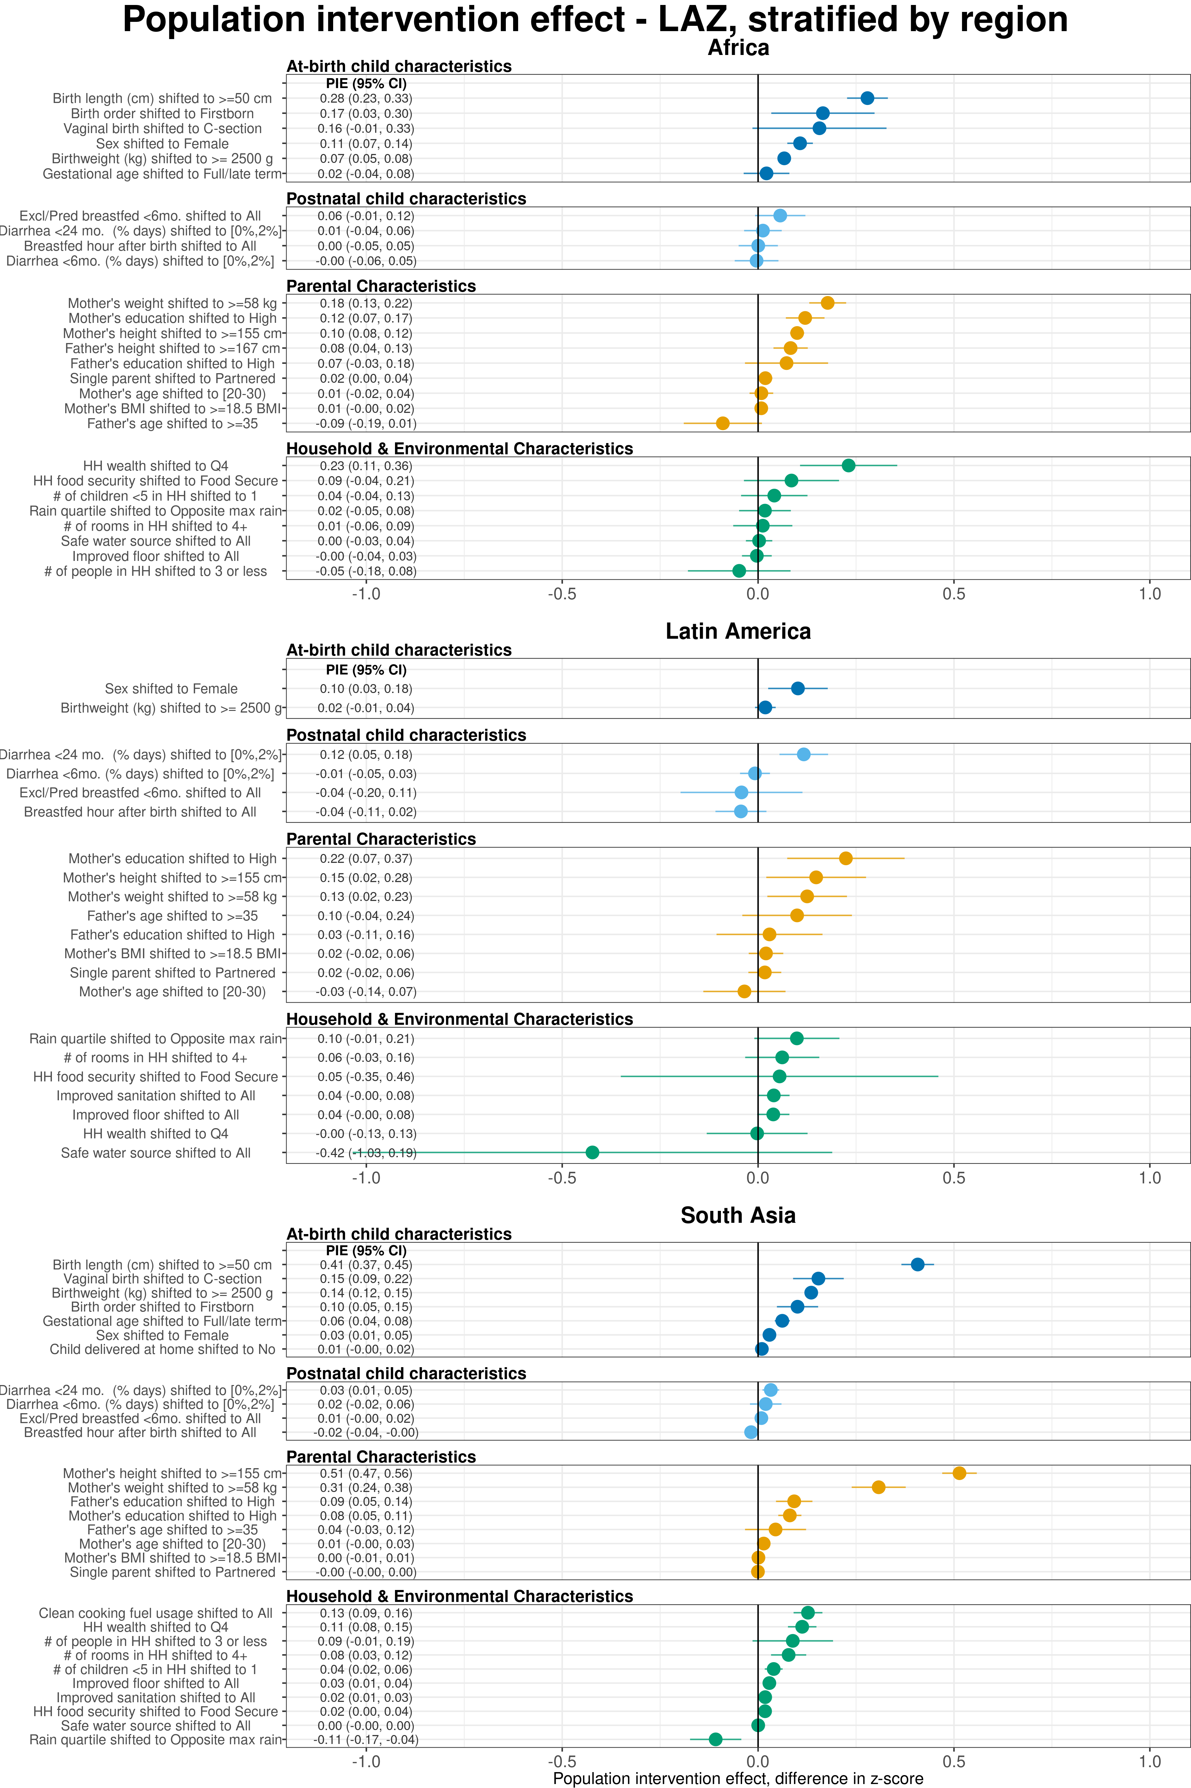 **Extended Data Figure 7 | Region-stratified population attributable differences in length-for-age Z-scores estimated using fixed effects.**

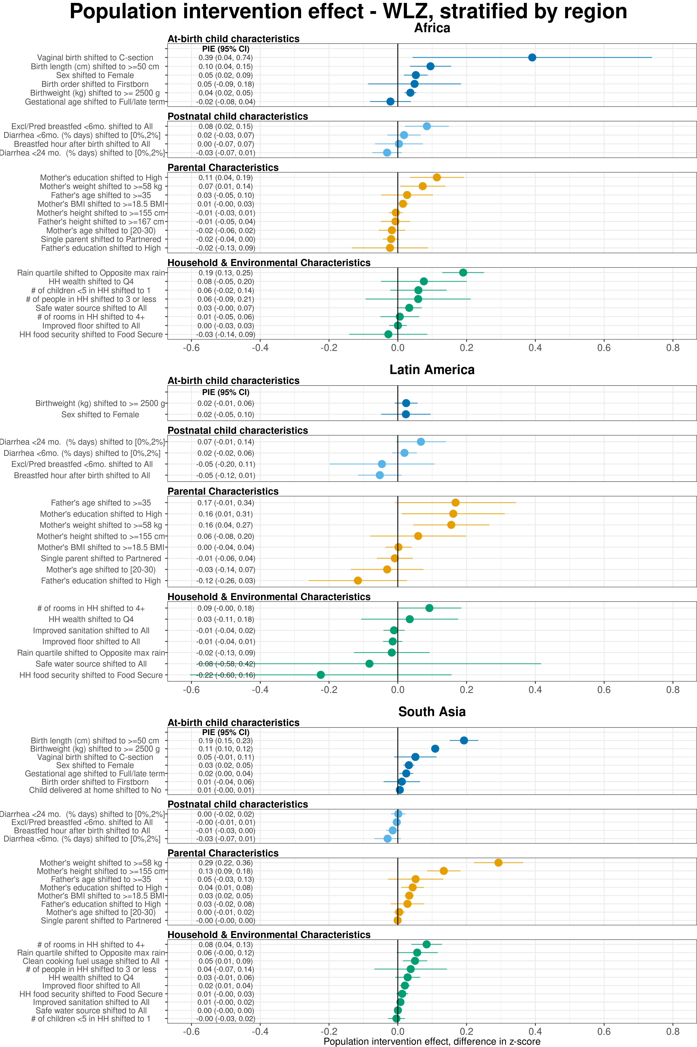 **Extended Data Figure 8 | Region-stratified population attributable differences in weight-for-length Z-scores estimated using fixed effects.**

# 4 Unadjusted Population Attributable Difference plots

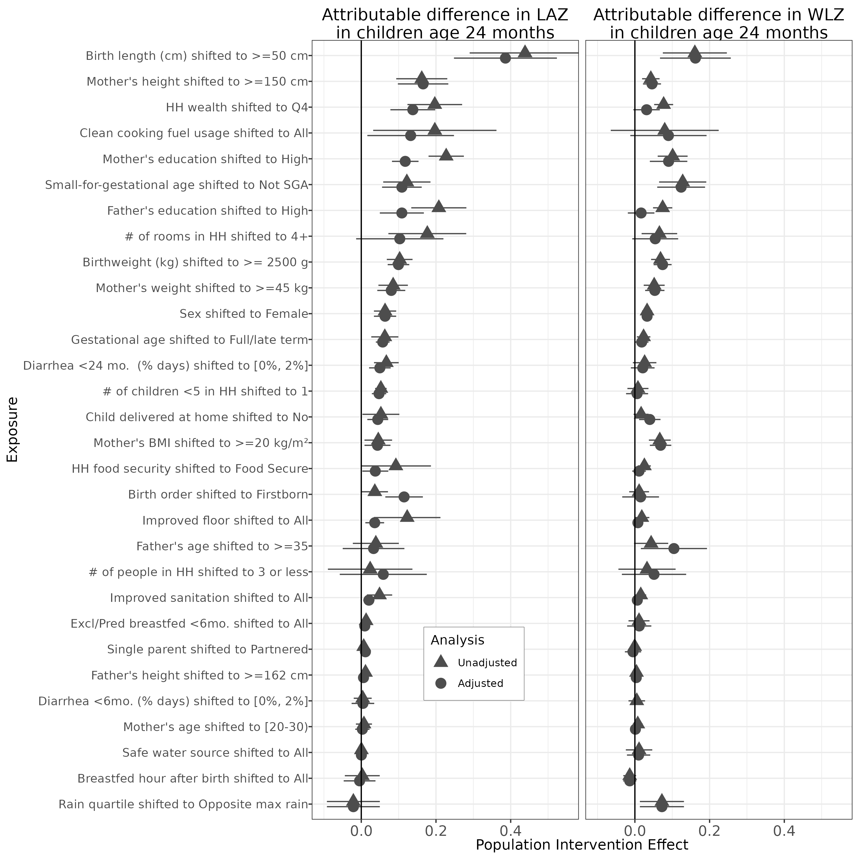

# 5 Spline plots: all exposures

Spline plots of HAZ and WHZ over the first two years of children’s lives, stratified by levels of risk factors. Plots were constructed using the same methods as for Figures 4a and 4b for all risk factors (details in the Methods section).

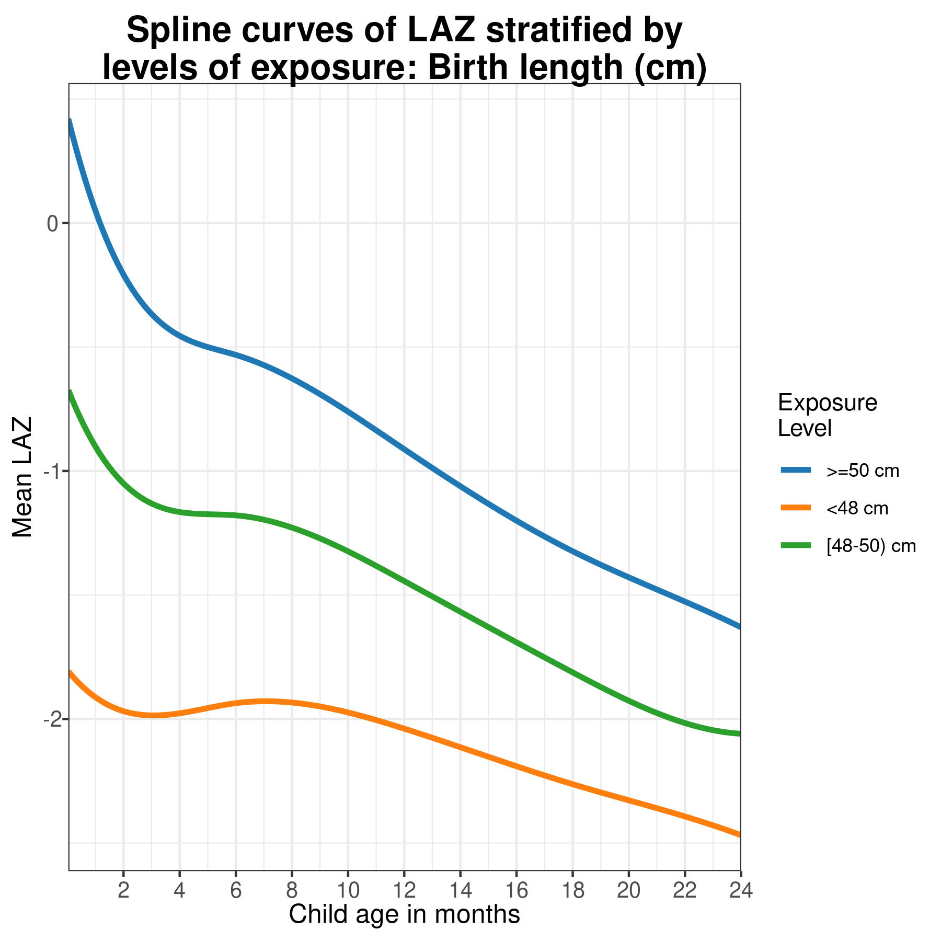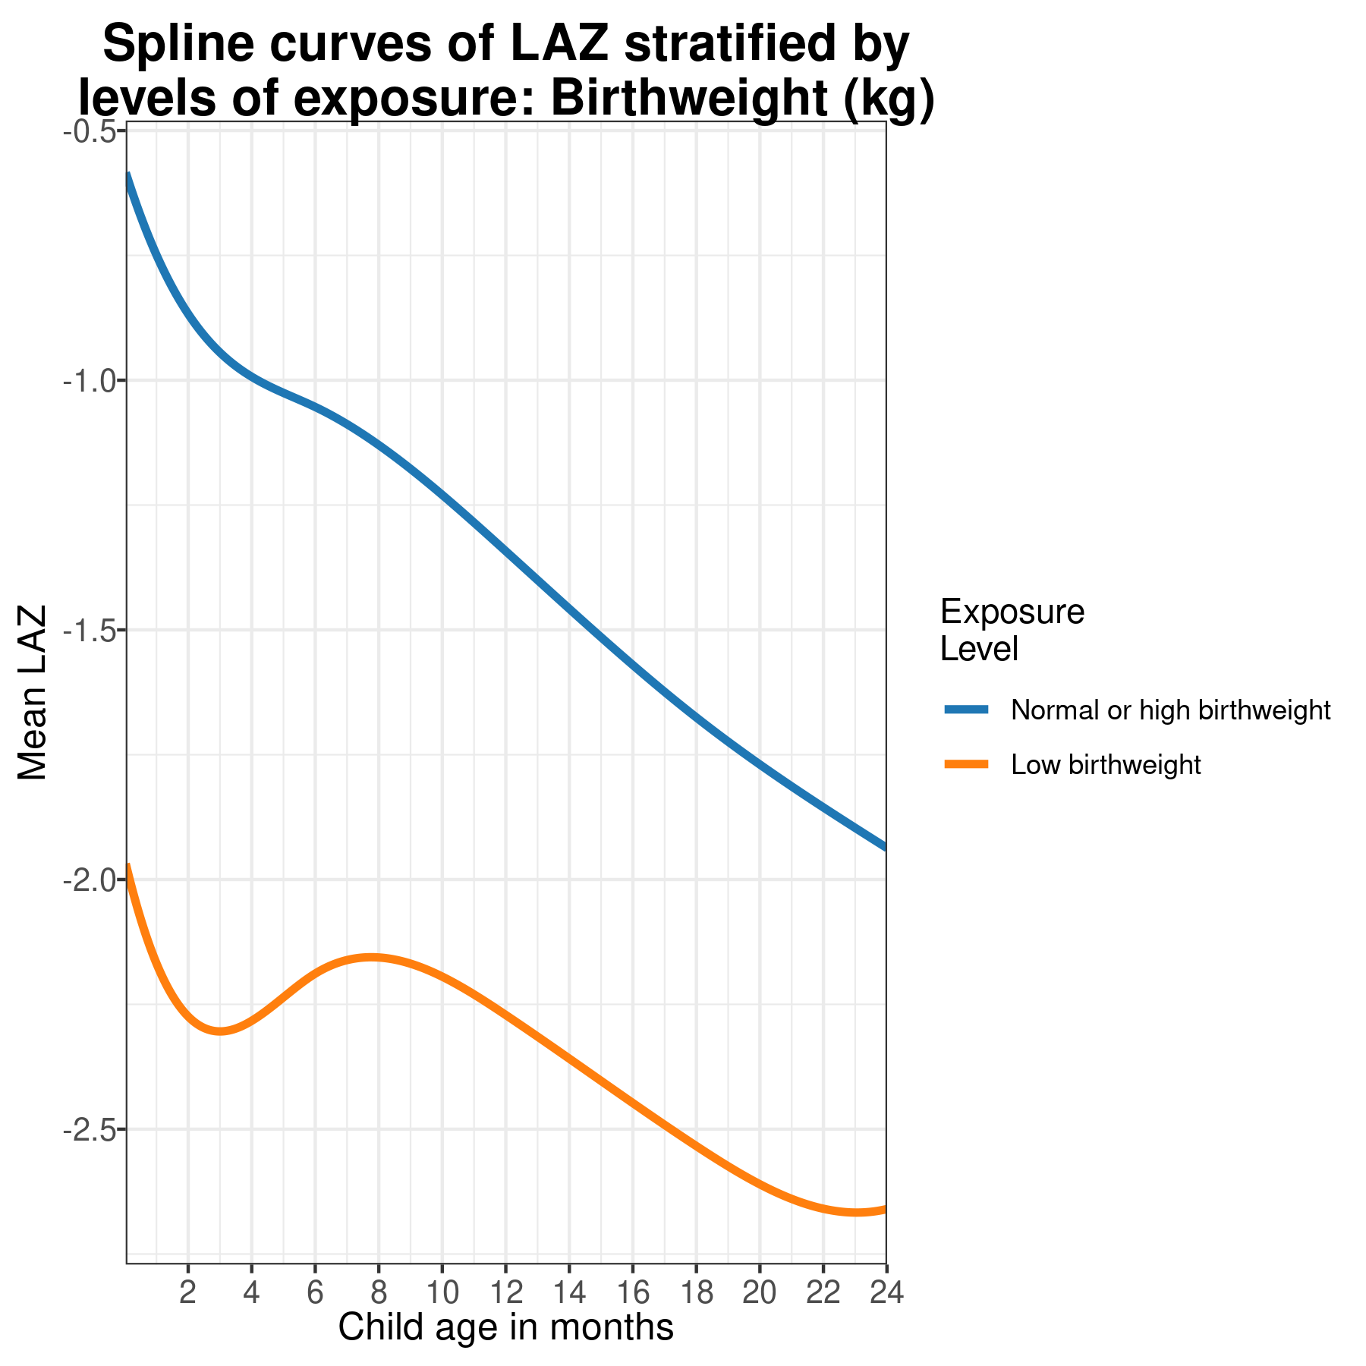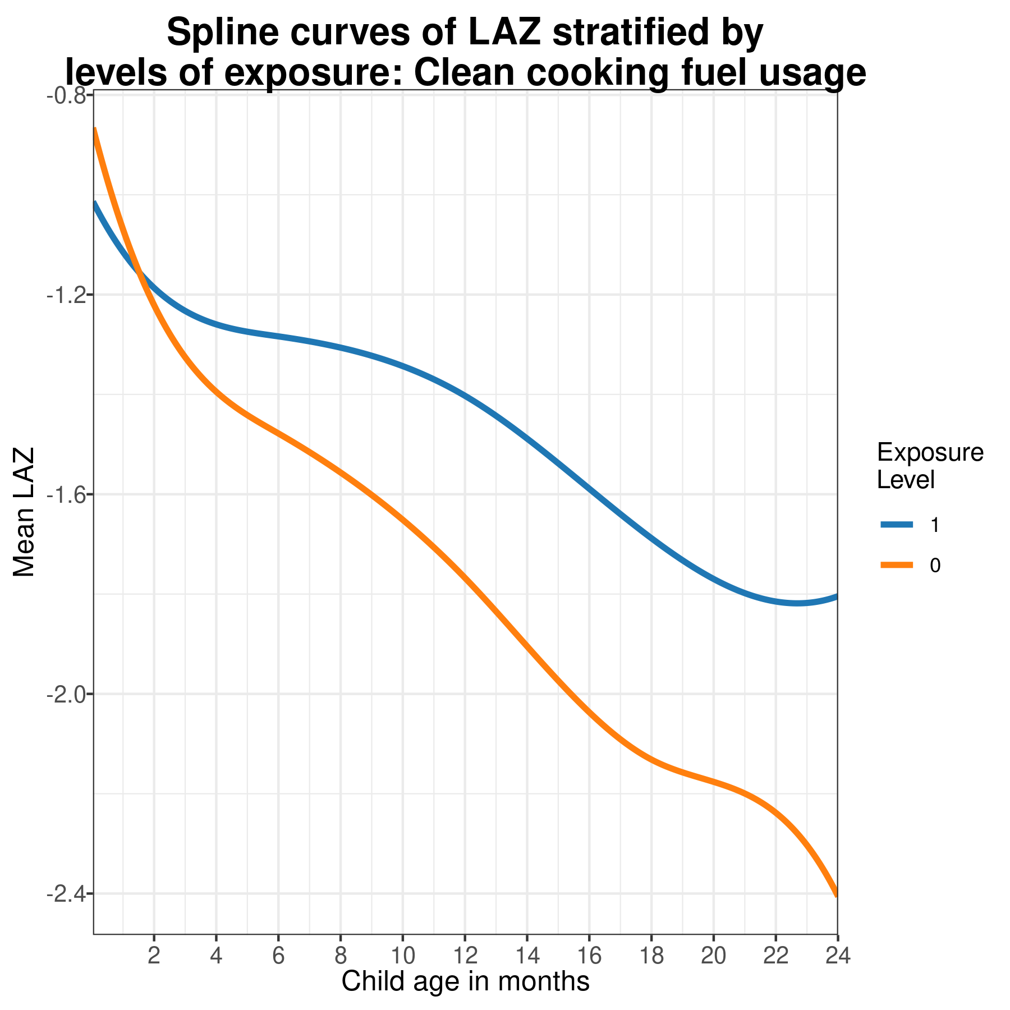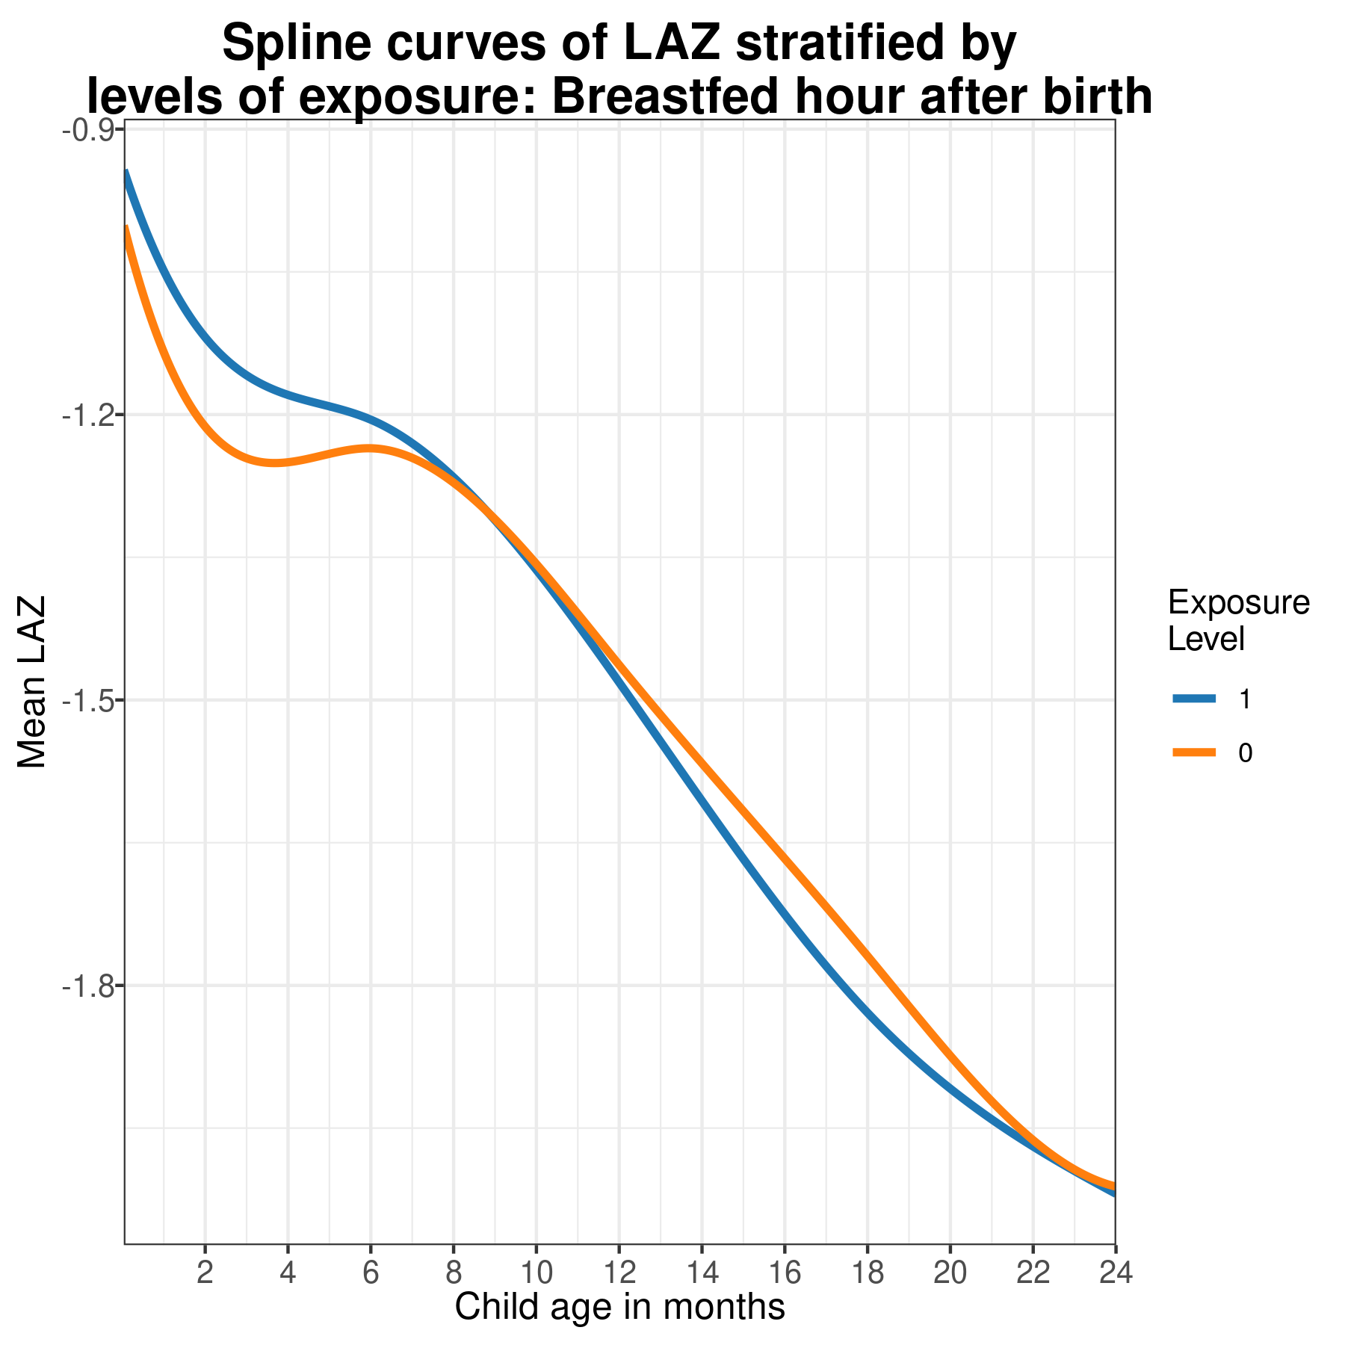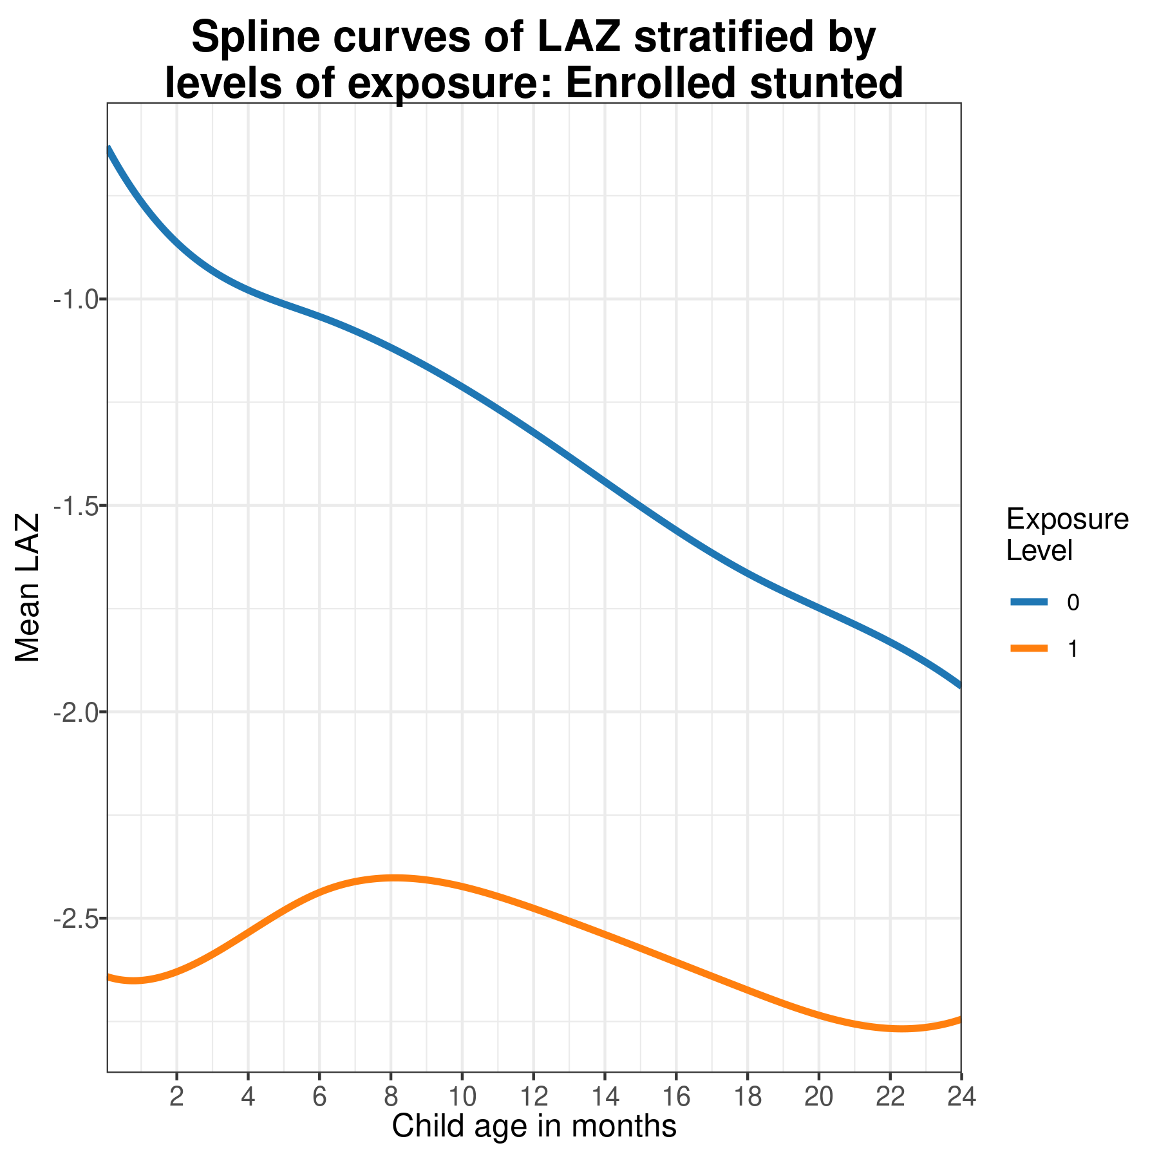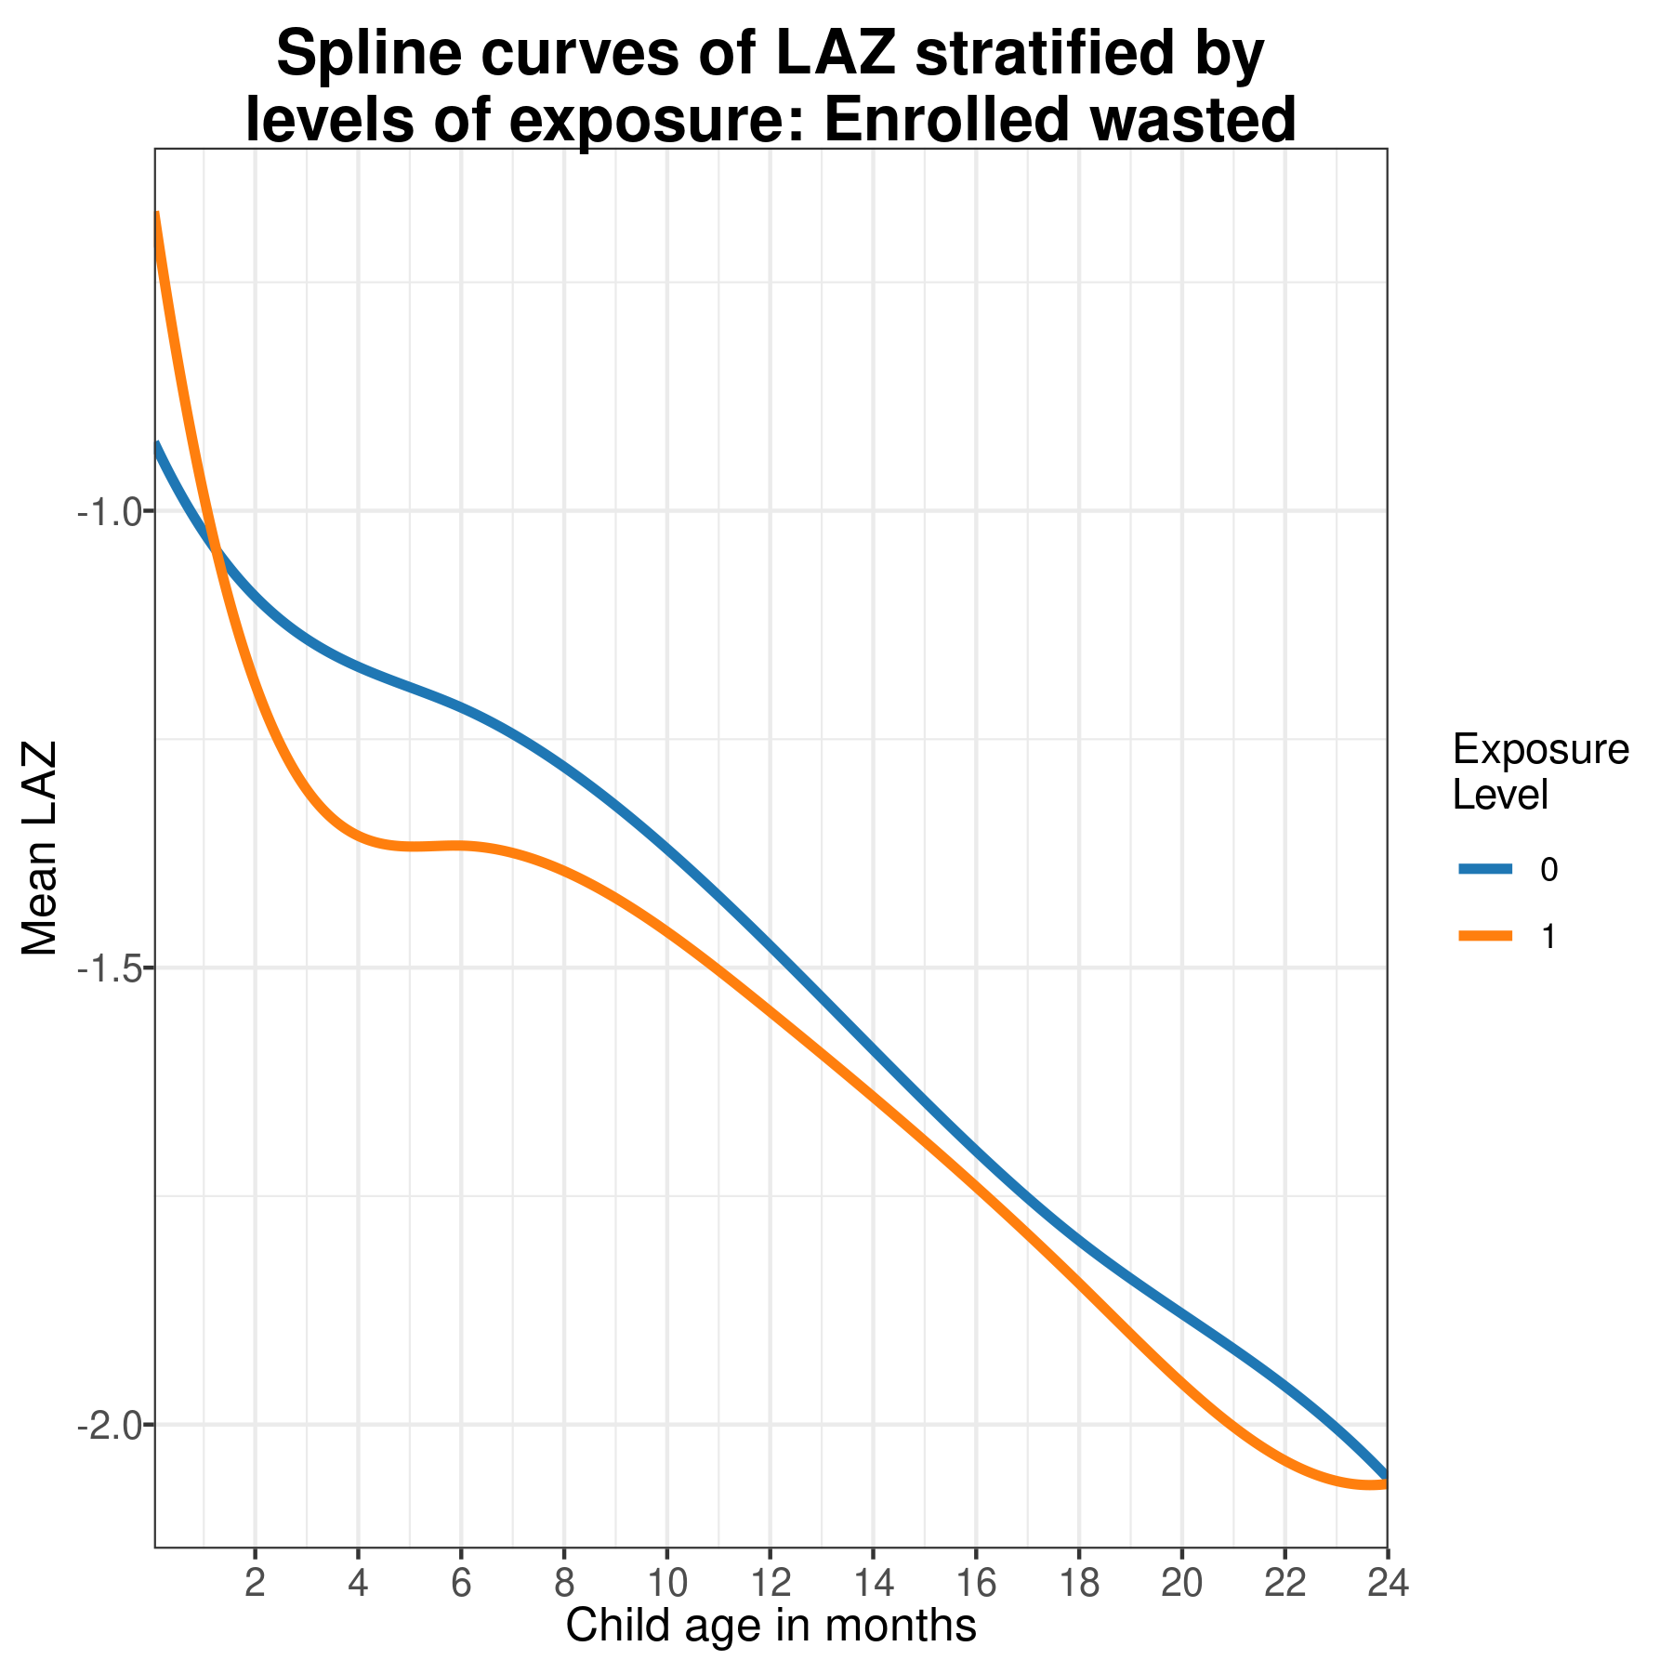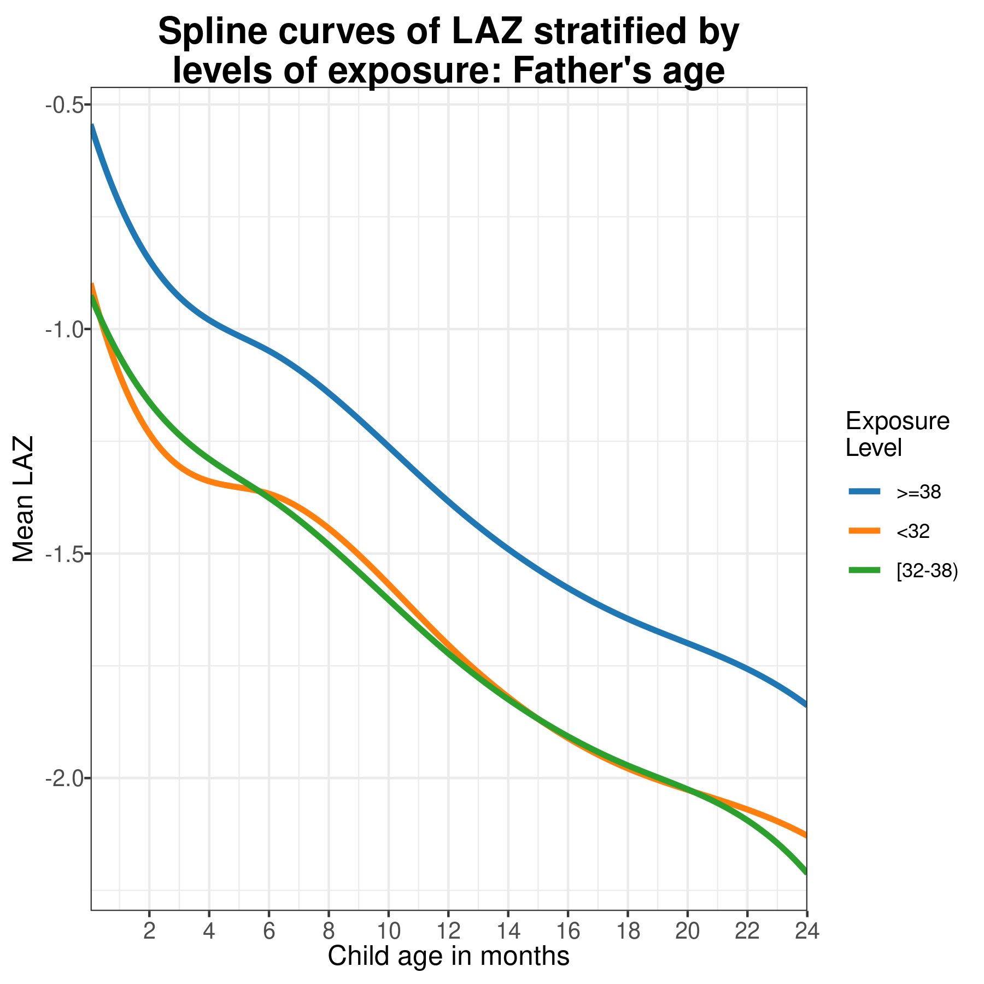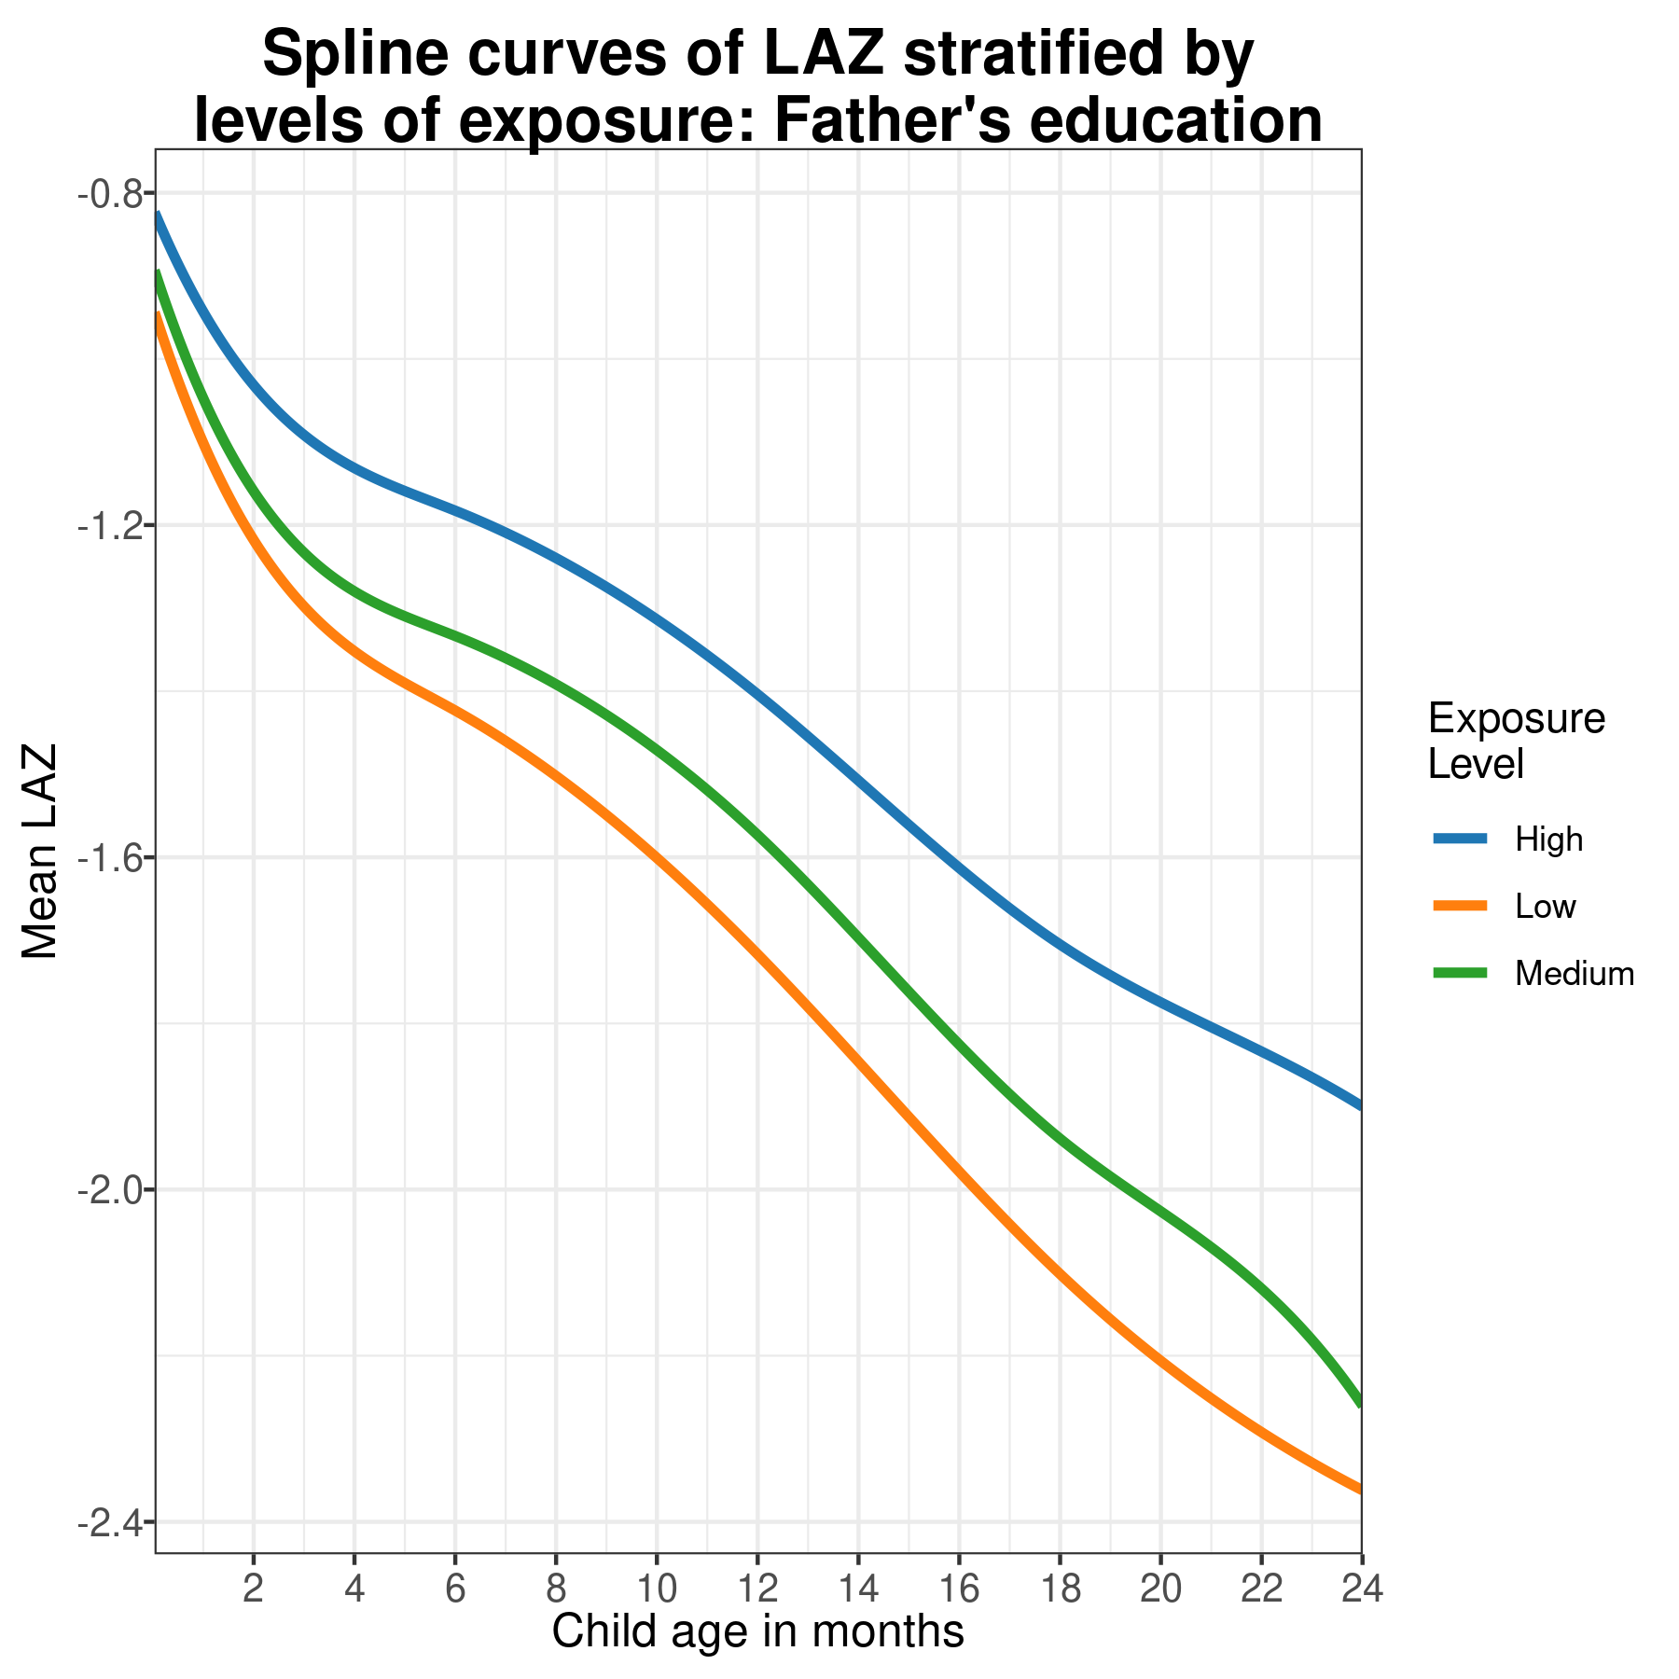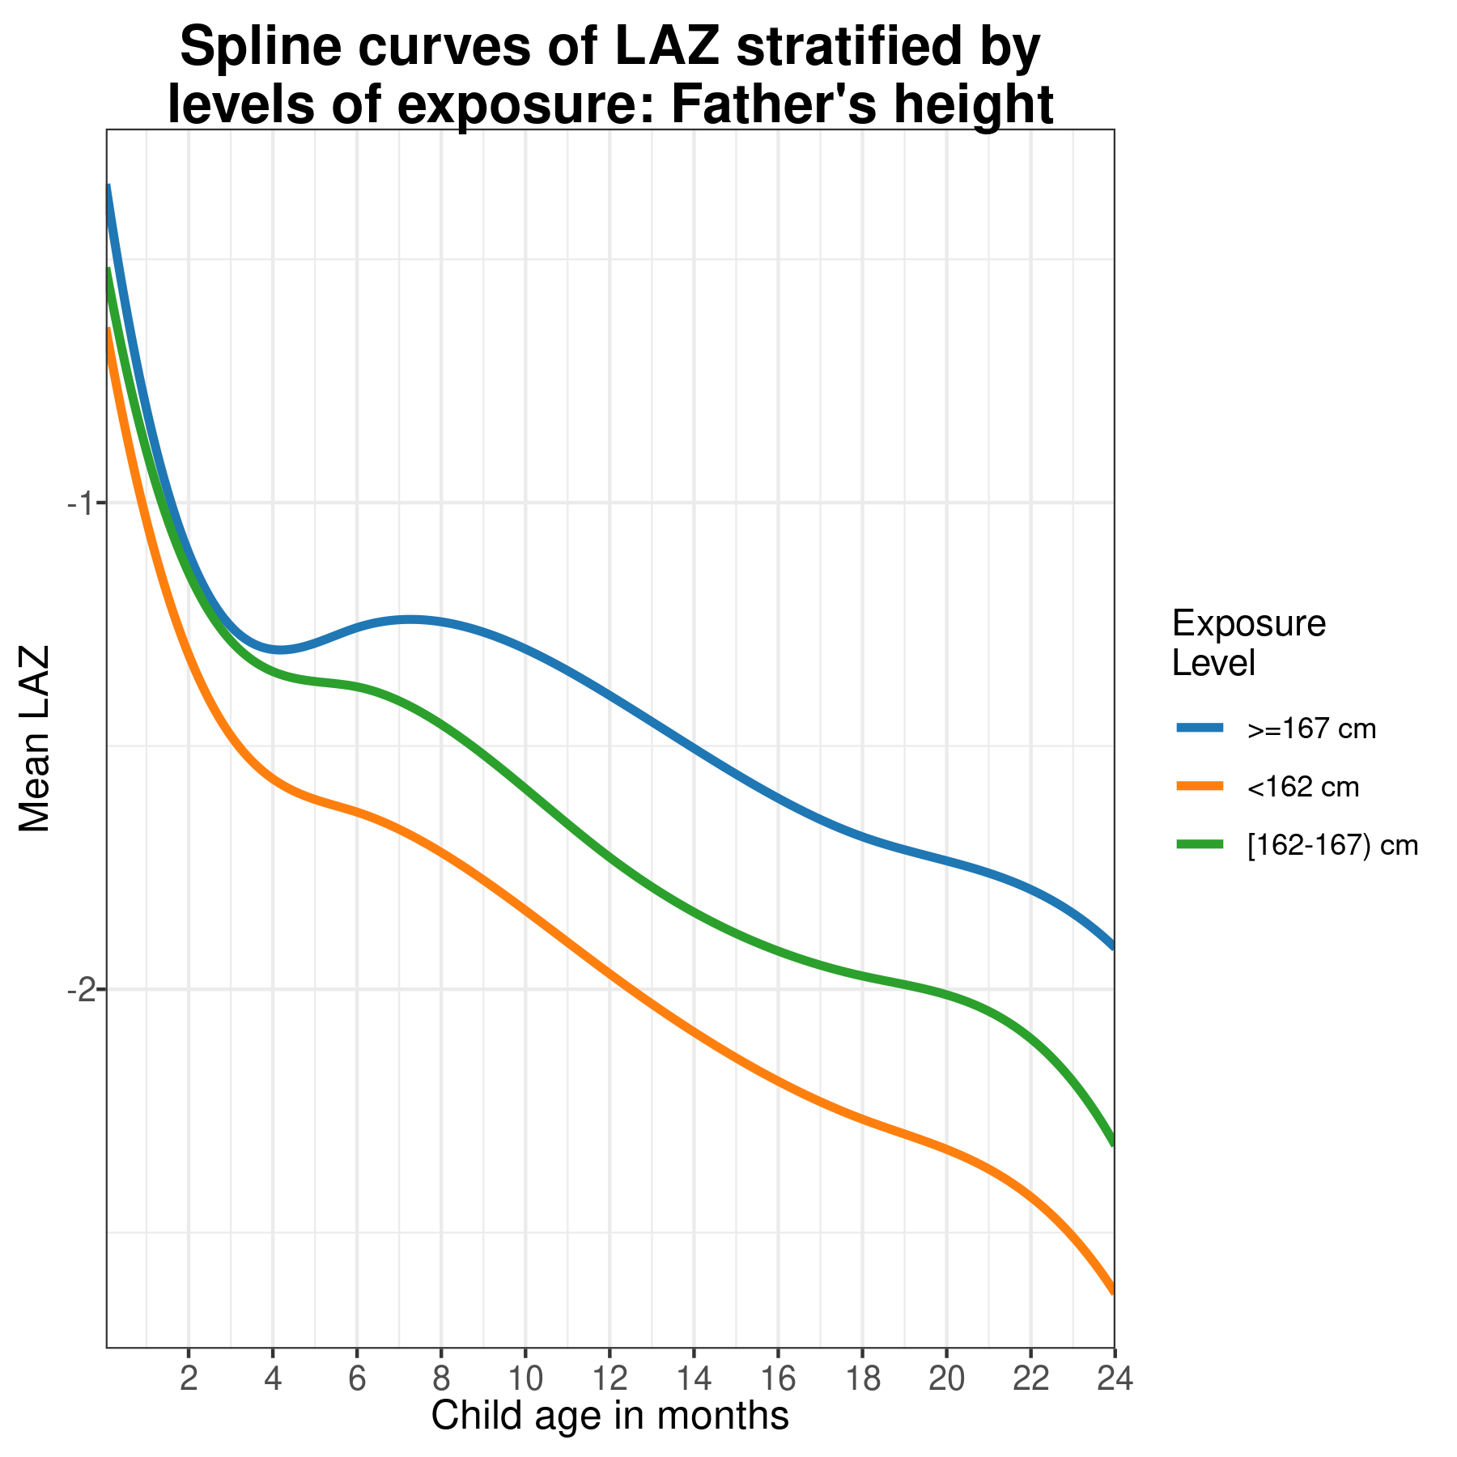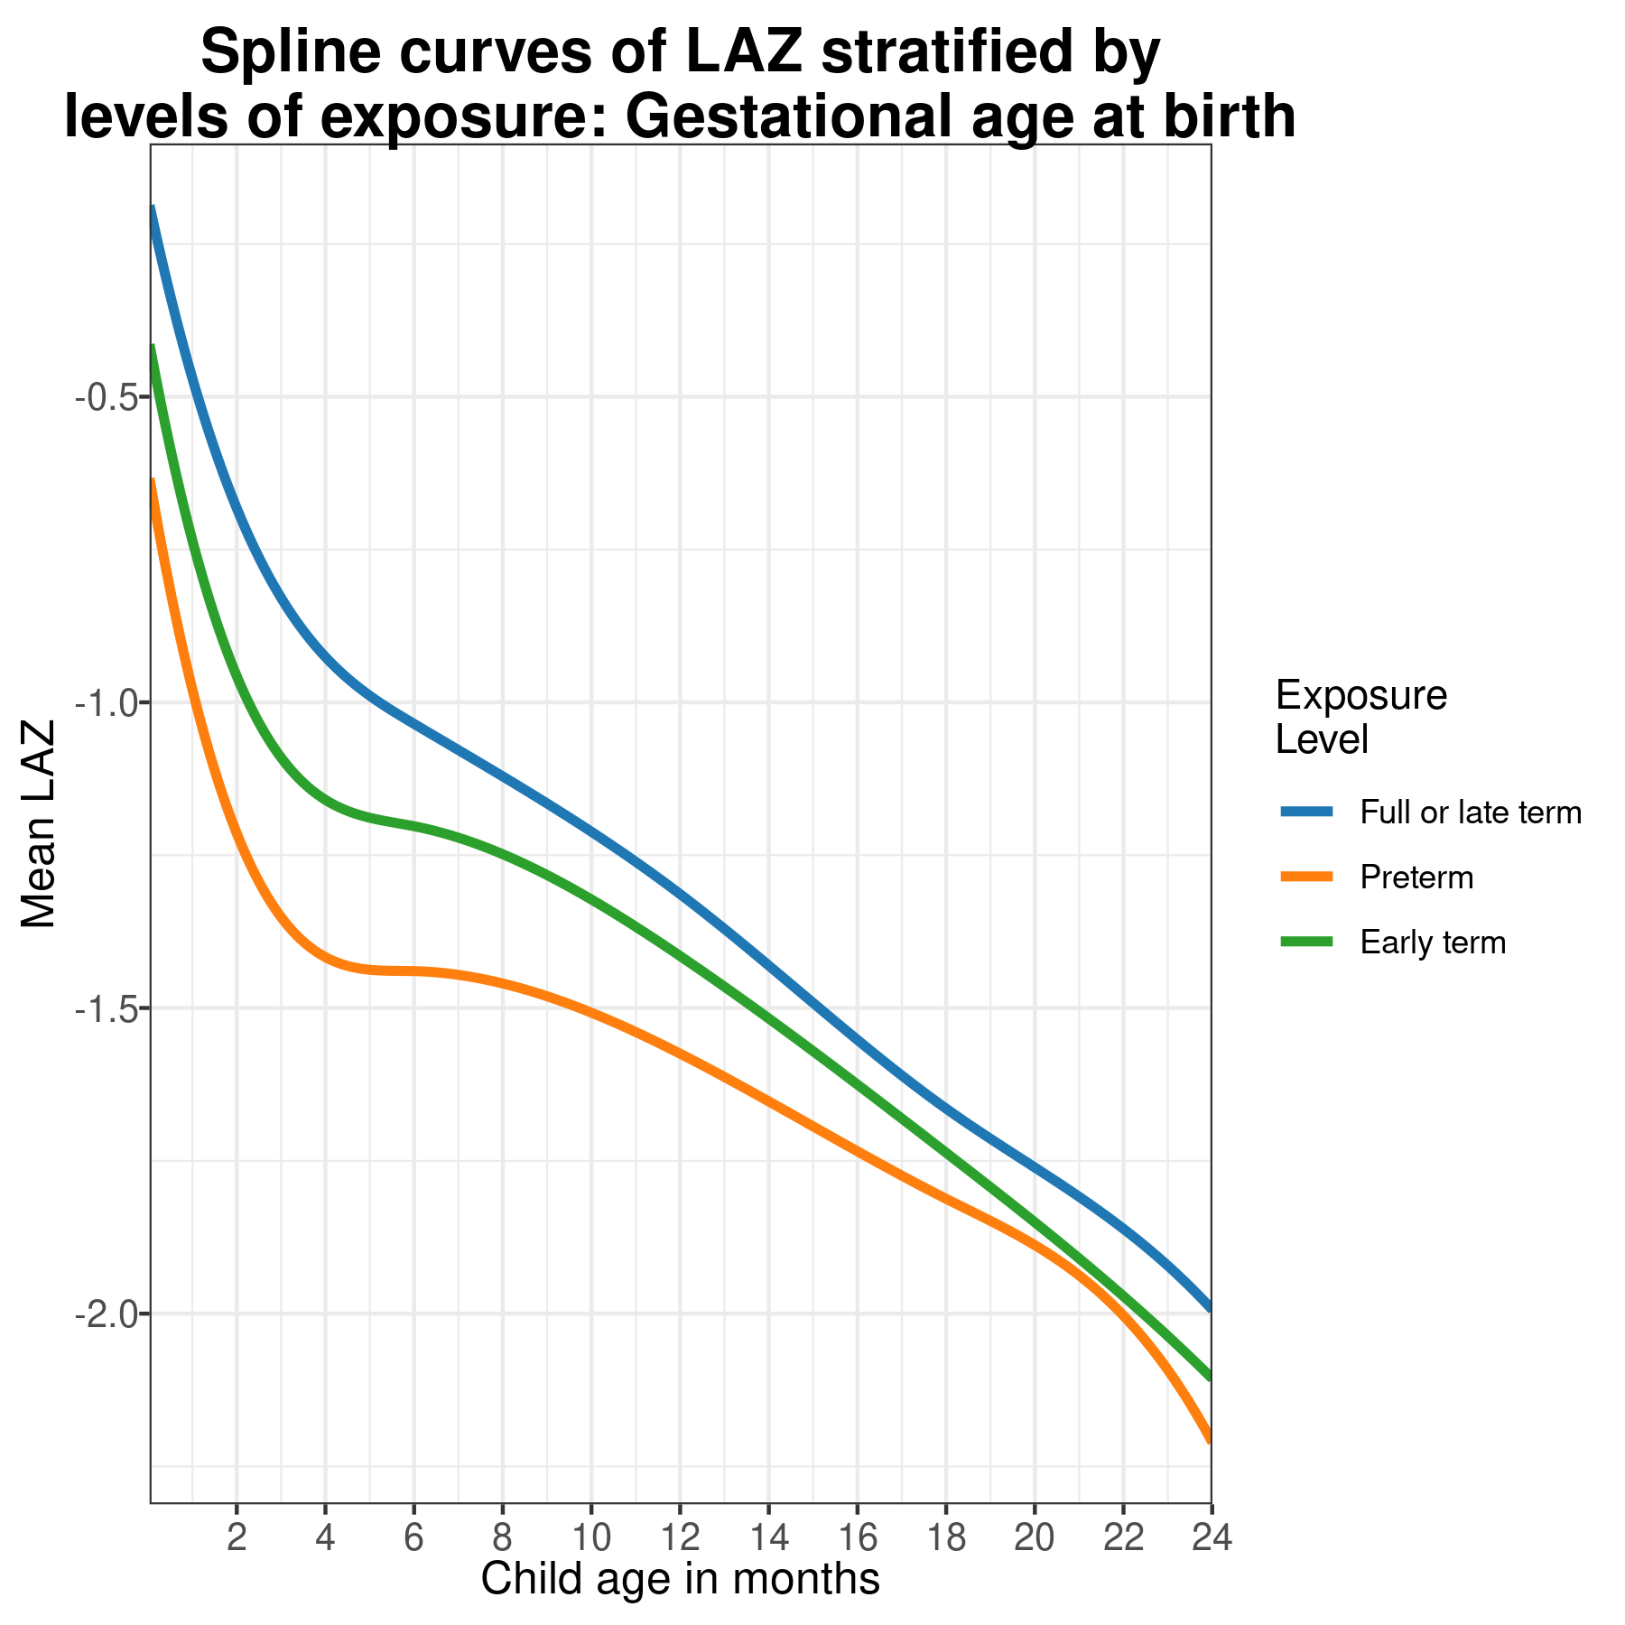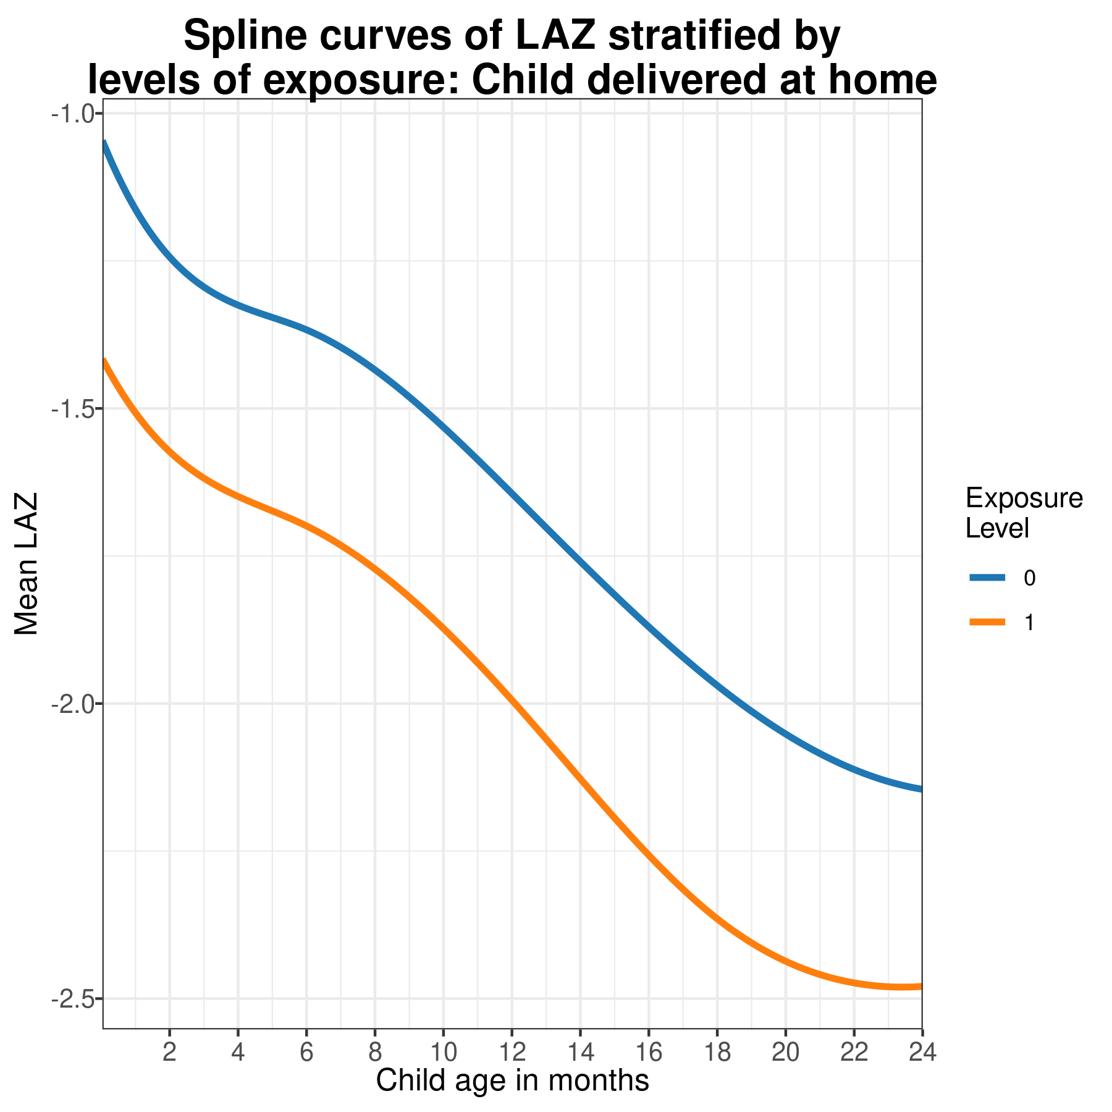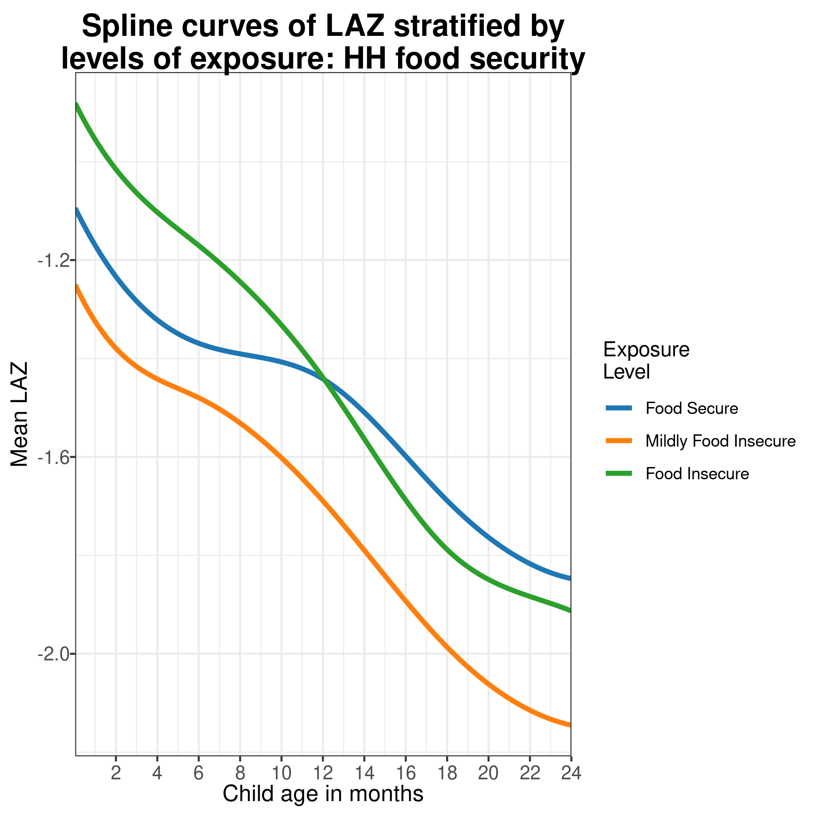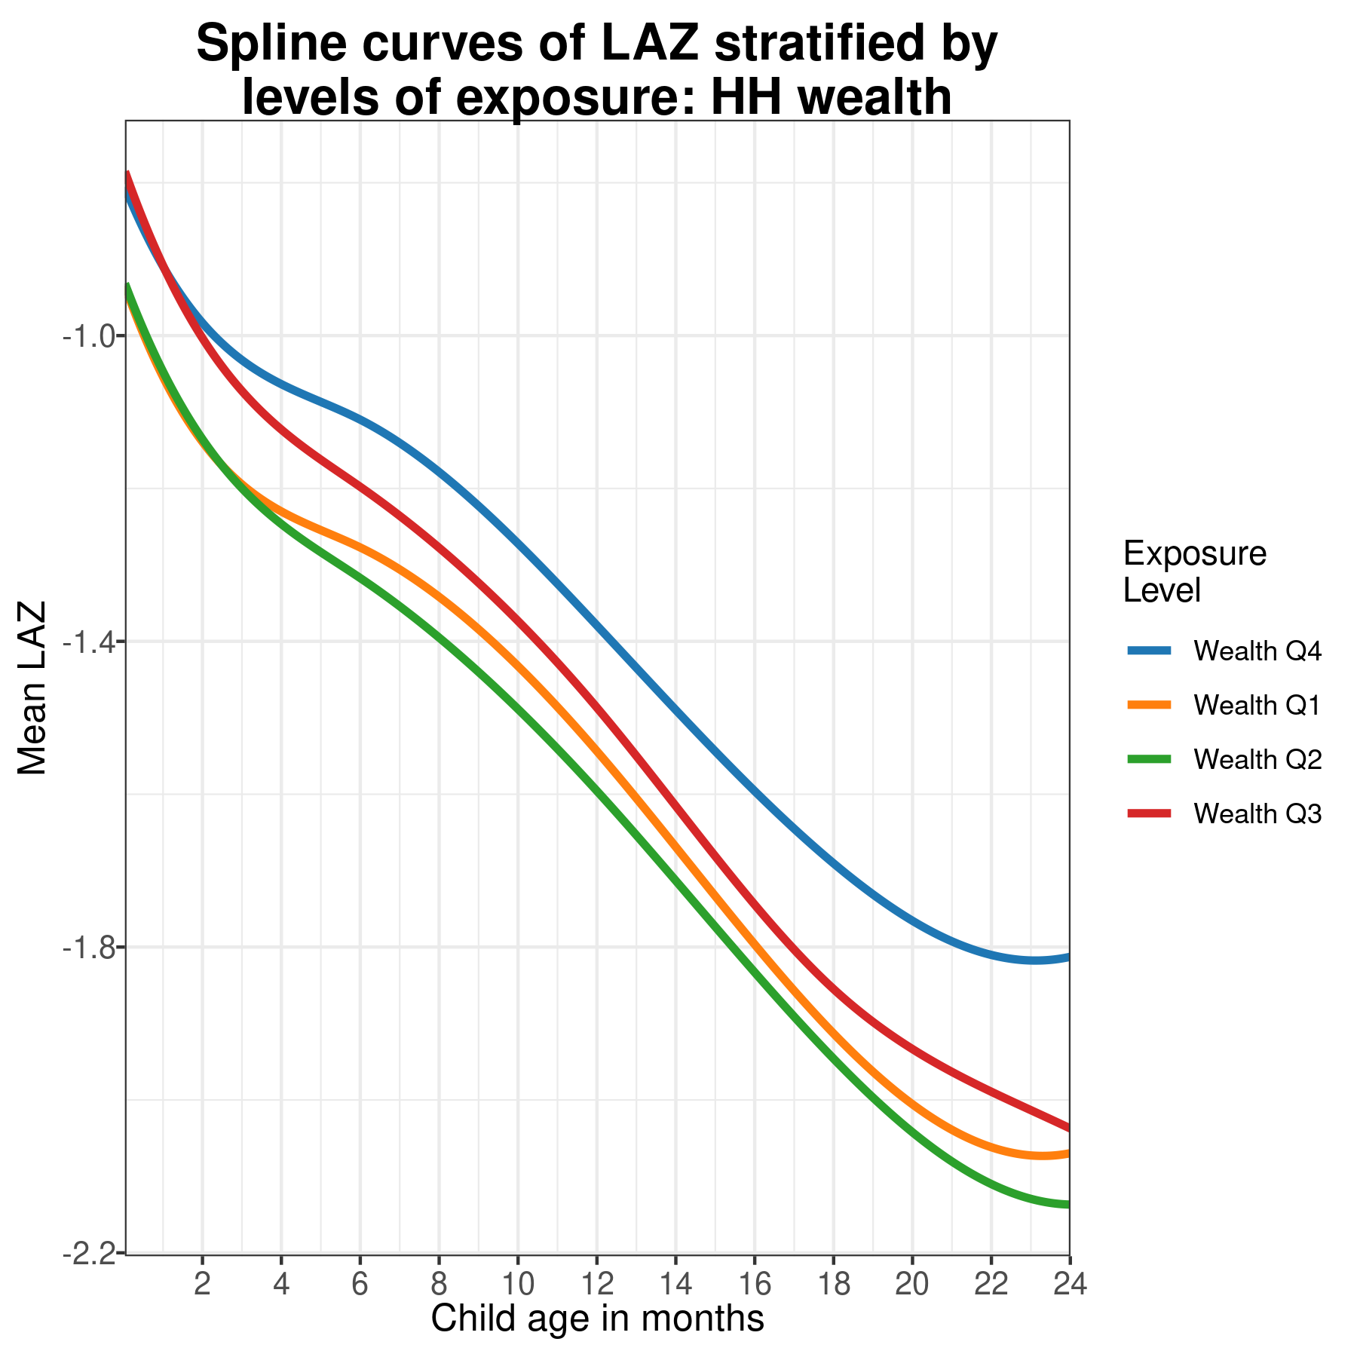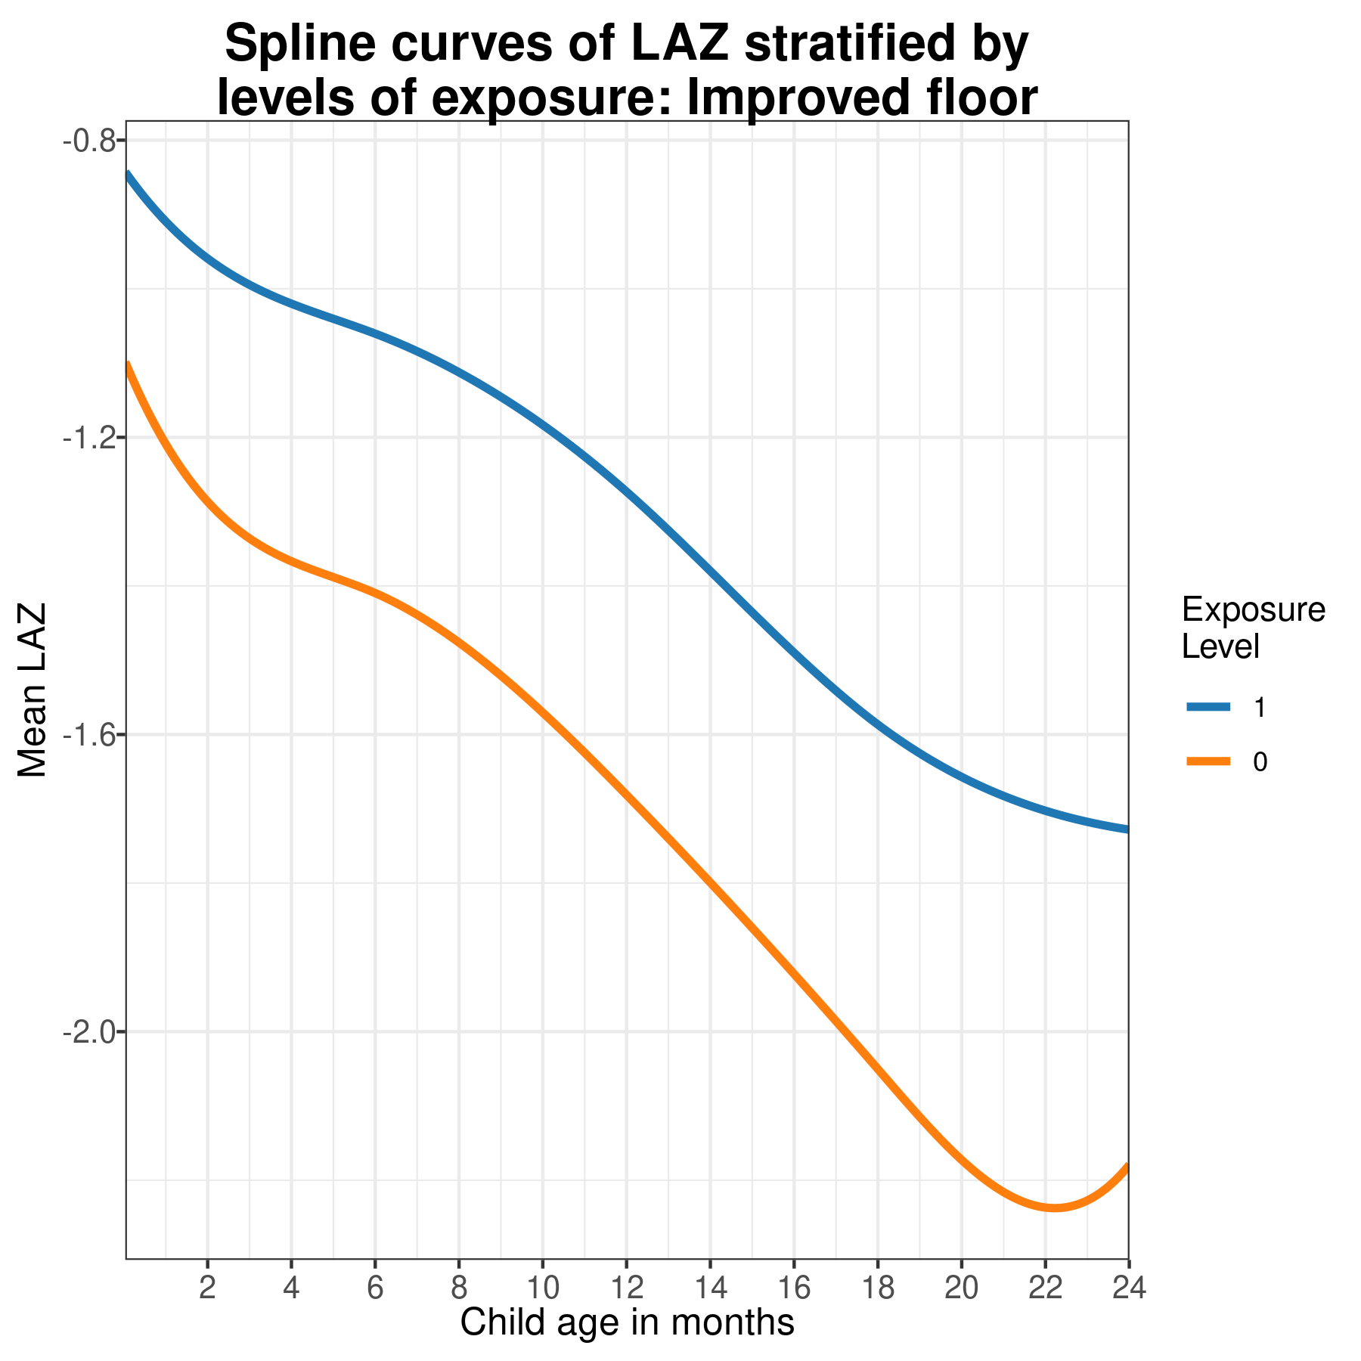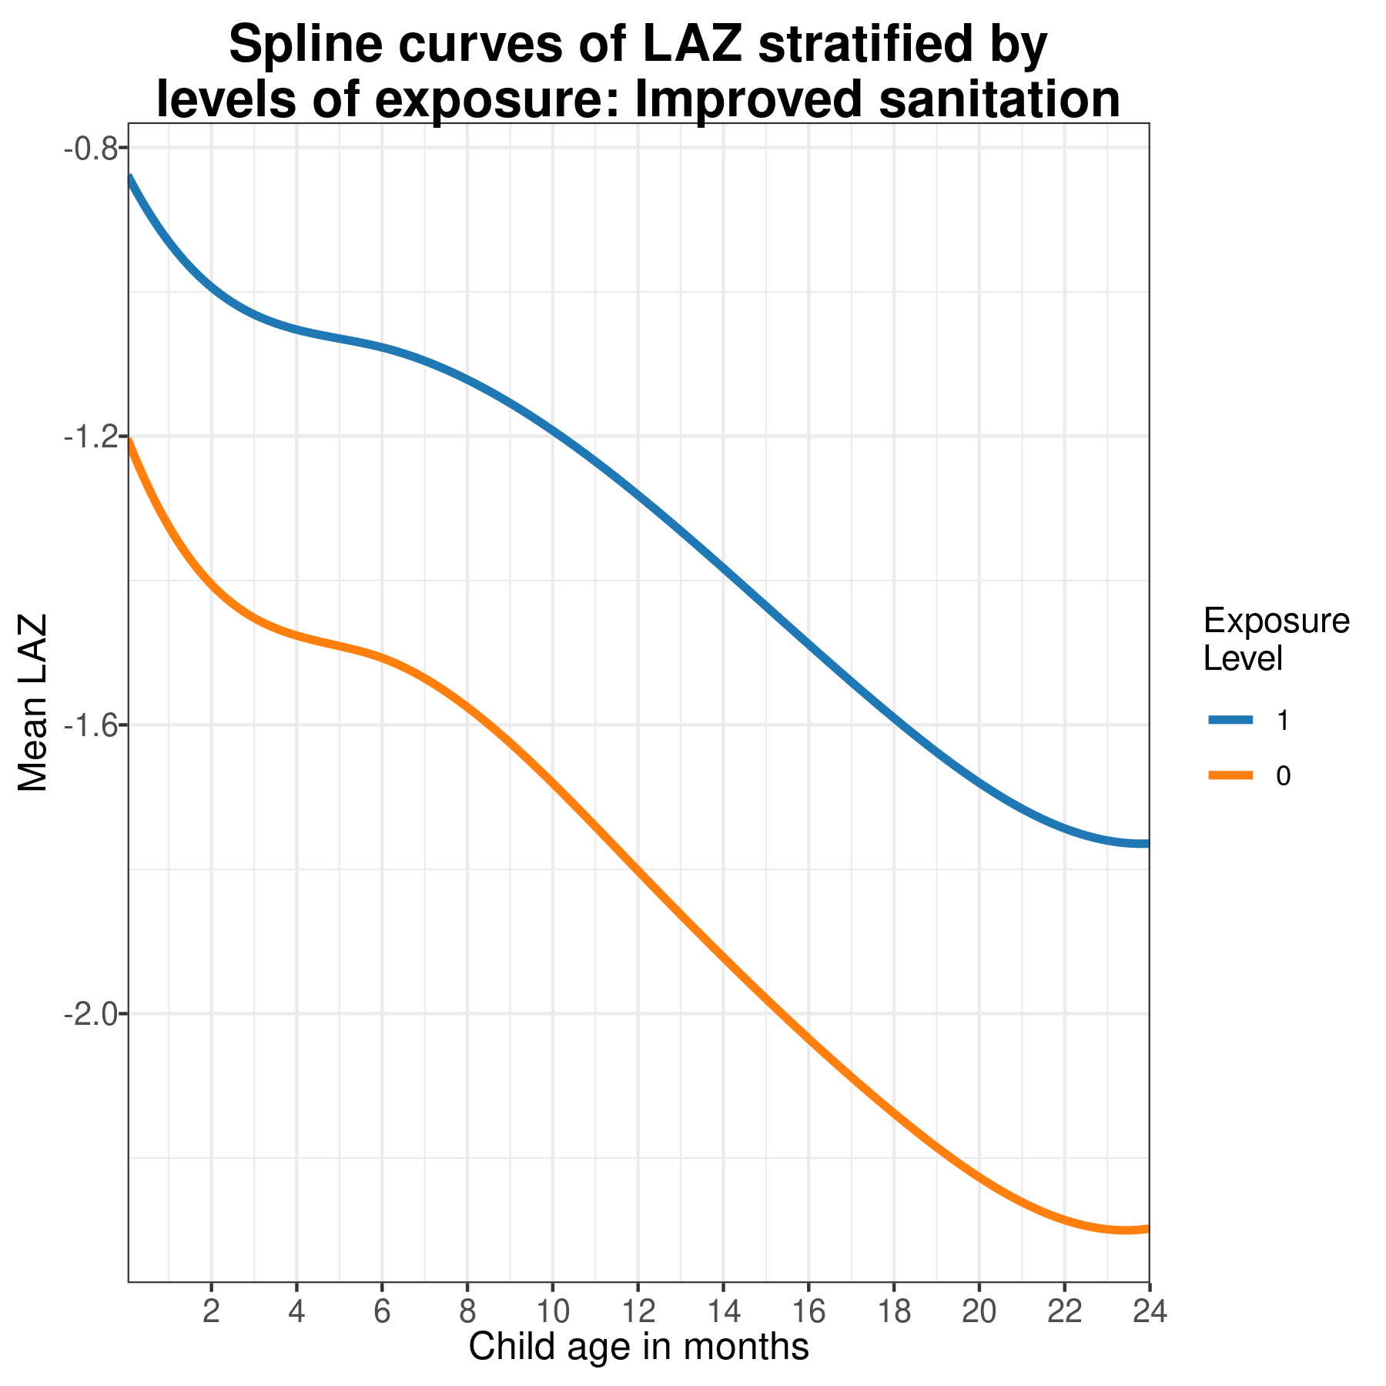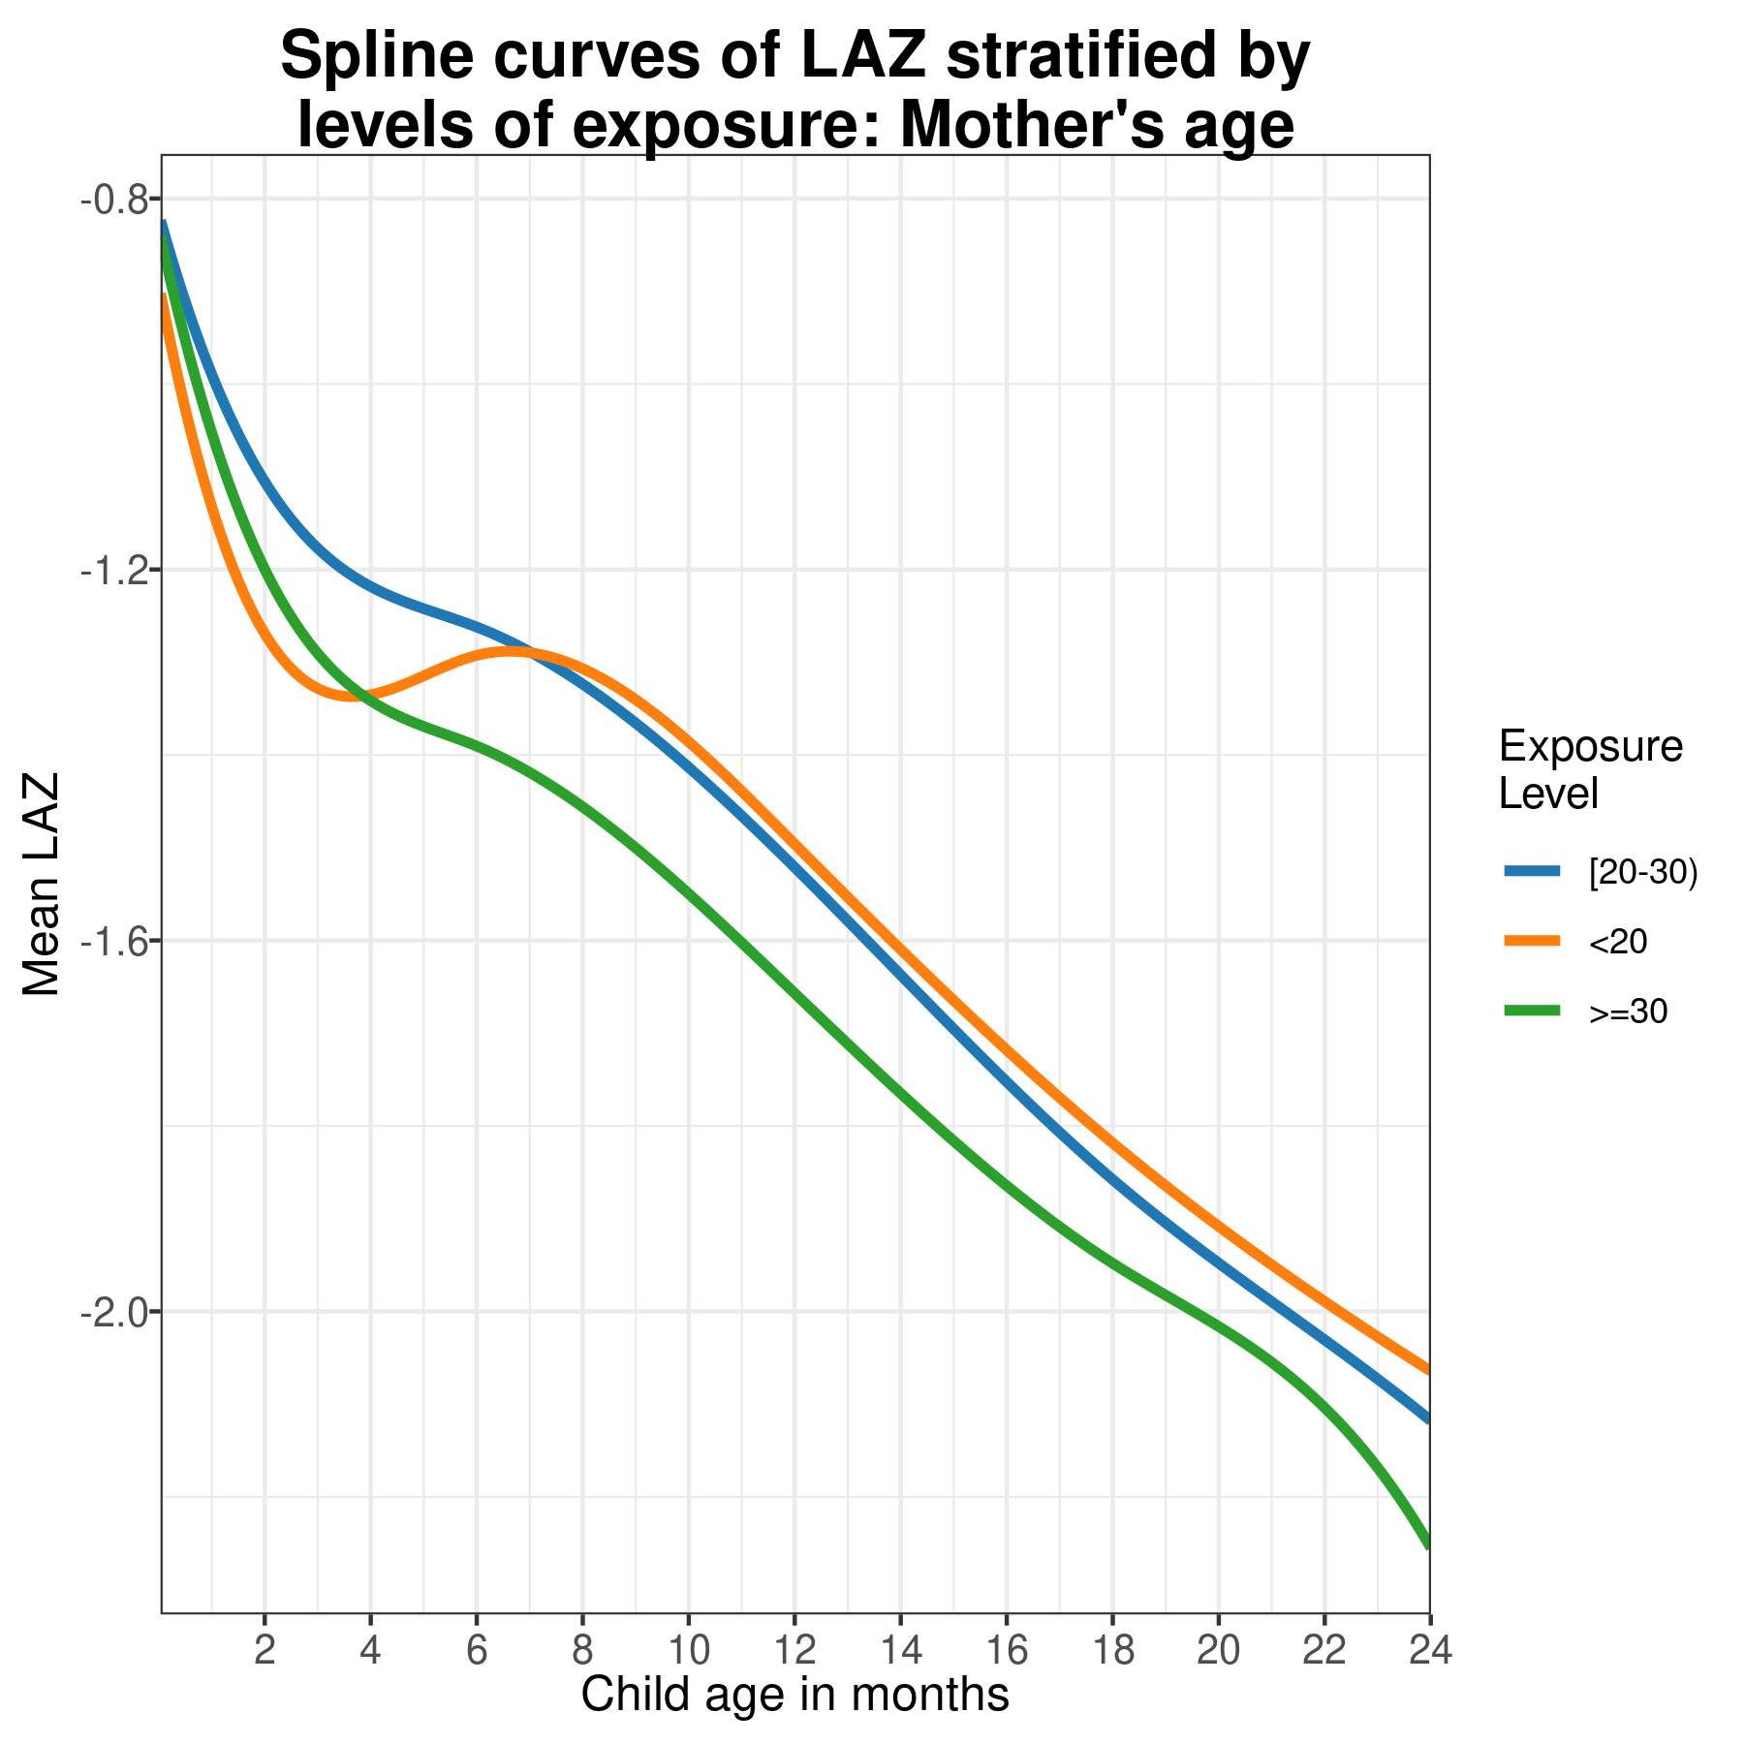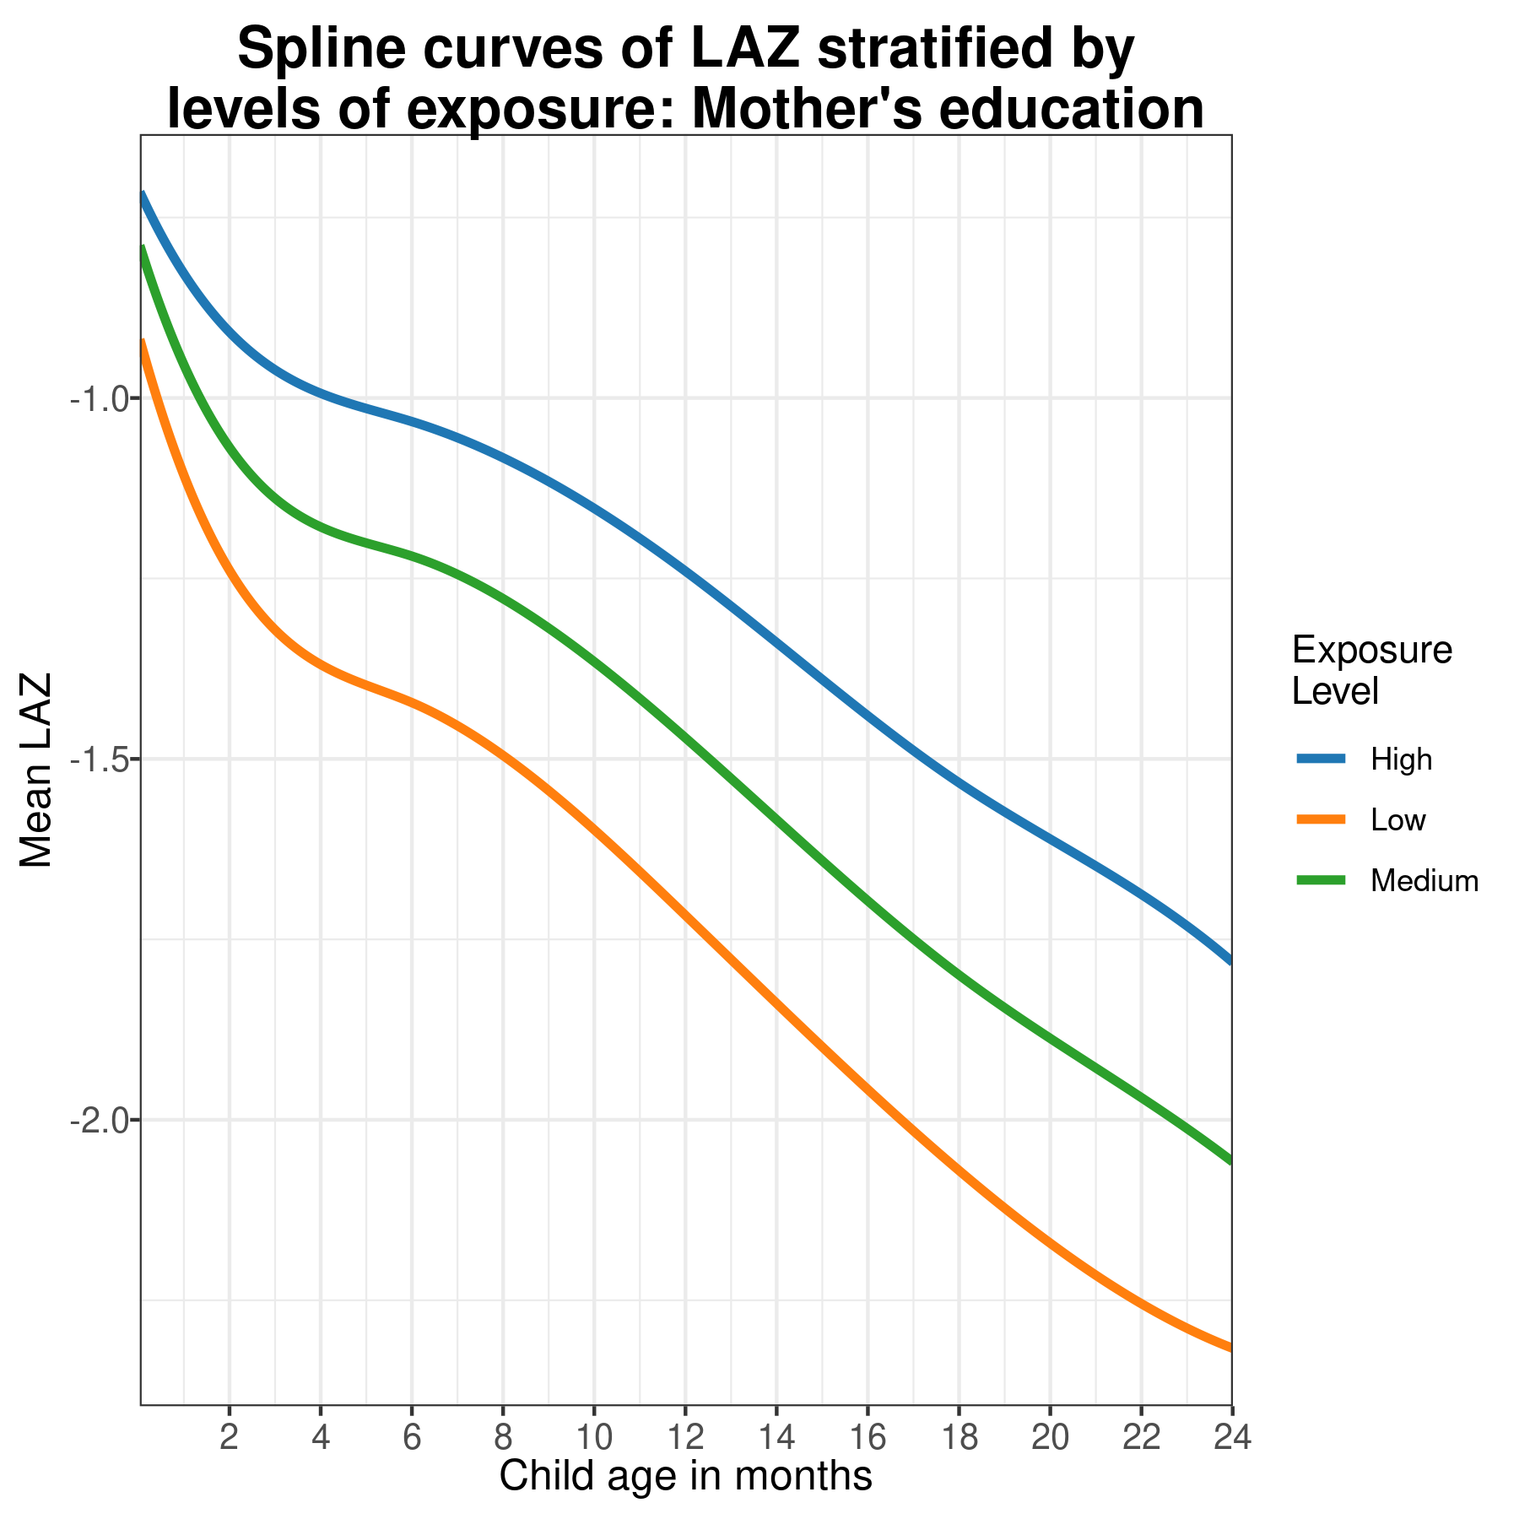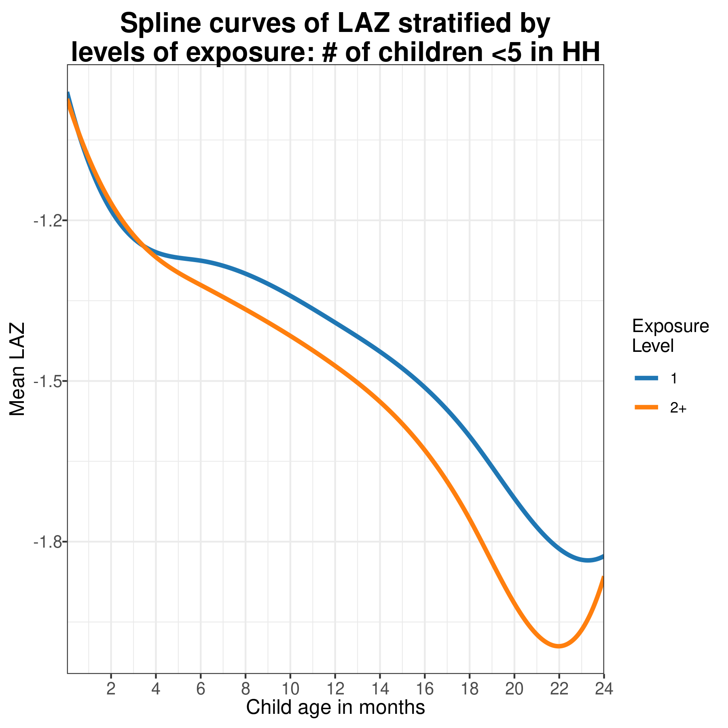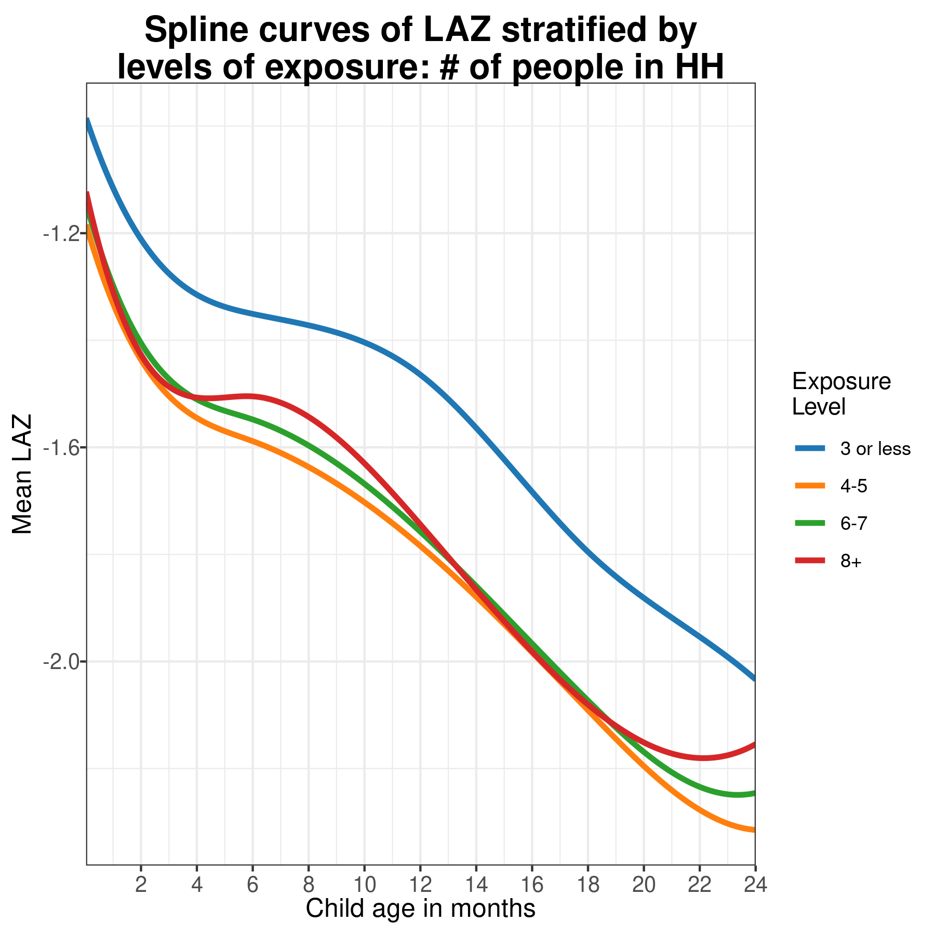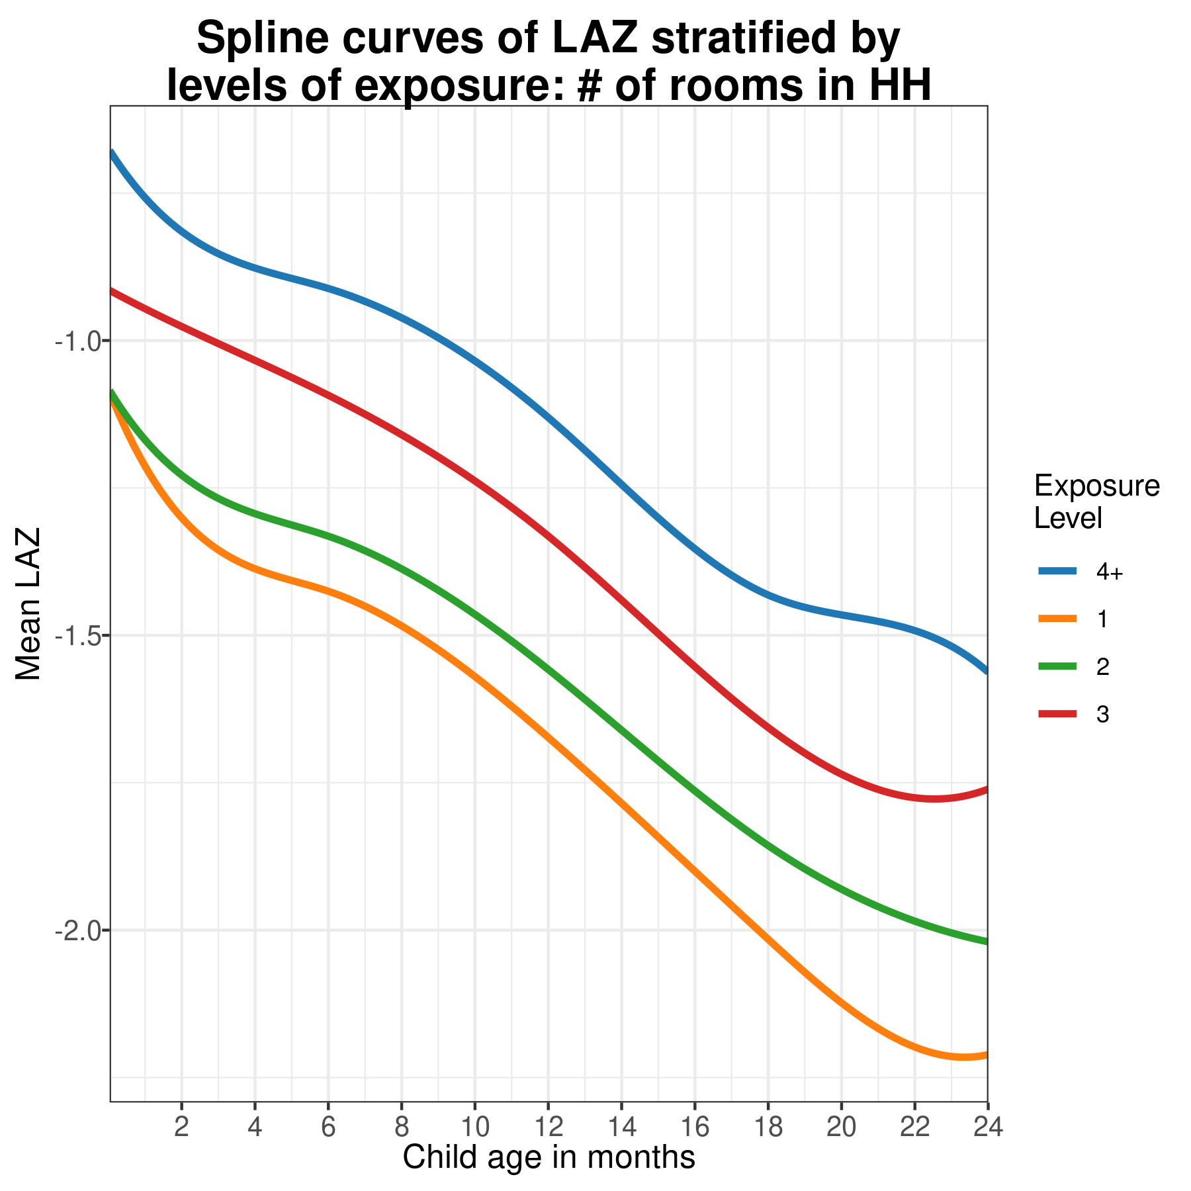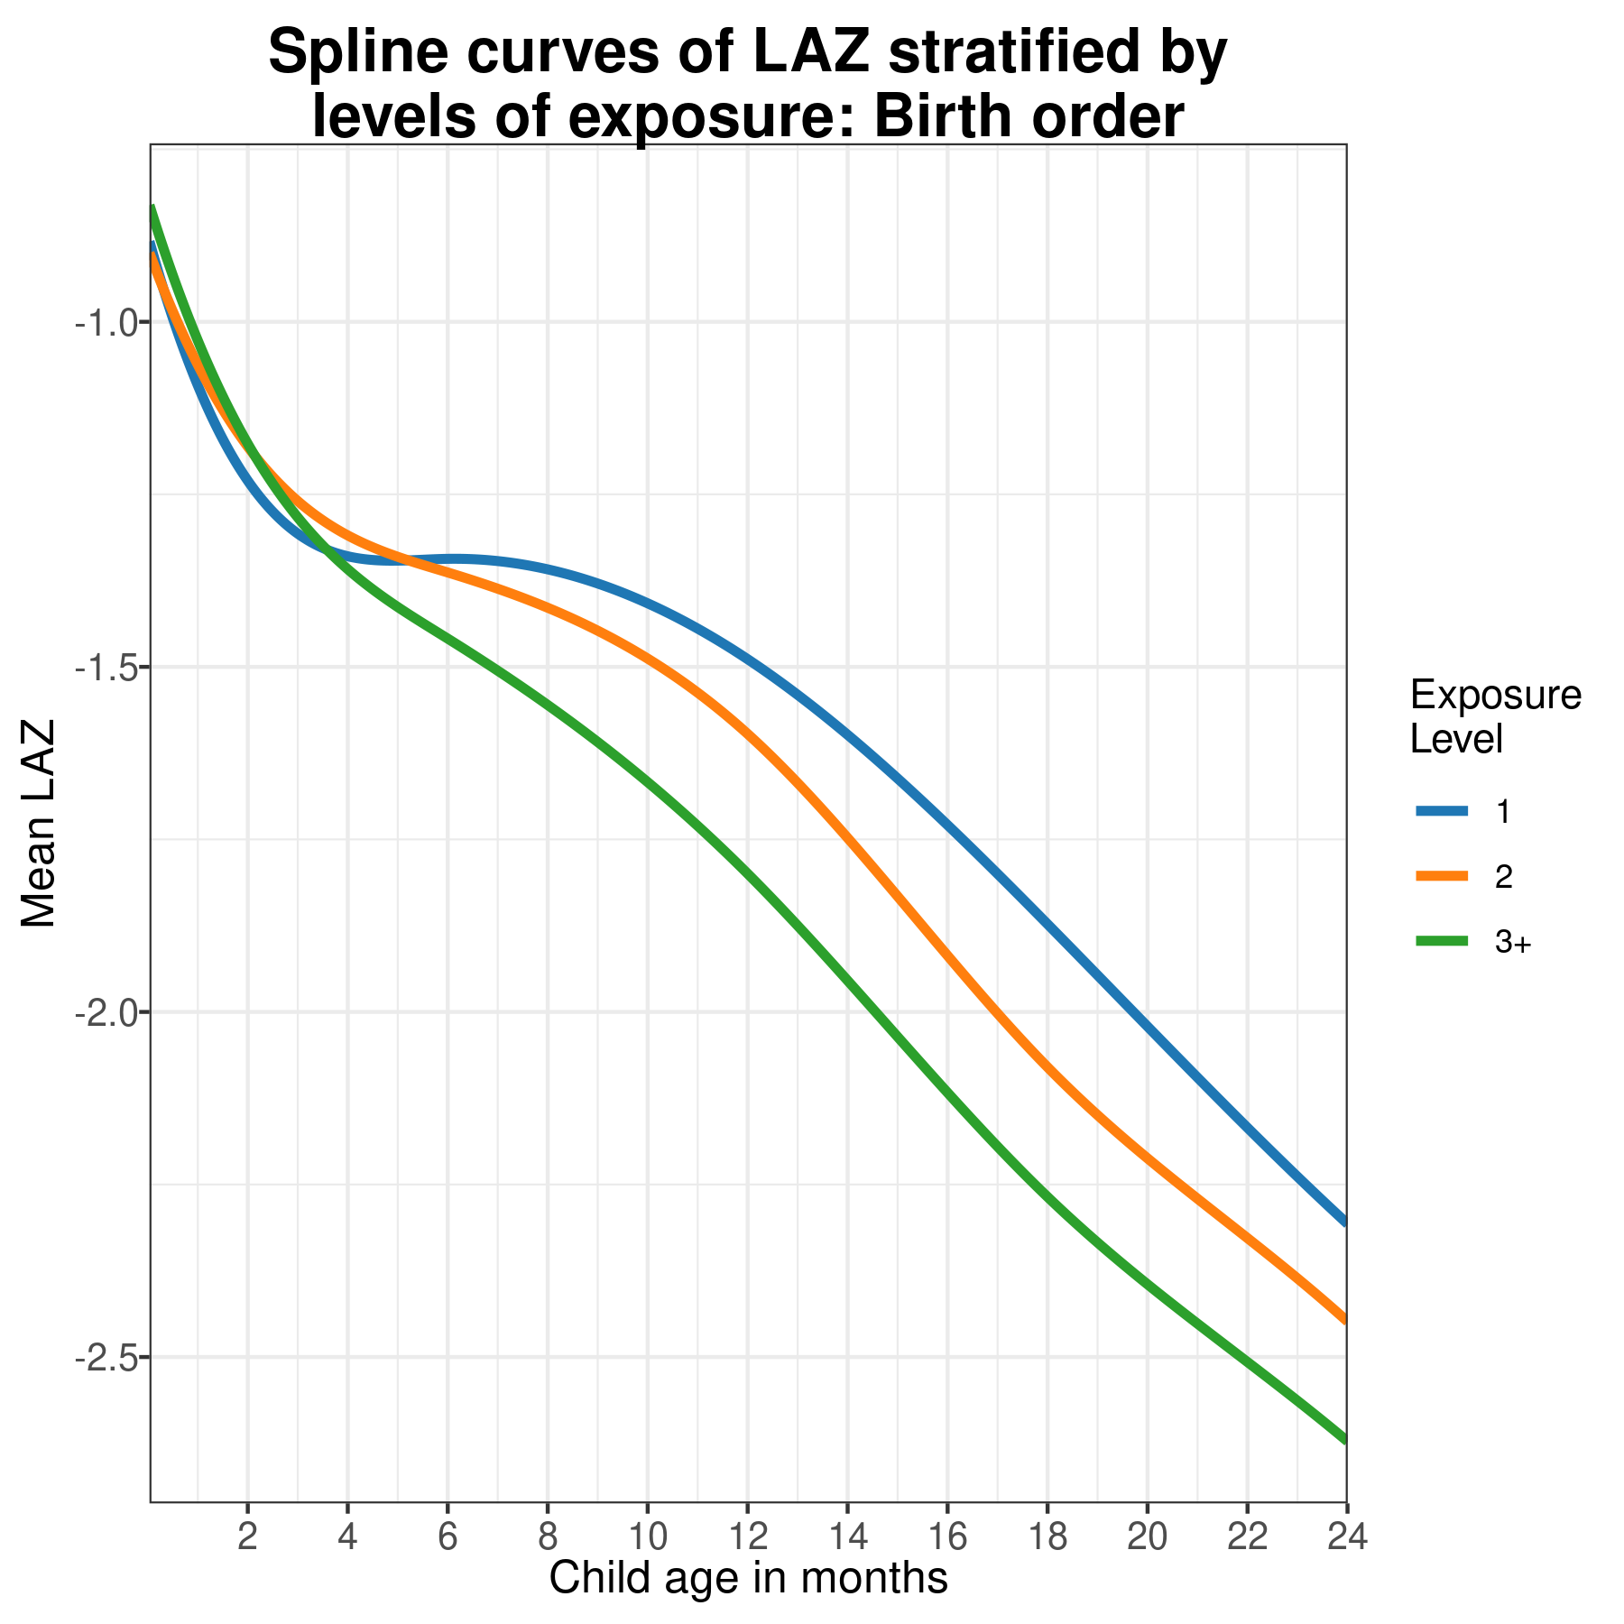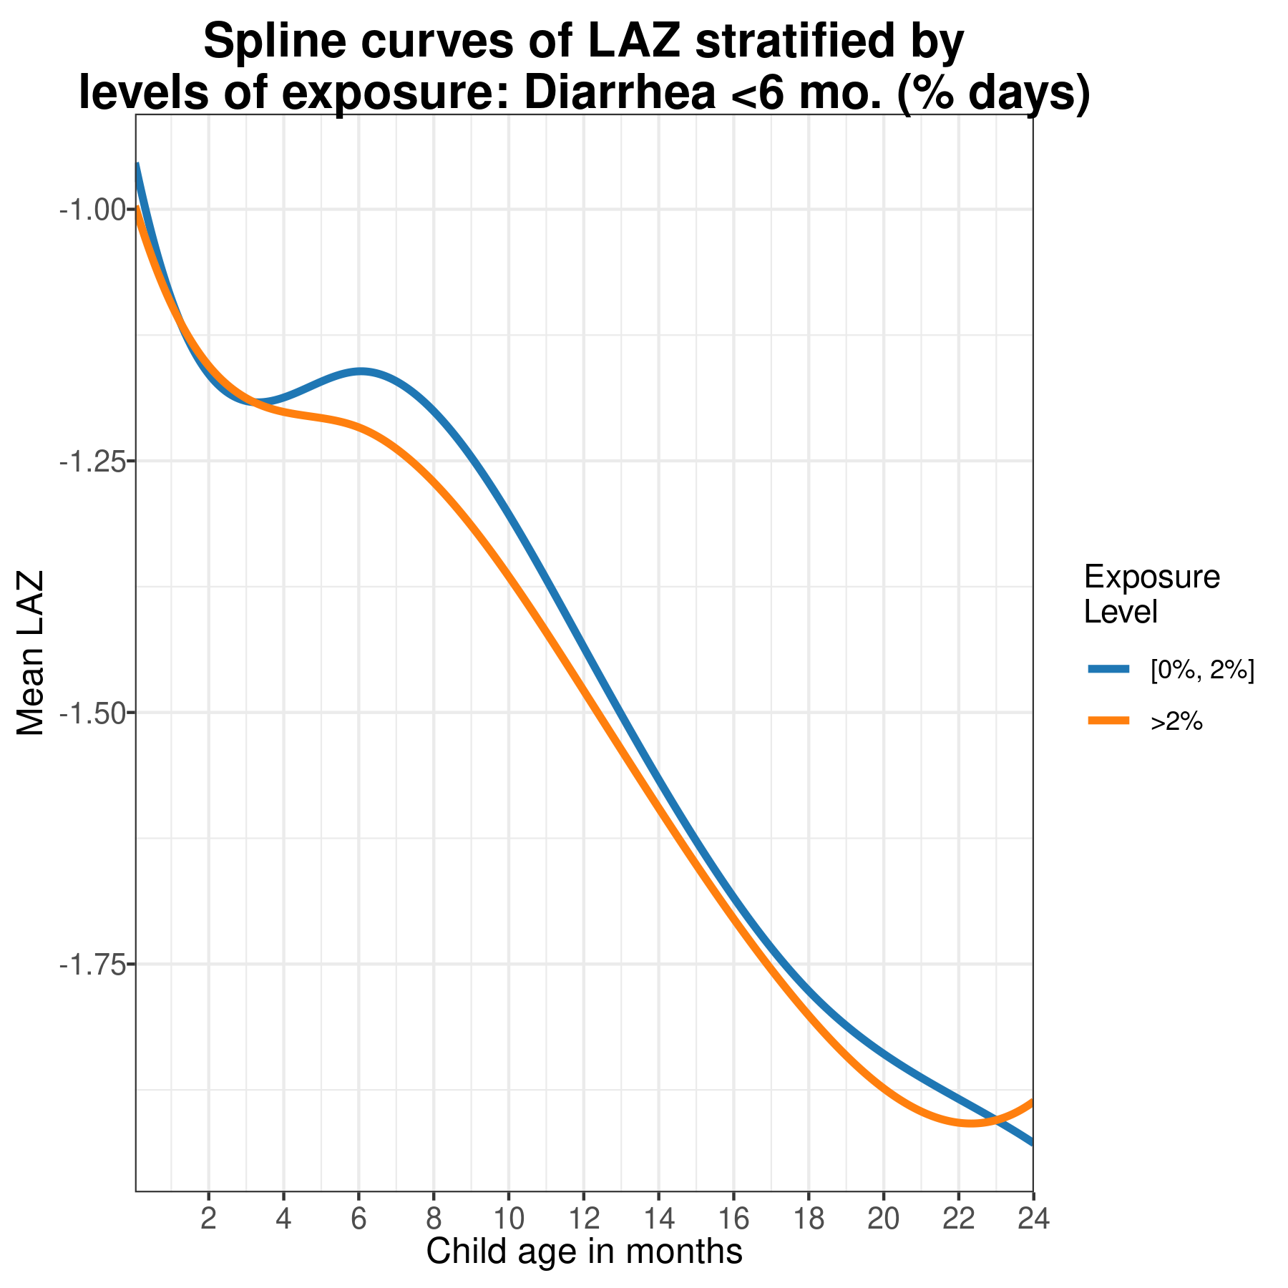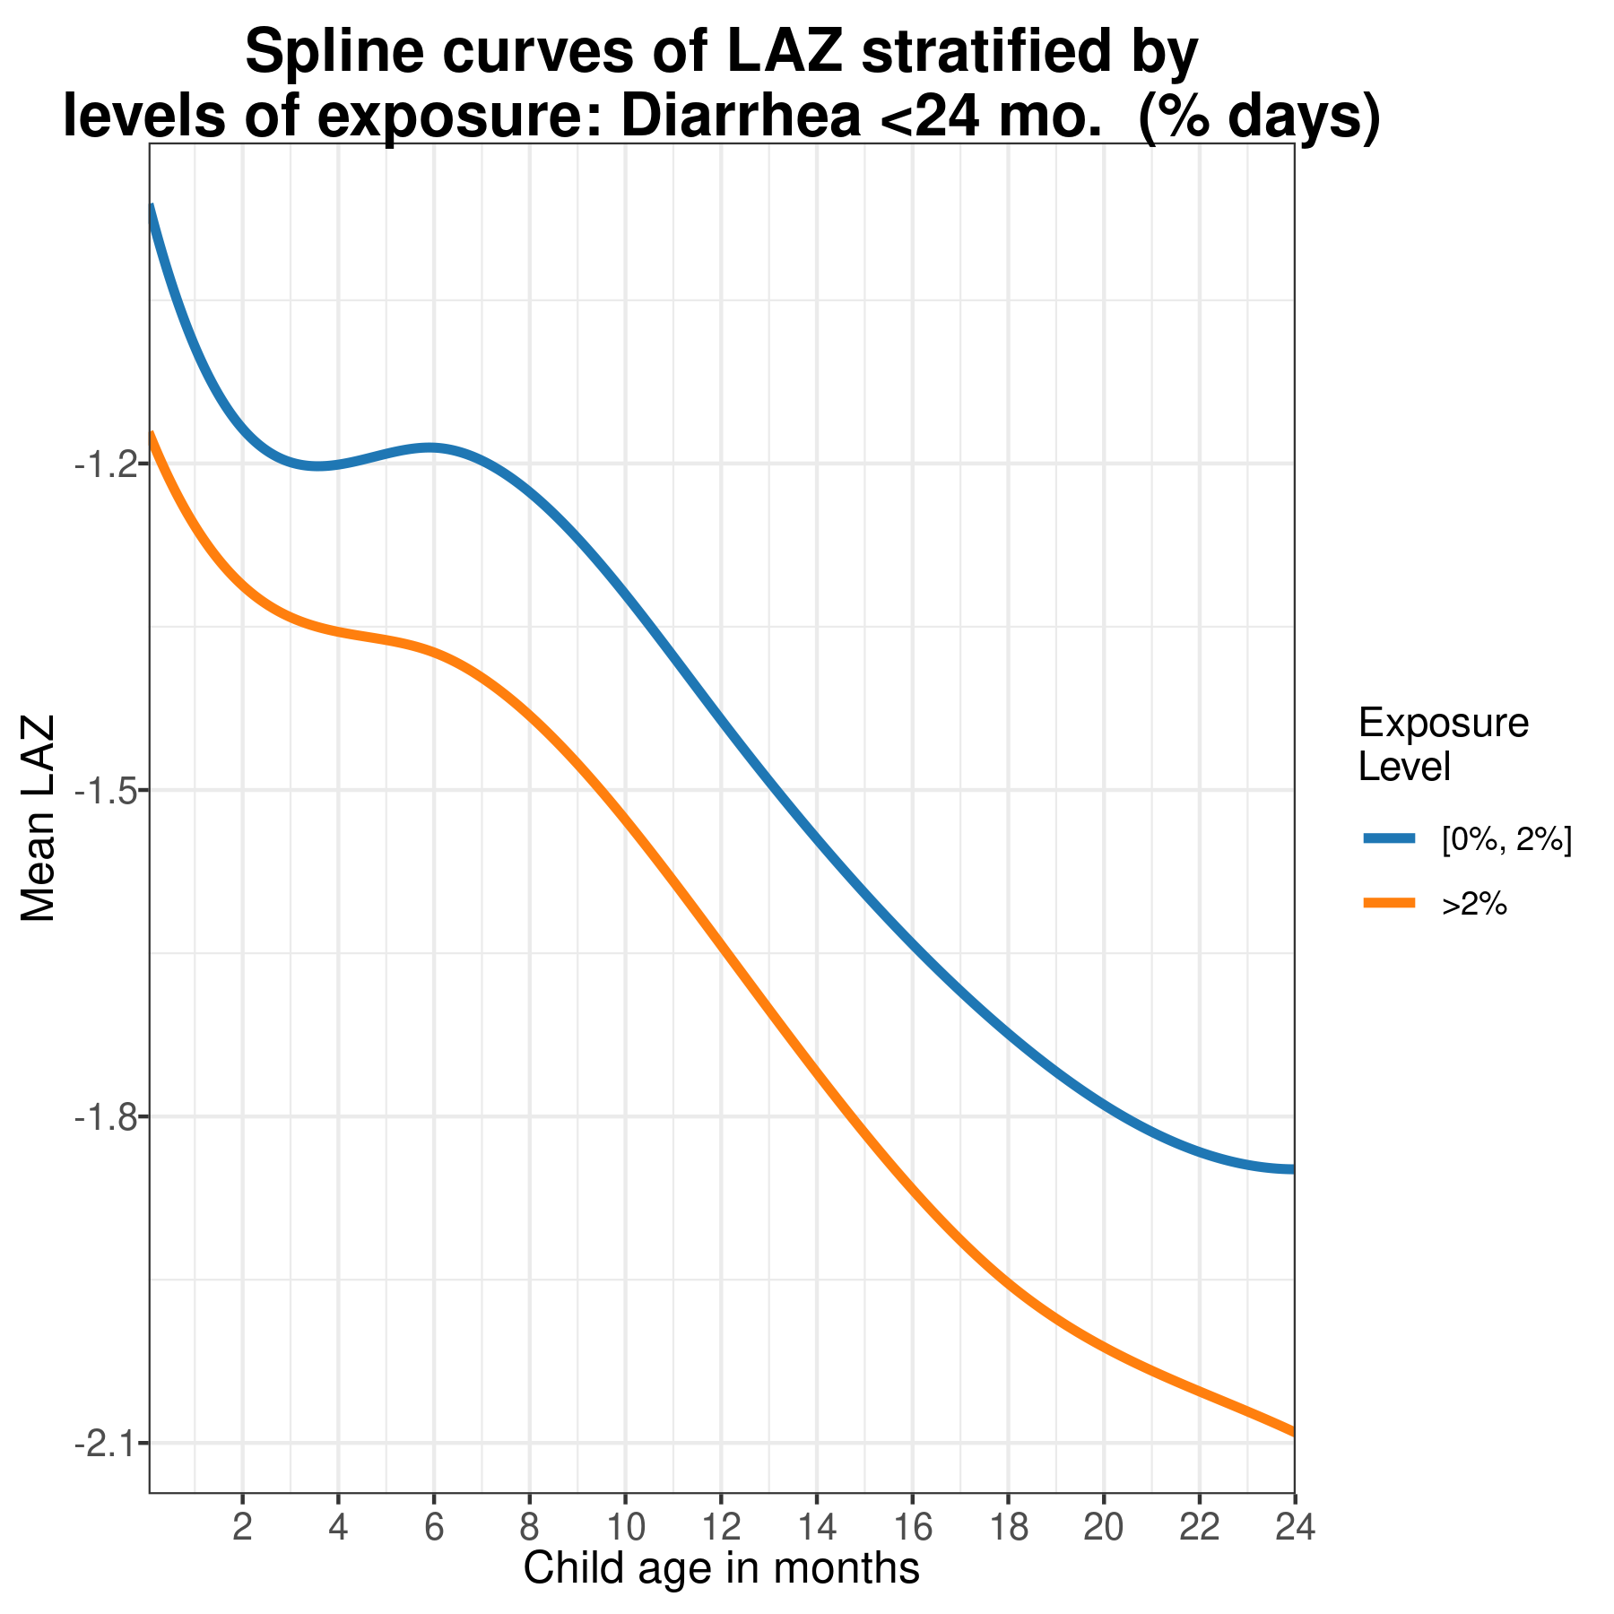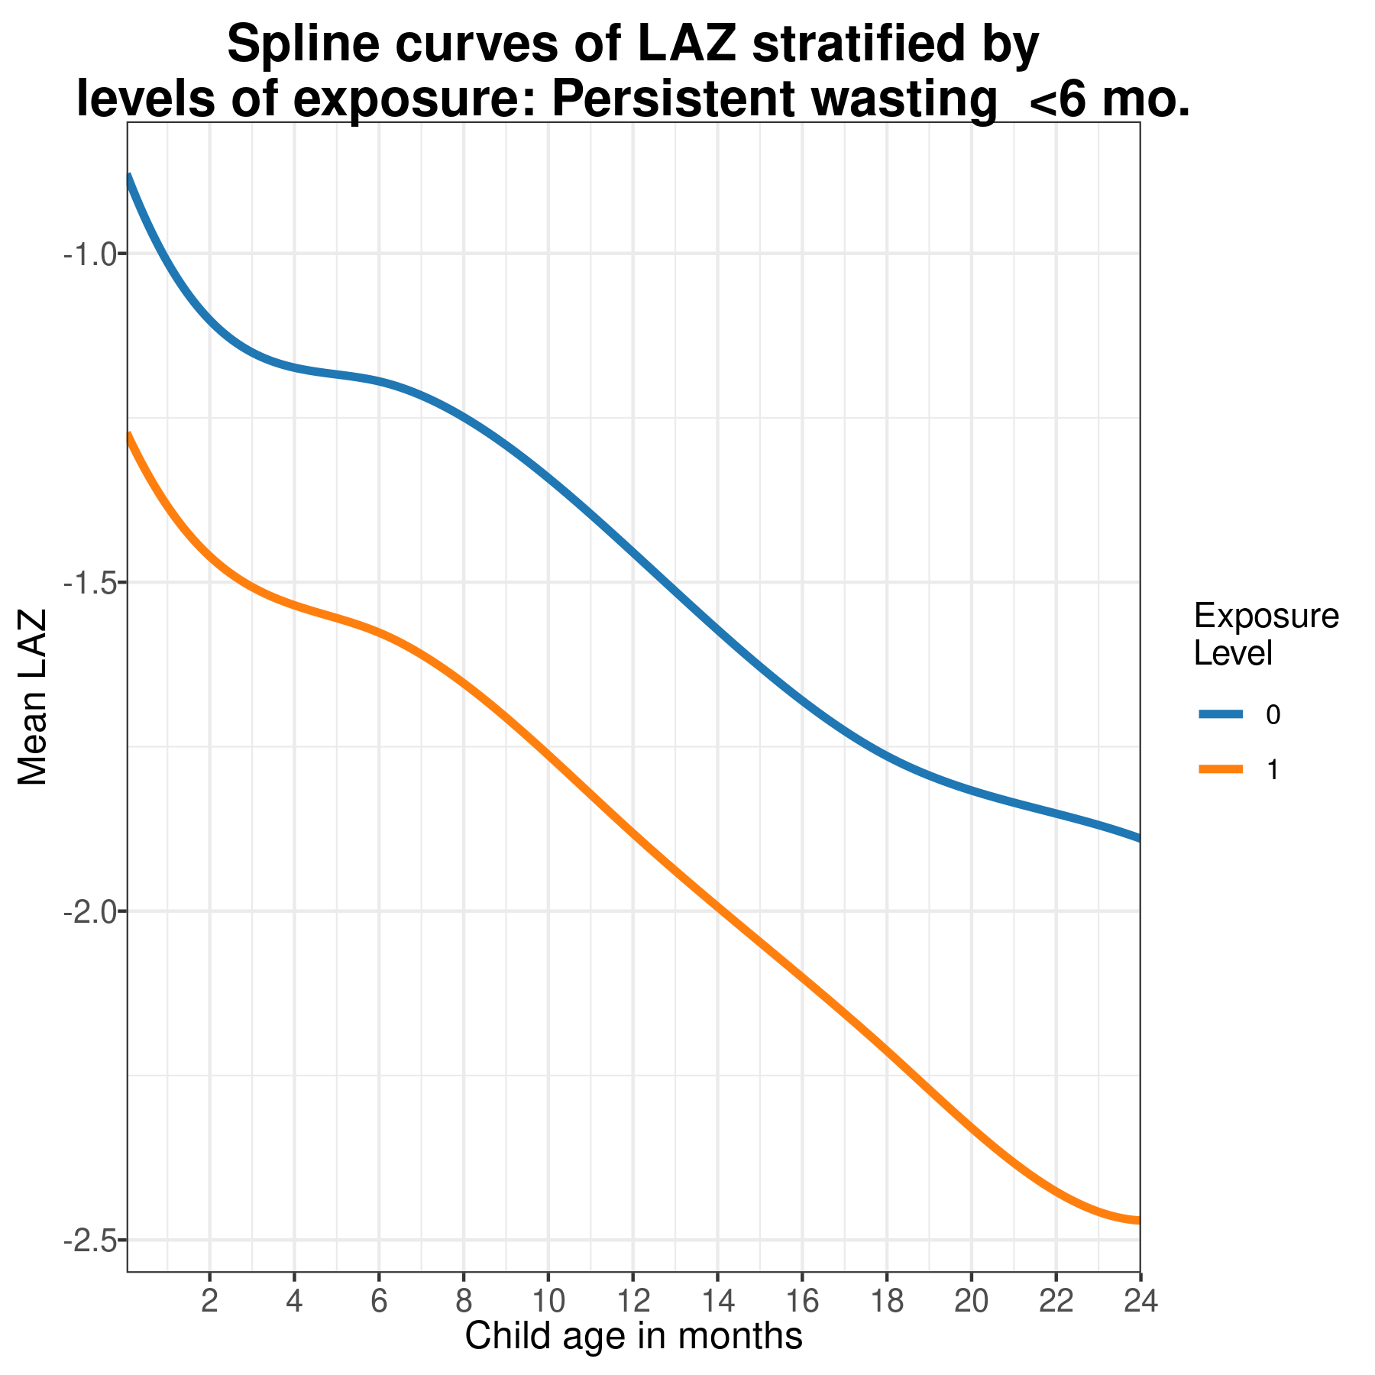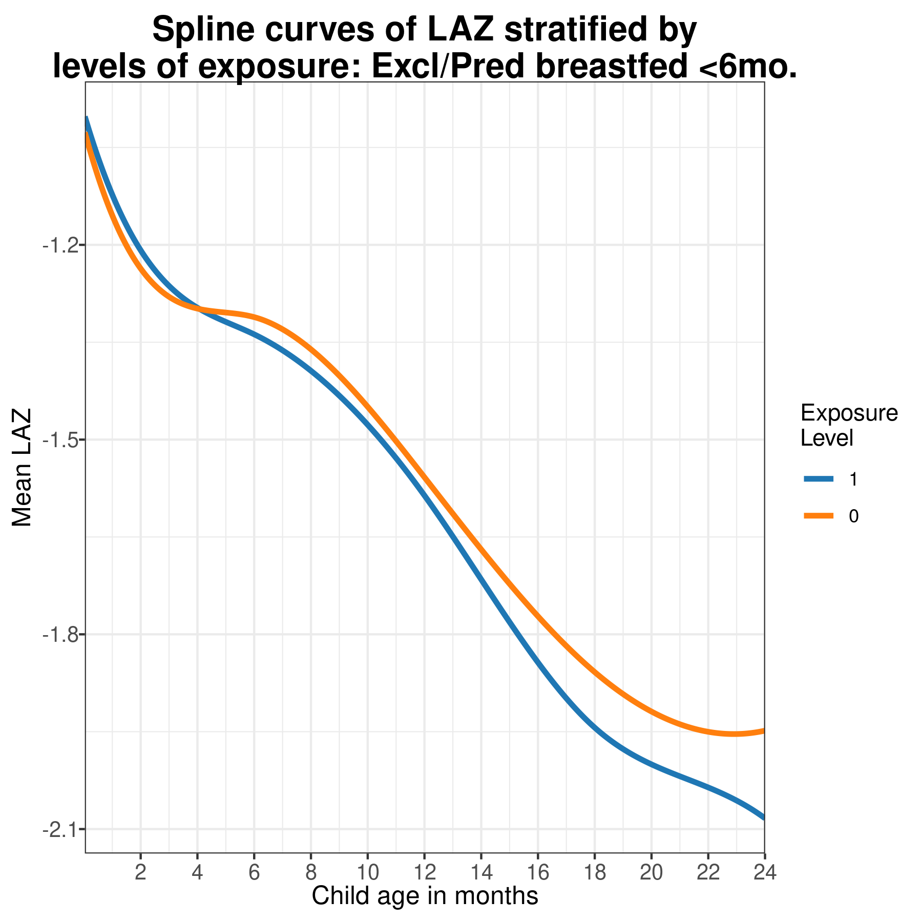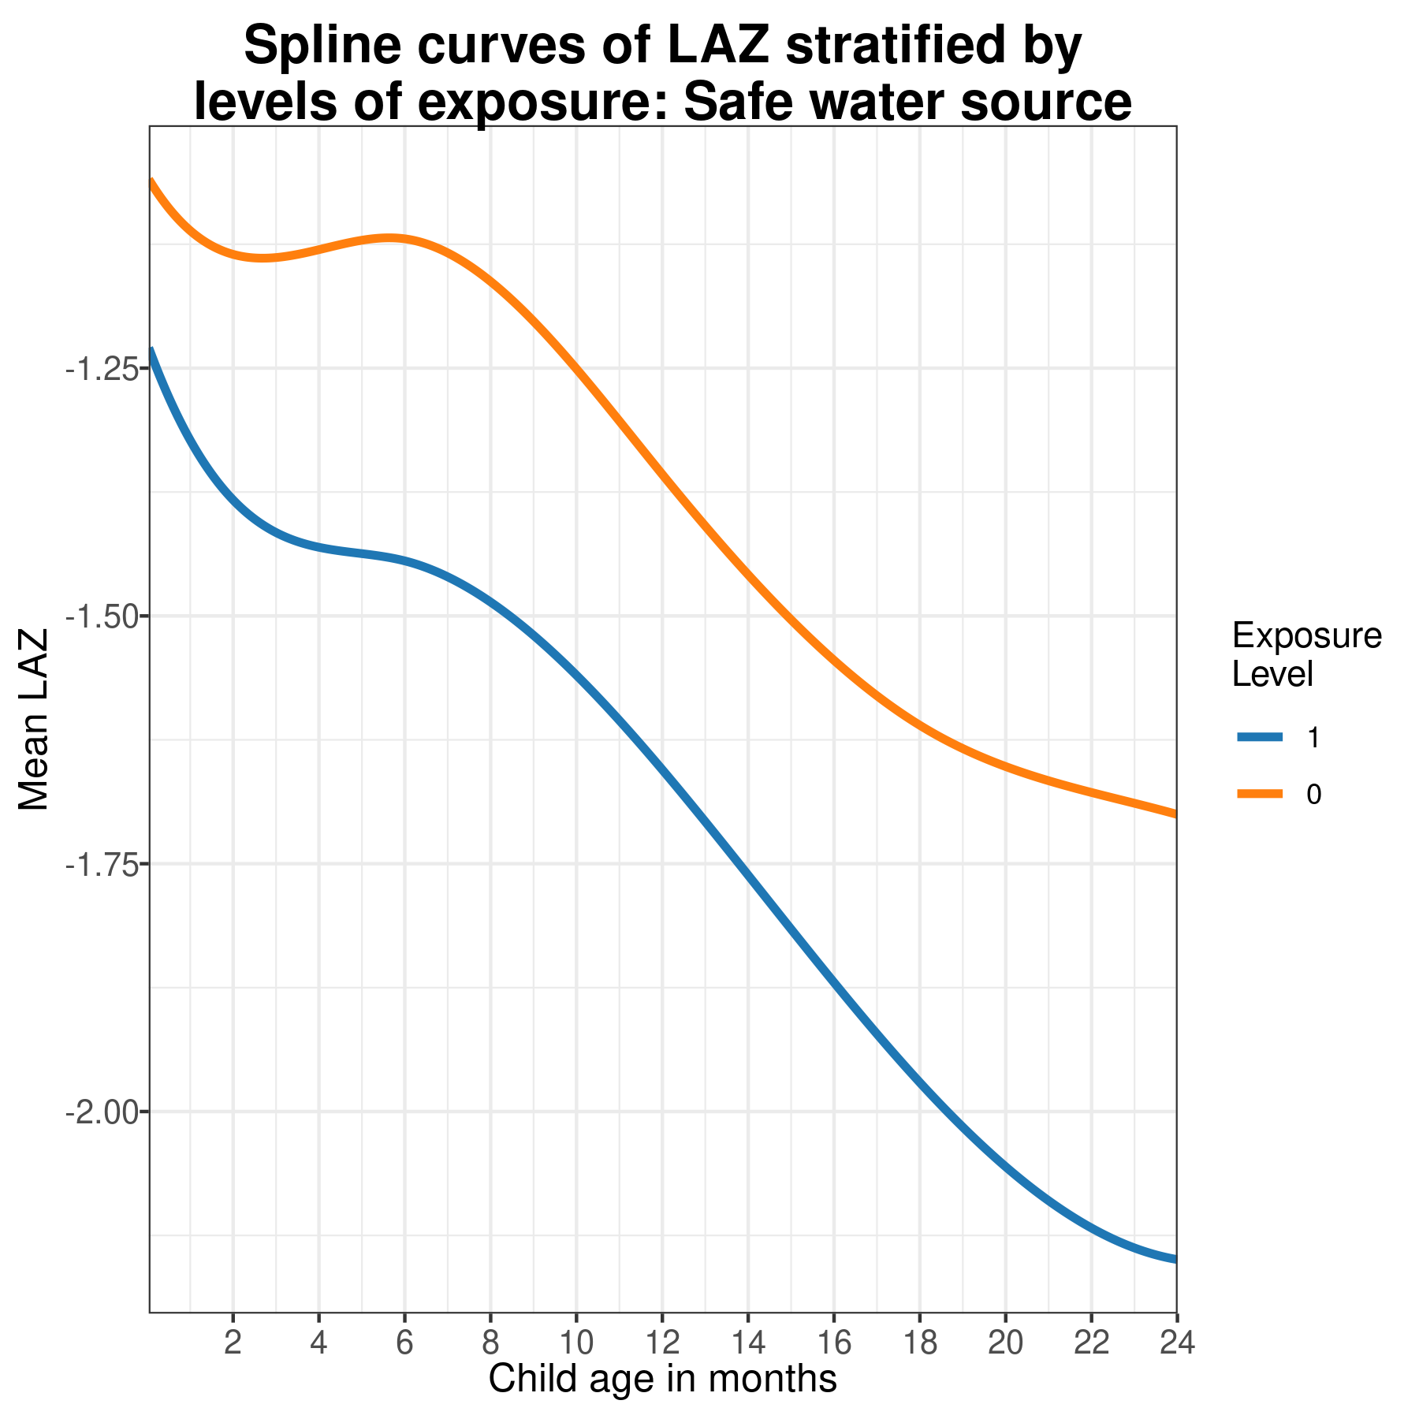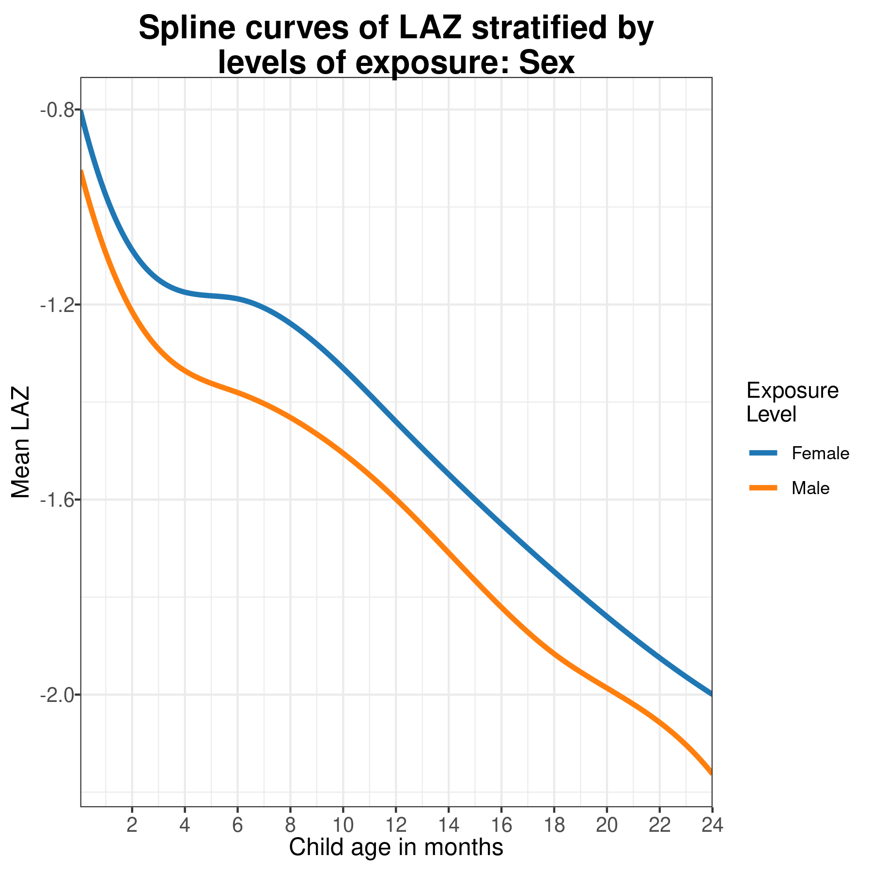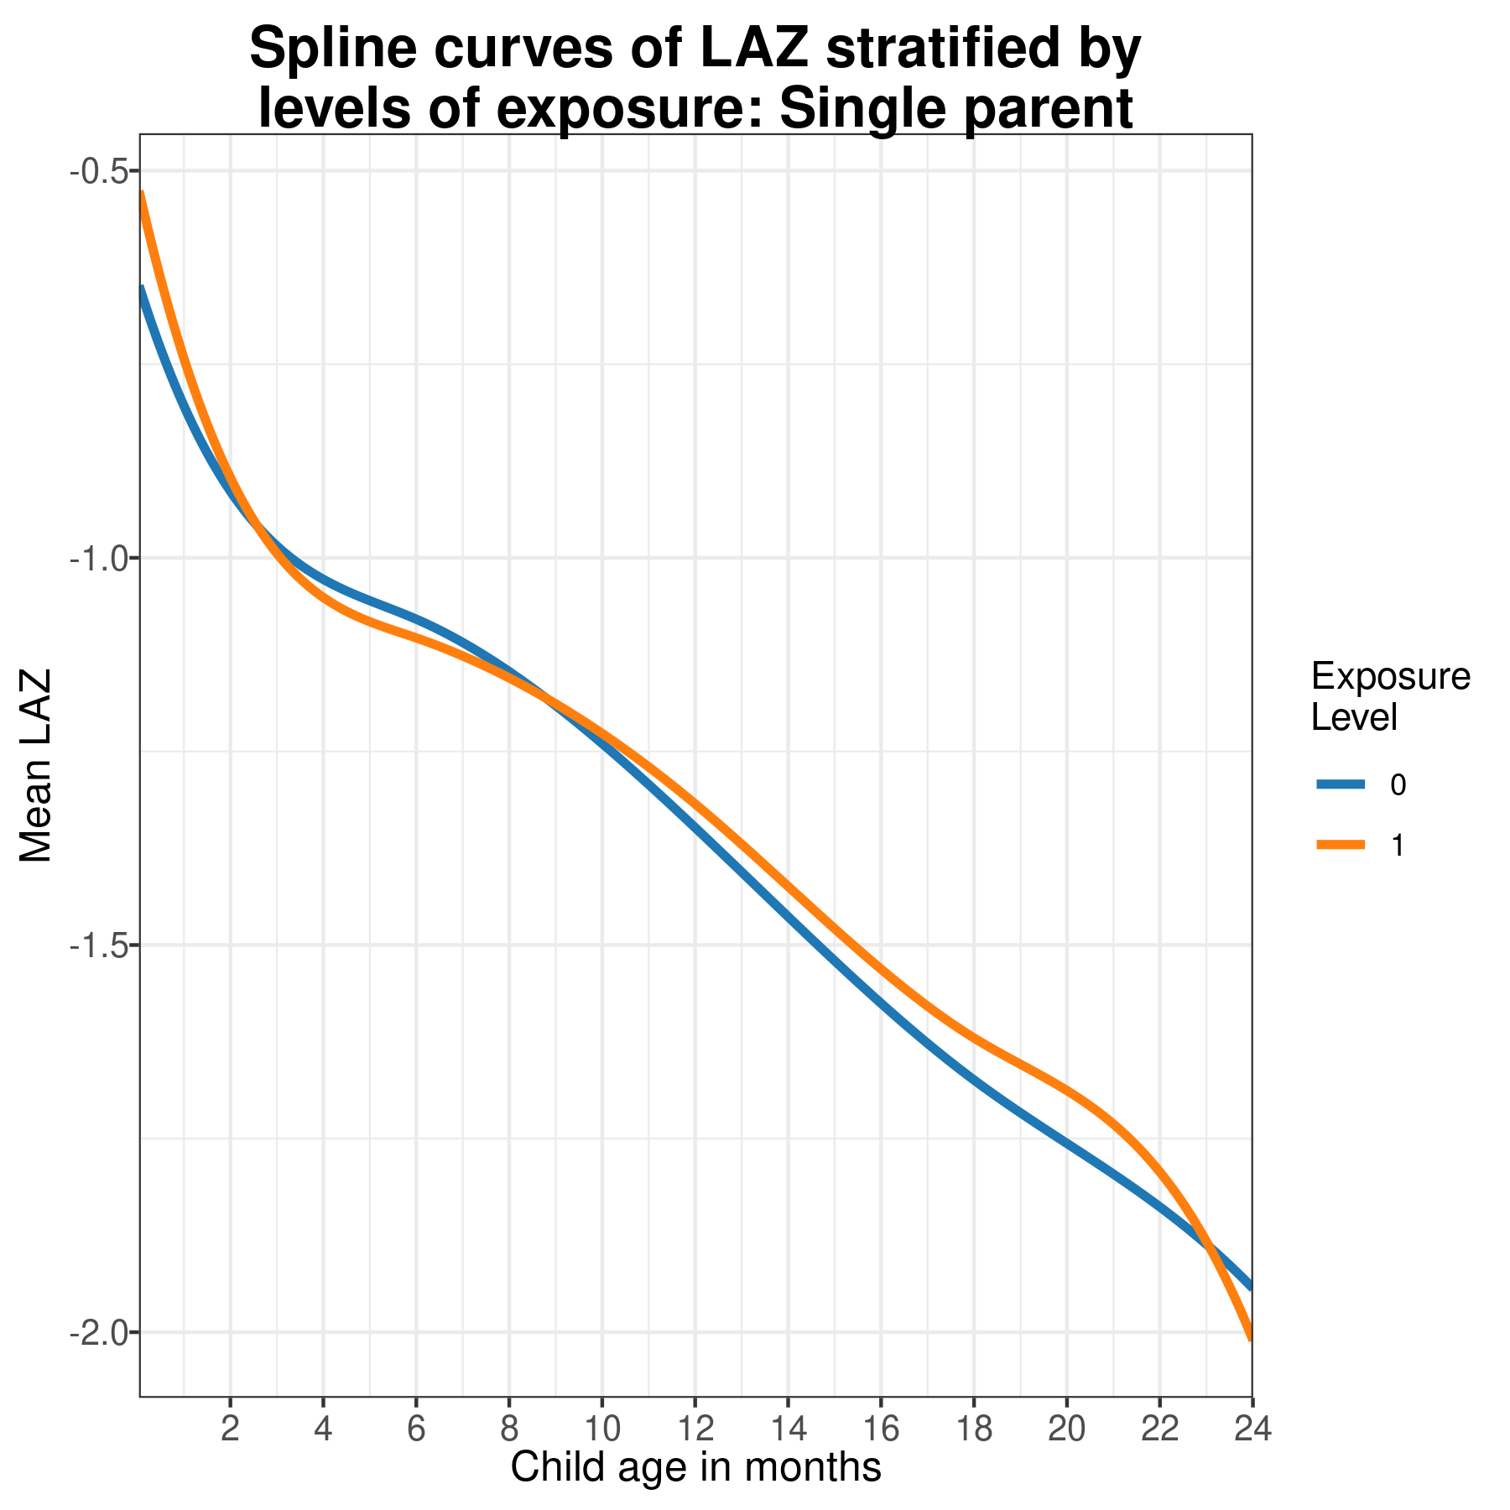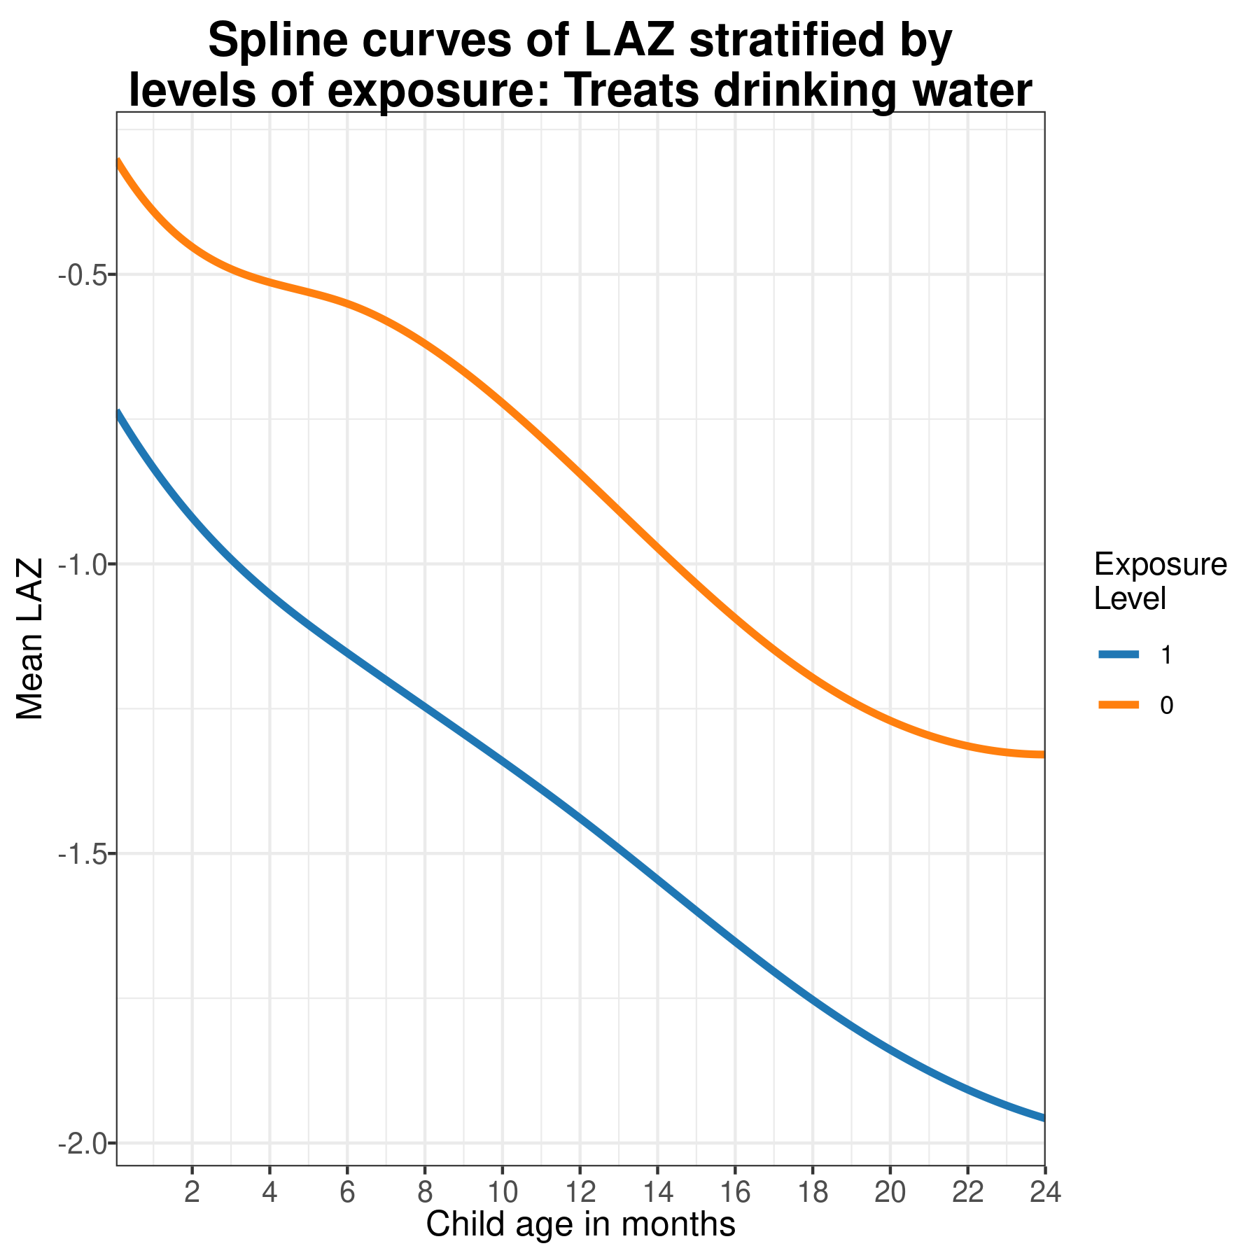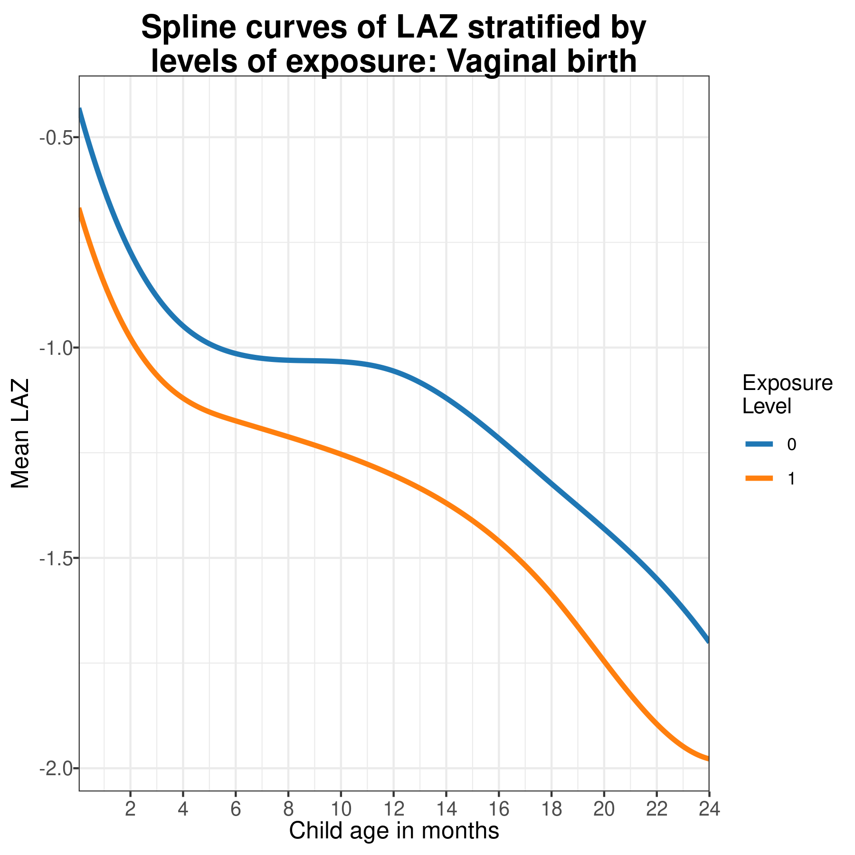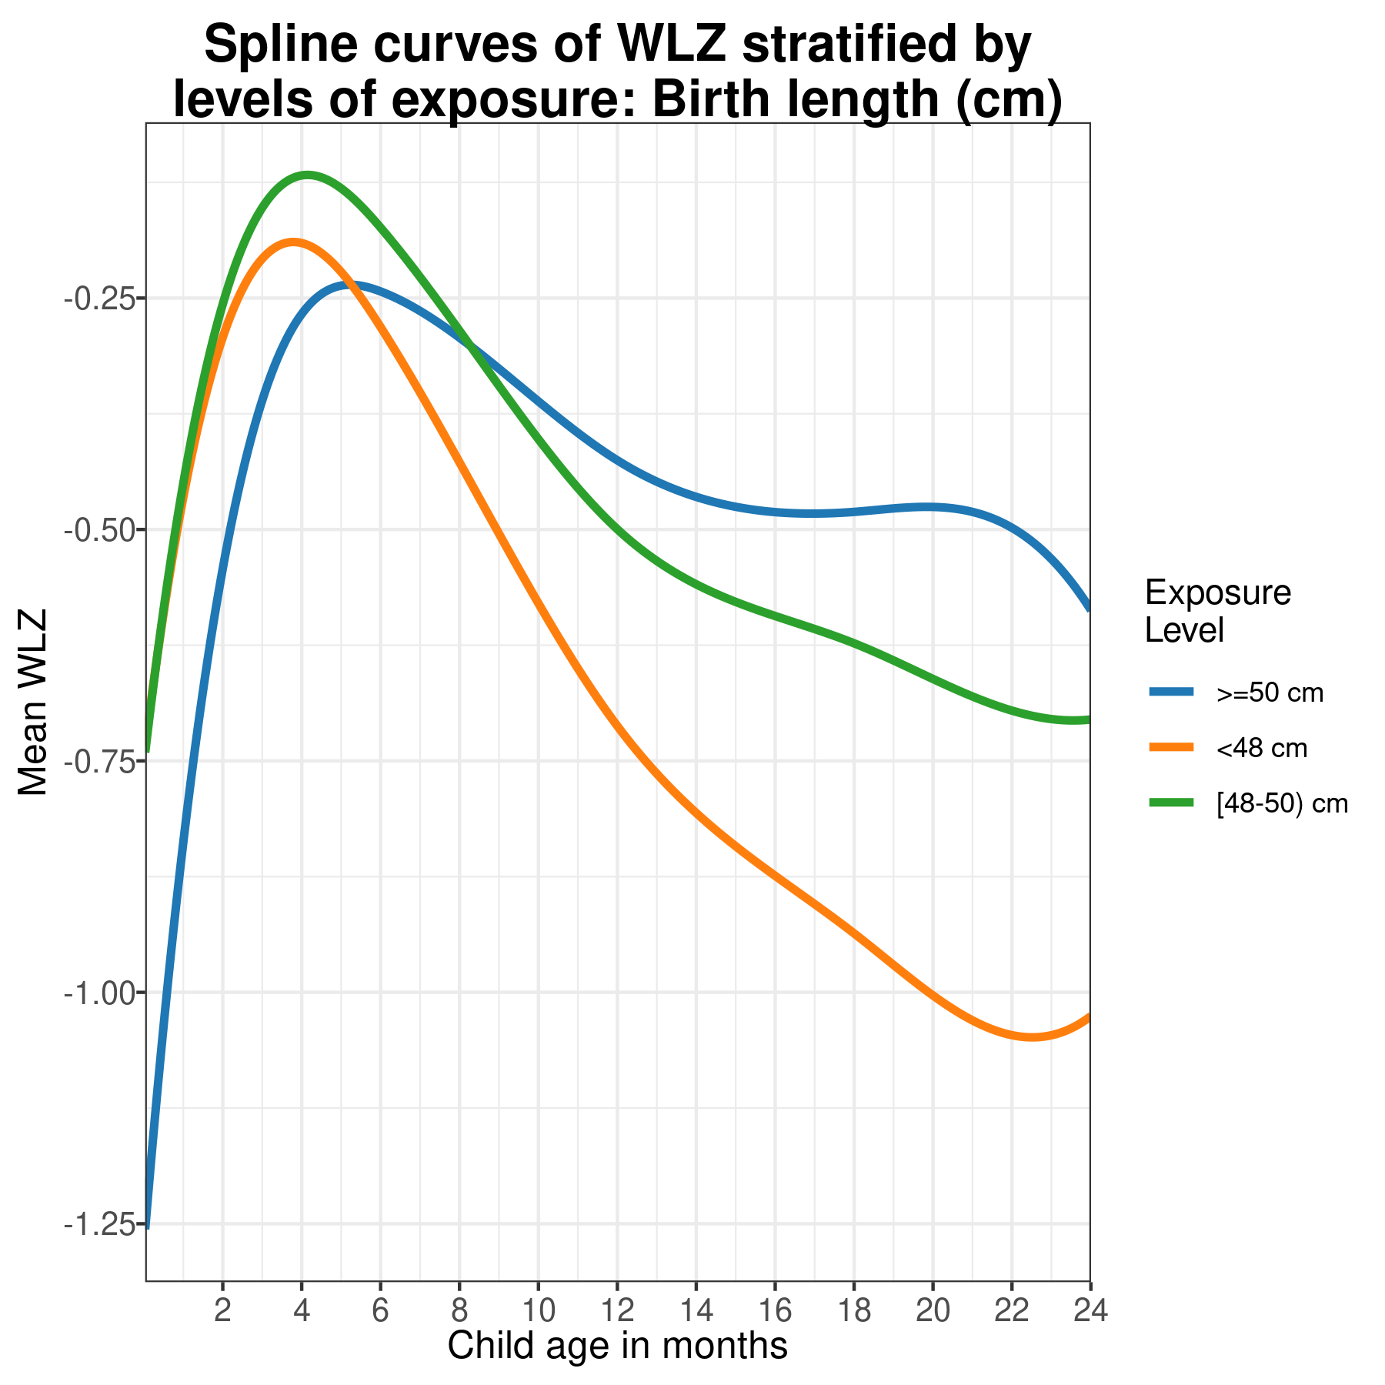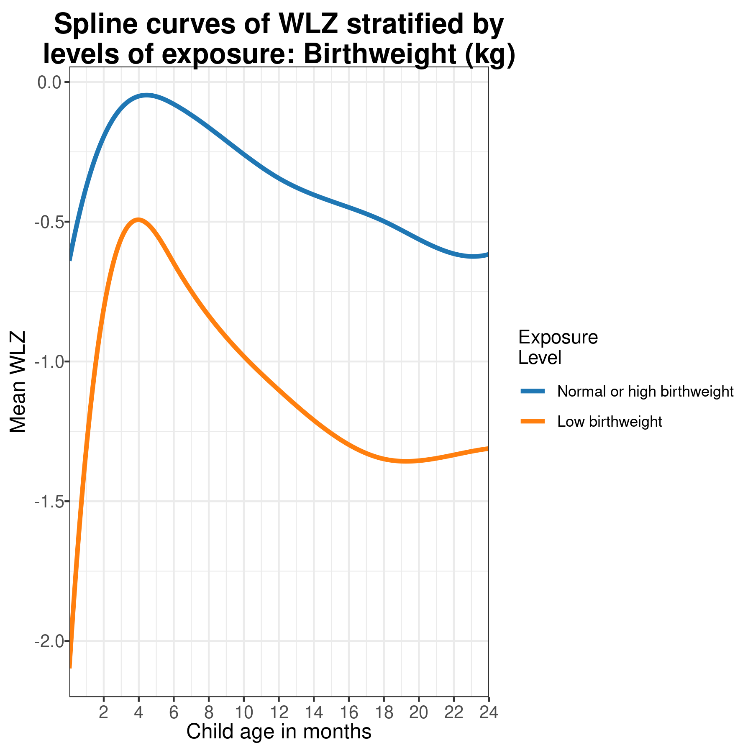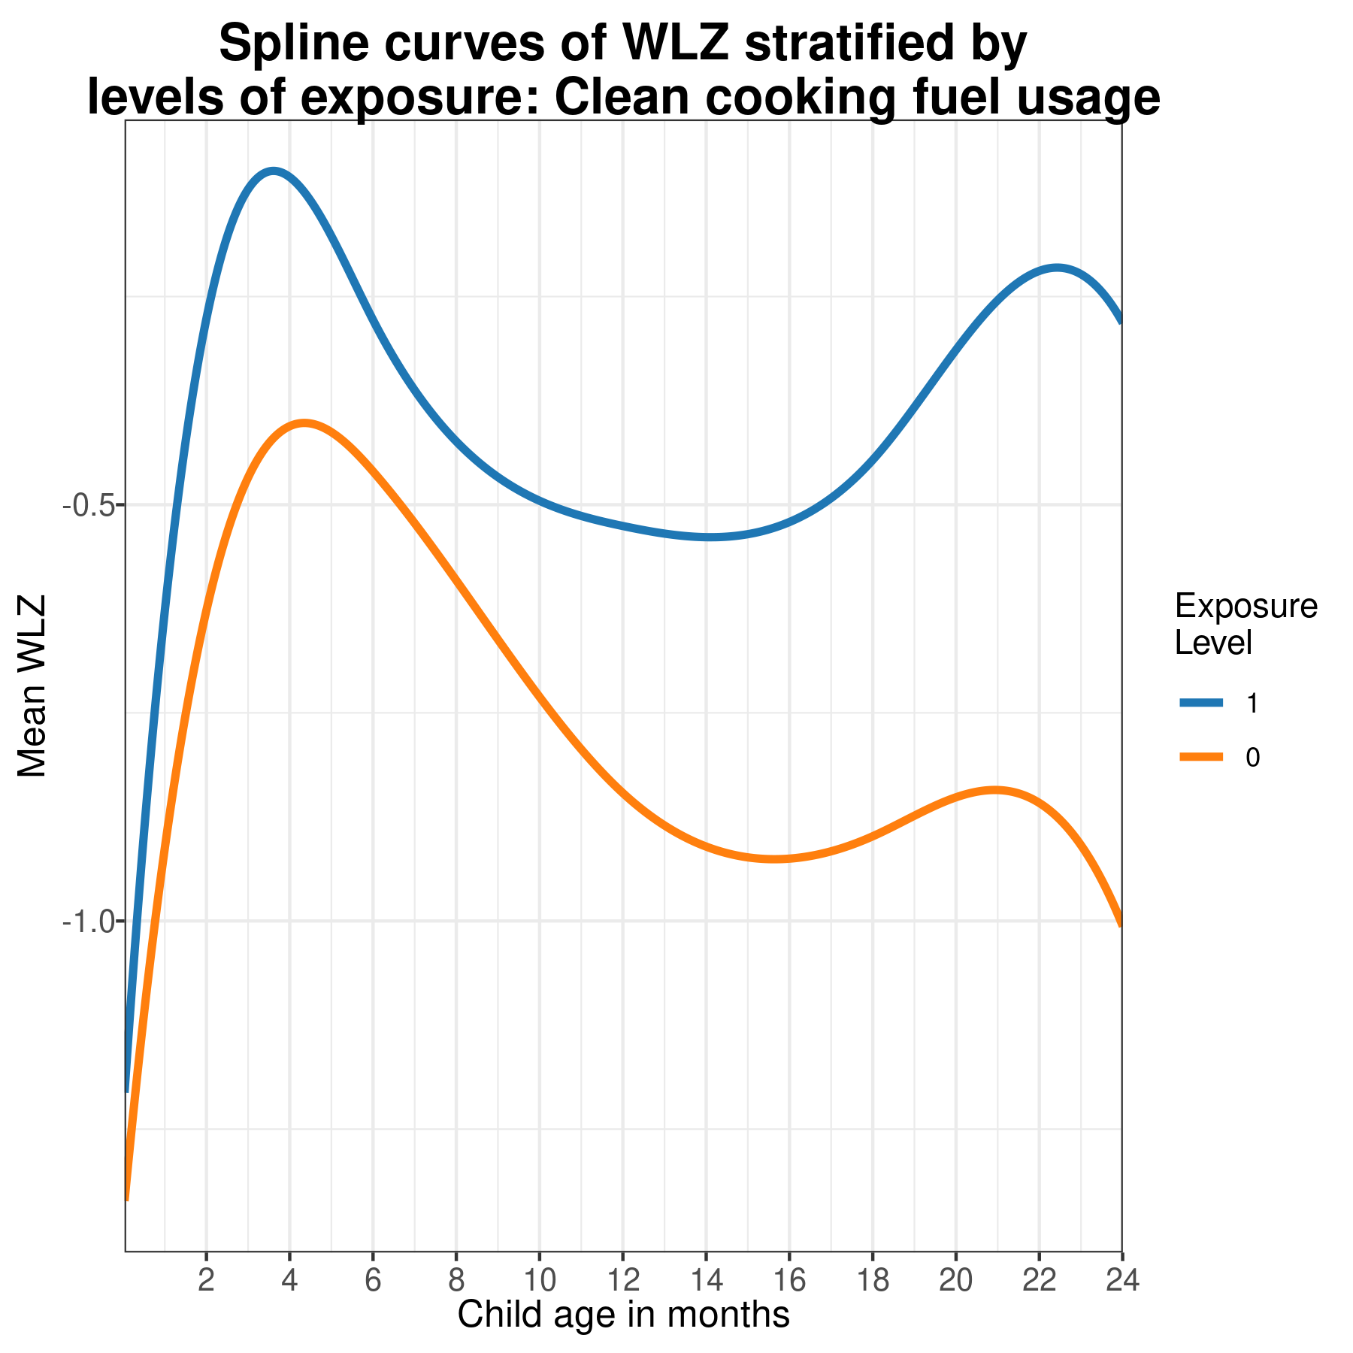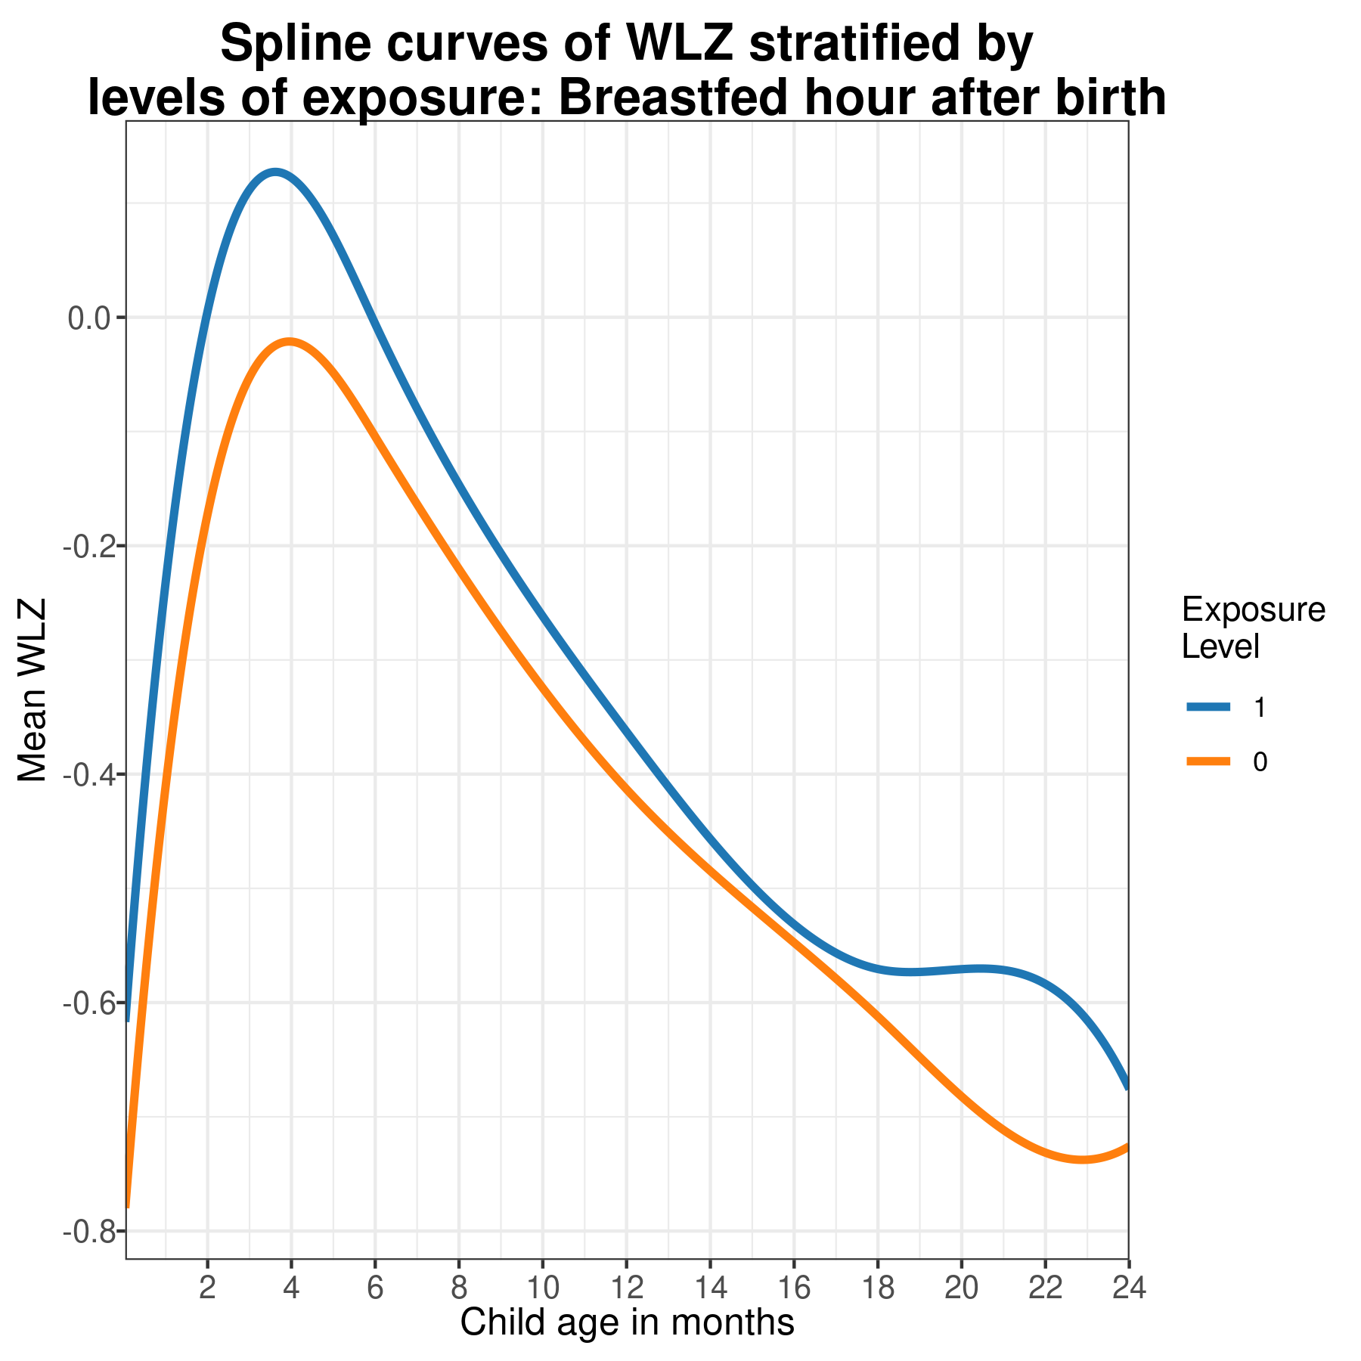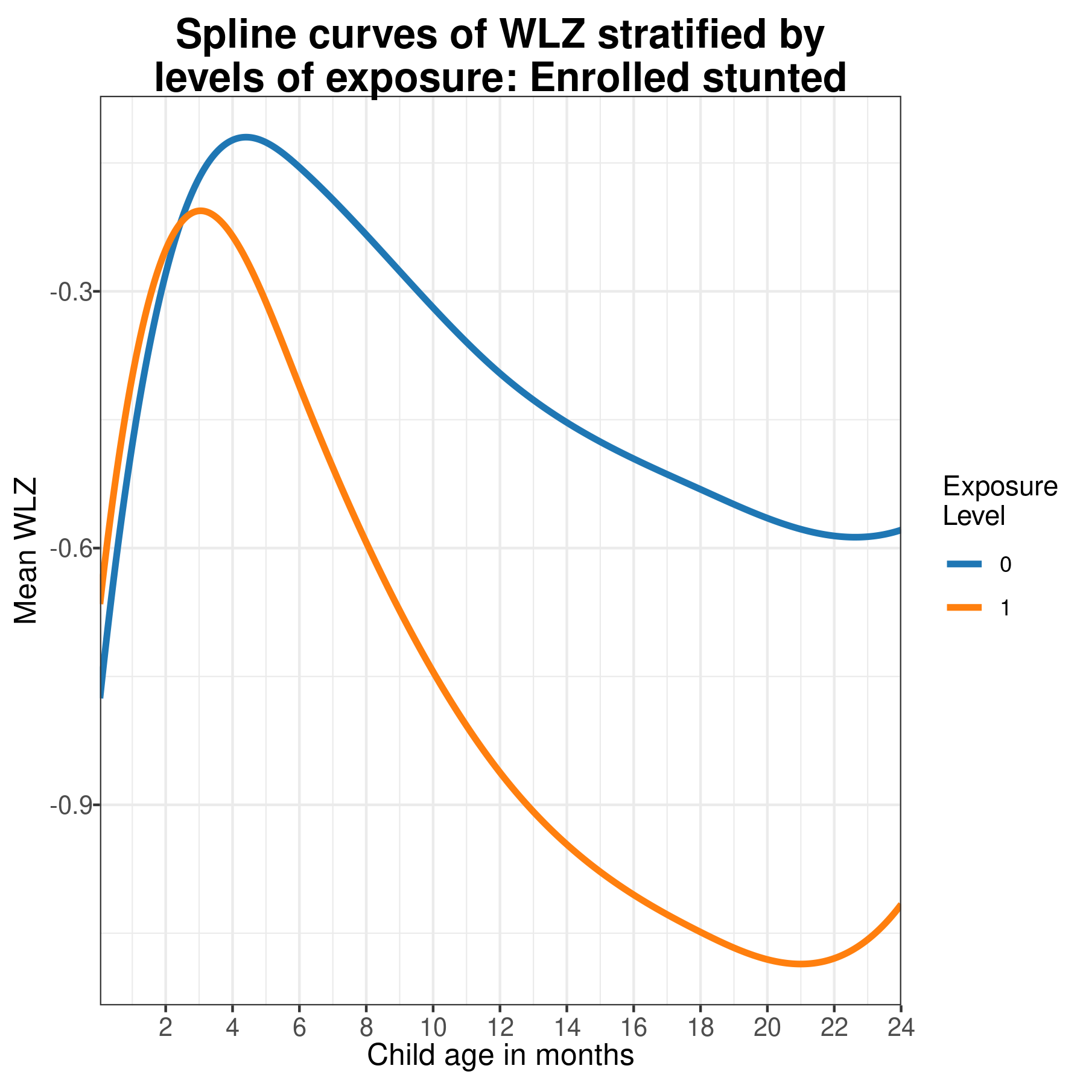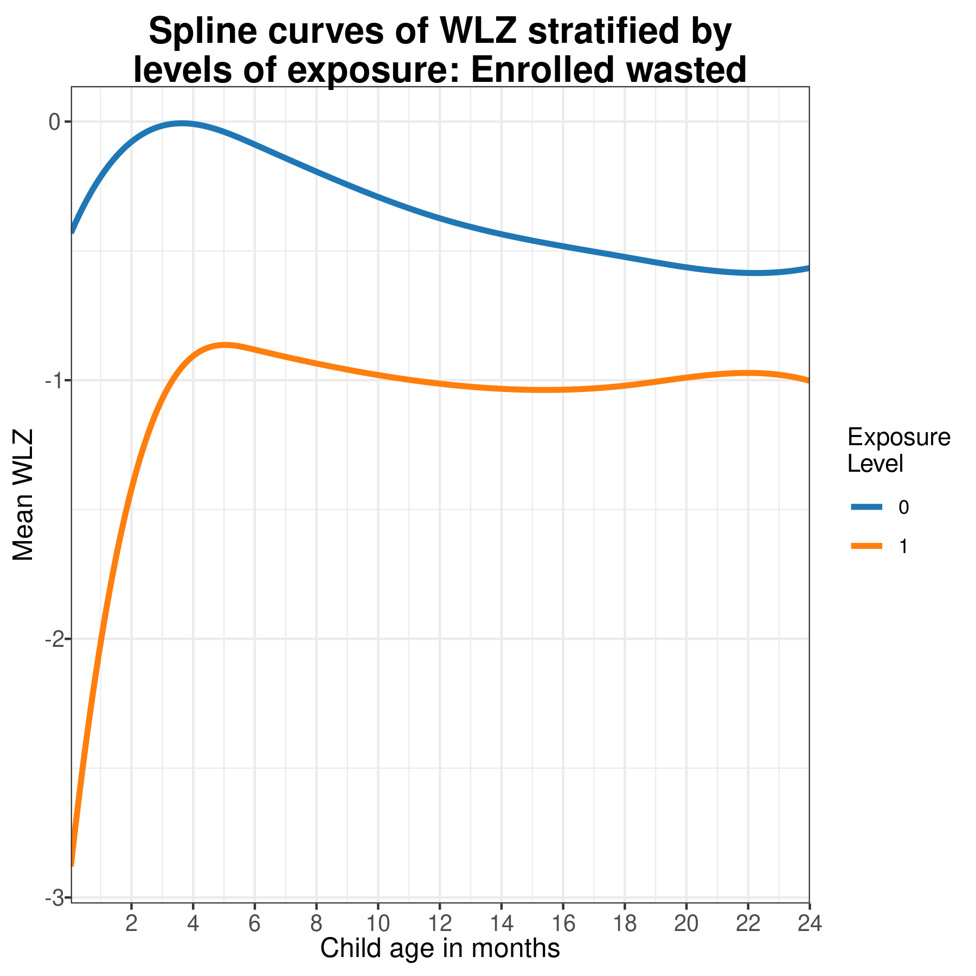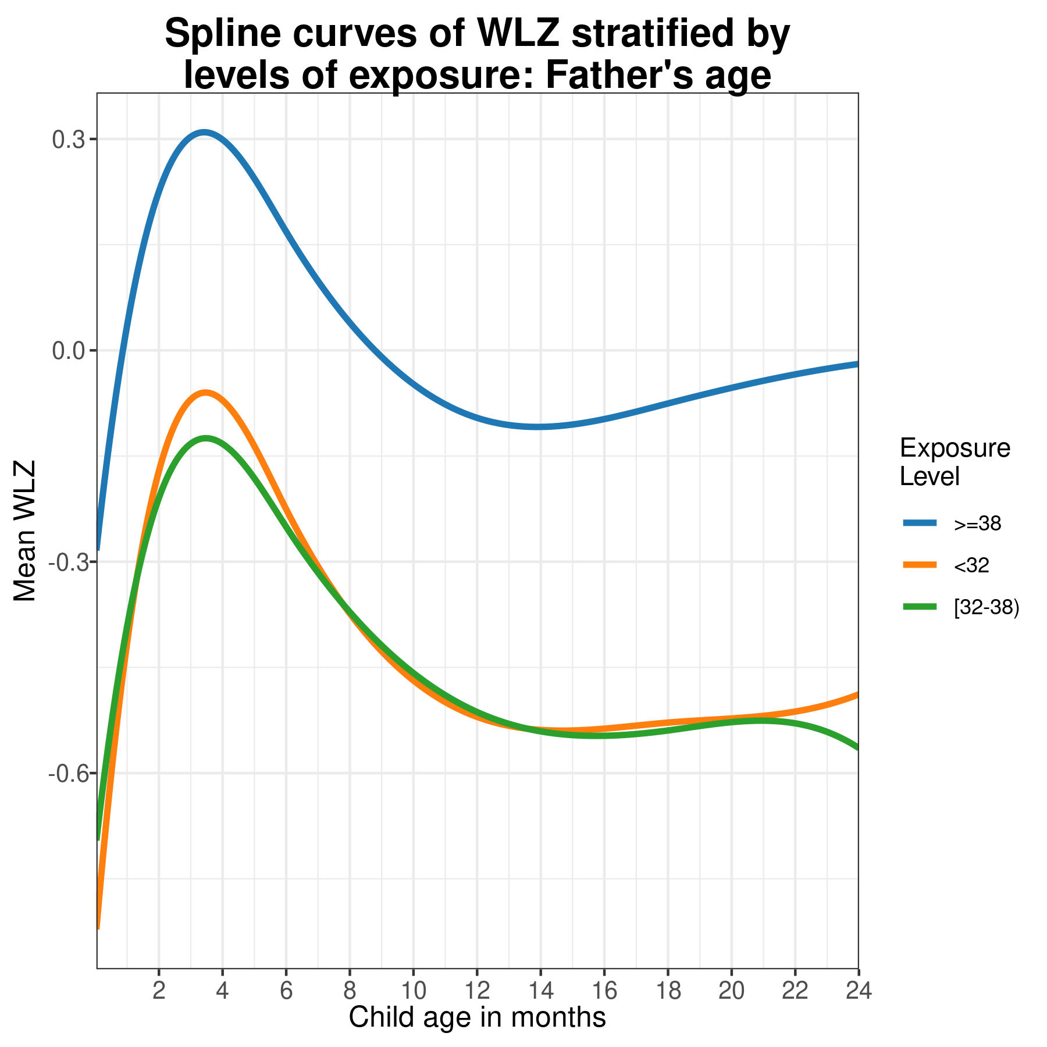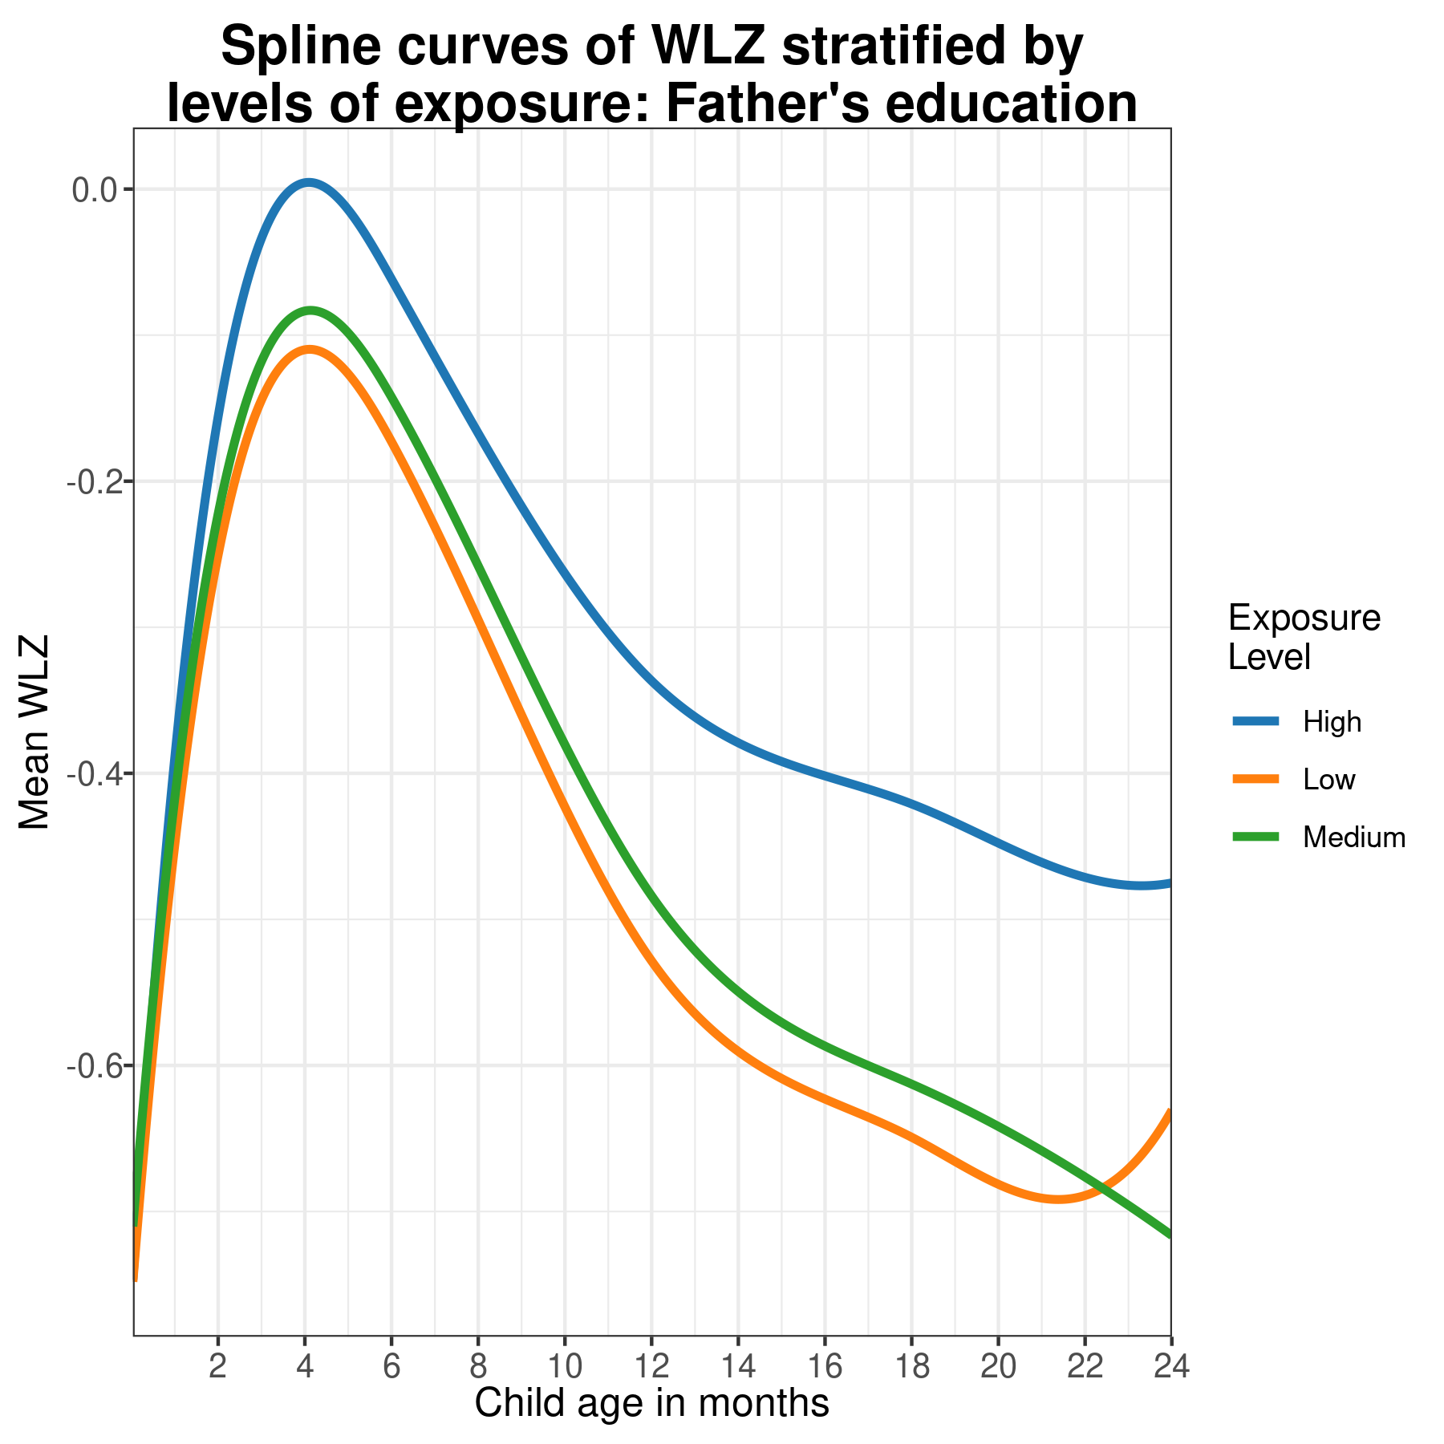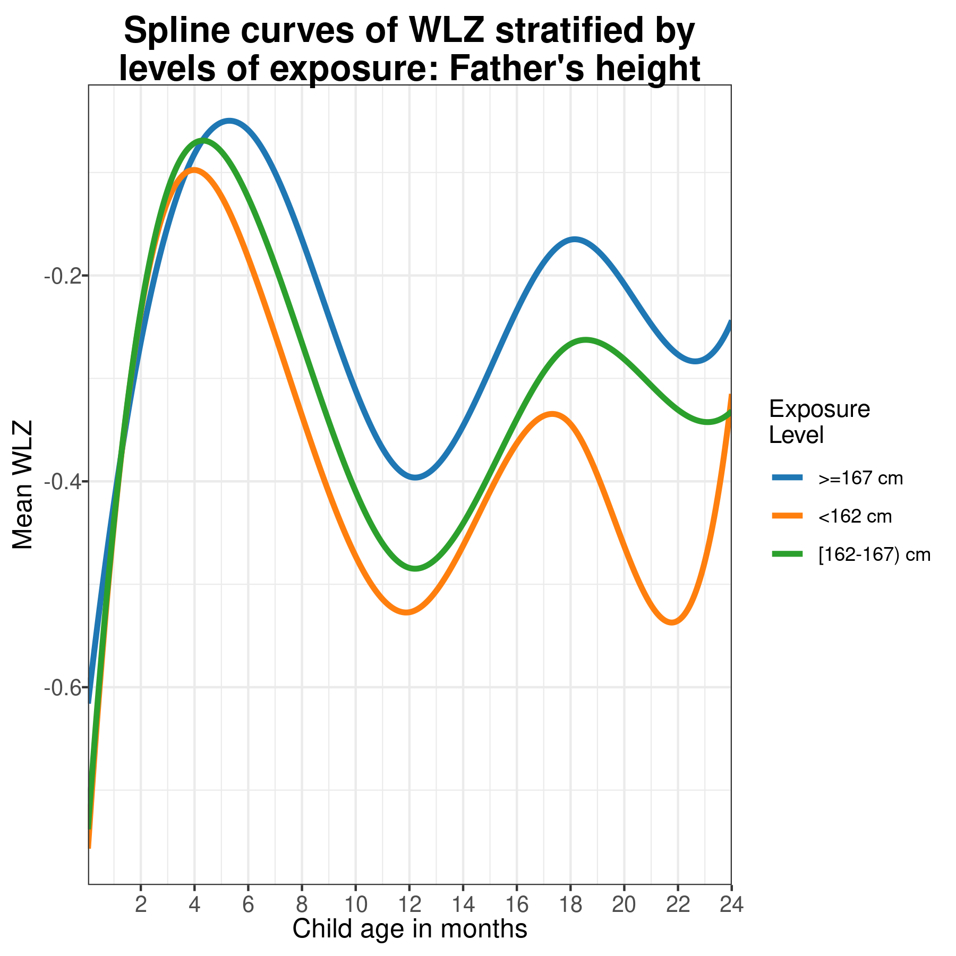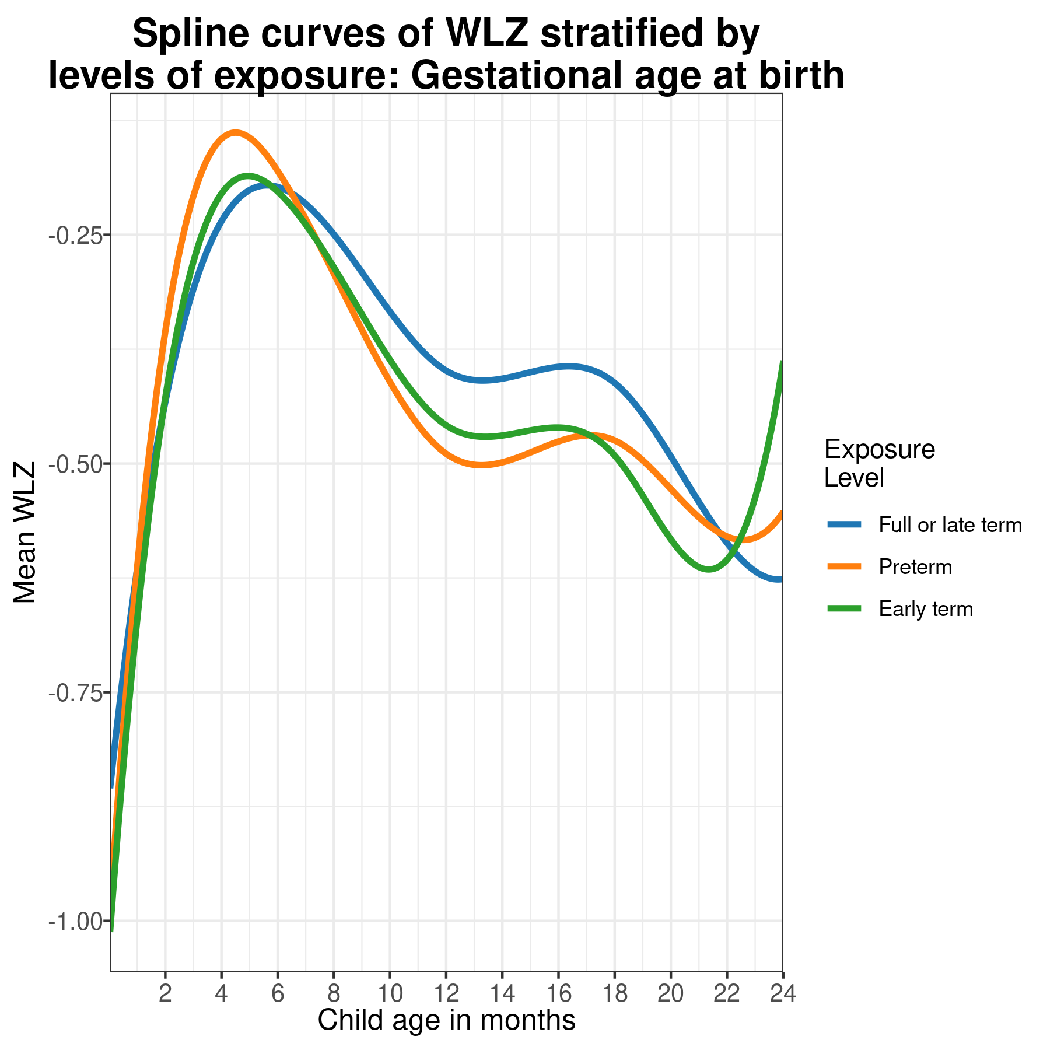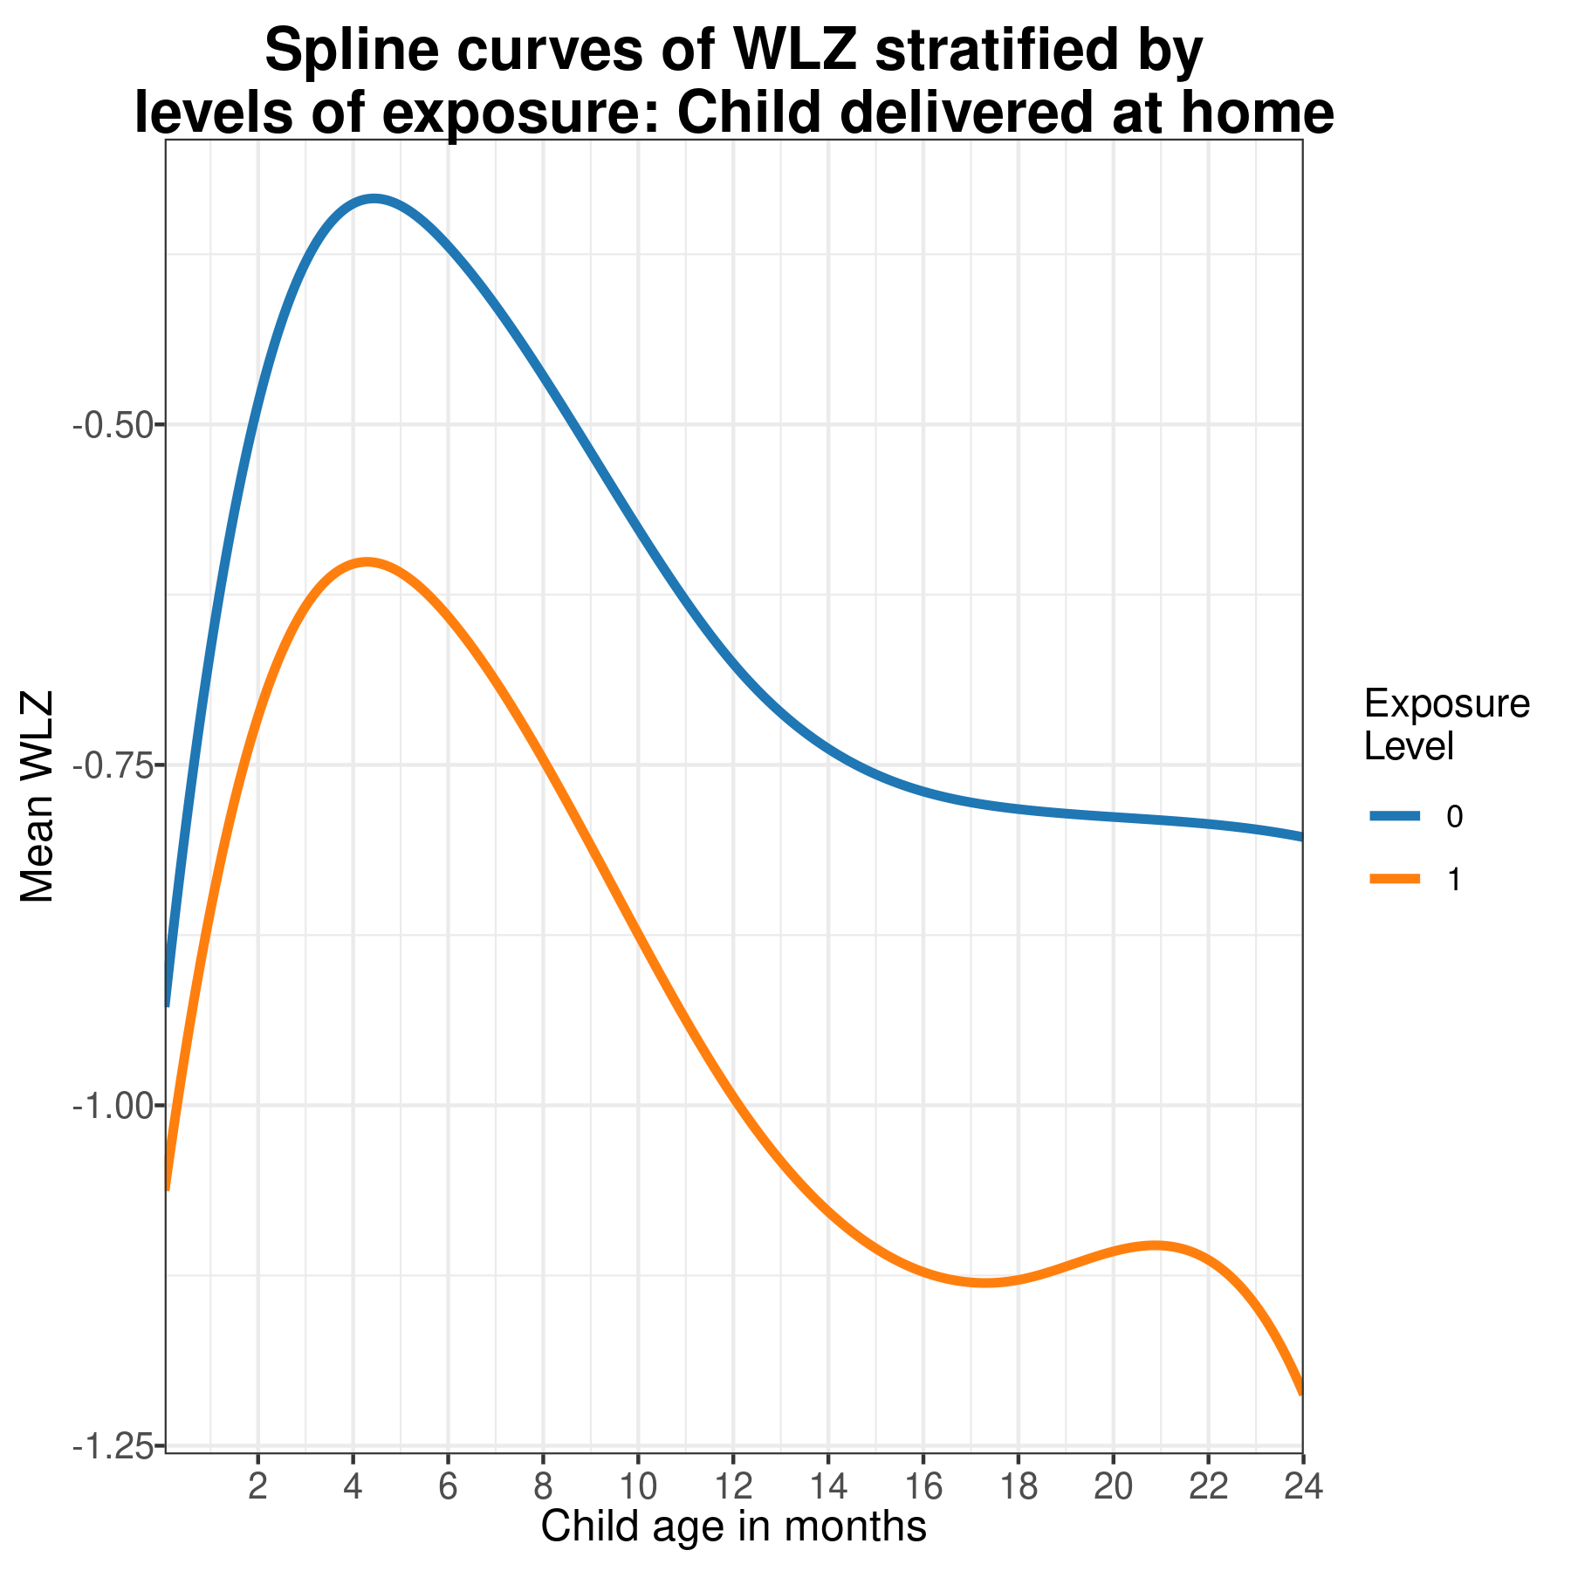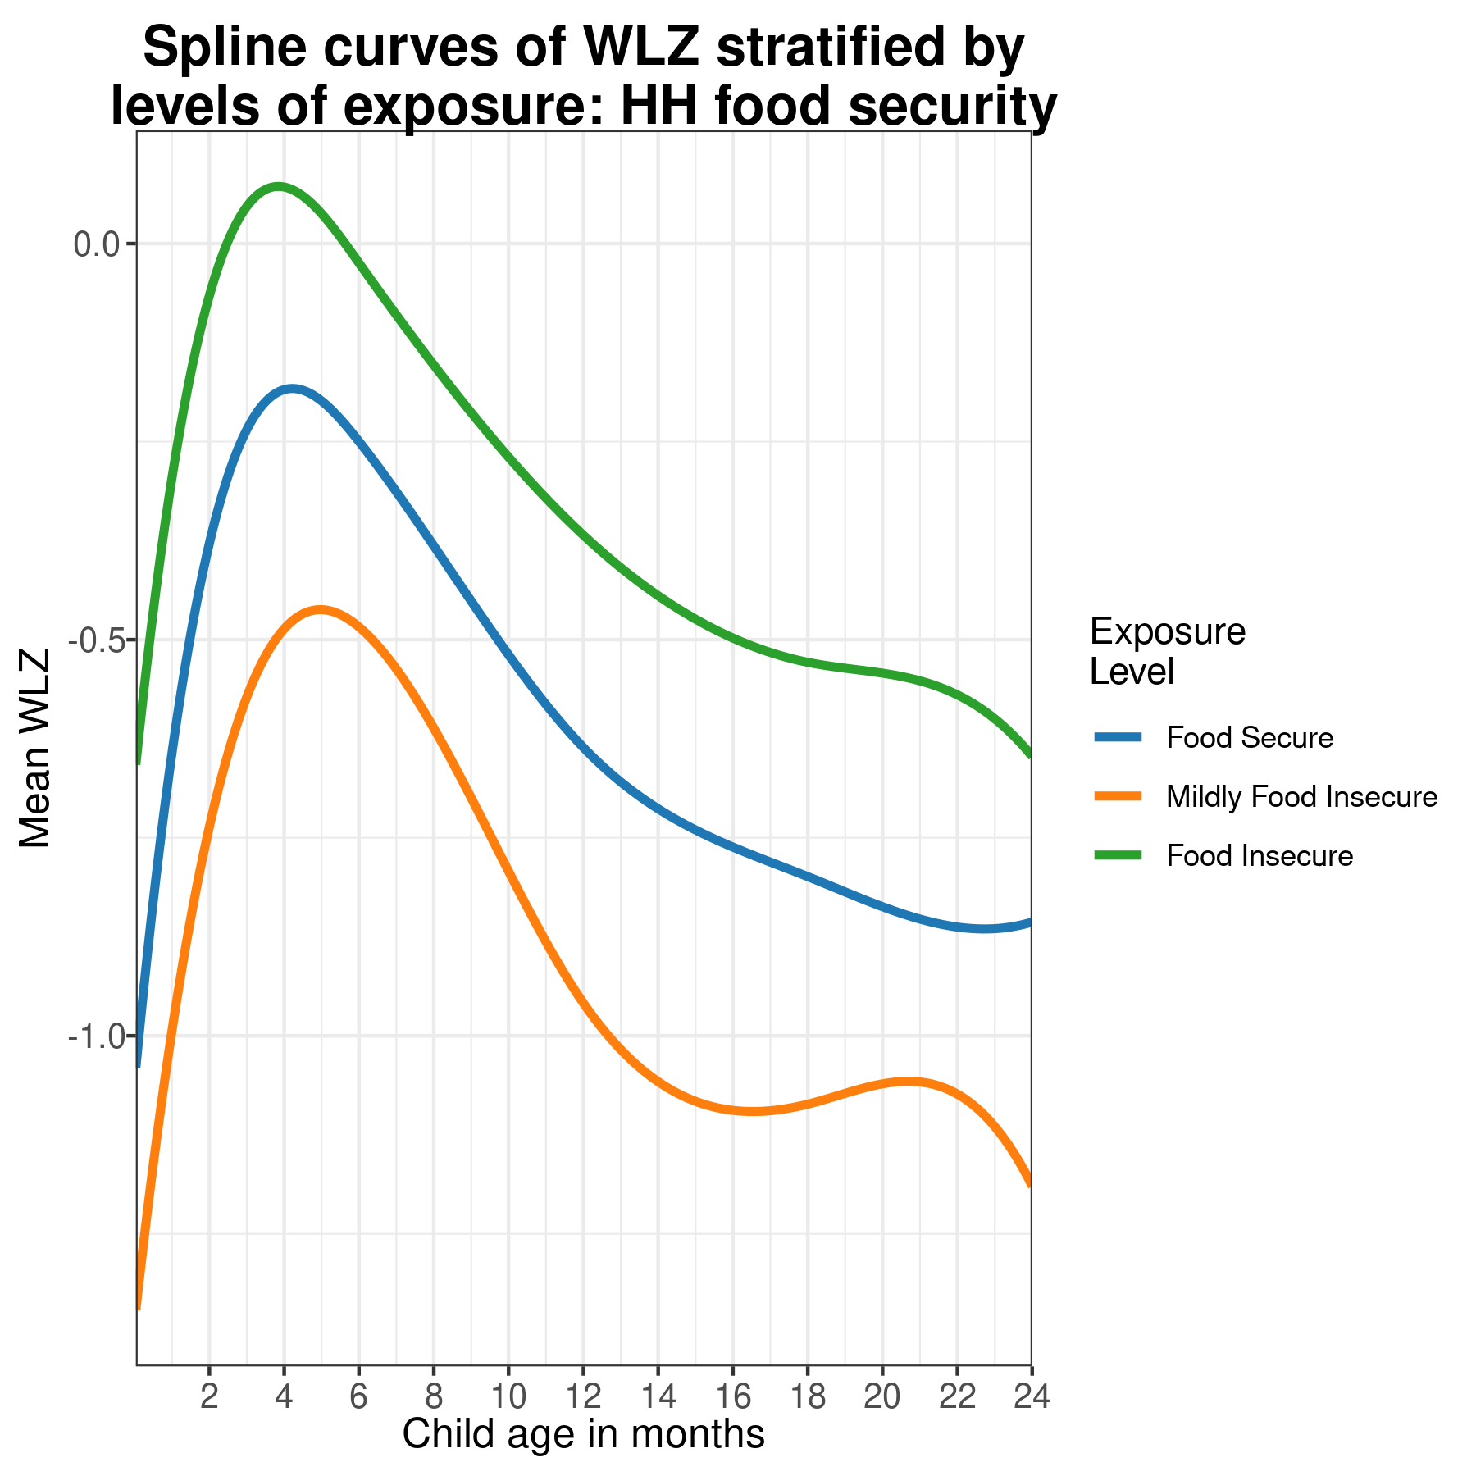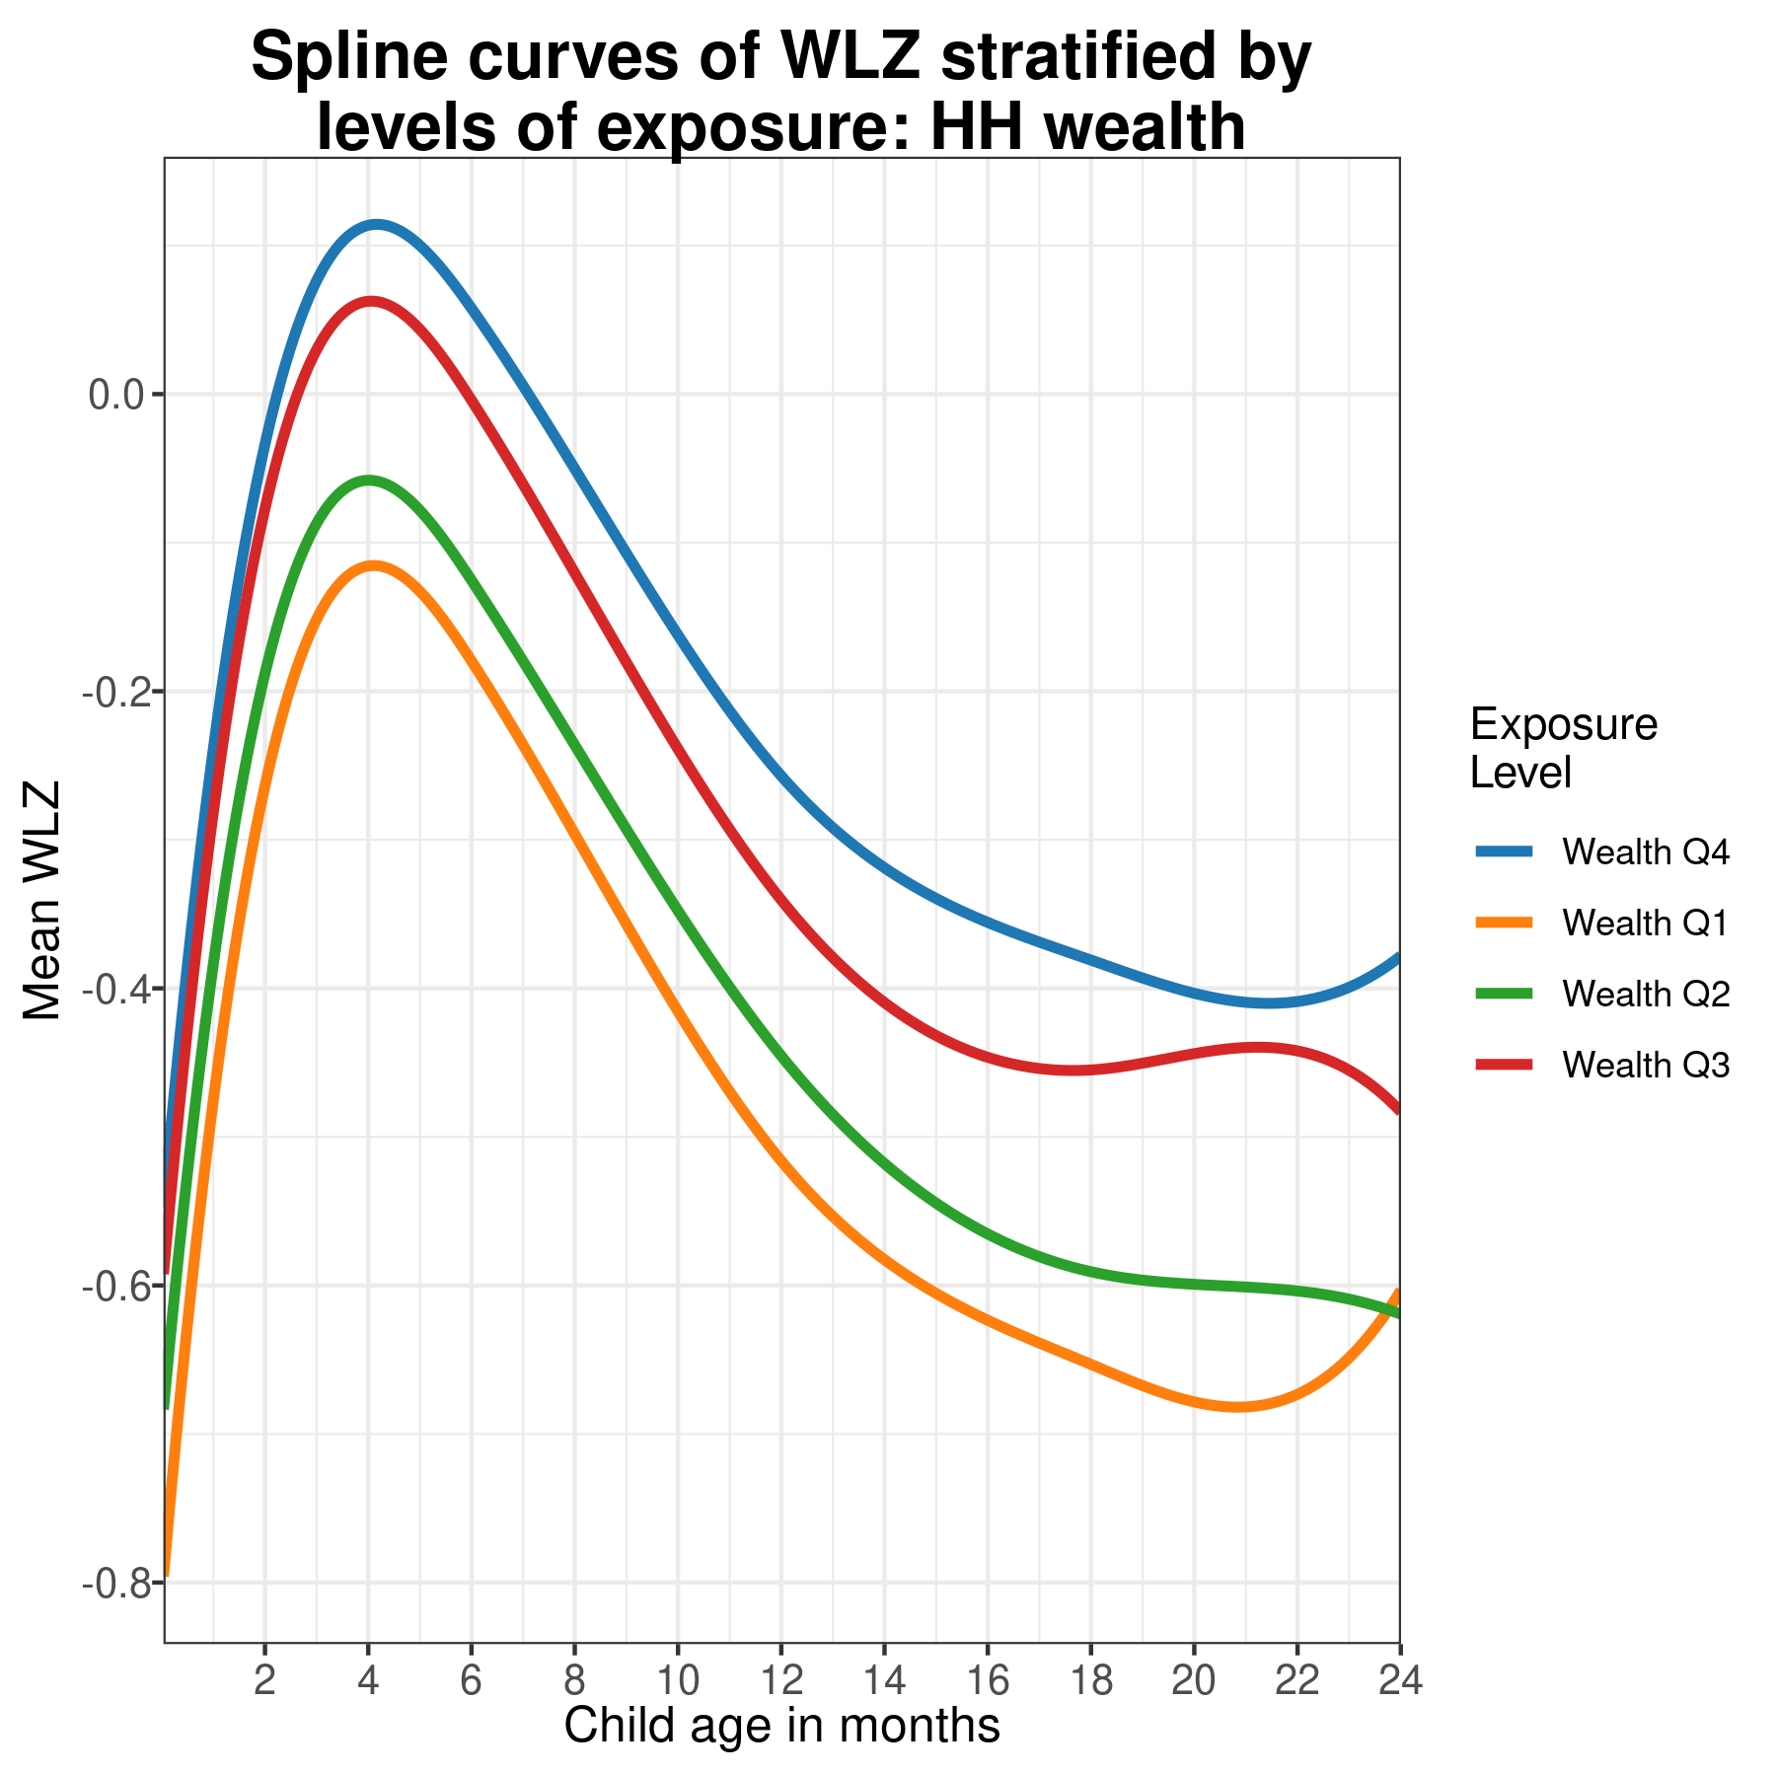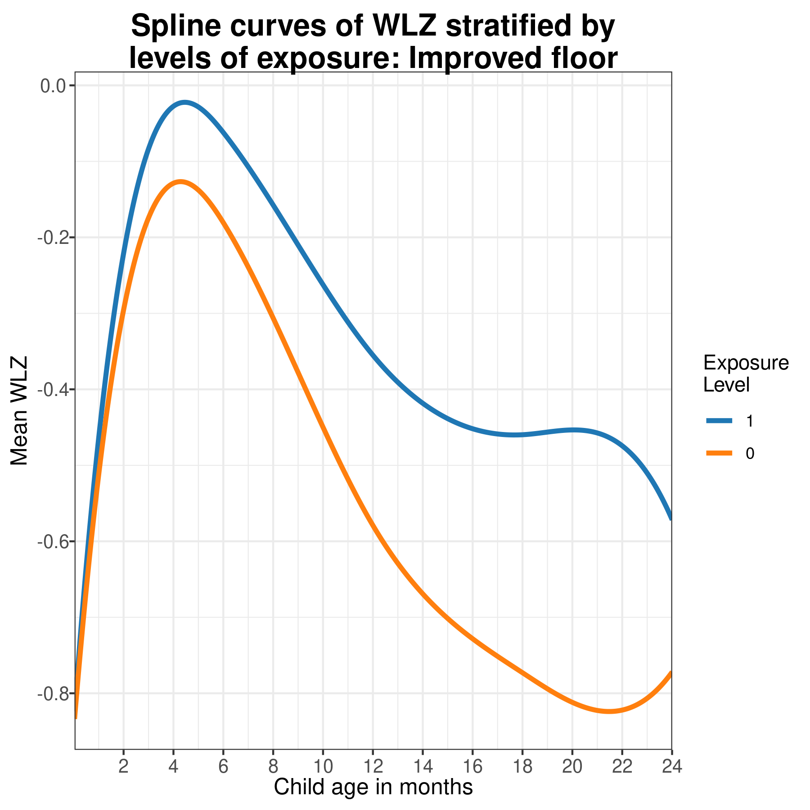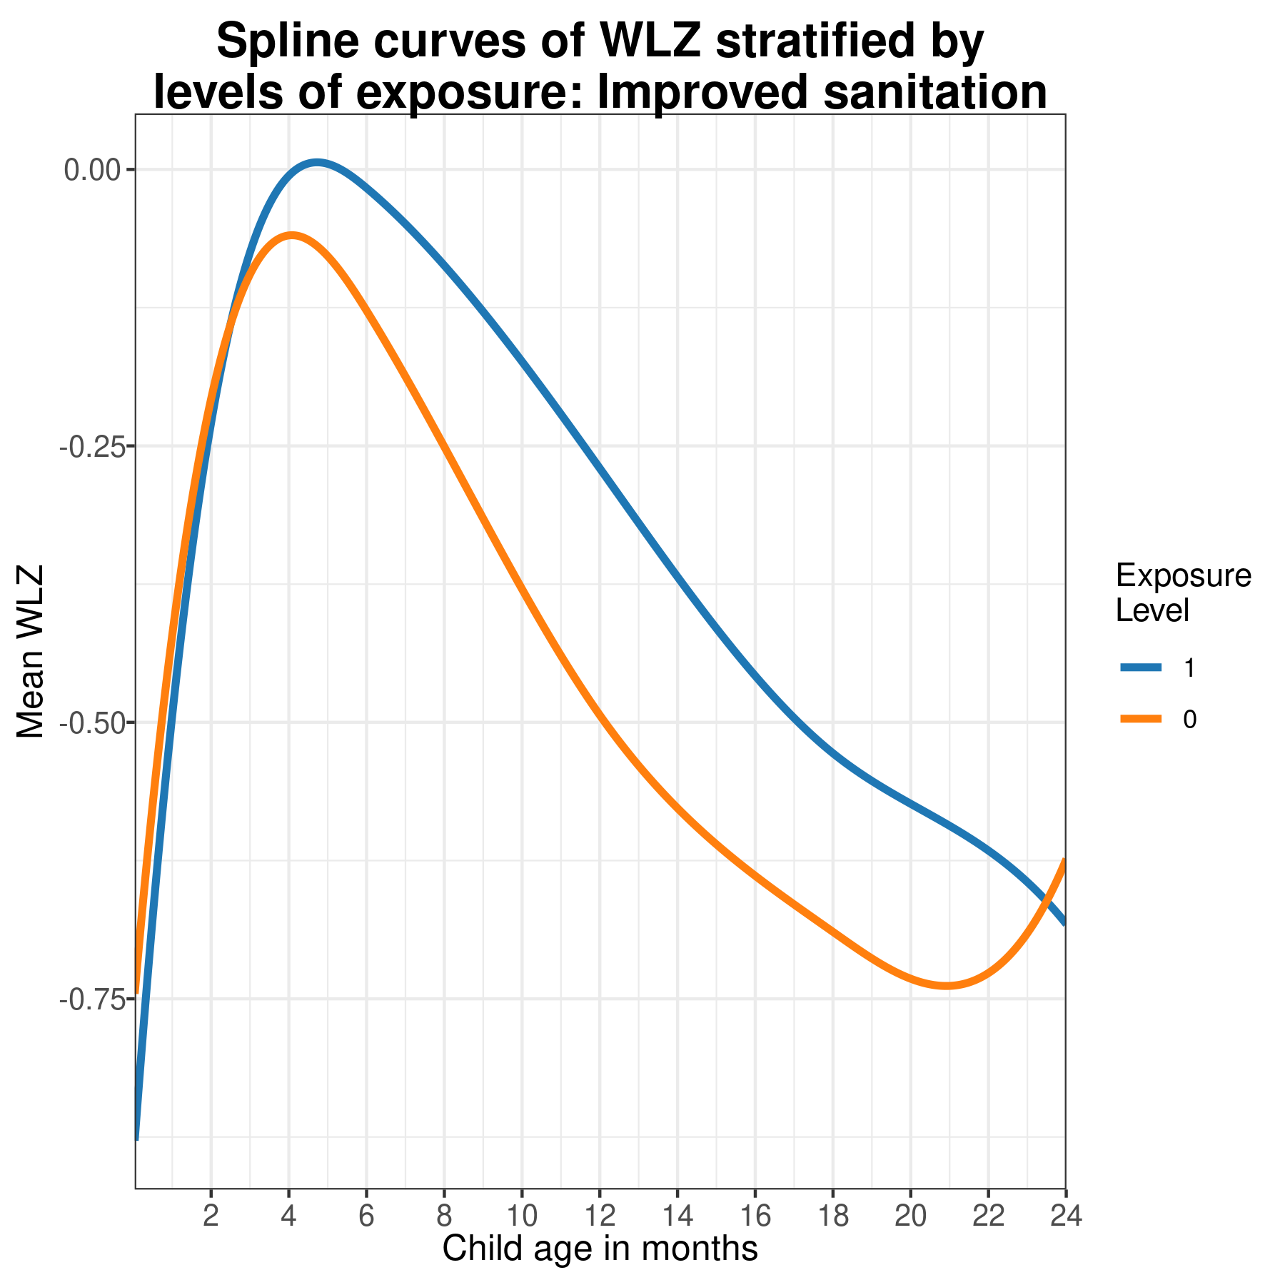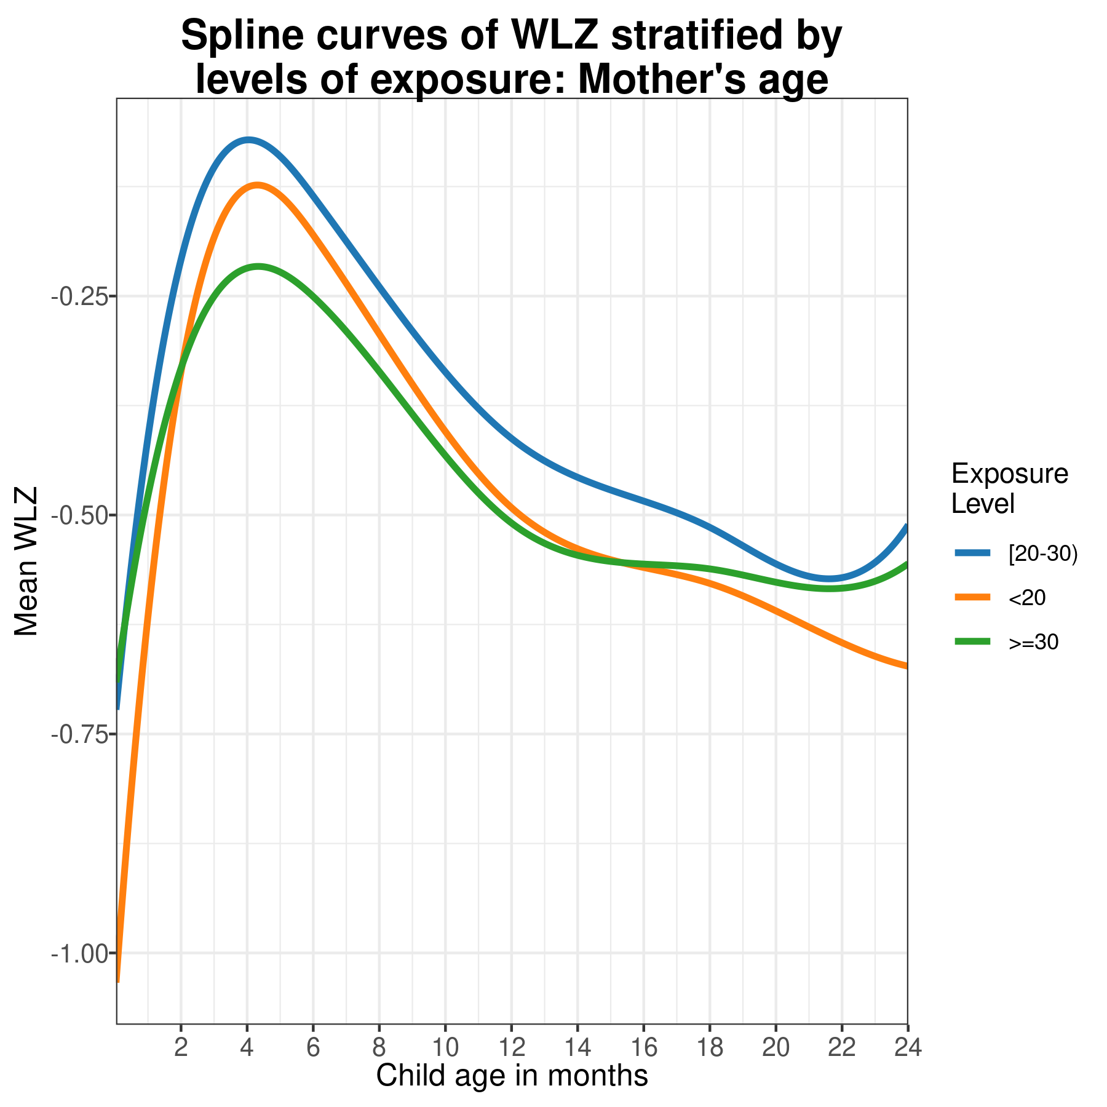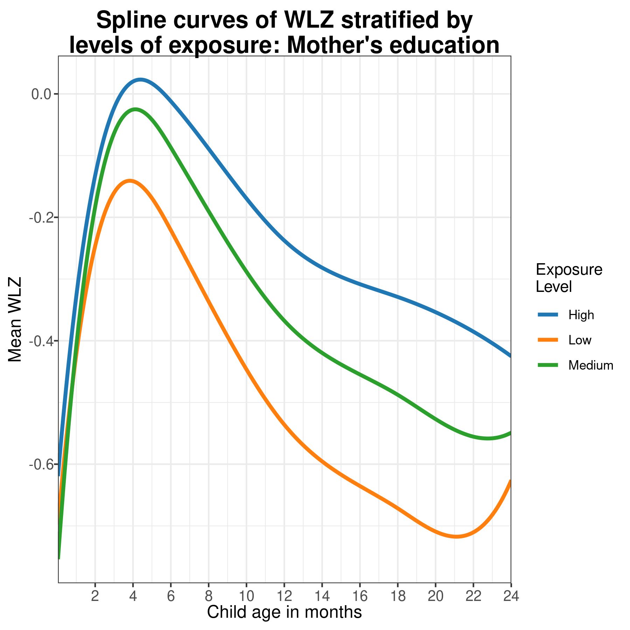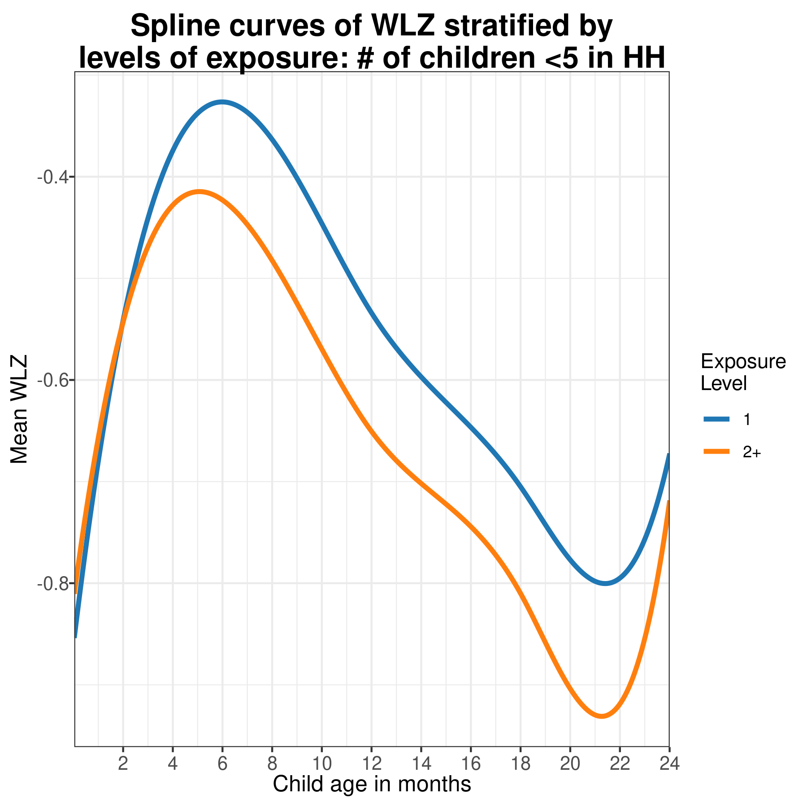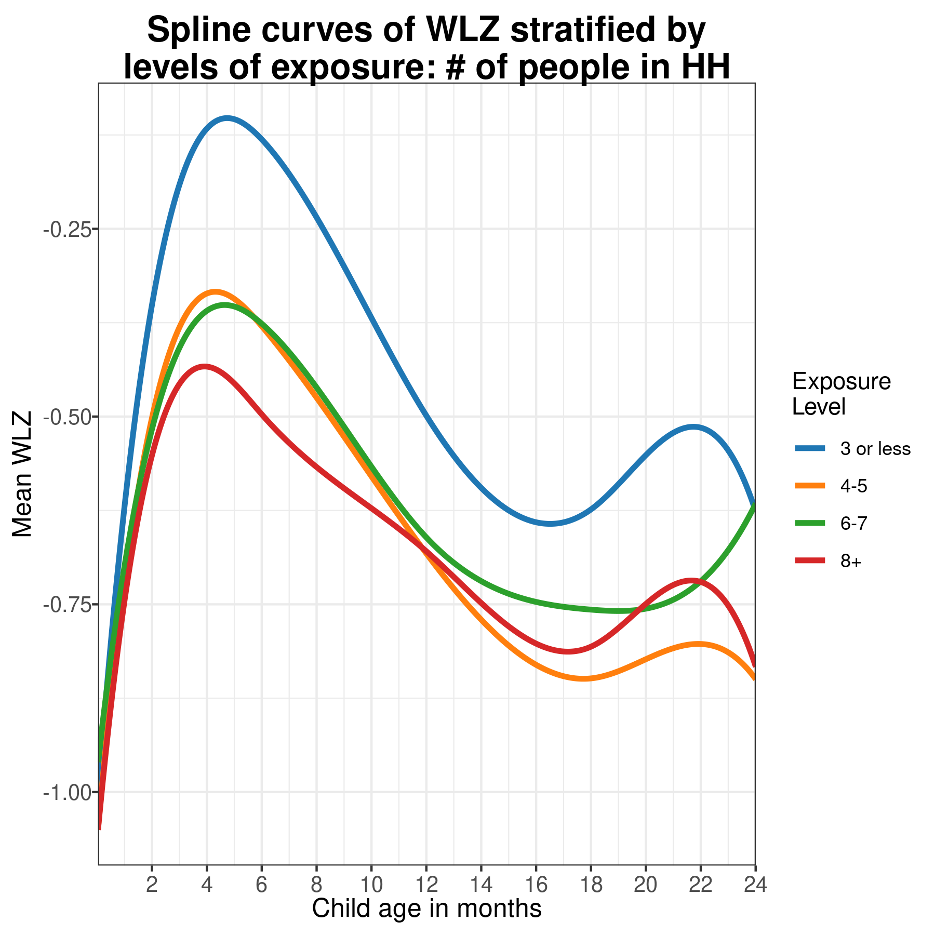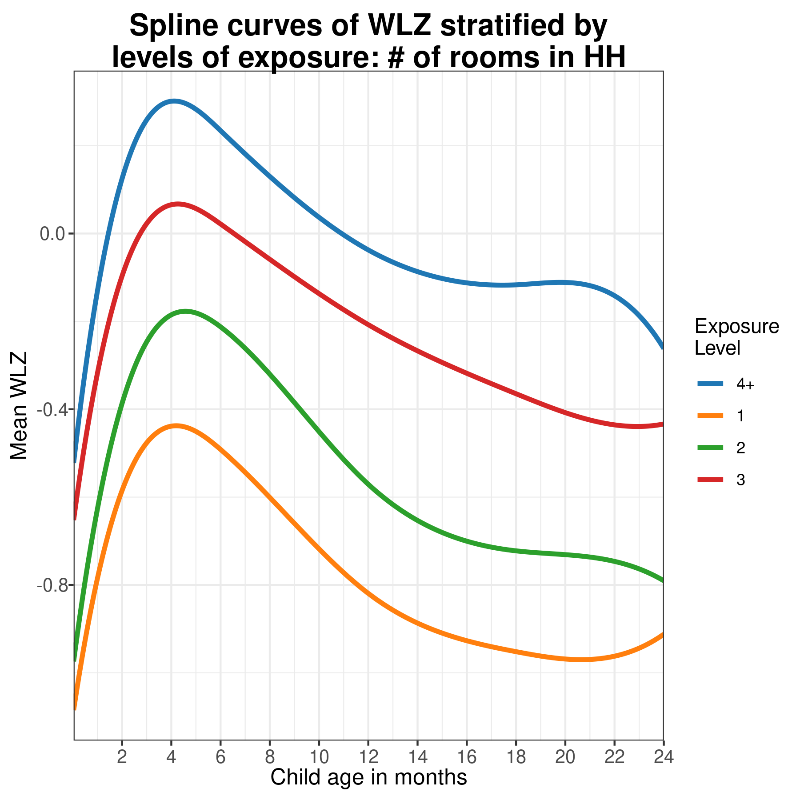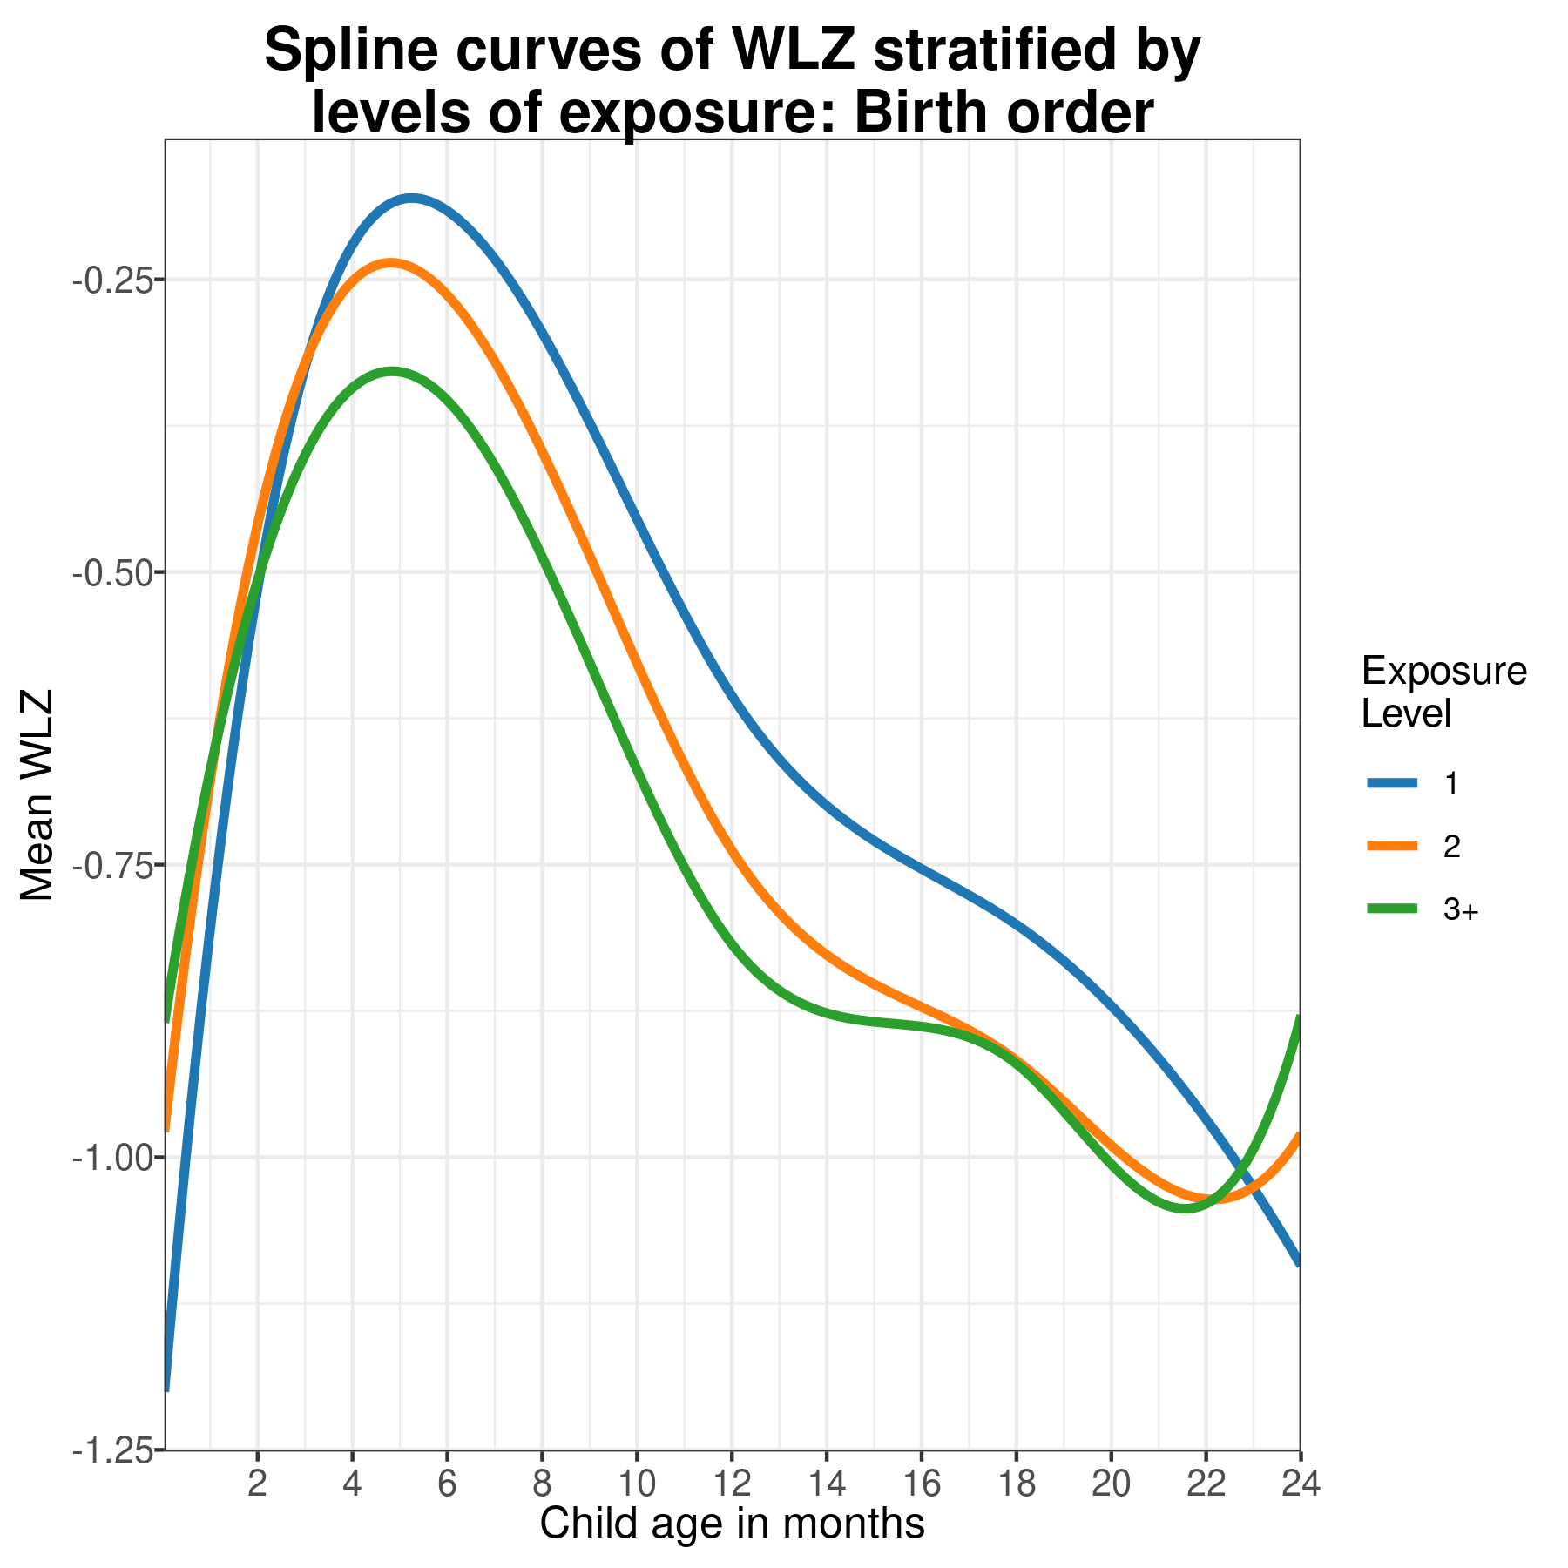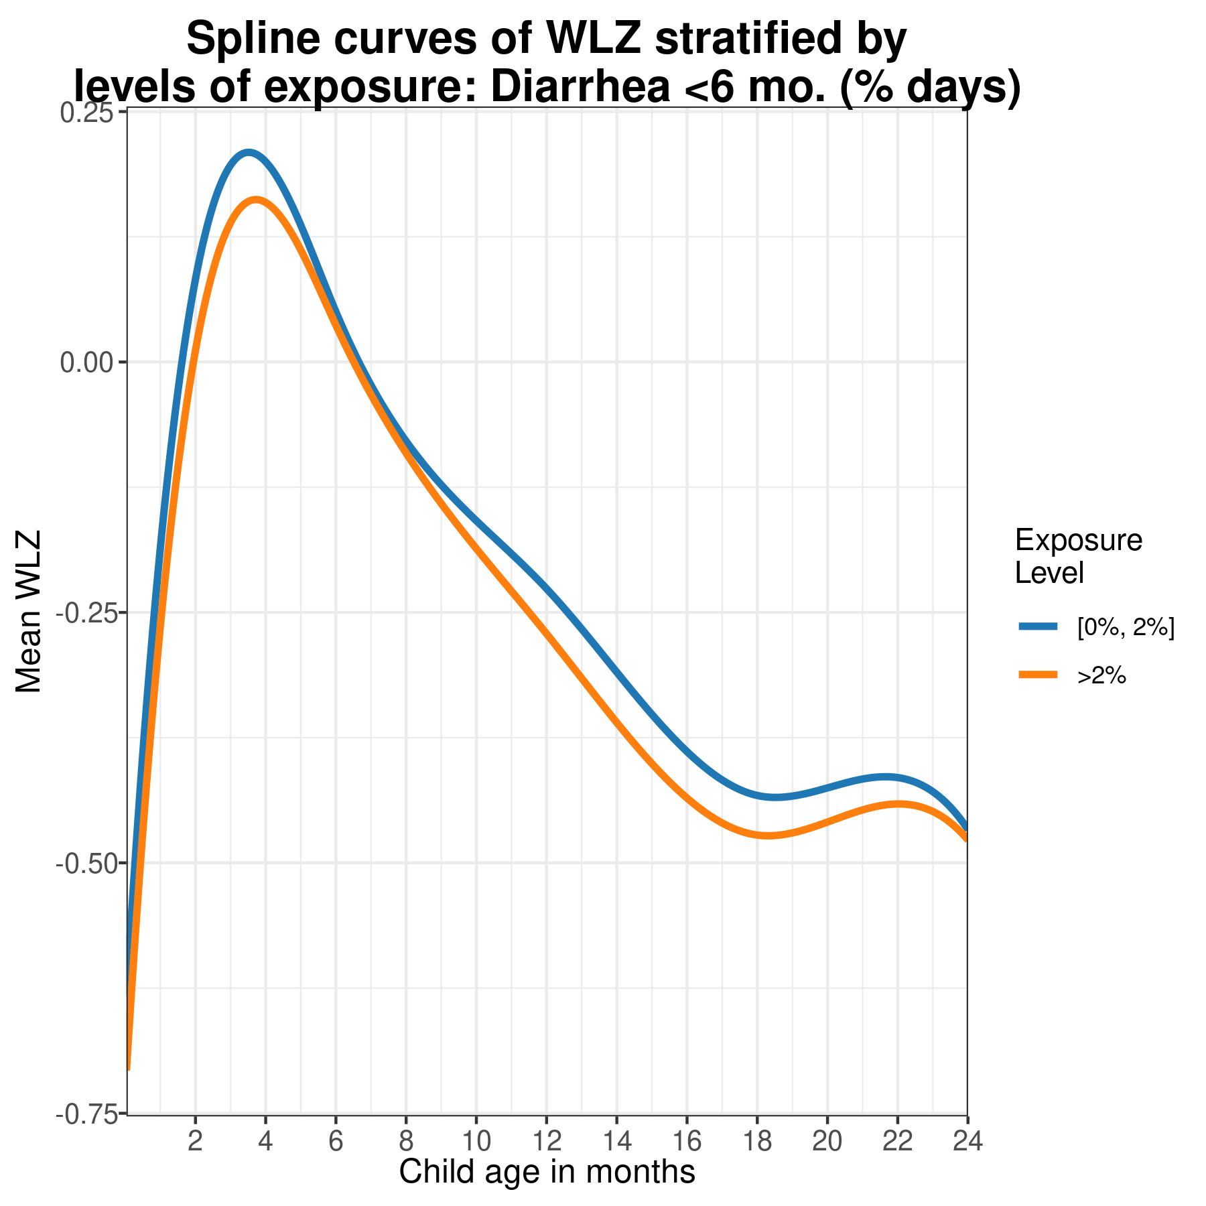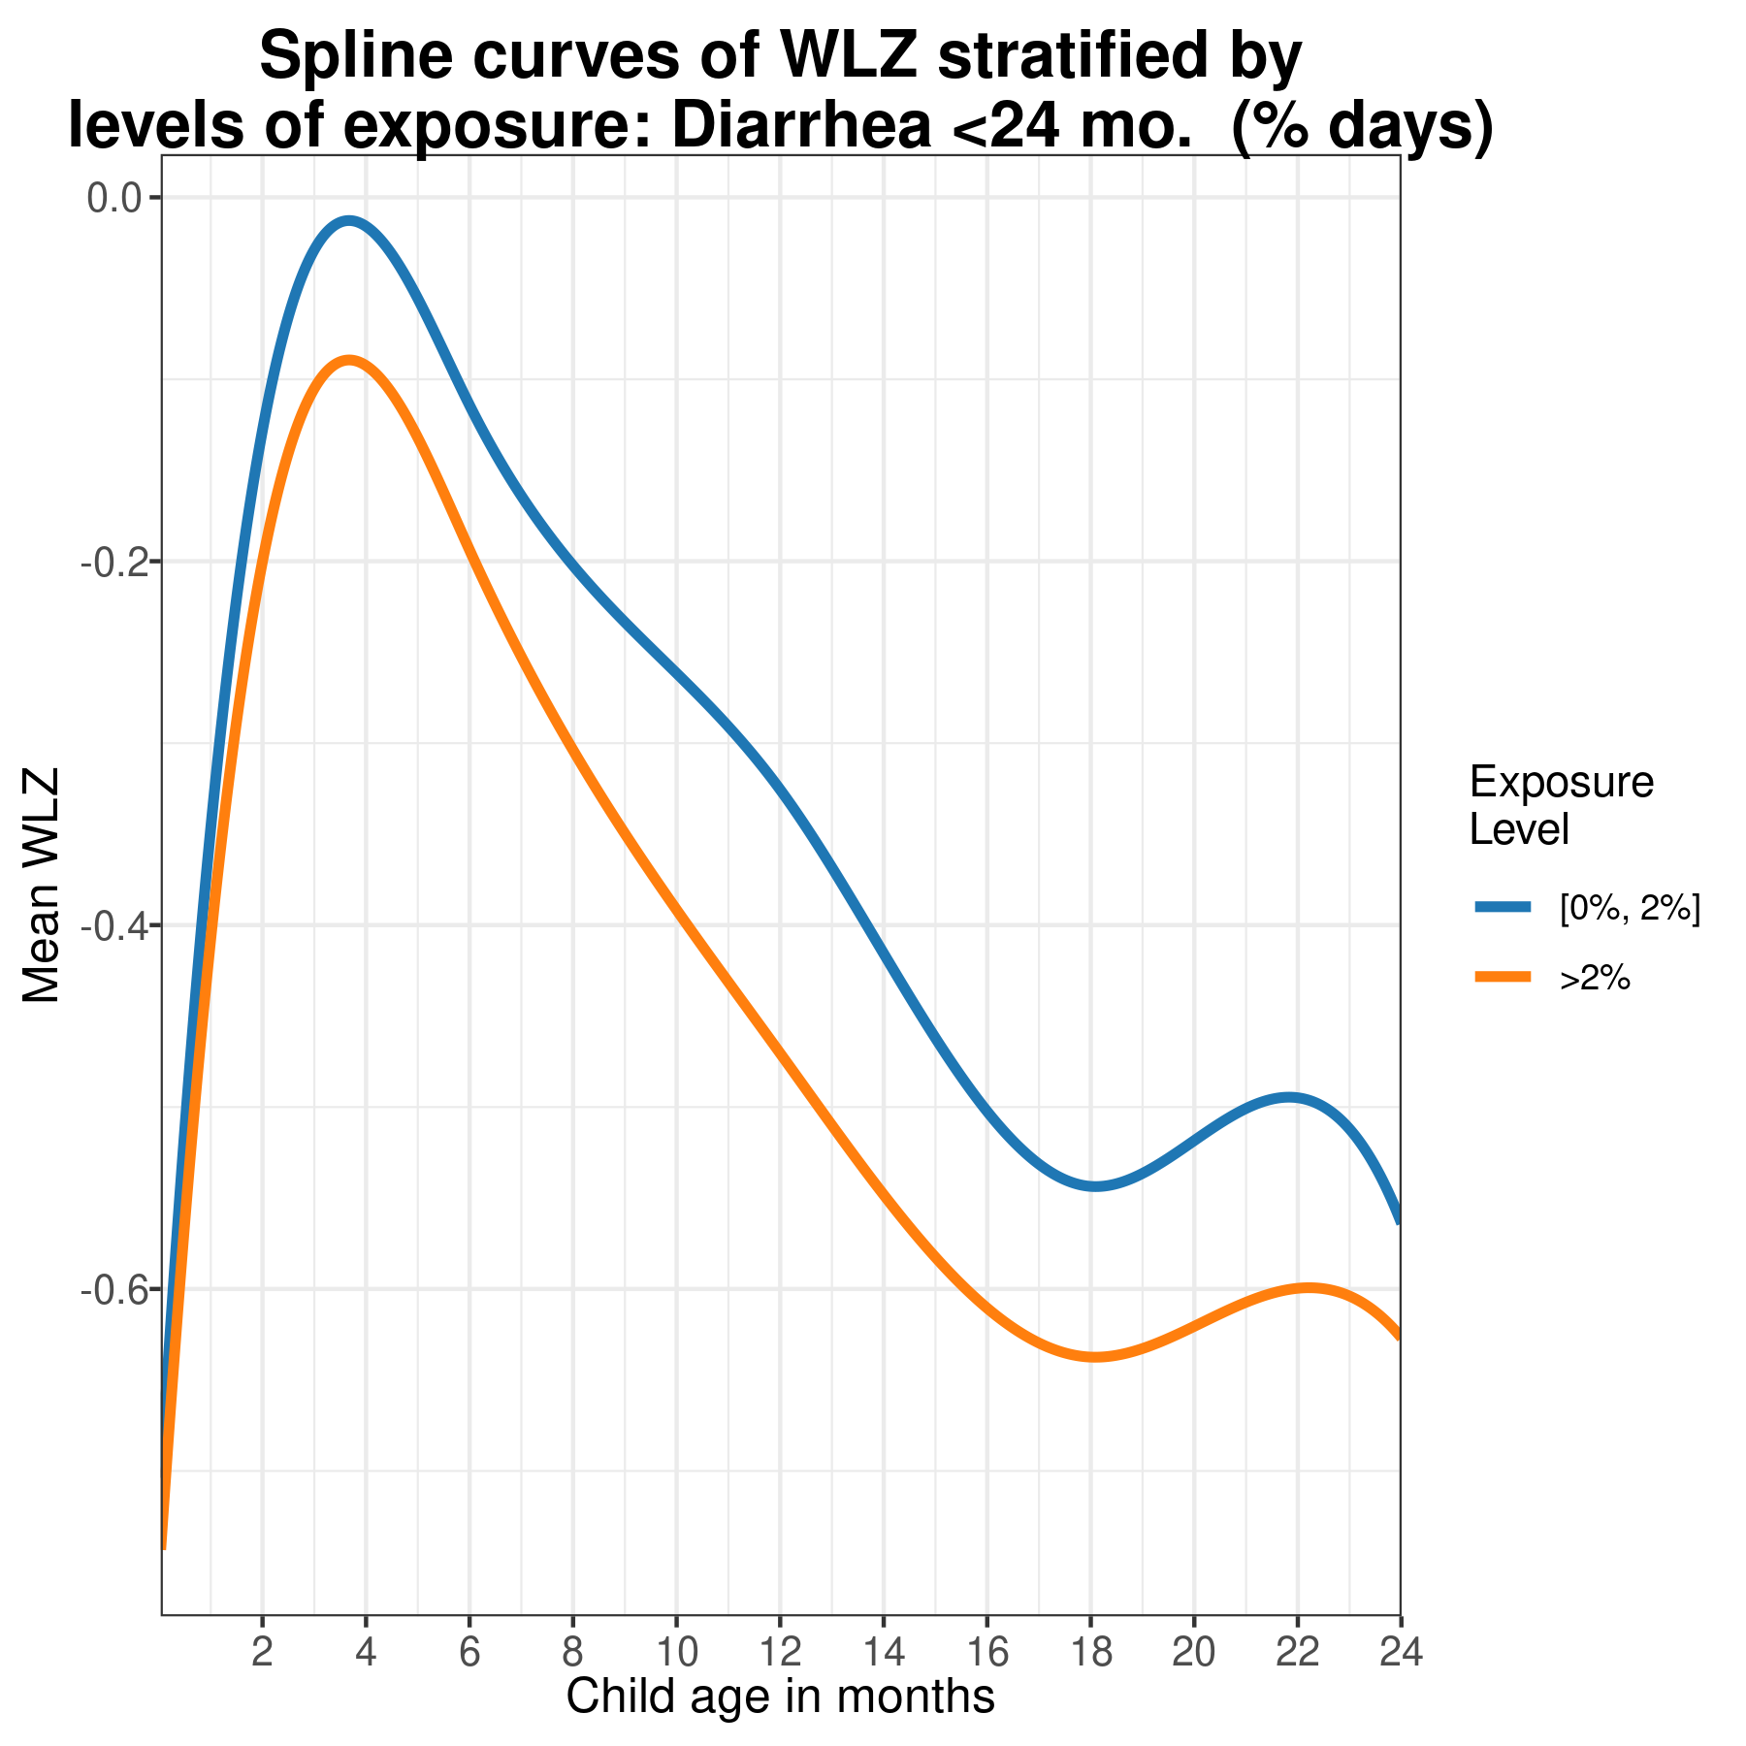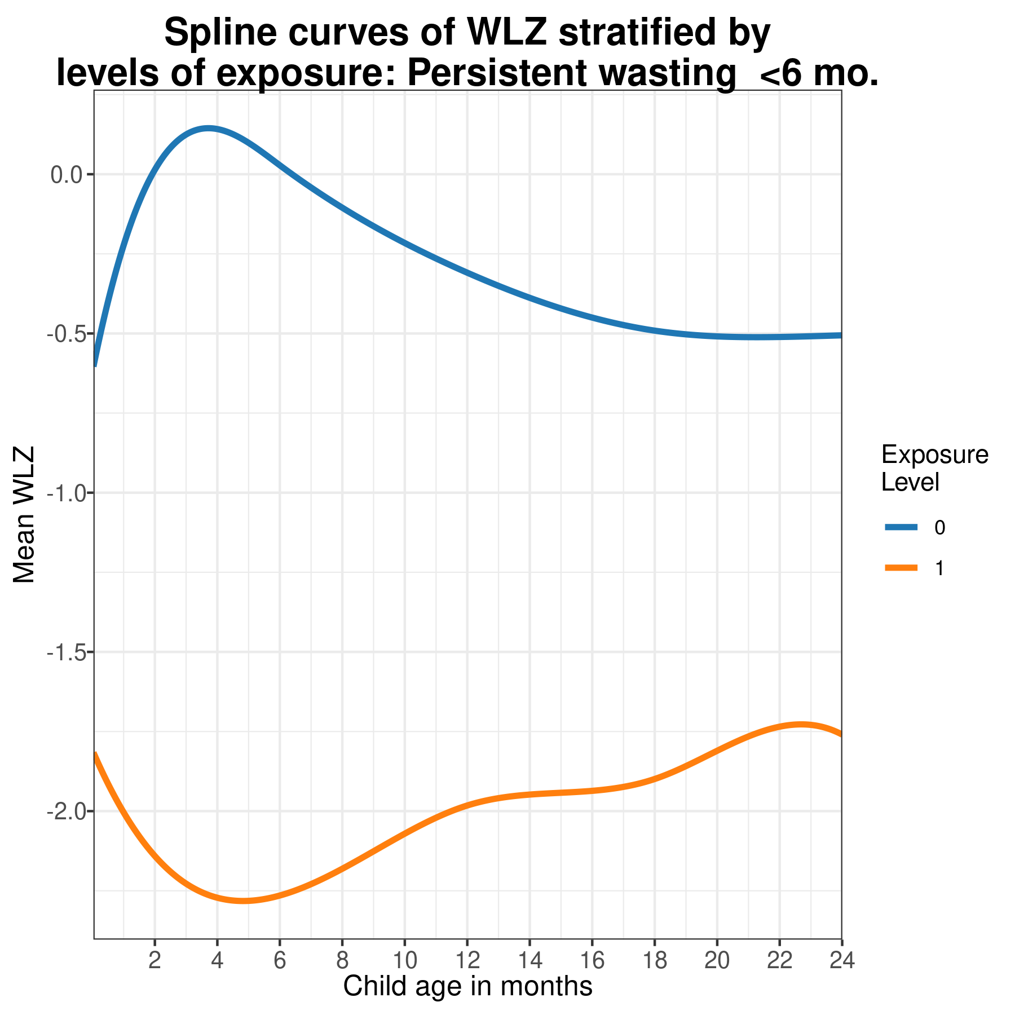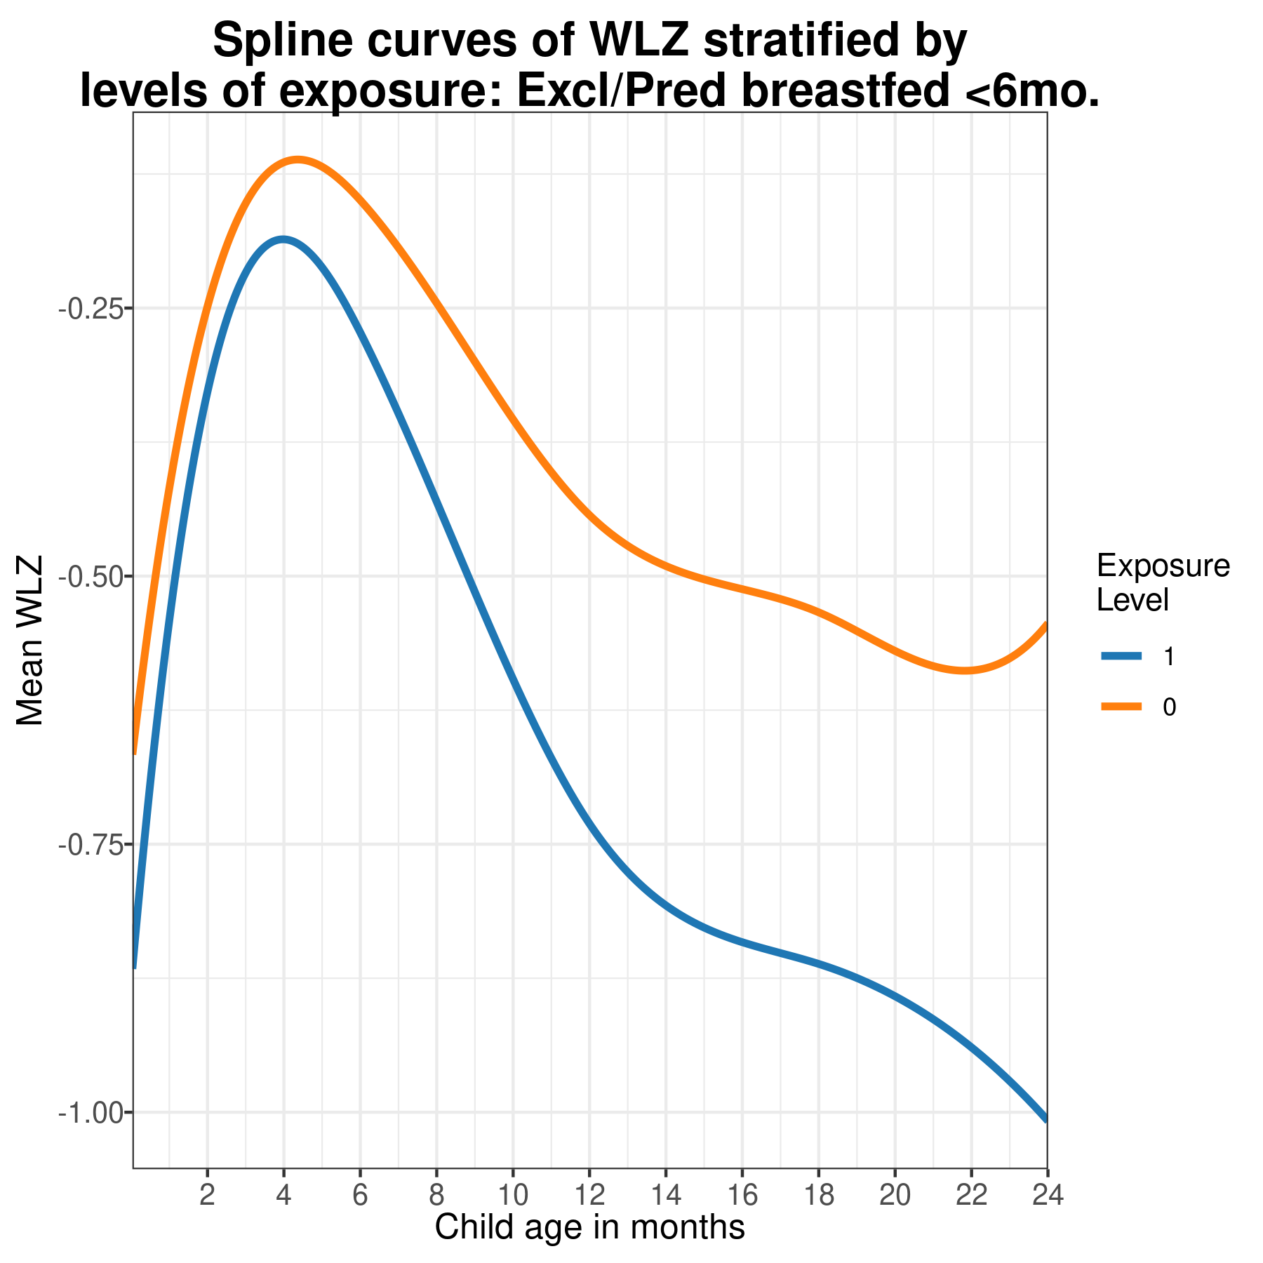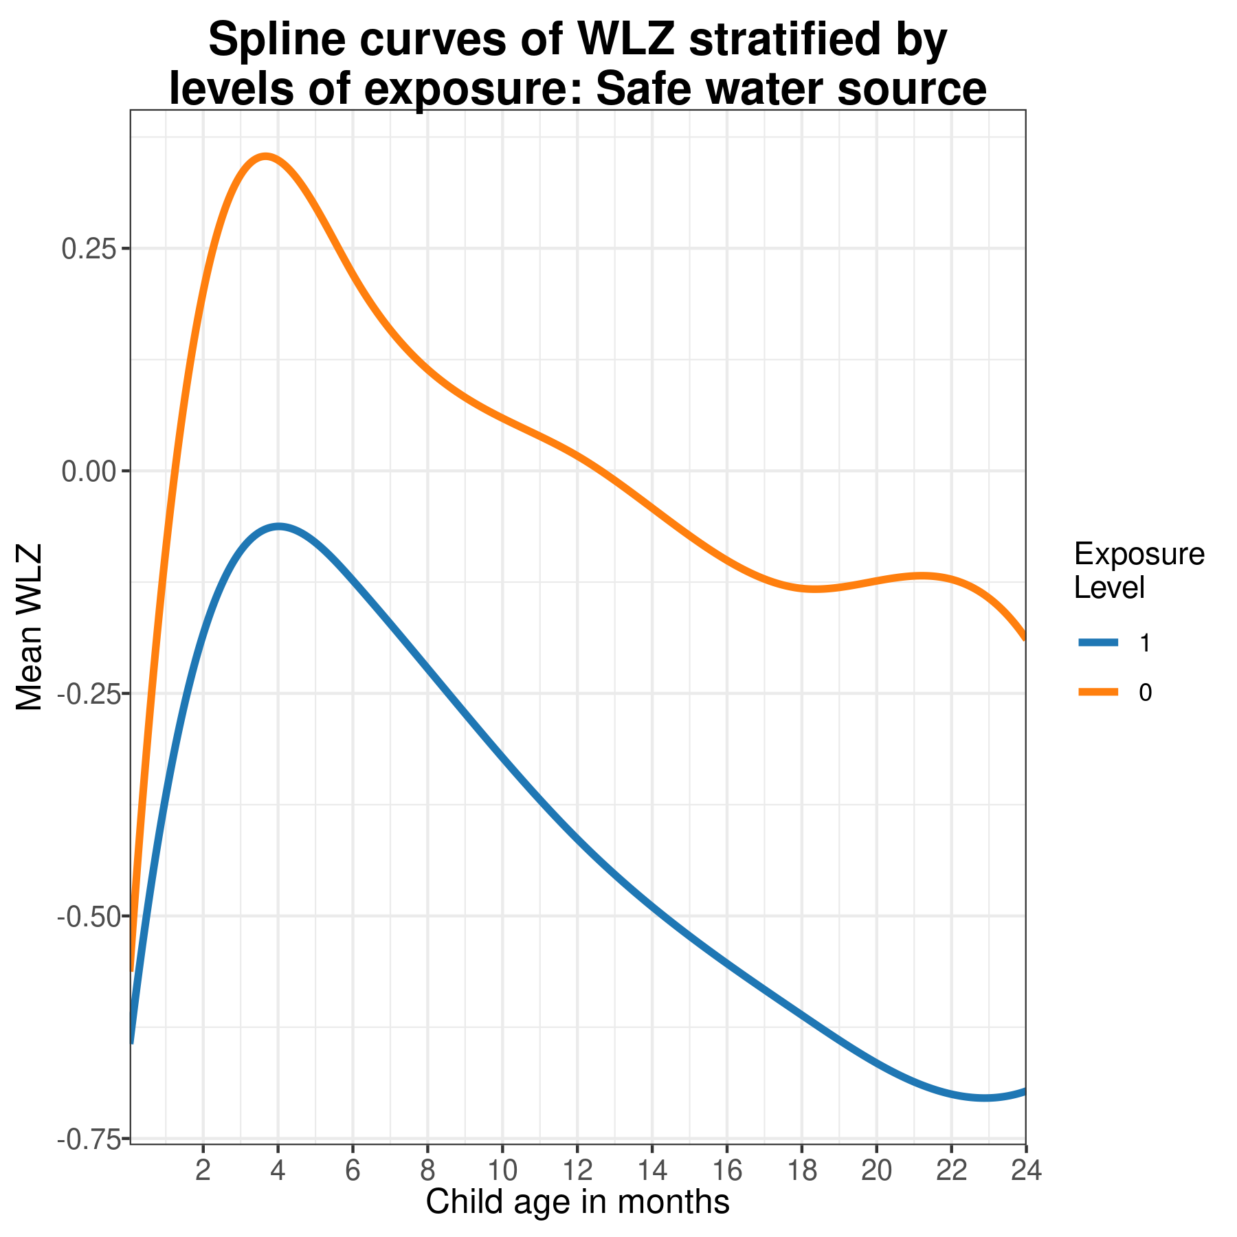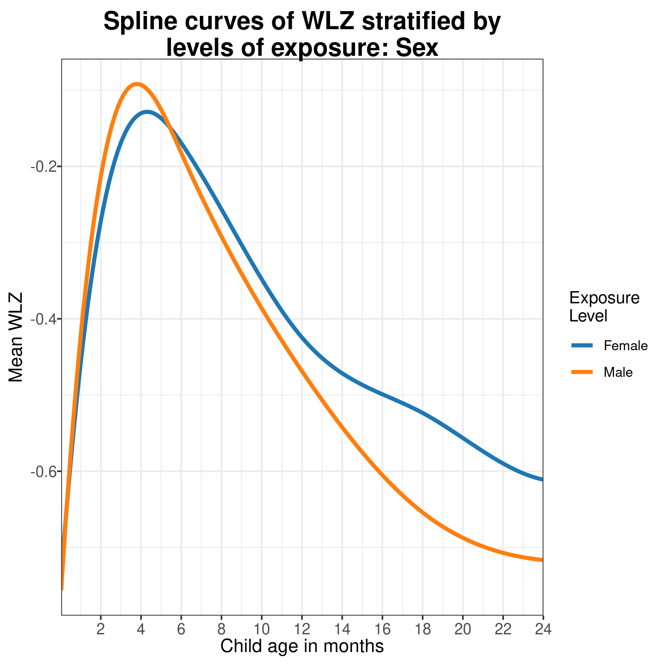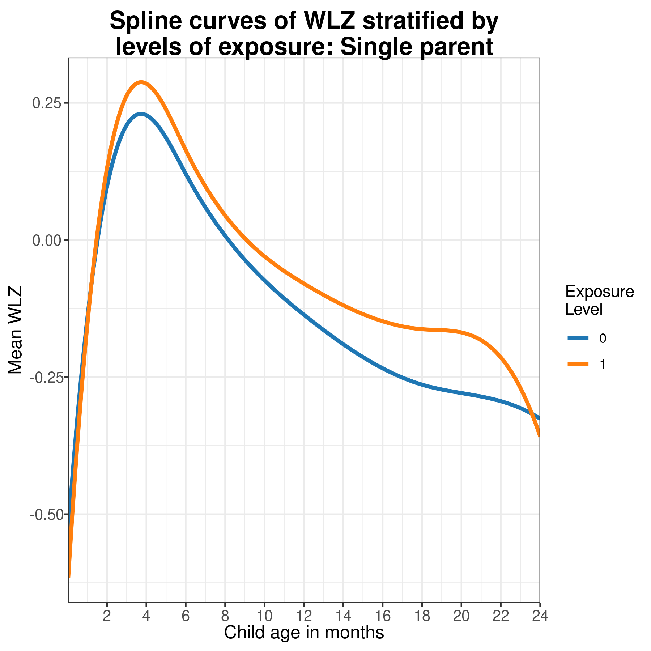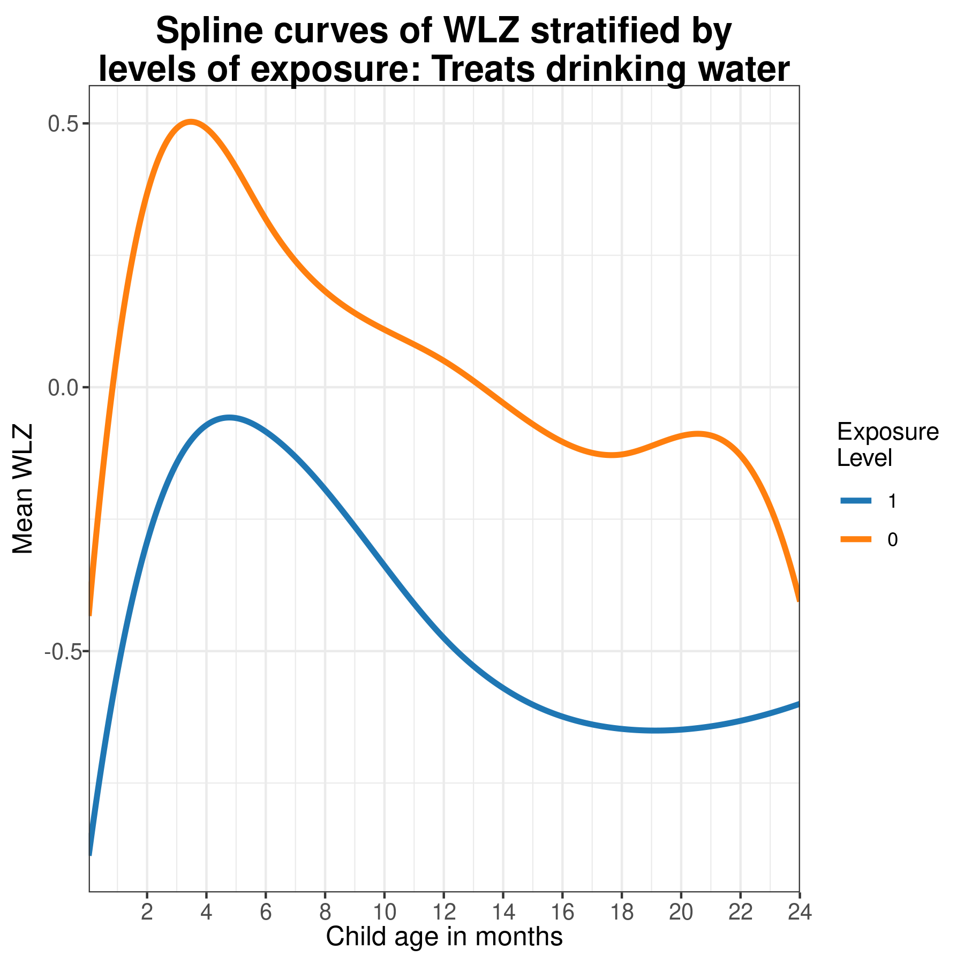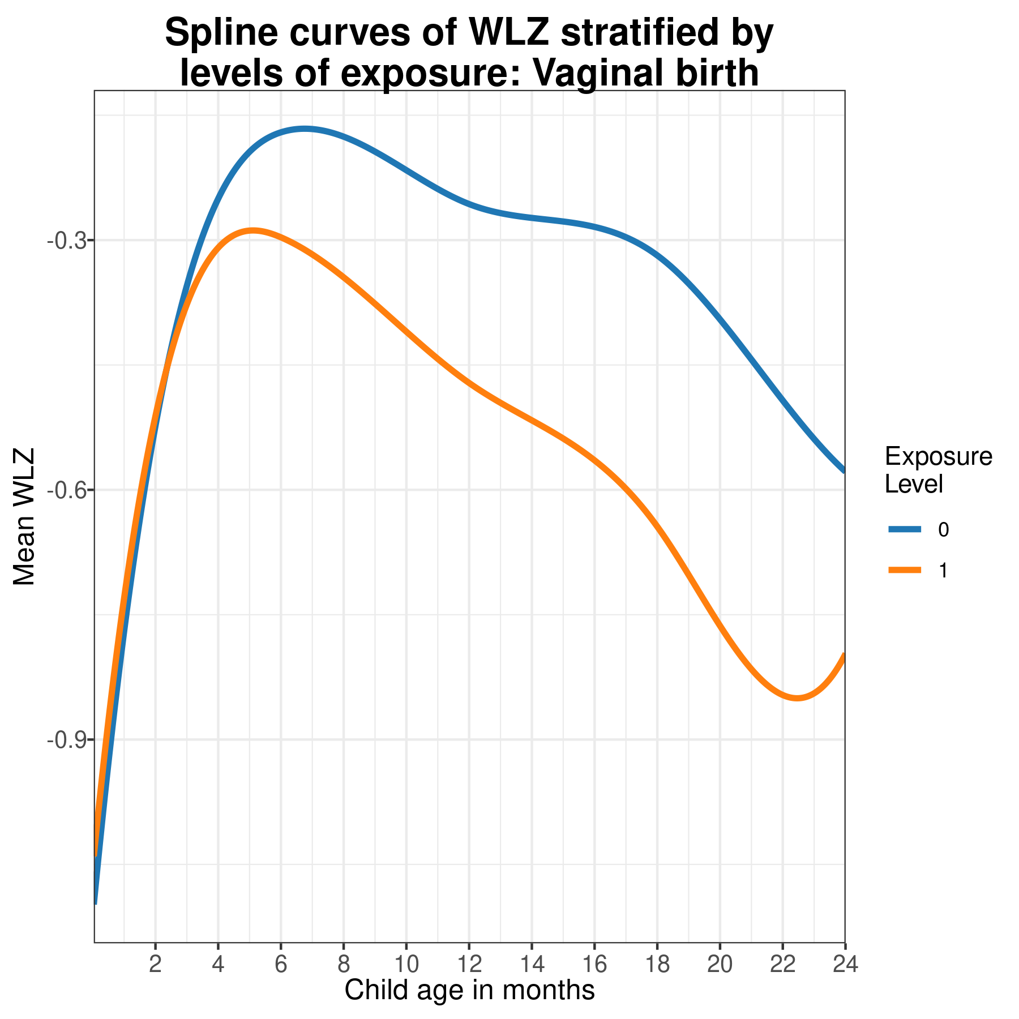

# 6 Sensitivity to dropping PROBIT trial

## 6.1 Overview

**Purpose:**  The PROBIT trial, conducted in Belarus, was the only study included conducted in Europe, as opposed to Latin America, South Asia, or sub-Saharan Africa. It was also one of the largest studies, so may have an influential effect on the pooled estimates. Because of differences in income, environmental conditions, and population anthropometry, we reconducted the primary analyses without the PROBIT trial and present the results here. **Interpretation:**  Exclusion of the PROBIT trail did not affect the main inferences presented in the manuscript. **Implications:**  It was appropriate to include the PROBIT trial in the pooled results presented as the primary results of the manuscript.

## 6.2 Comparison of attributable differences estimated with and without the PROBIT trial

Because PROBIT was the only European study, we also conducted a sensitivity analysis as to the effect of removing PROBIT on attributable differences at 24 months (within the exposures measures during the PROBIT trial). Other than for the estimated associations between father’s height and child Z-scores at 24 months (which was measured in few other studies), PROBIT is not highly influential.

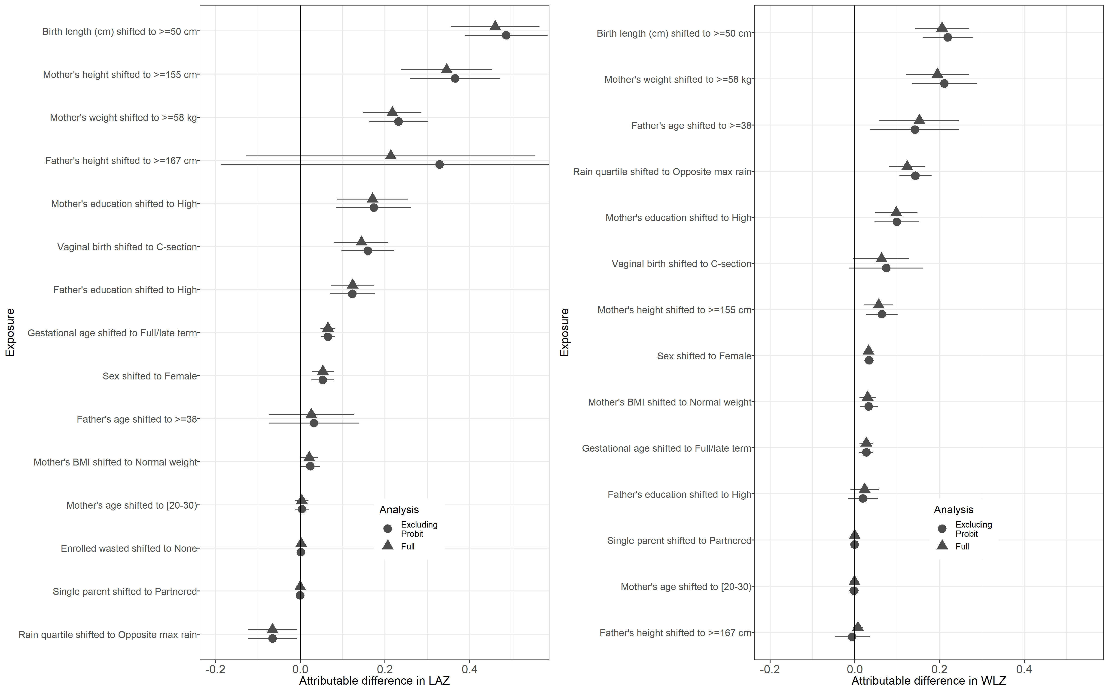

# 7 Relative risk plots

/raggedright

## 7.1 Overview

**Purpose:**

The primary parameter presented in the “Causes and Consequences of Child Growth Failure in Low- and Middle-income Countries” publications is the population intervention effect (PIE), the change in mean population Z-score if a exposure is shifted to the lowest-risk level, which combines the increase of risk associated with an exposure with the prevalence of the exposure in the population. This page of the supporting information presents plots for pooled relative risks (RR) and average treatment effects (ATE) for each level of each exposure. Relative risk are reported for binary CGF outcomes (stunting, wasting, underweight, severe stunting, severe wasting, and severe underweight) and ATEs are reported for continuous Z-score outcomes.

**Interpretation:**

The primary purpose of this page is to present the pooled point estimates and confidence intervals for all of the results summarized in the Extended Data Figure 2 heatmap, and to allow the reader to compare the levels of risk across categorical exposures. The population intervention effects and attributable fraction presented in the primary manuscript show the result when shifting the exposure distribution to the low-risk reference levels, but the results presented here allow for comparing other exposure levels, like food secure versus moderately food insecure.

**Implications:**

The strong risk factors identified through the use of Population Attributable Factors (Extended Data Figure 6) were almost always the strongest risk factors when examining average treatment effects and relative risks across different age categories and outcomes.

### 7.1.1 Relative risks between levels of all exposures for prevalence and cumulative incidence of wasting and stunting outcomes

Plots are grouped and titles by exposure, and each panel of grouped plots visualizez the relative risk between levels of the exposure and different age-specific growth failure outcomes.

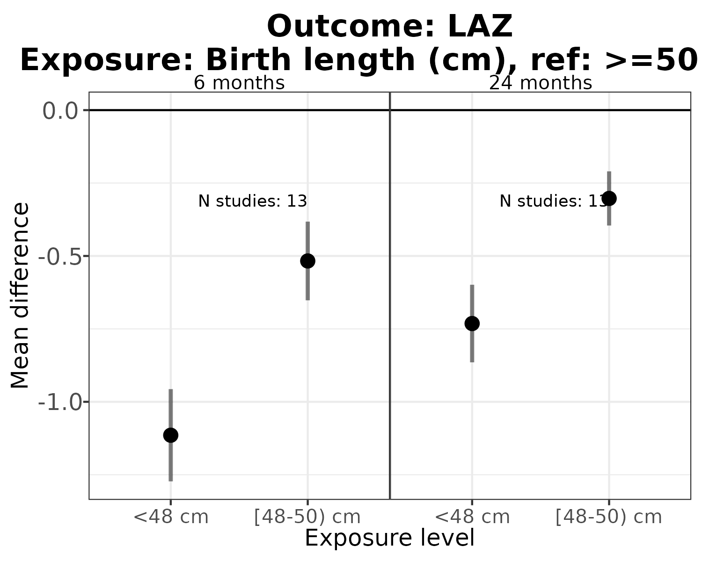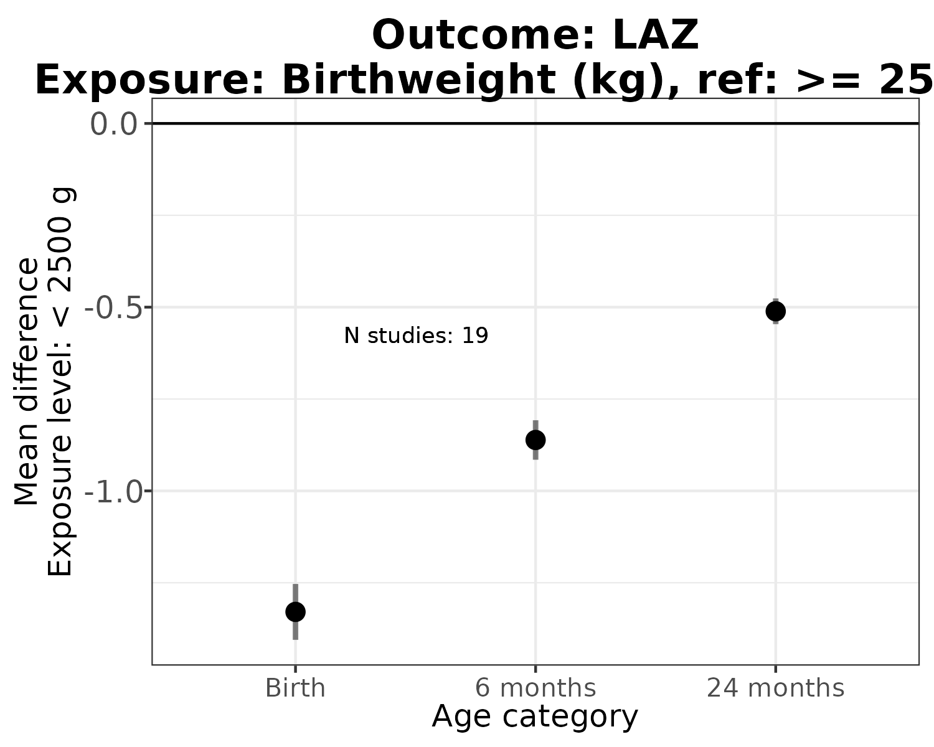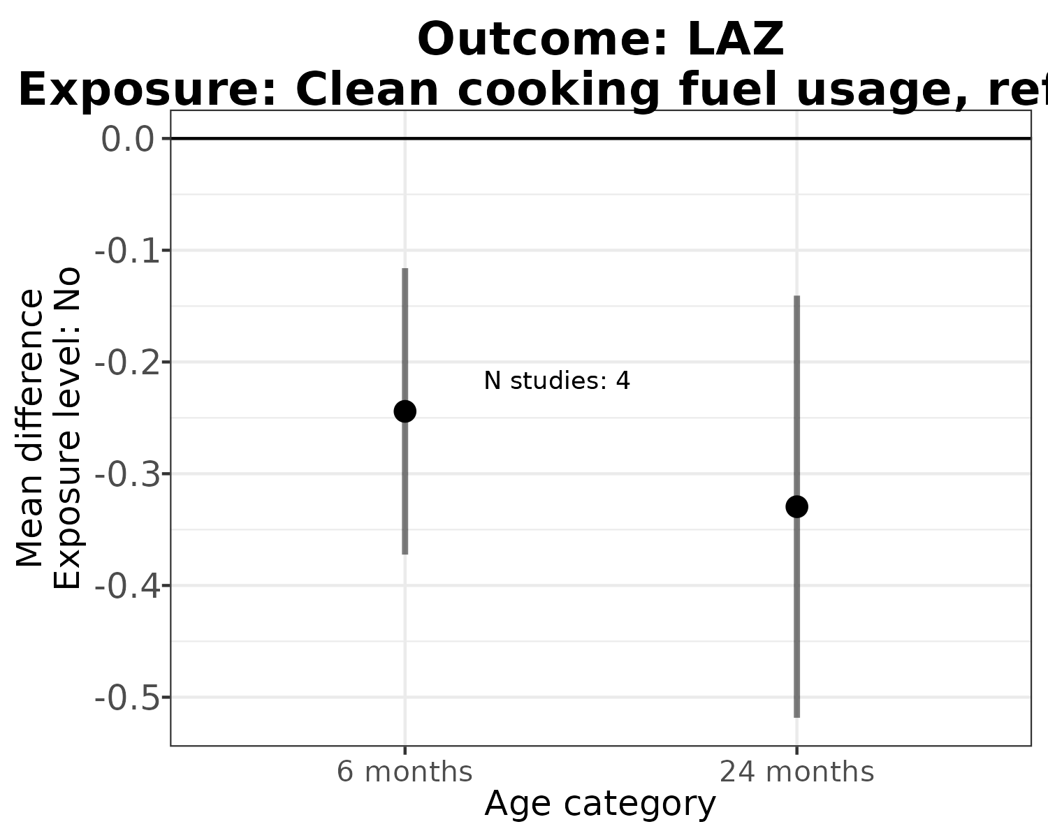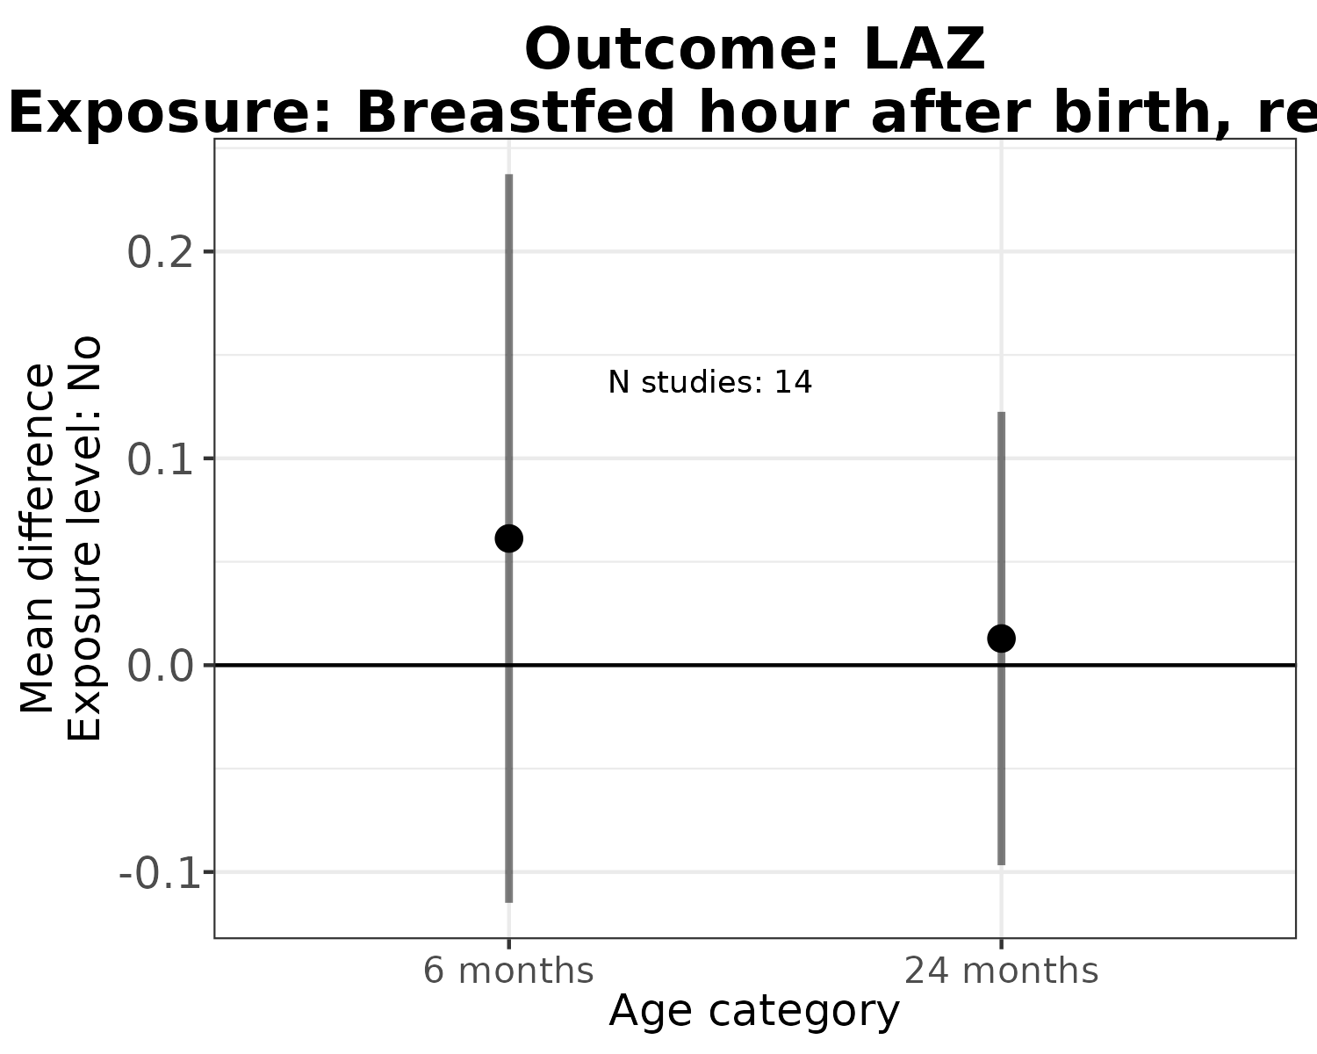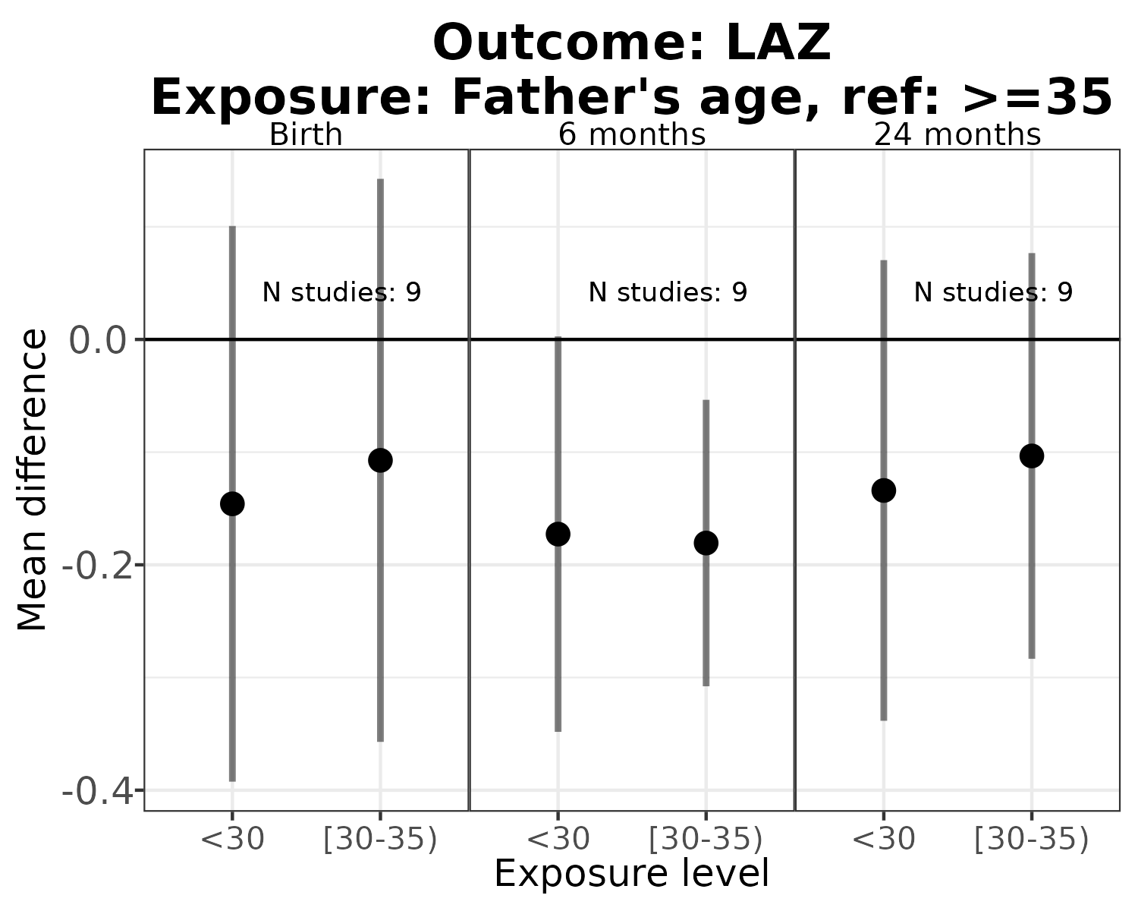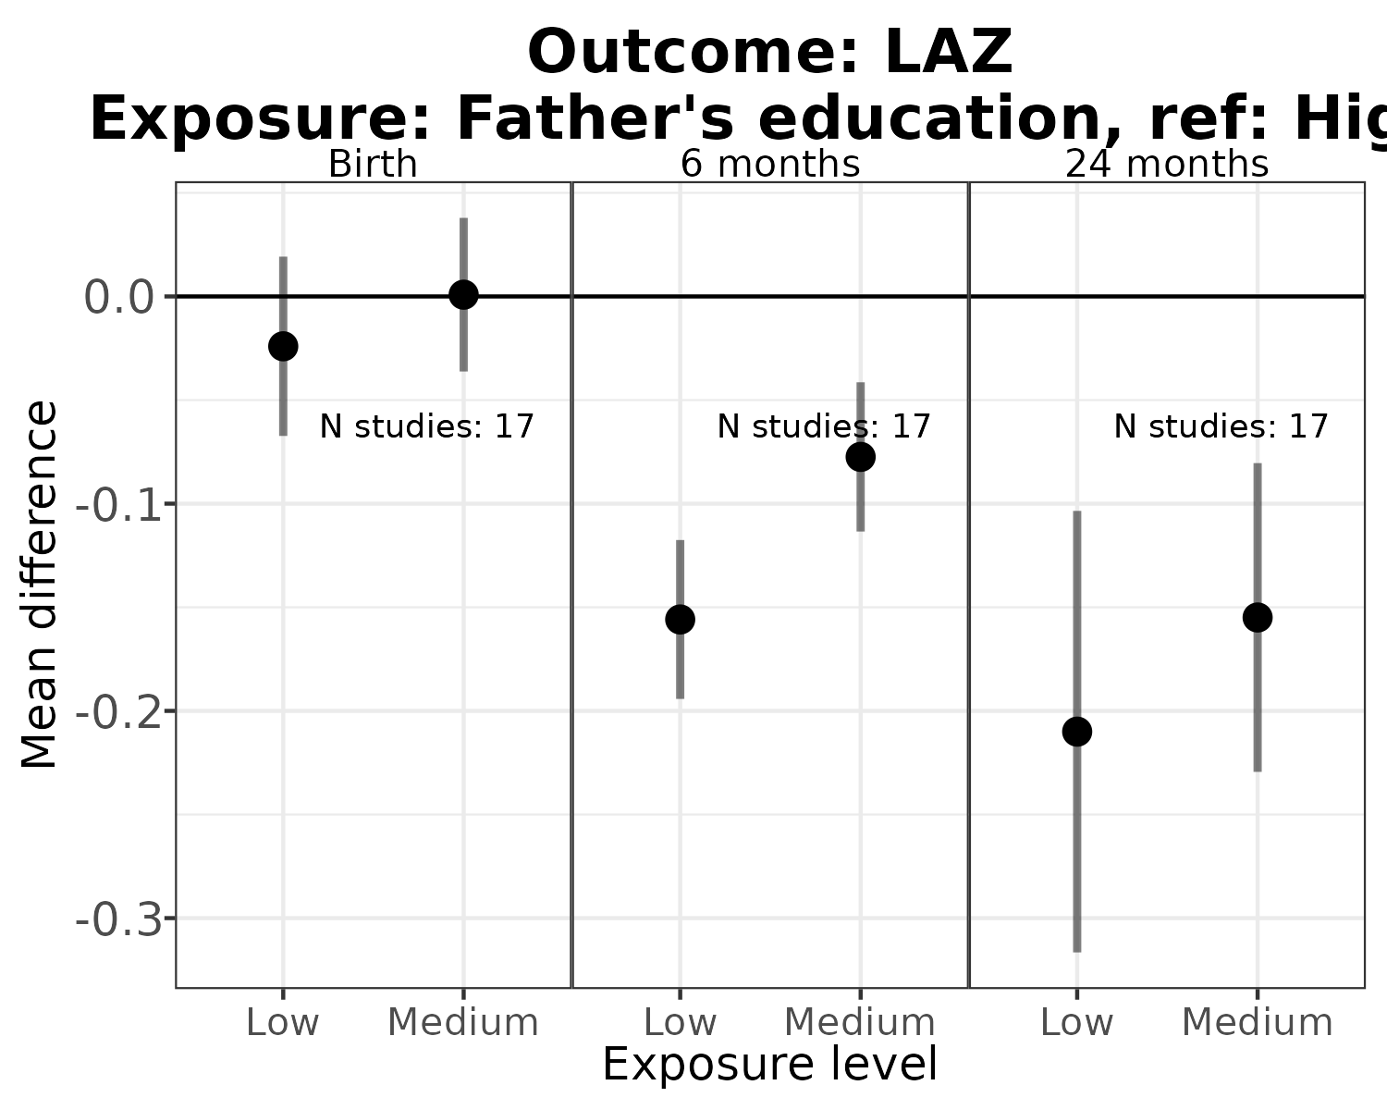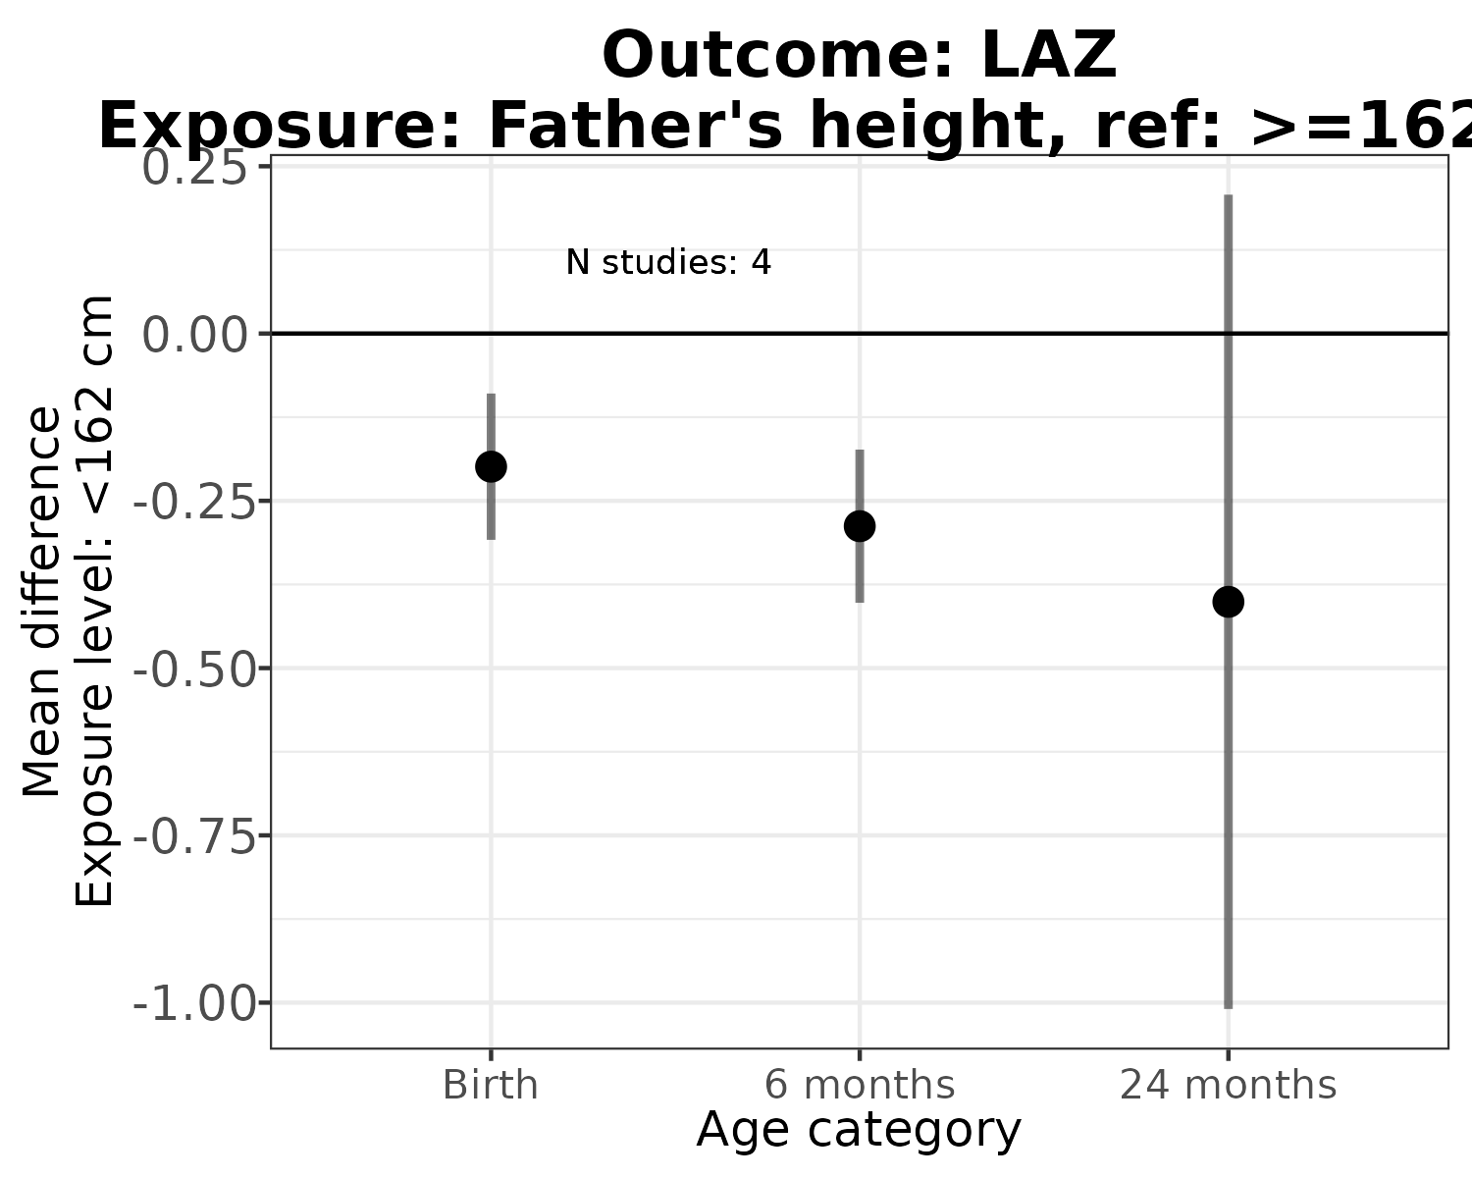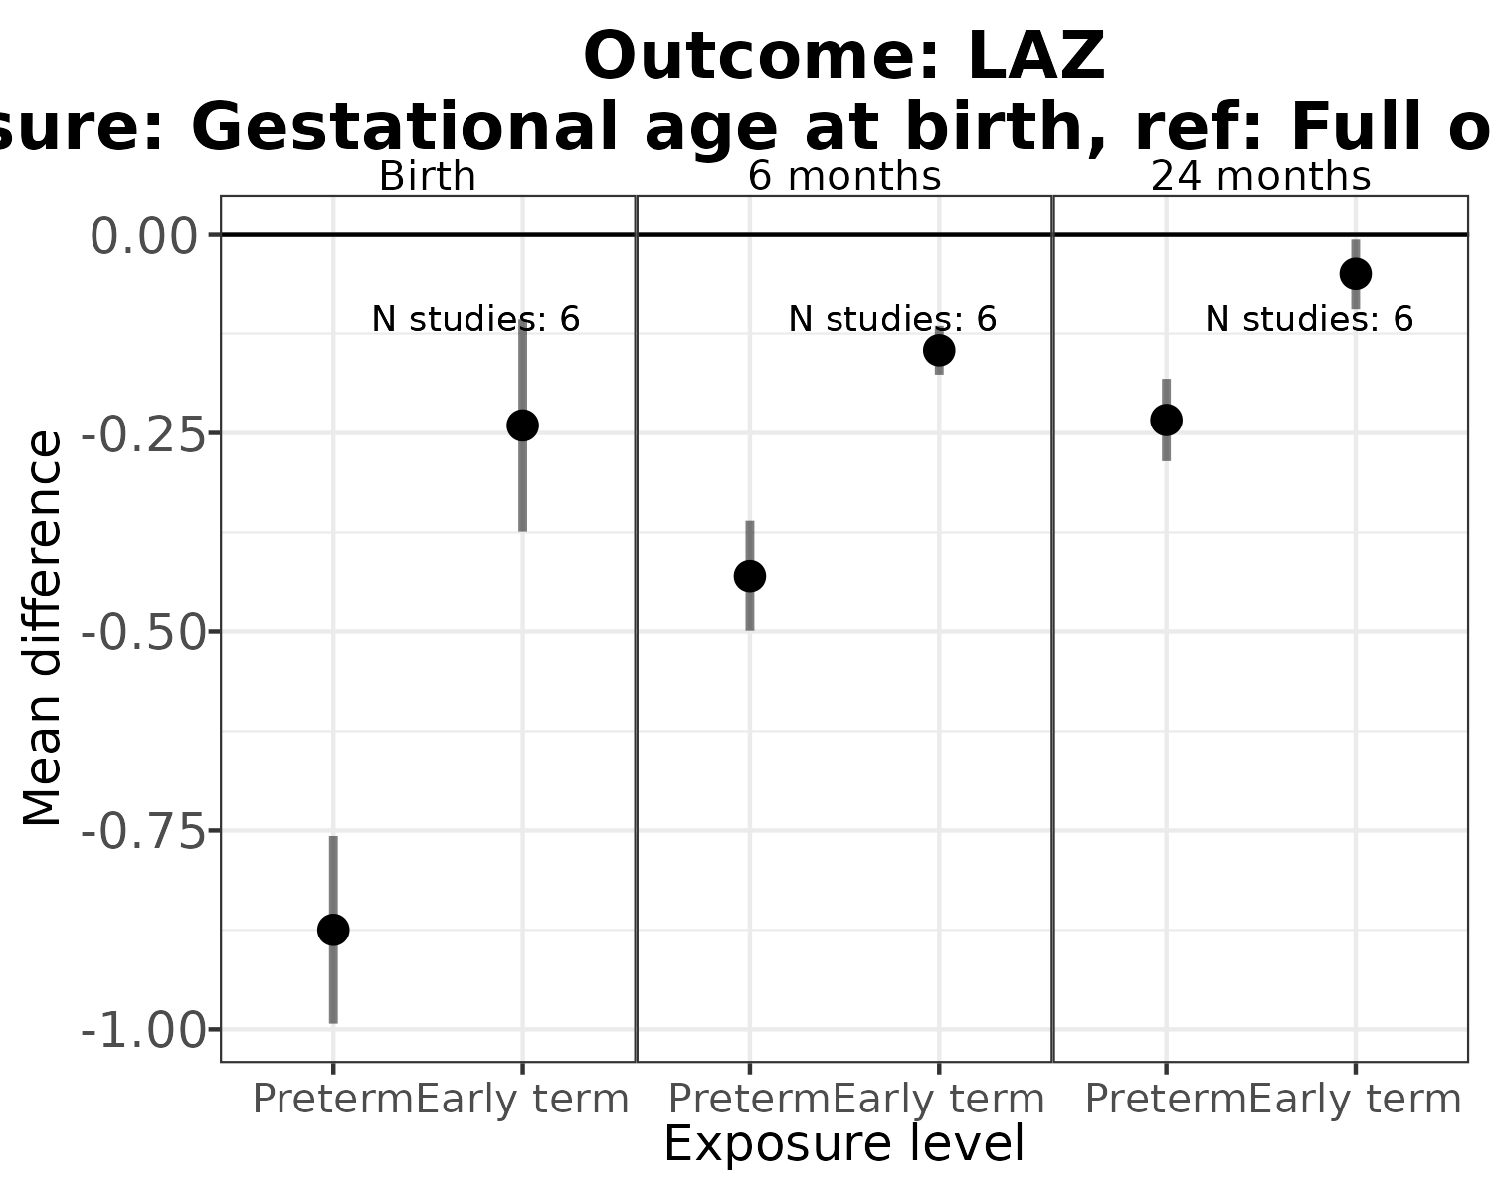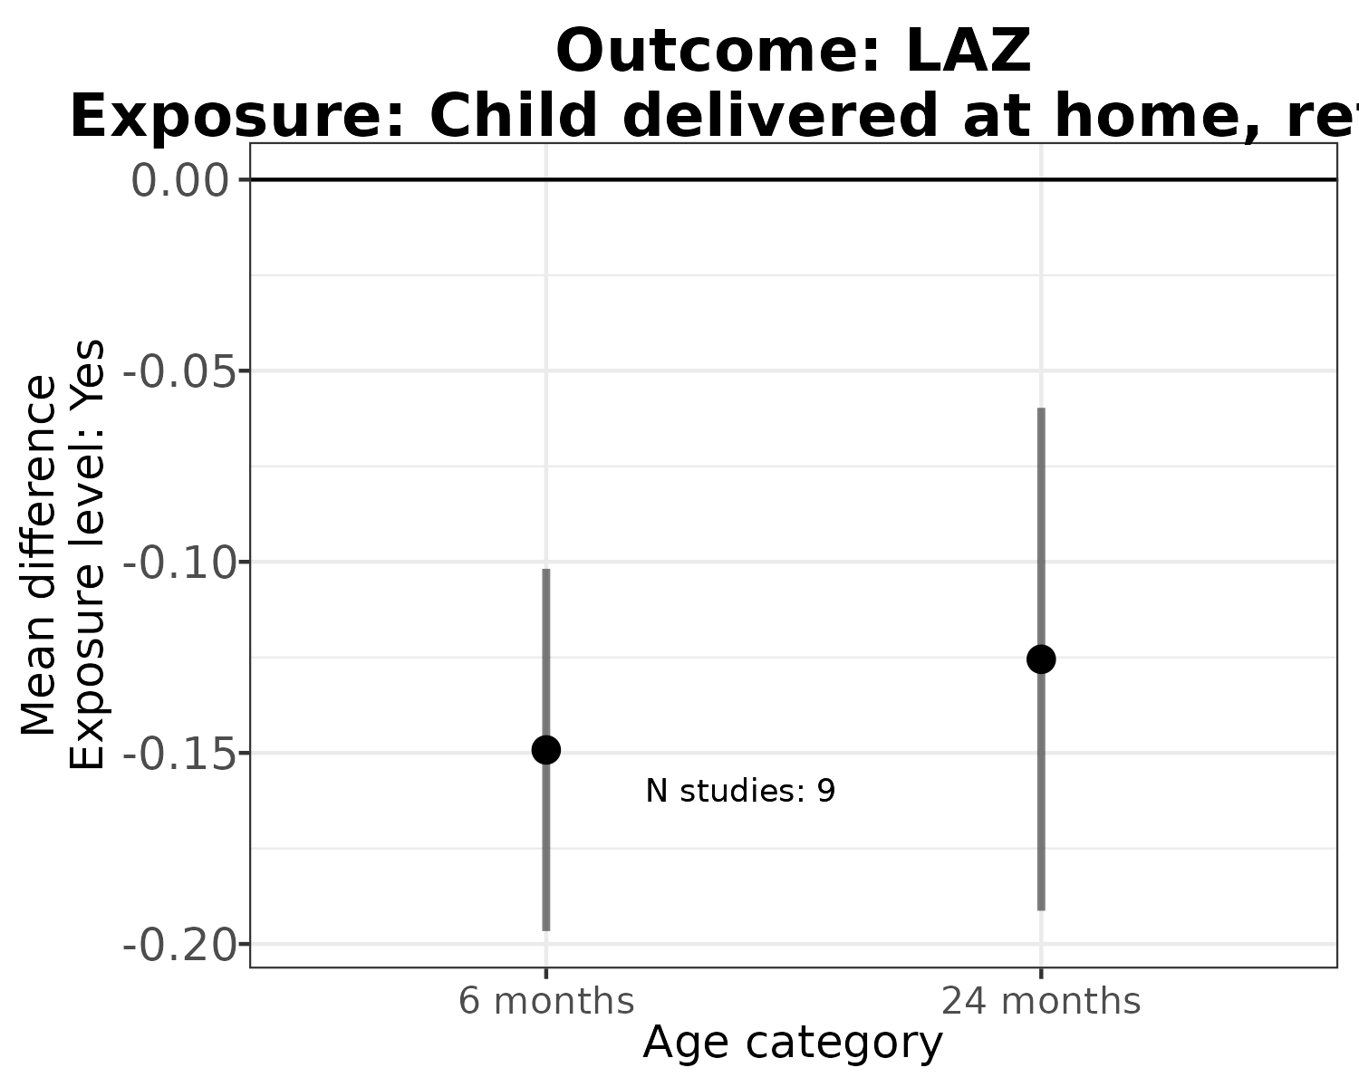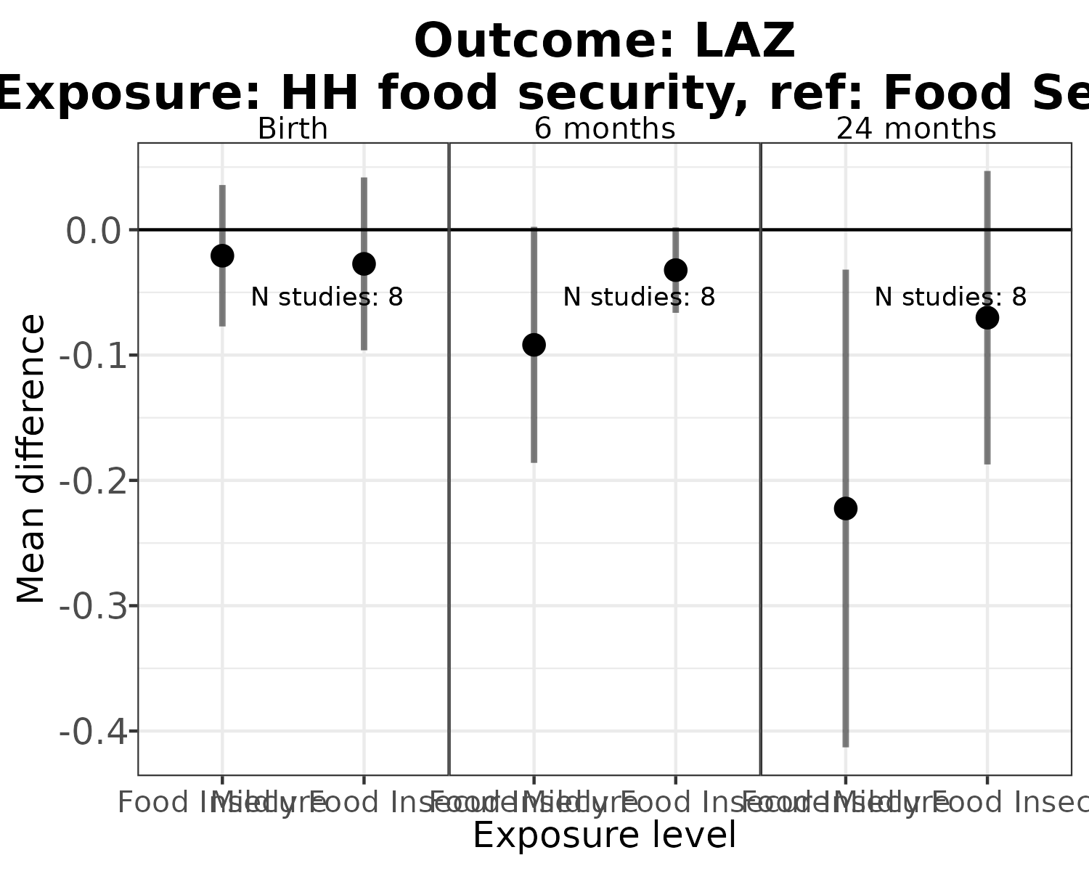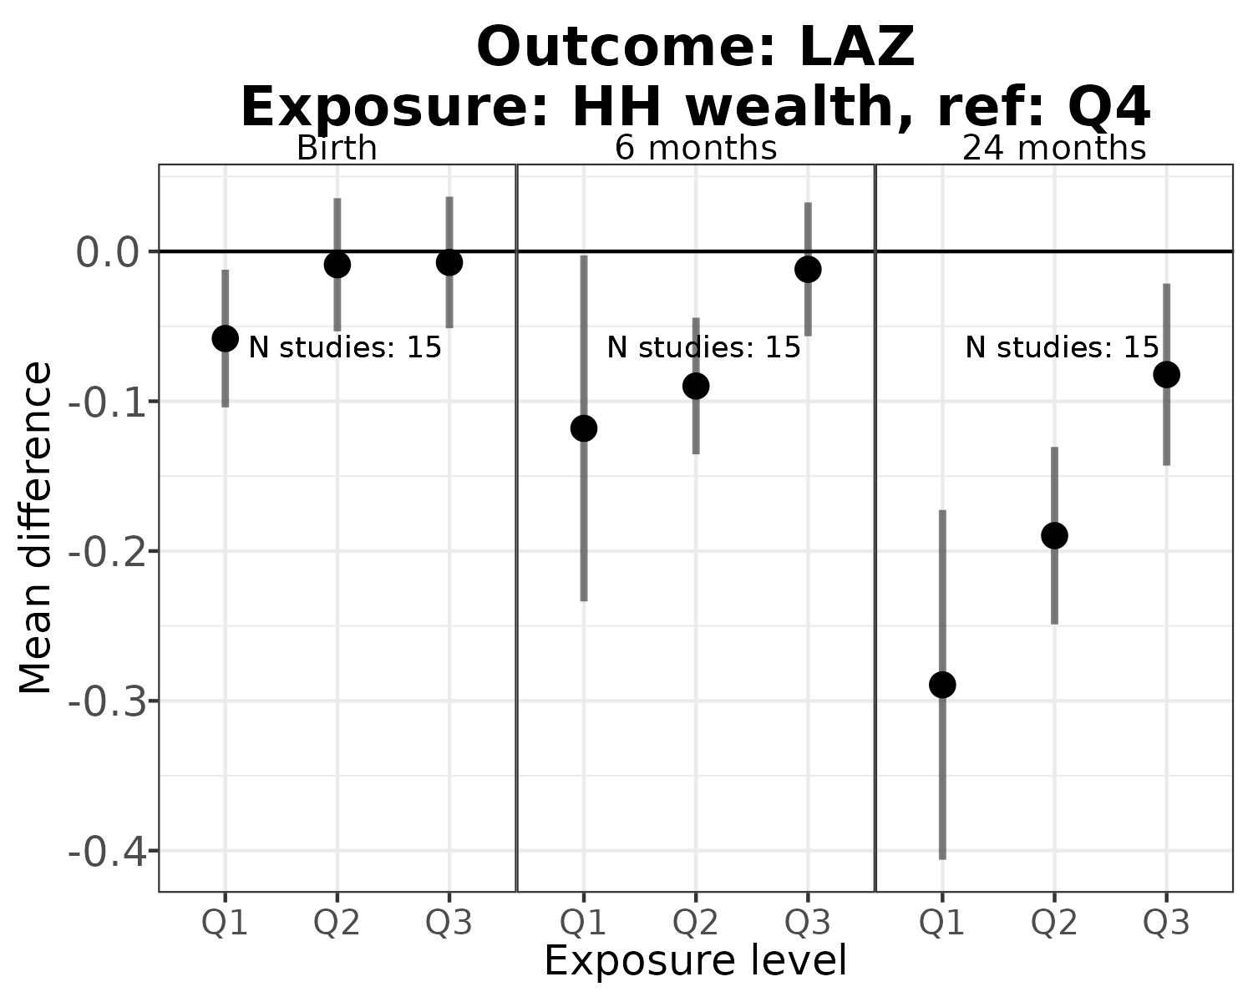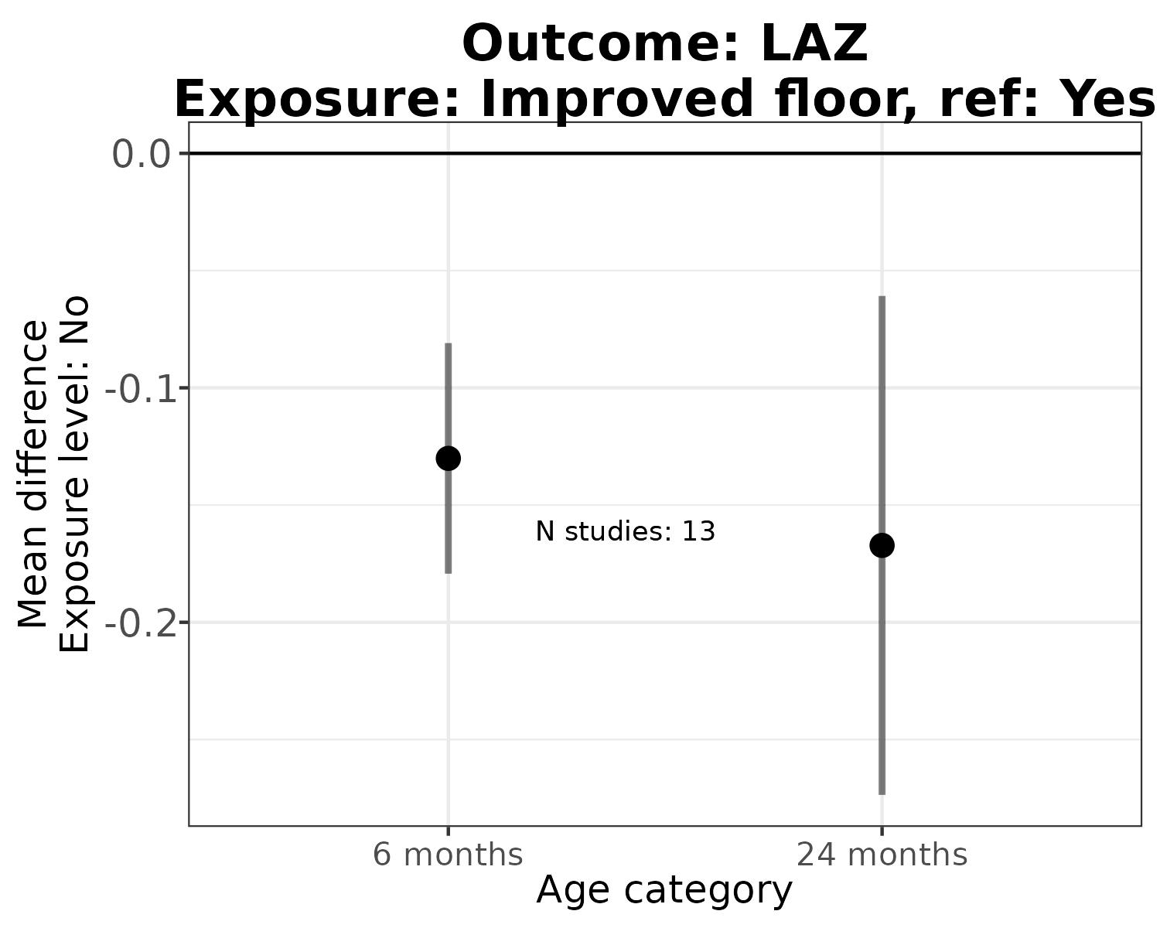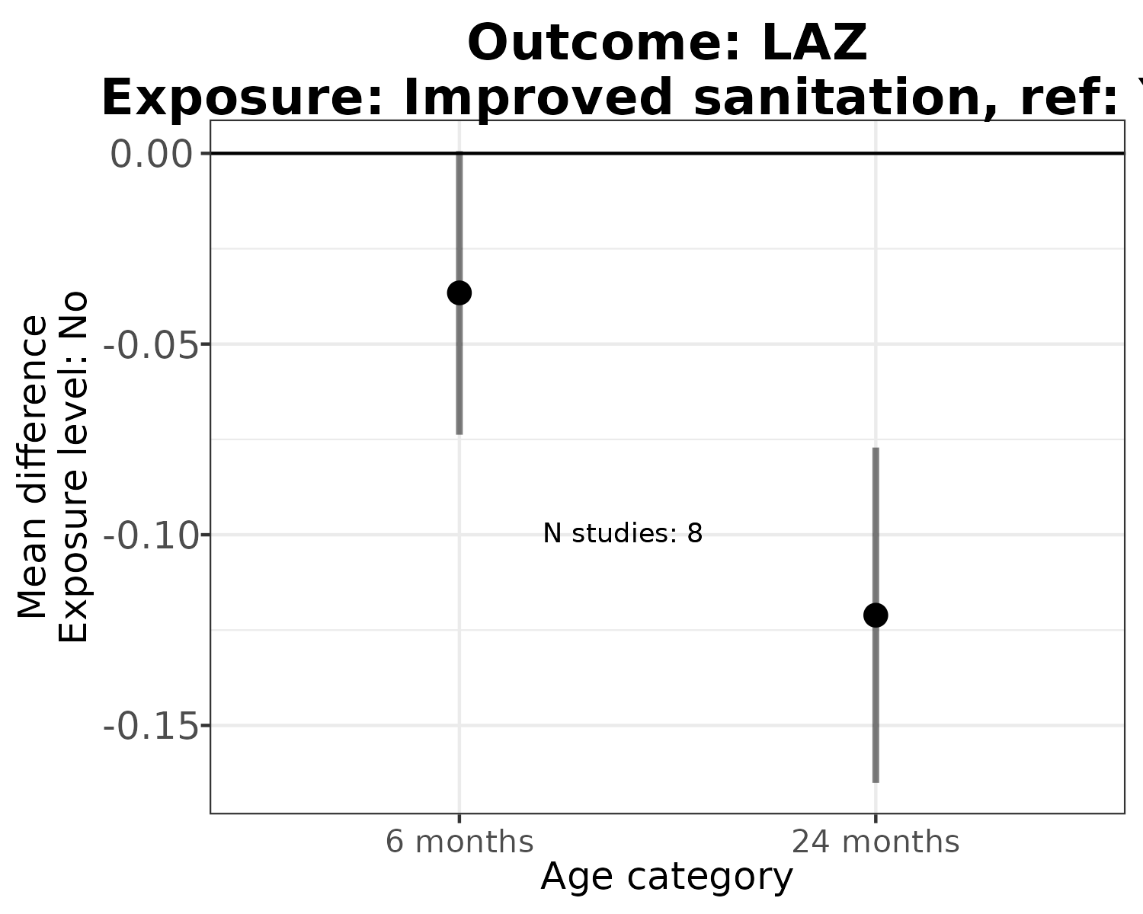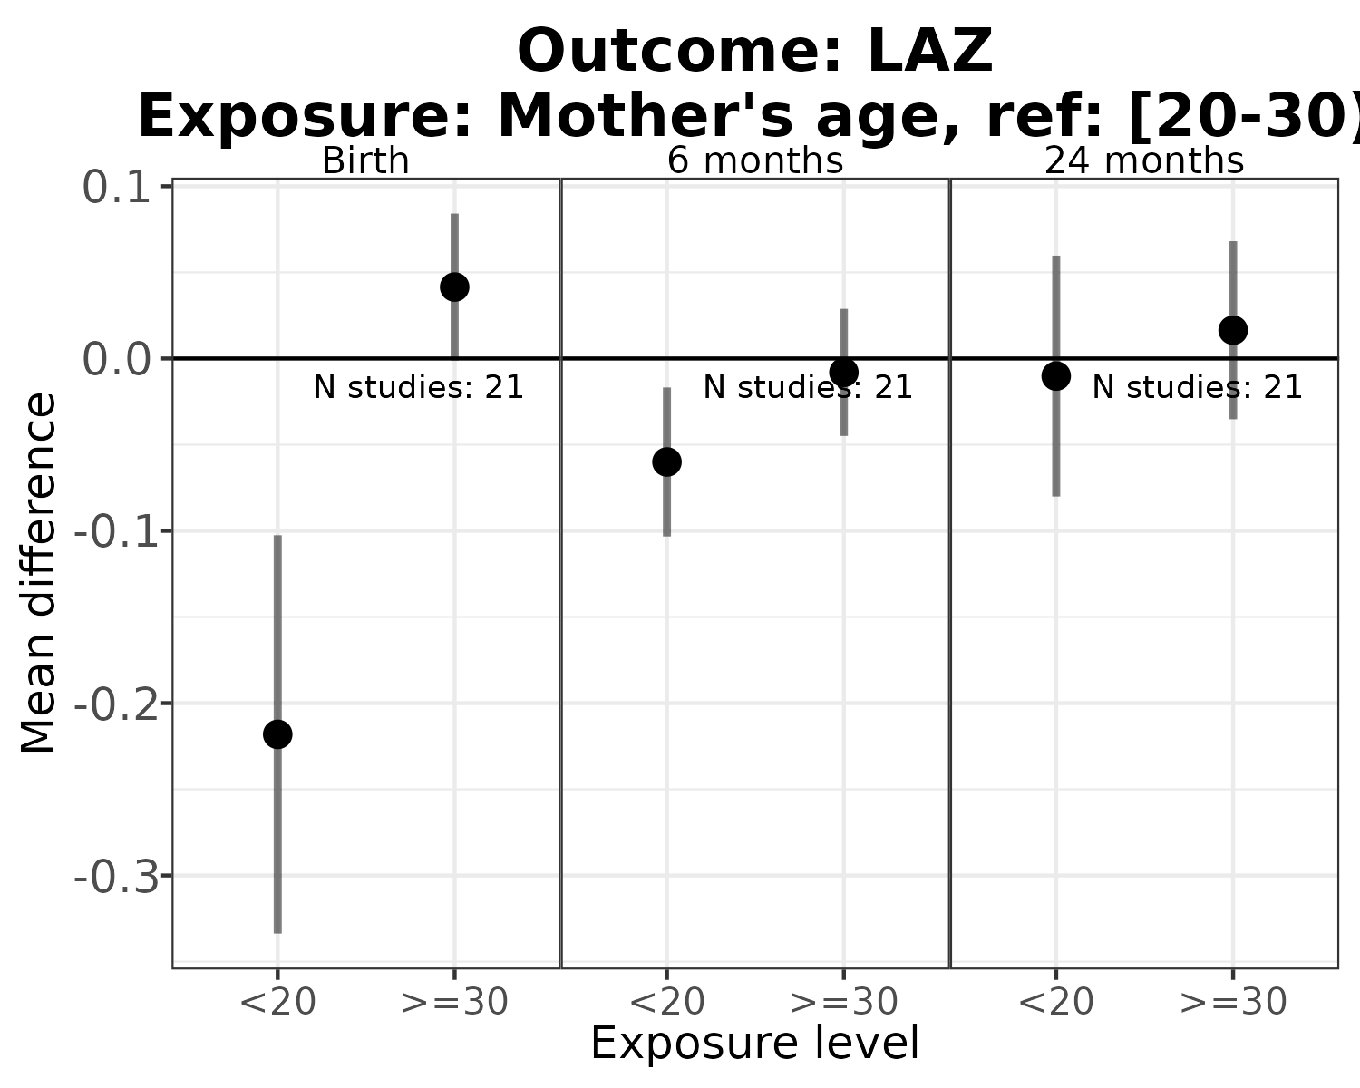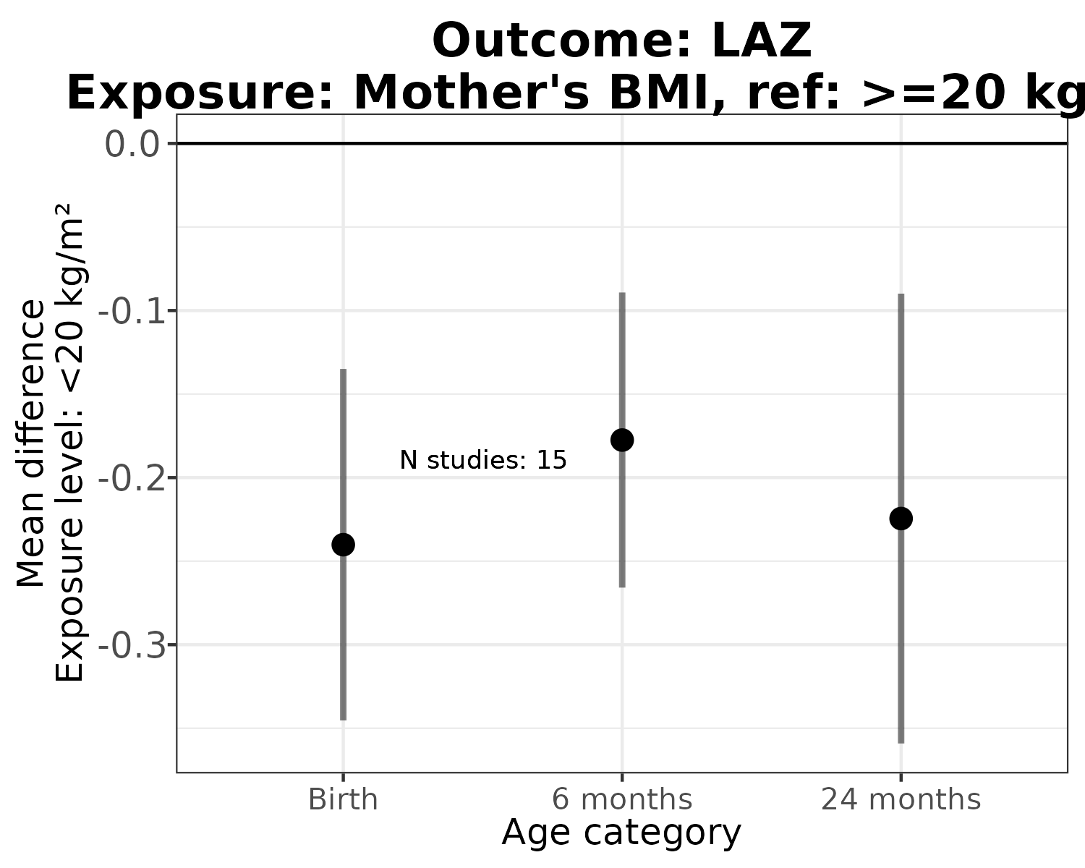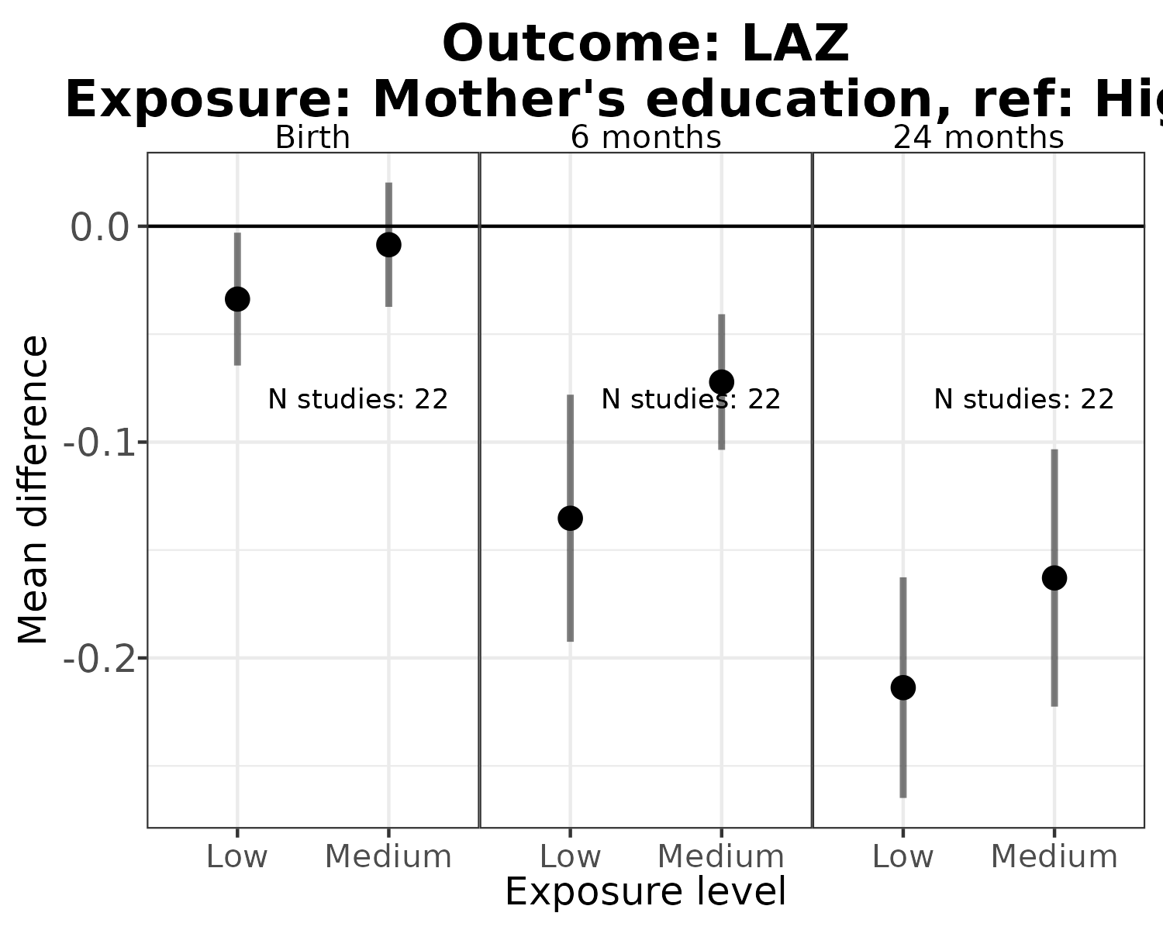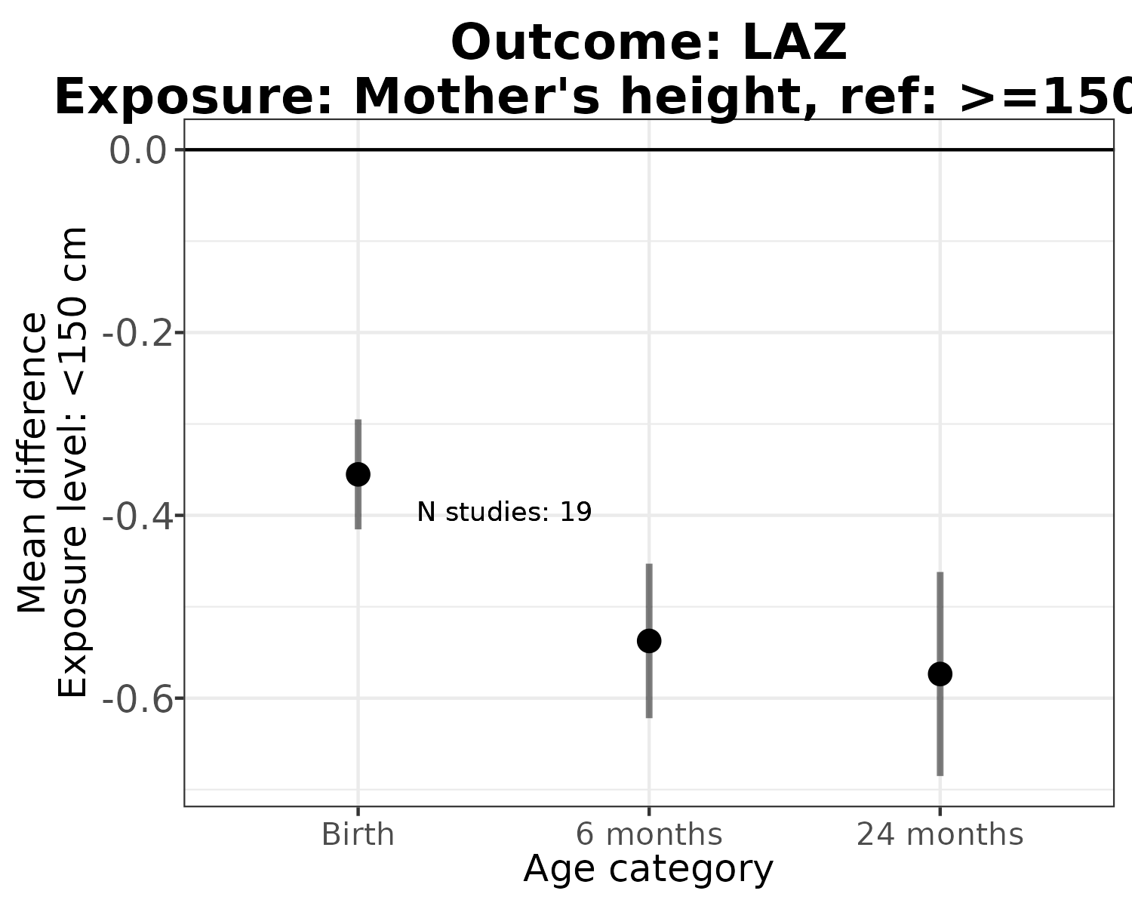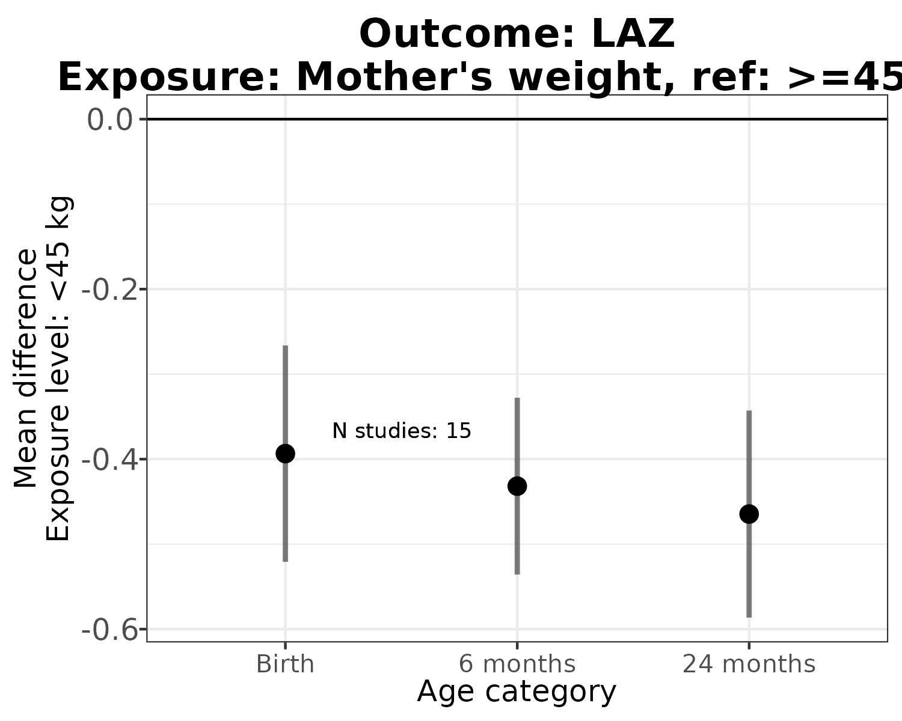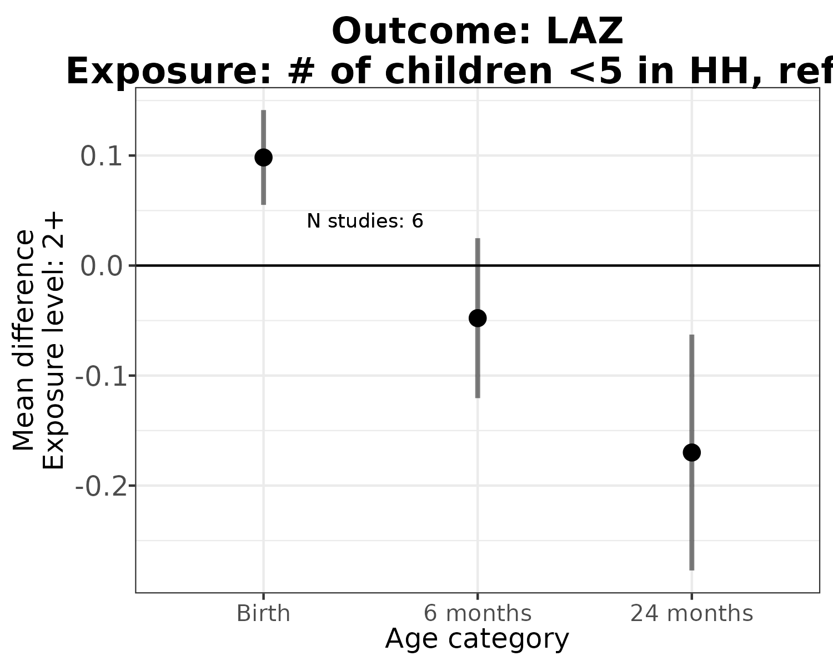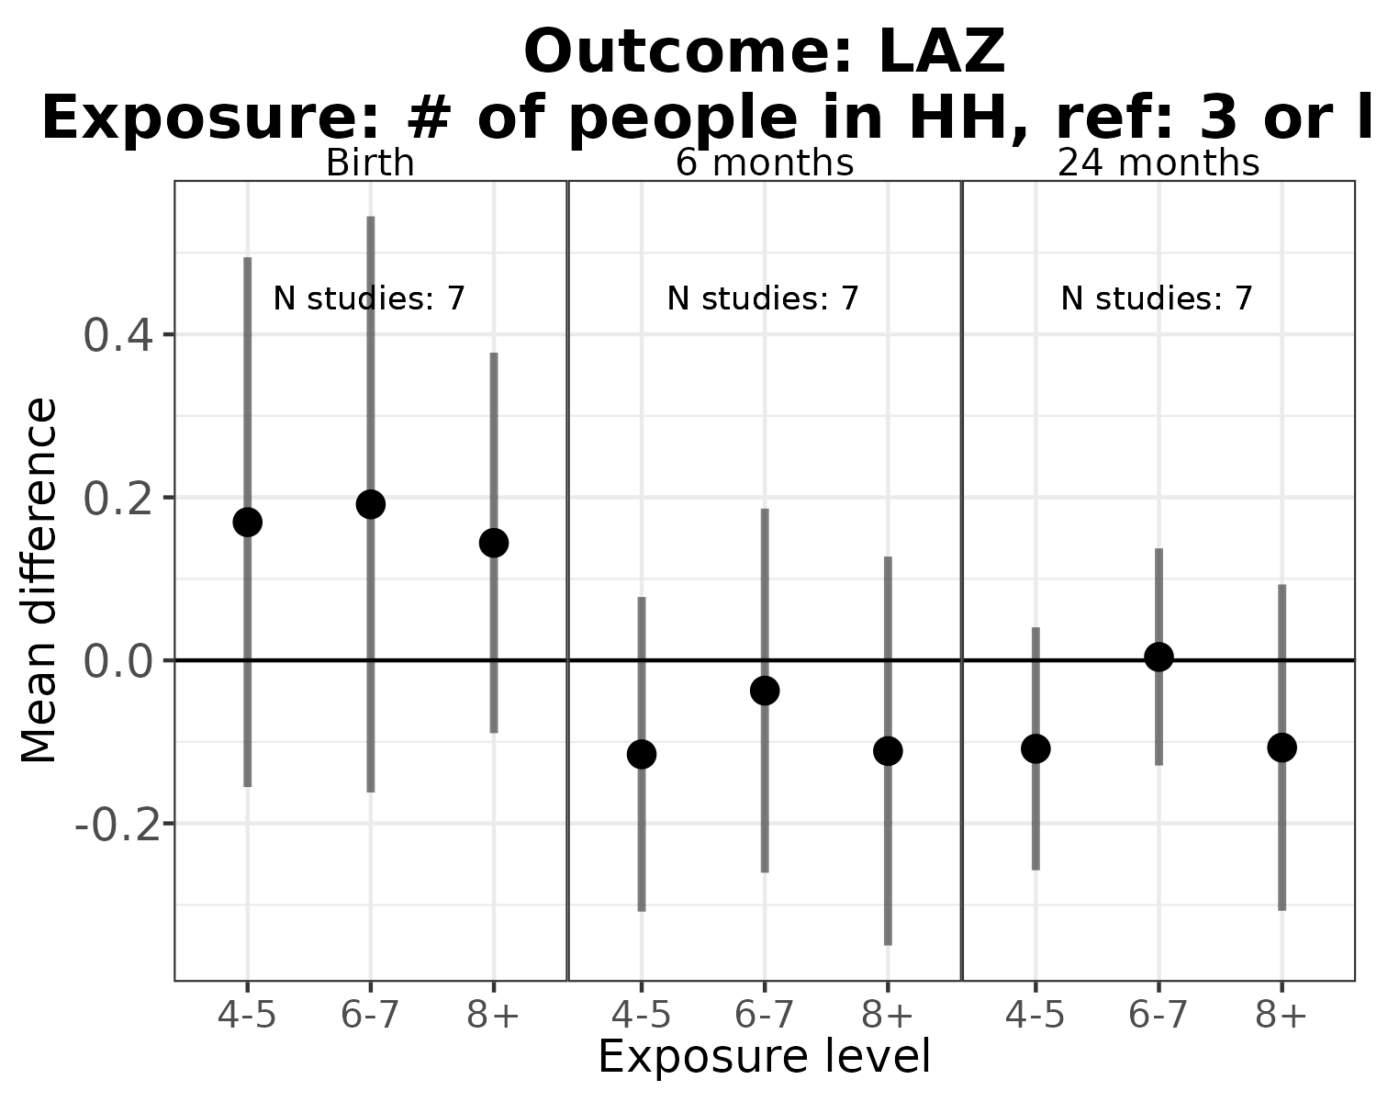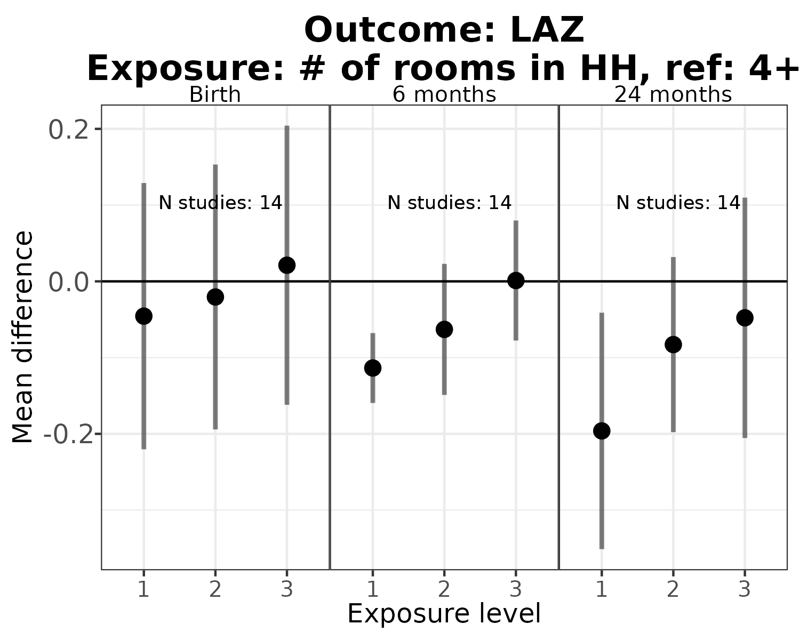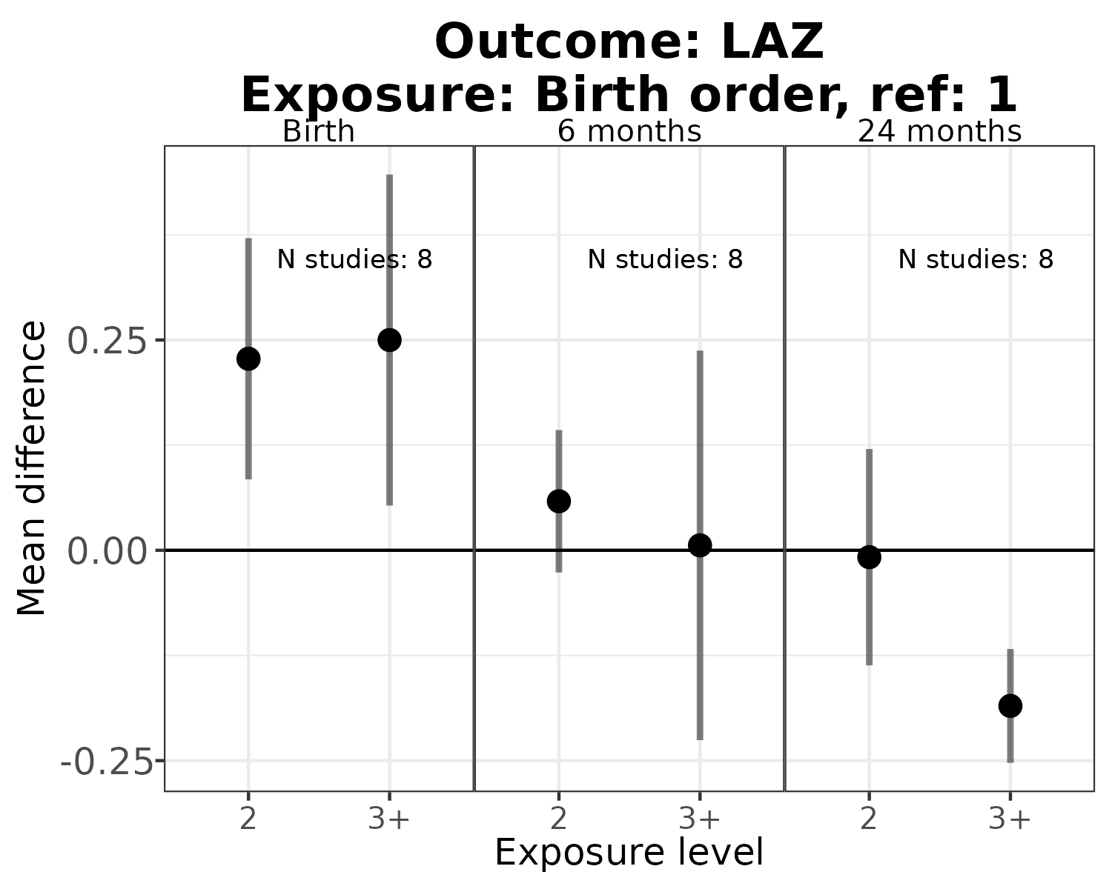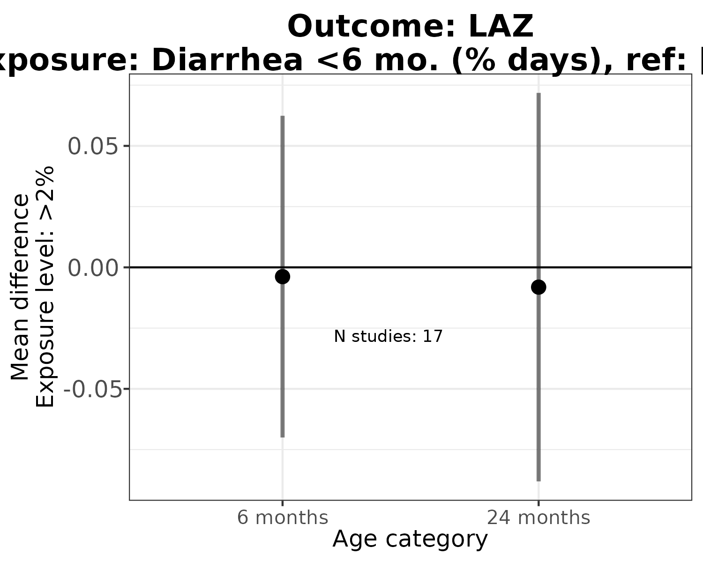

## Error in include_graphics(paste0(fig_dir, "/risk-factor/RR-plots/supplement/fig-Pooled-LAZ-pers_wast-ATE.png")) :   
## Cannot find the file(s): "figures//risk-factor/RR-plots/supplement/fig-Pooled-LAZ-pers_wast-ATE.png"

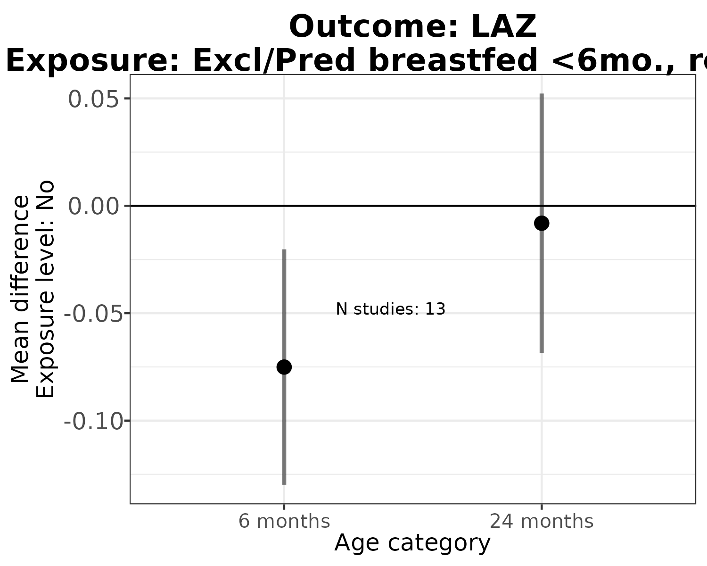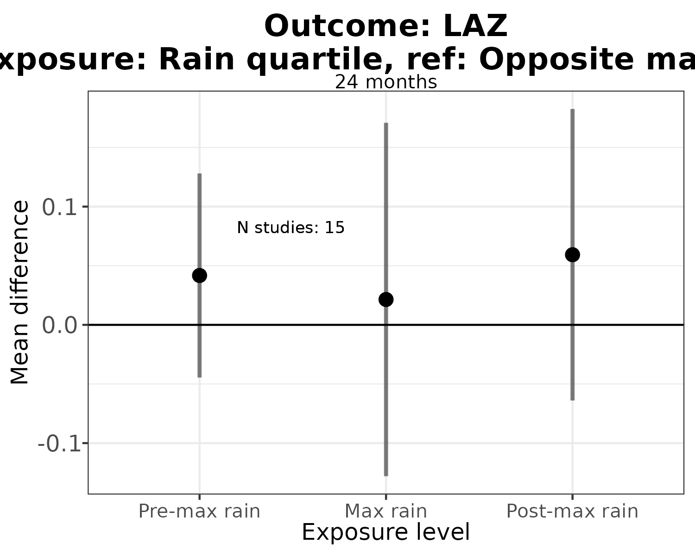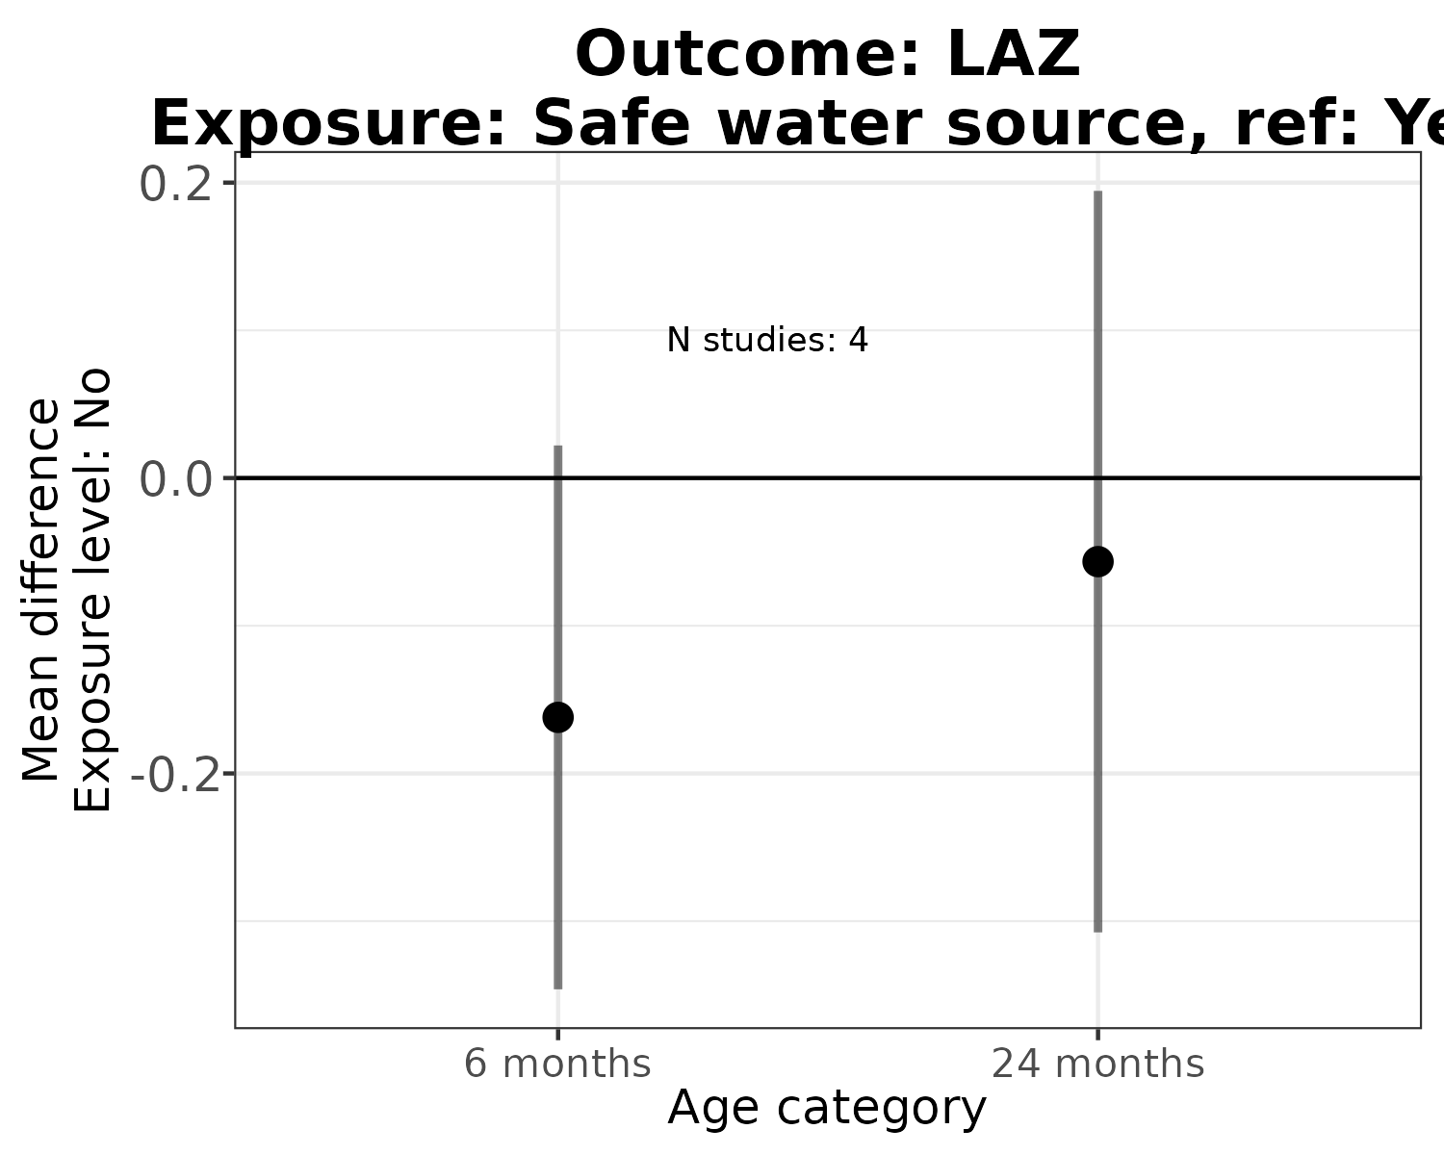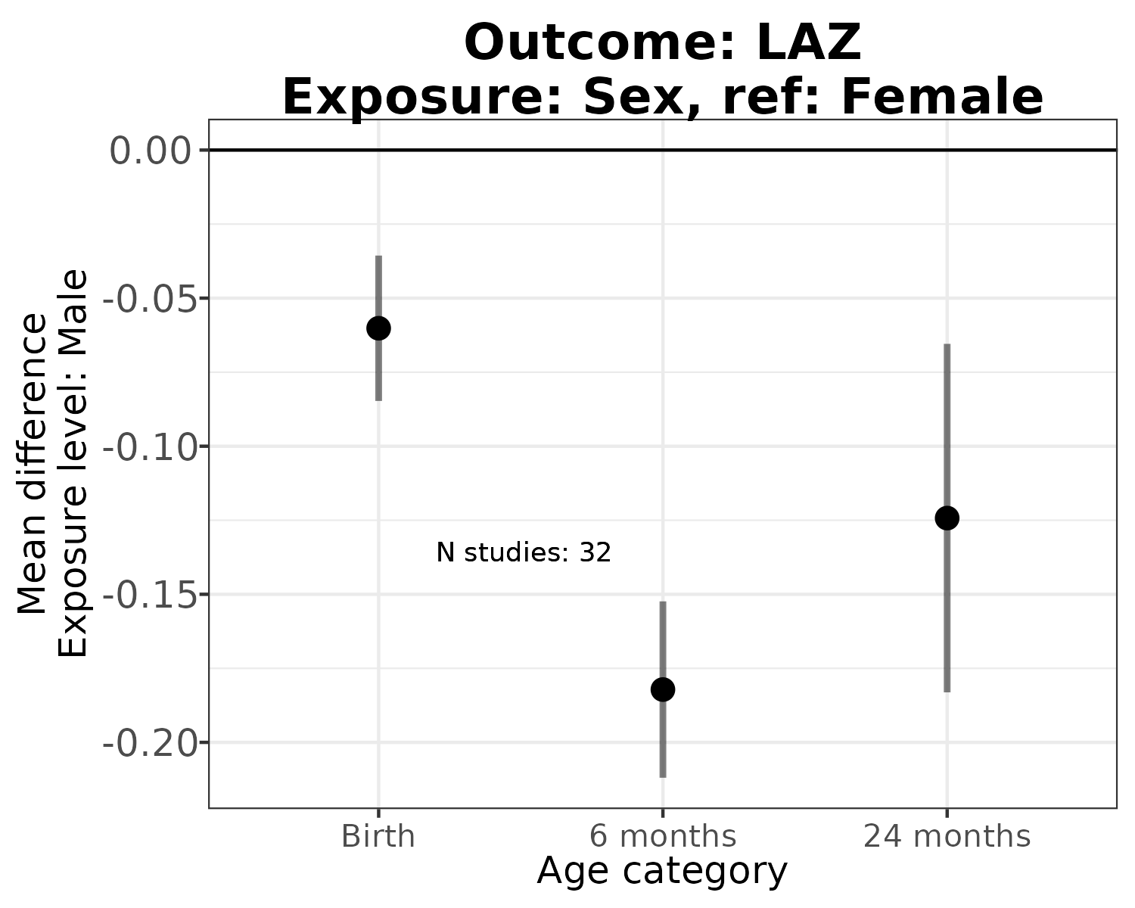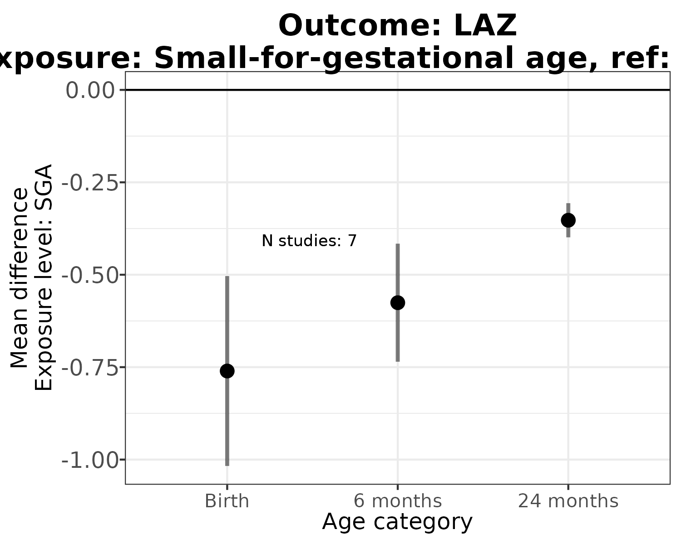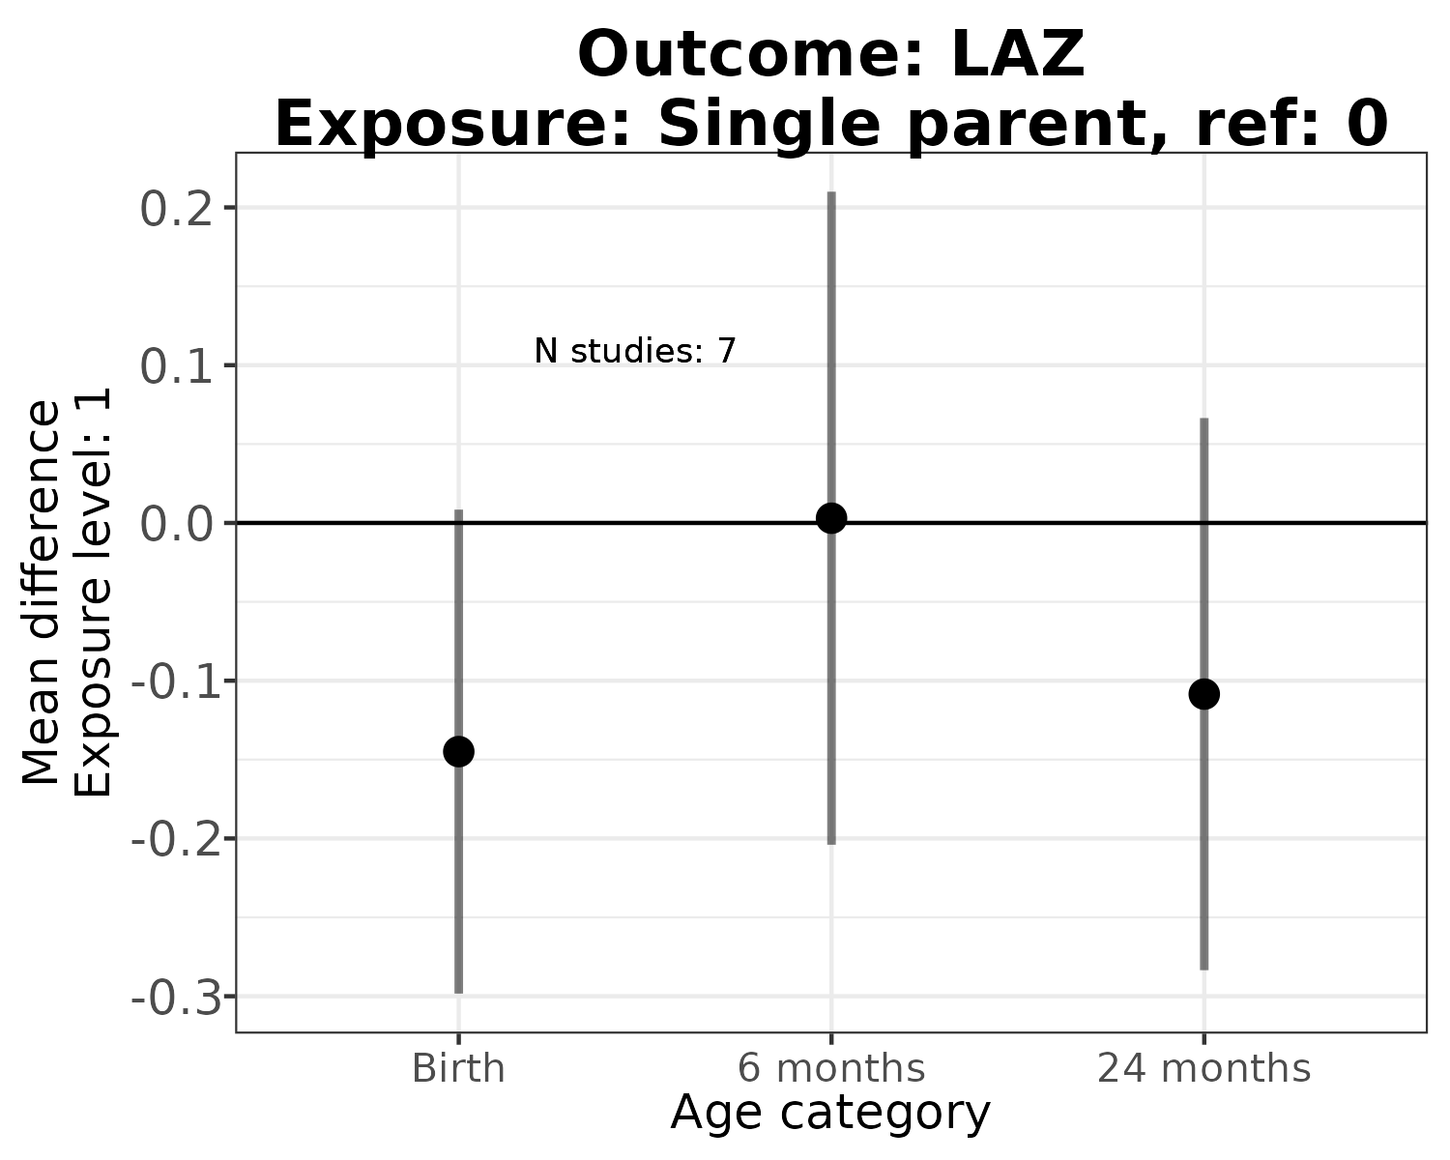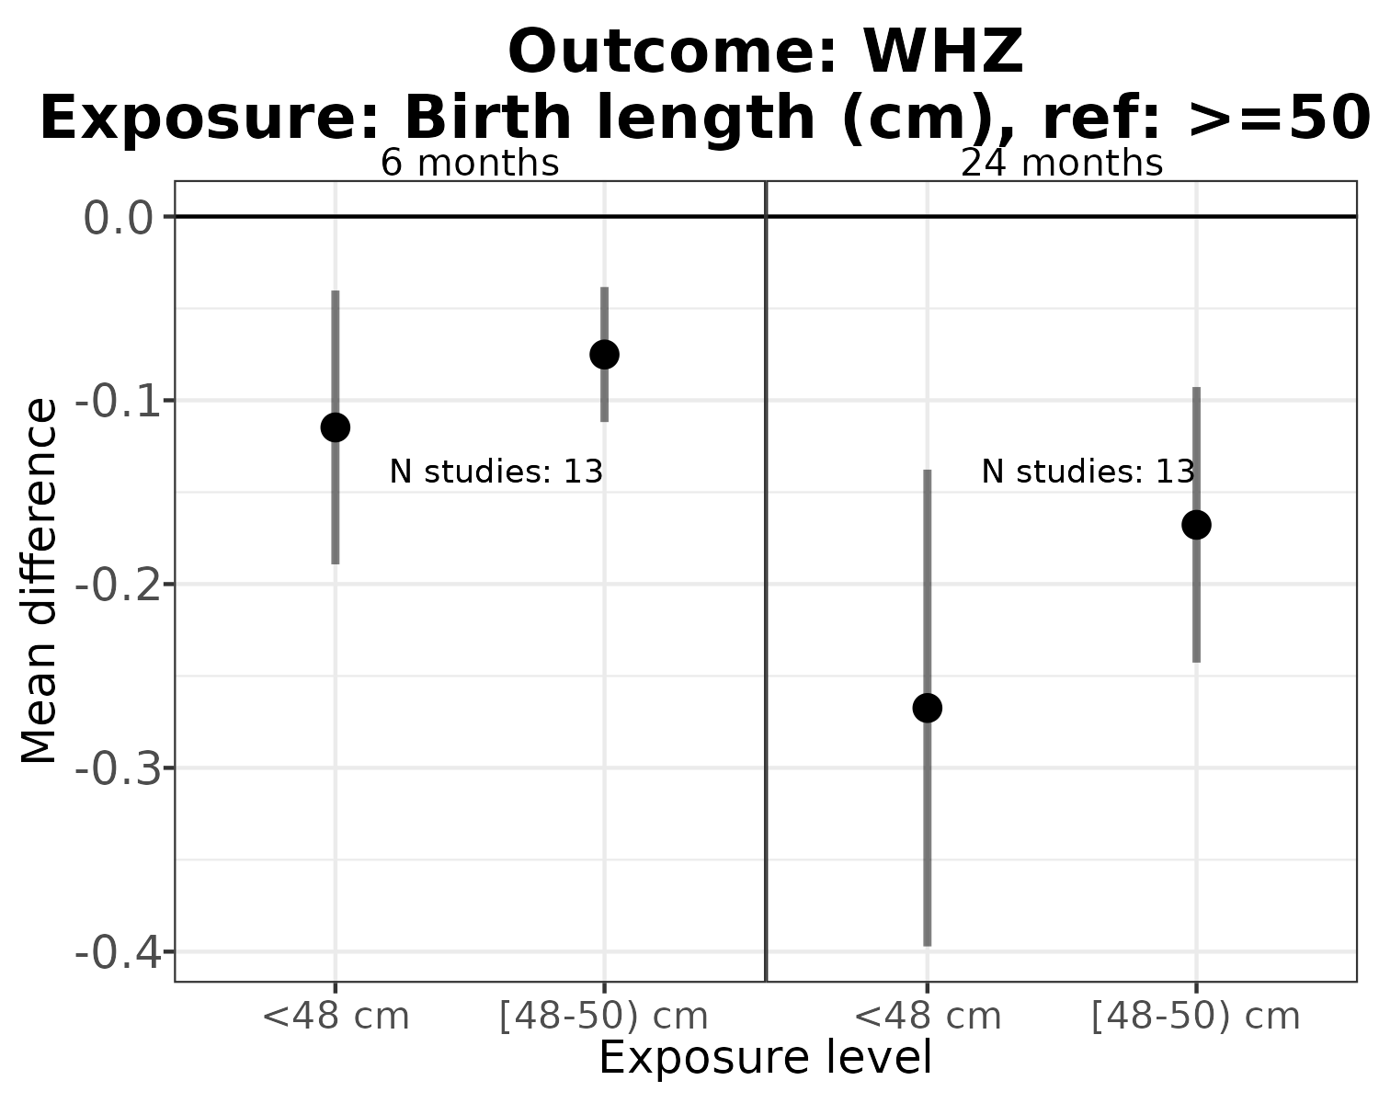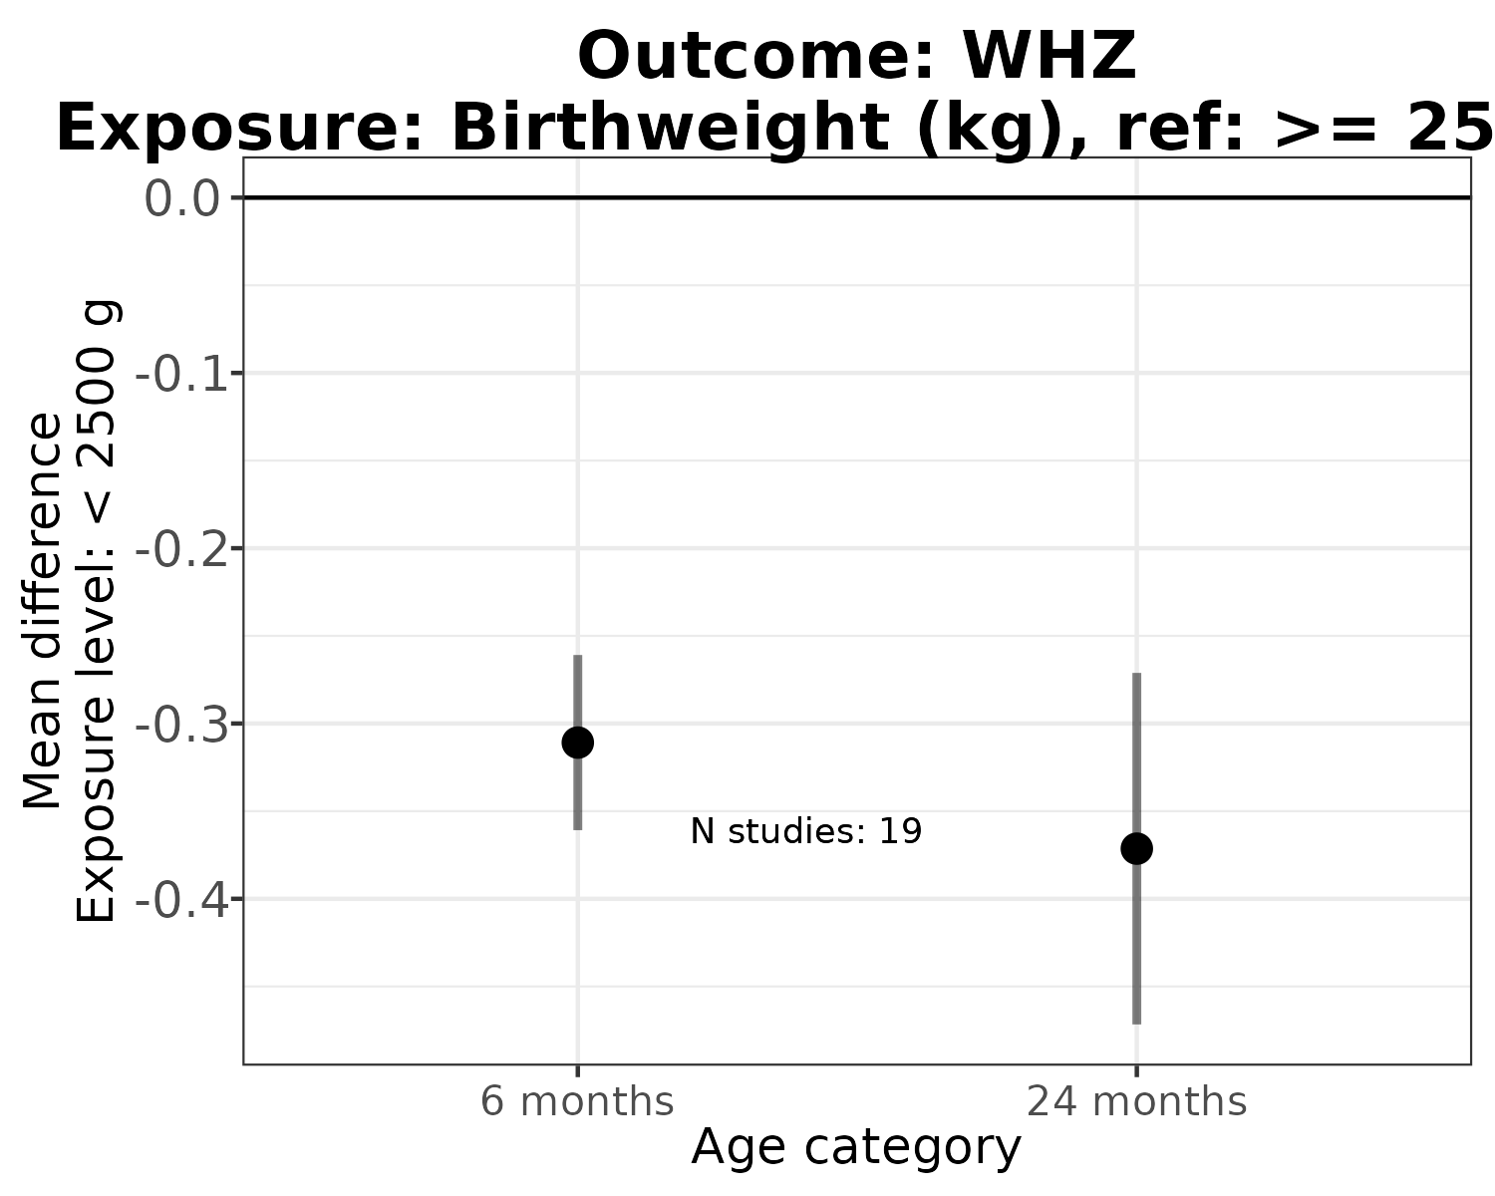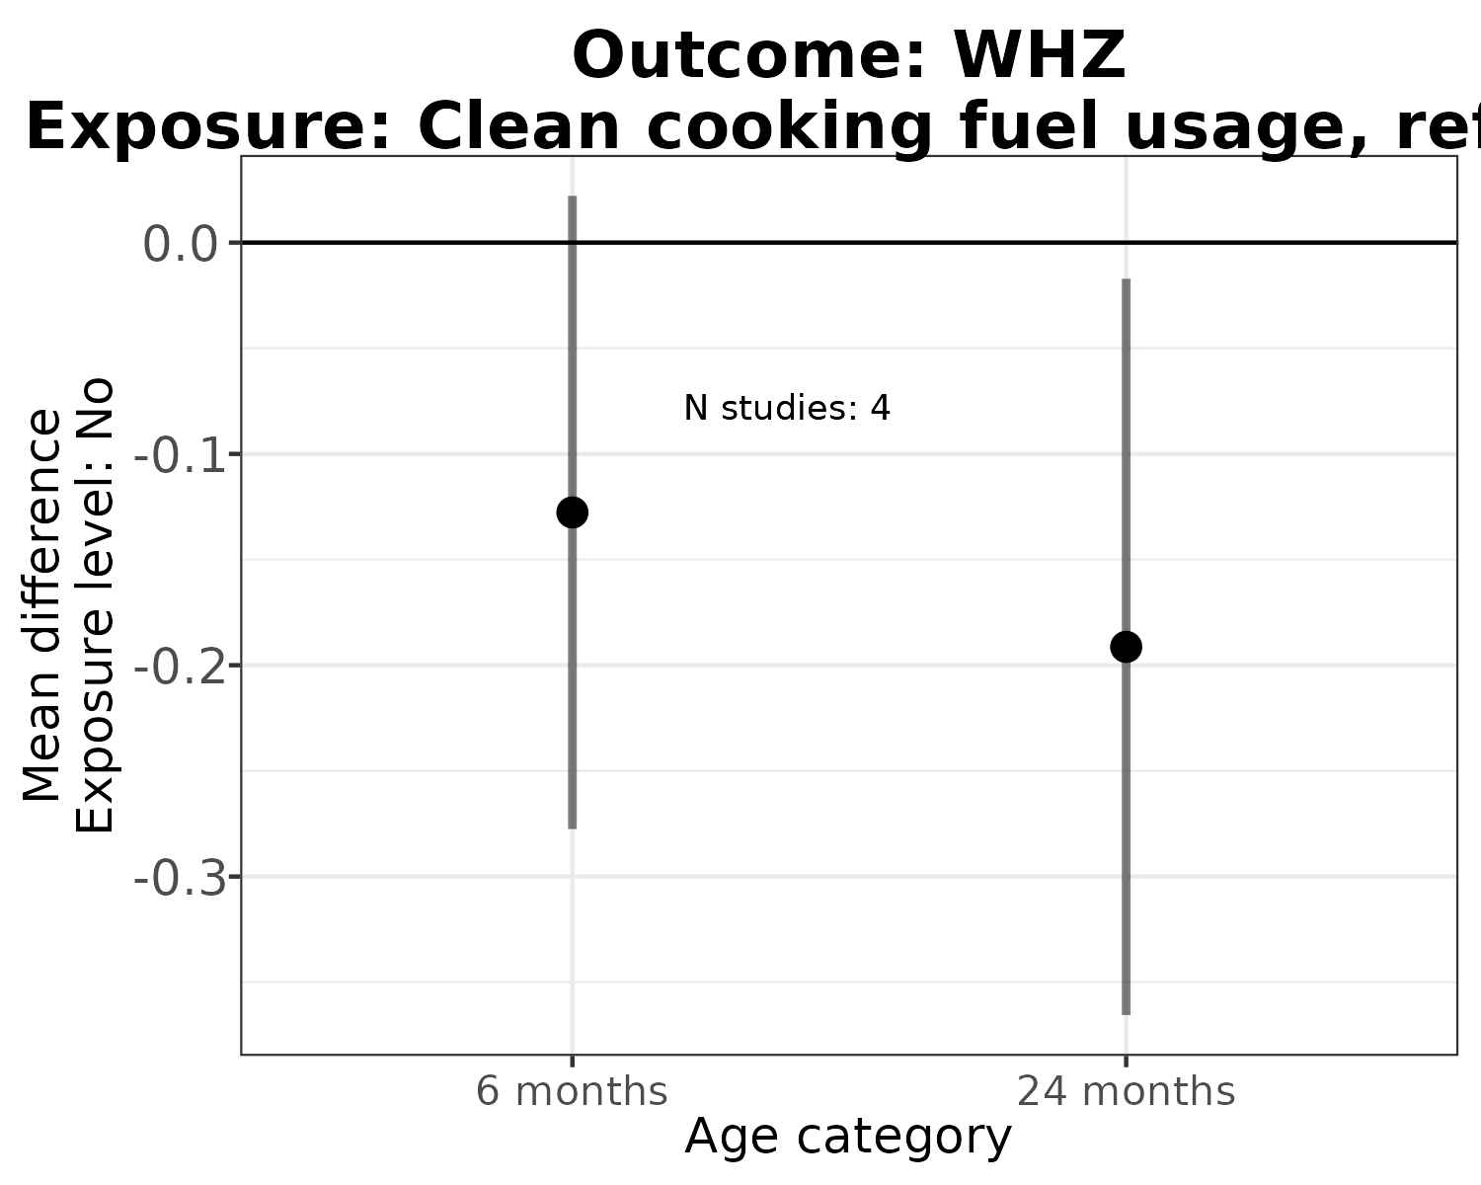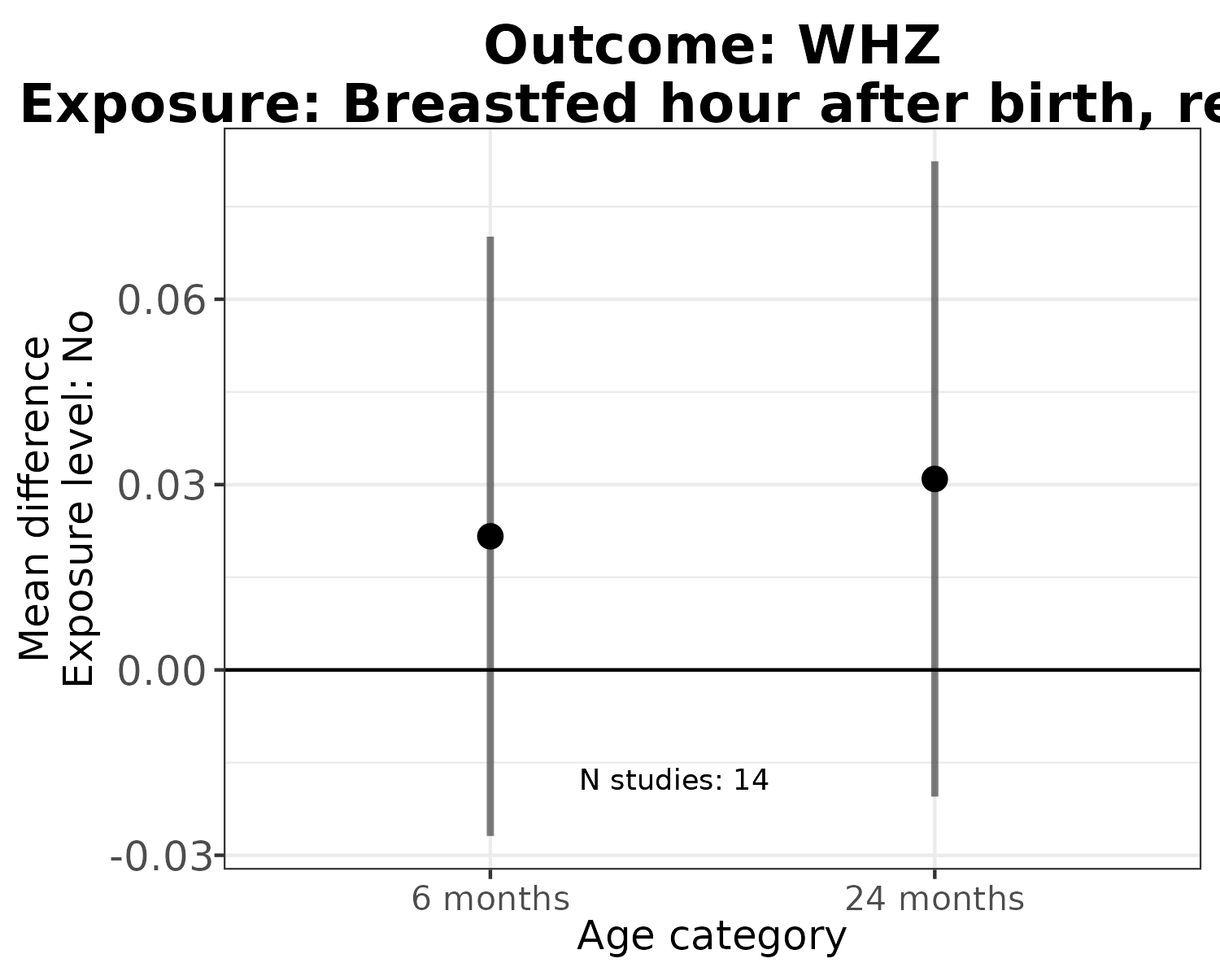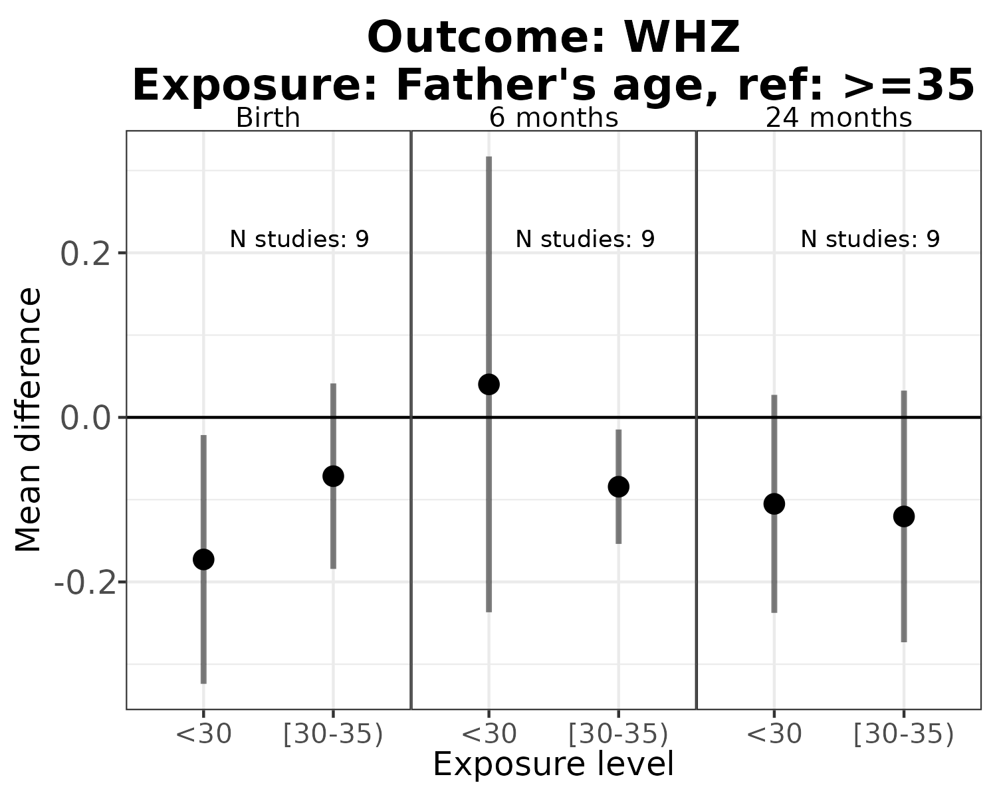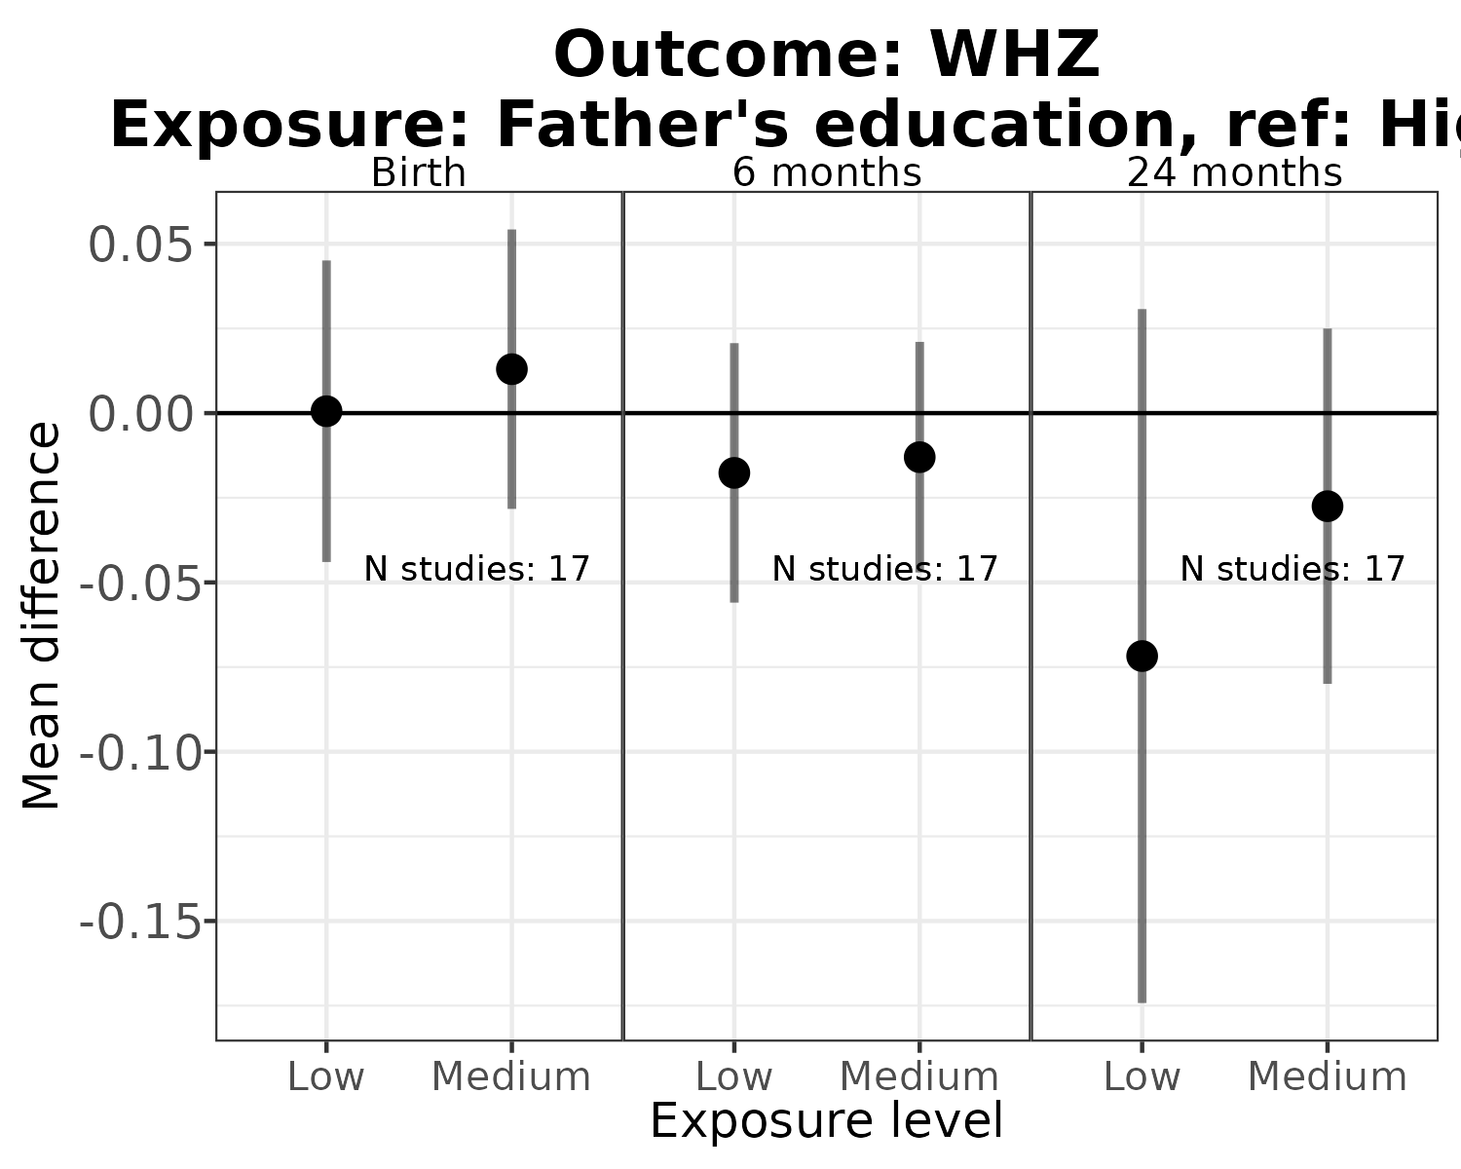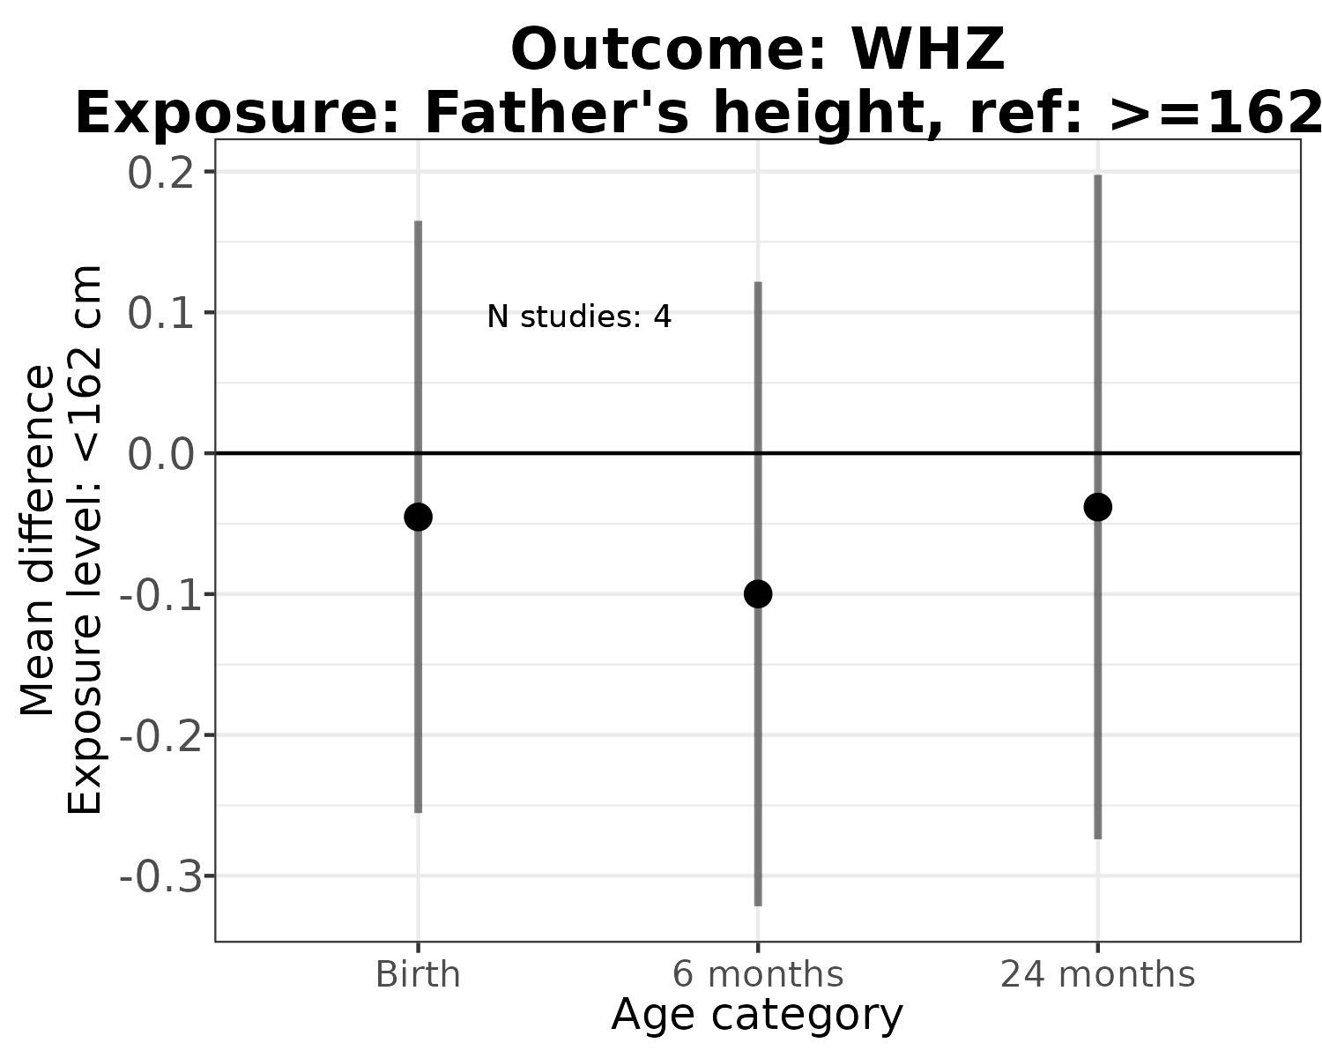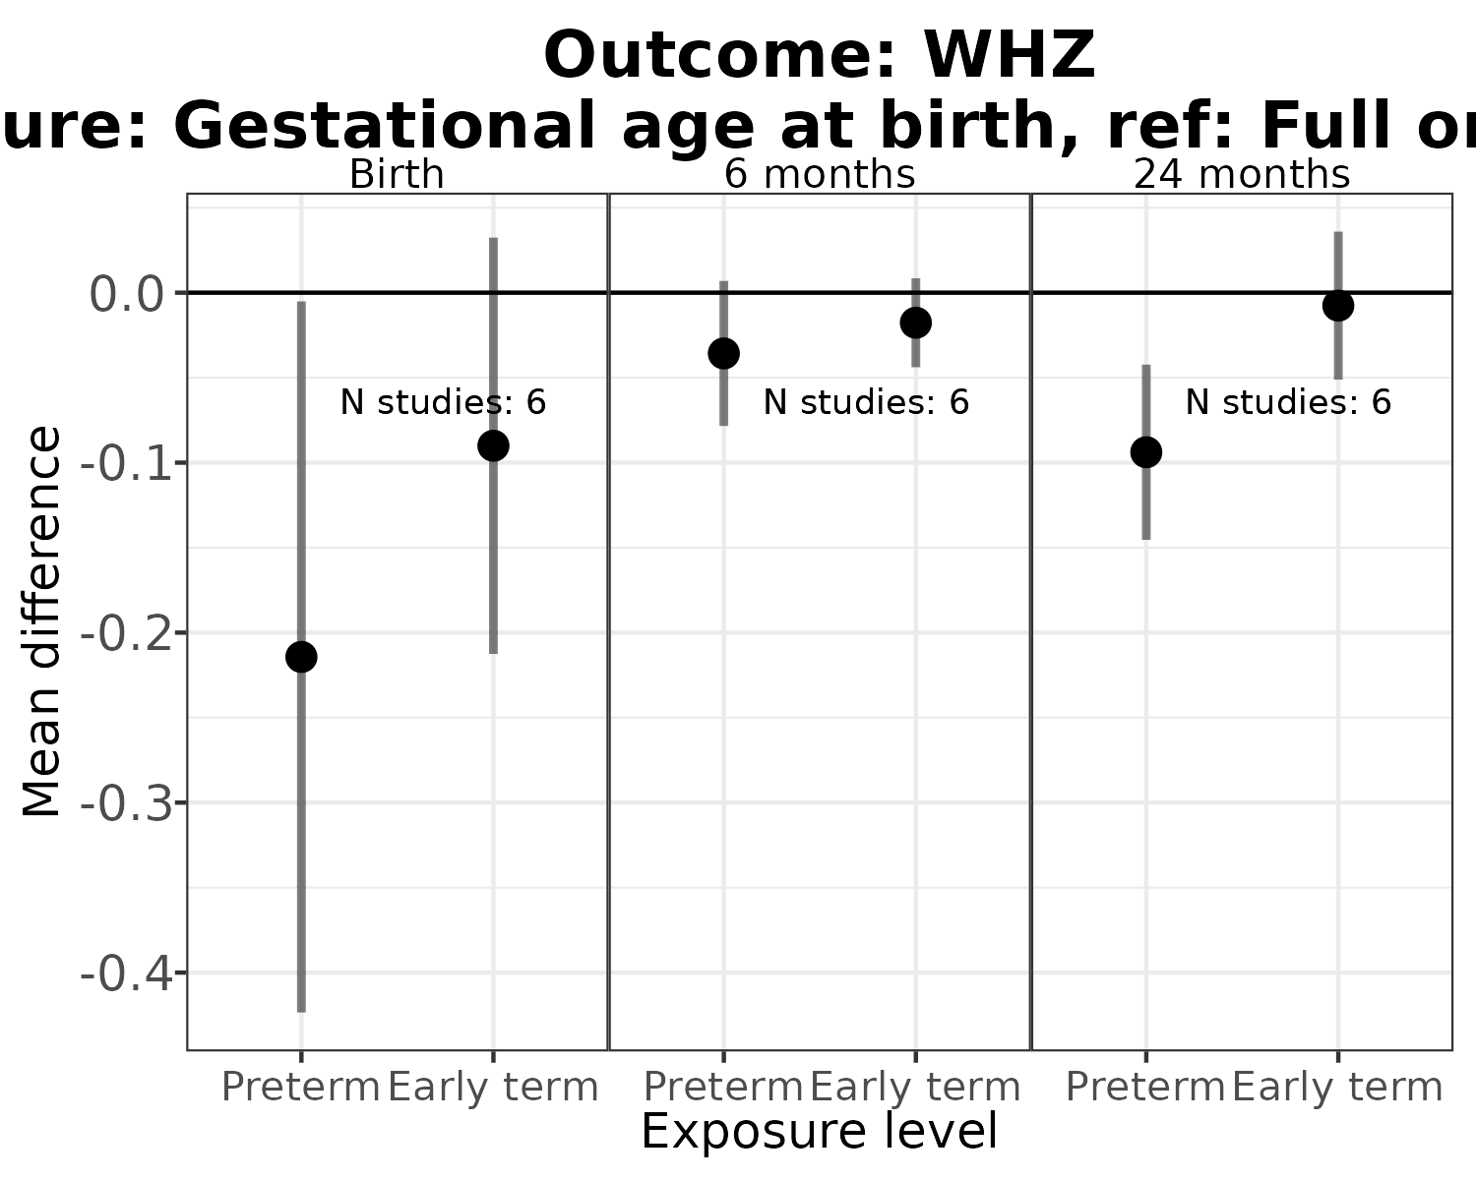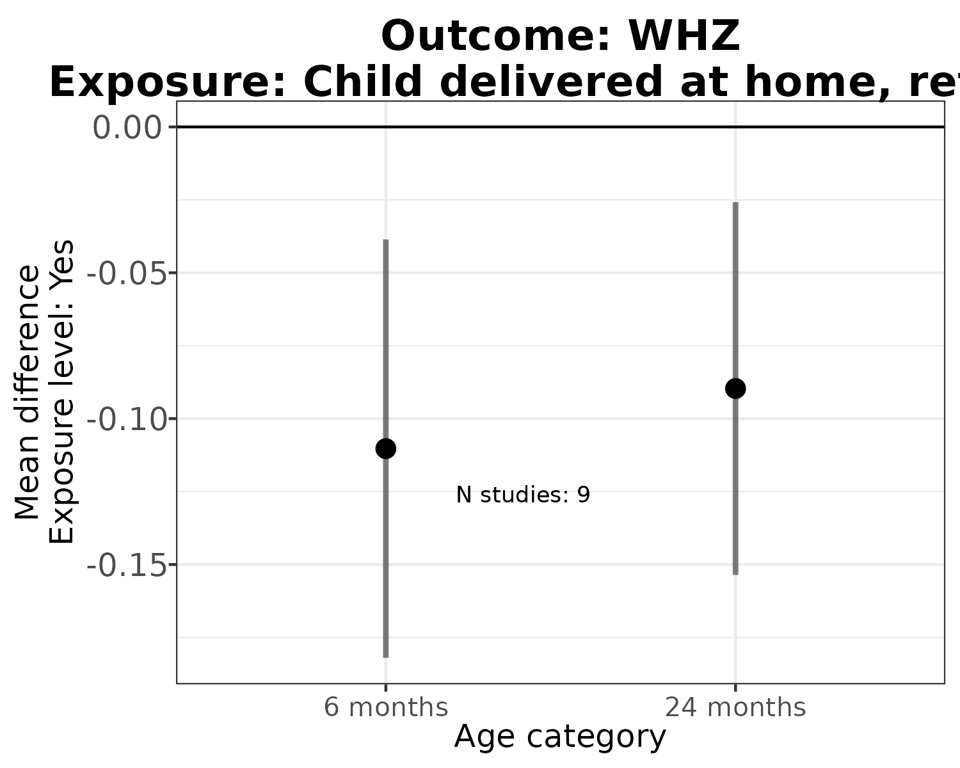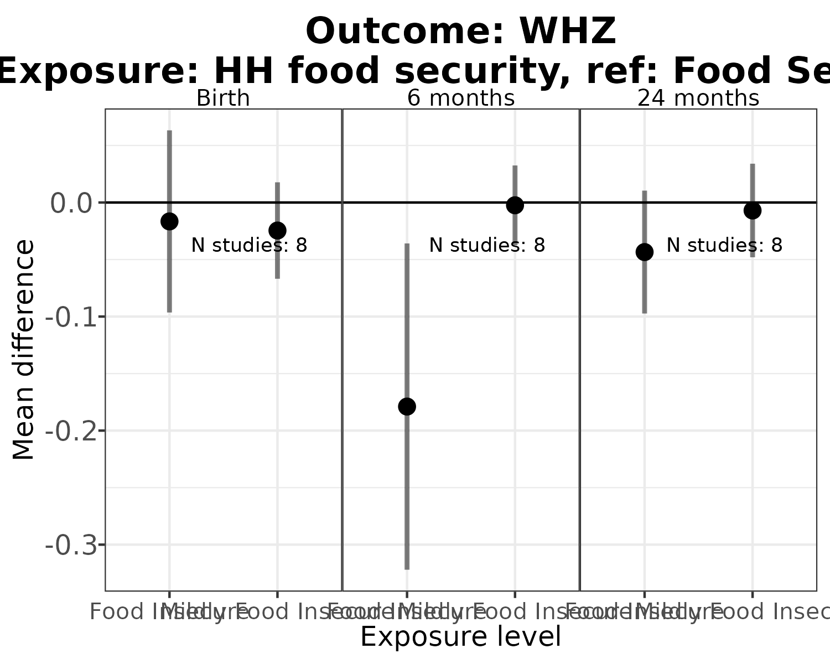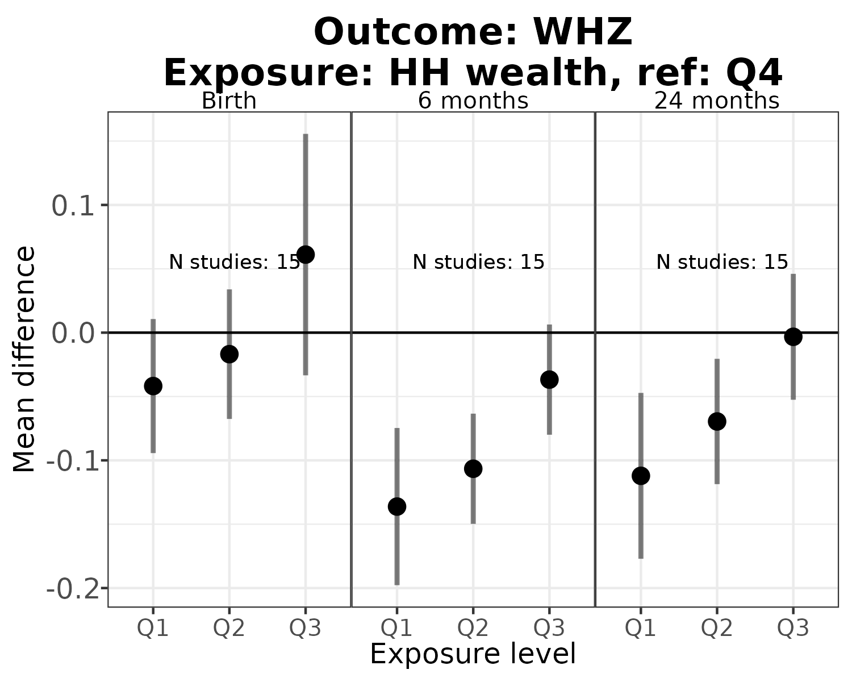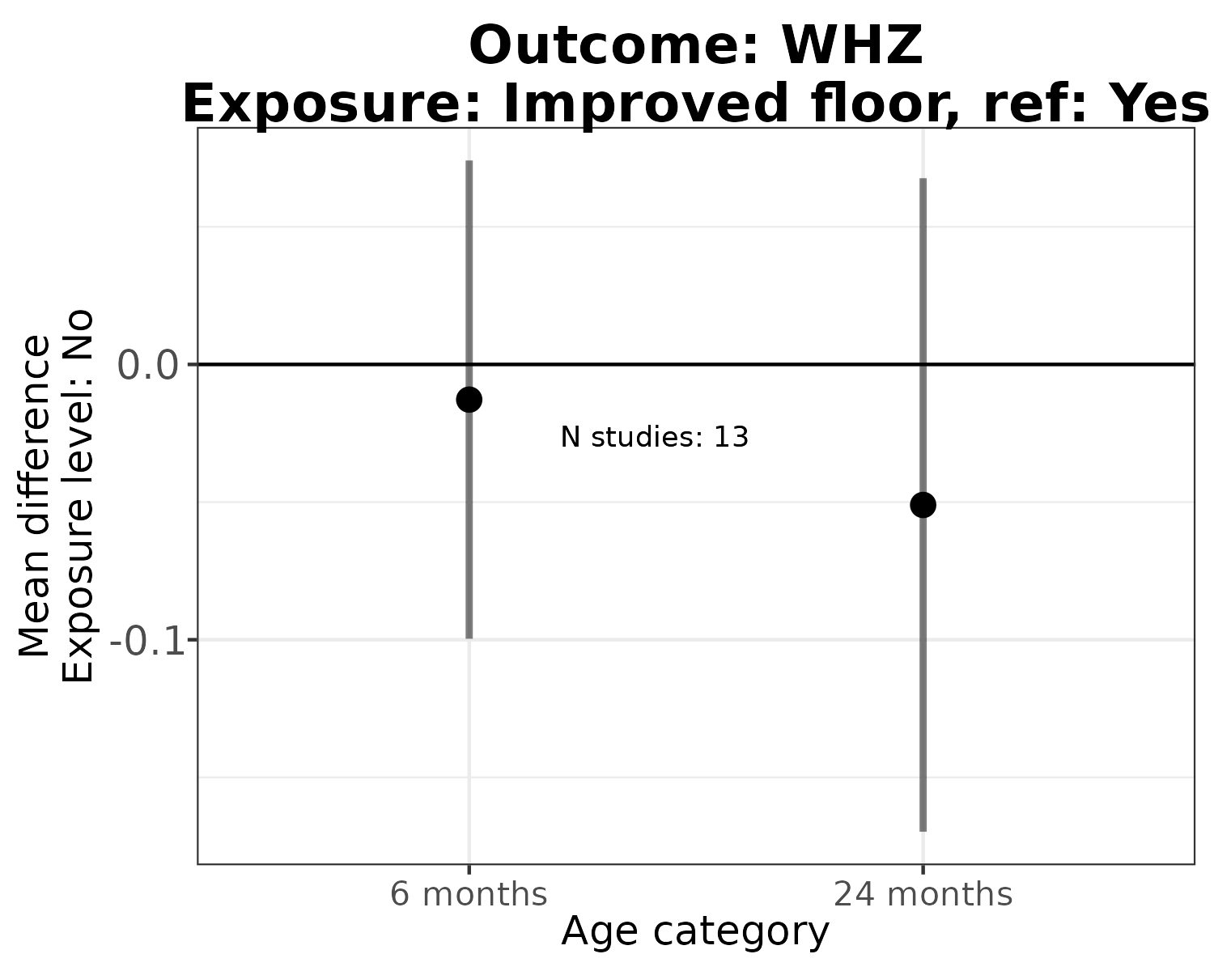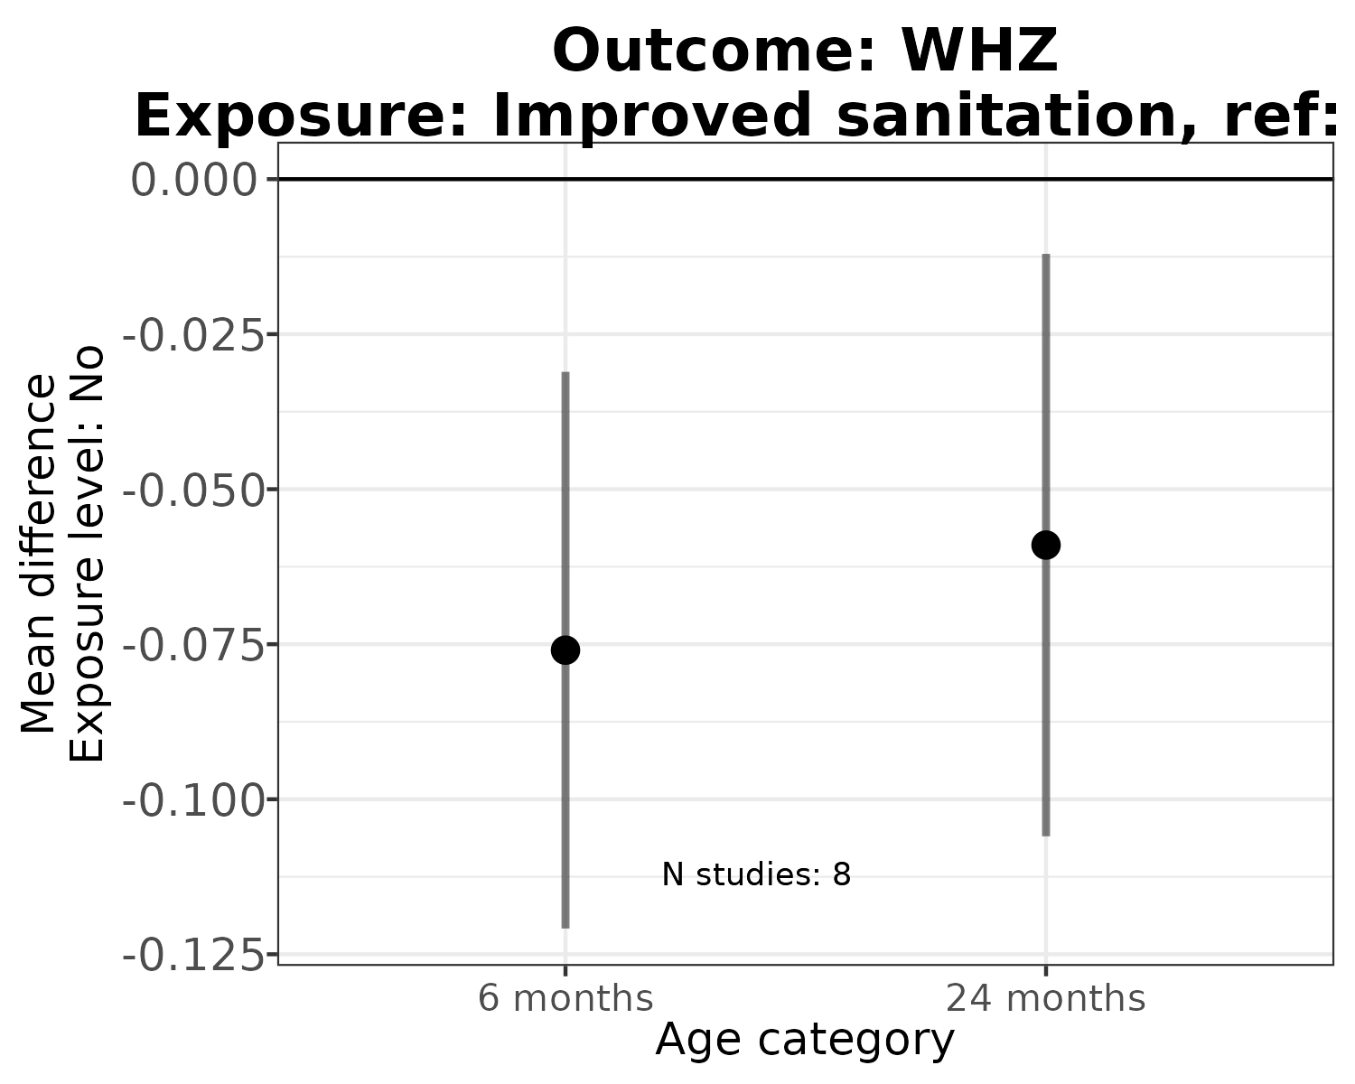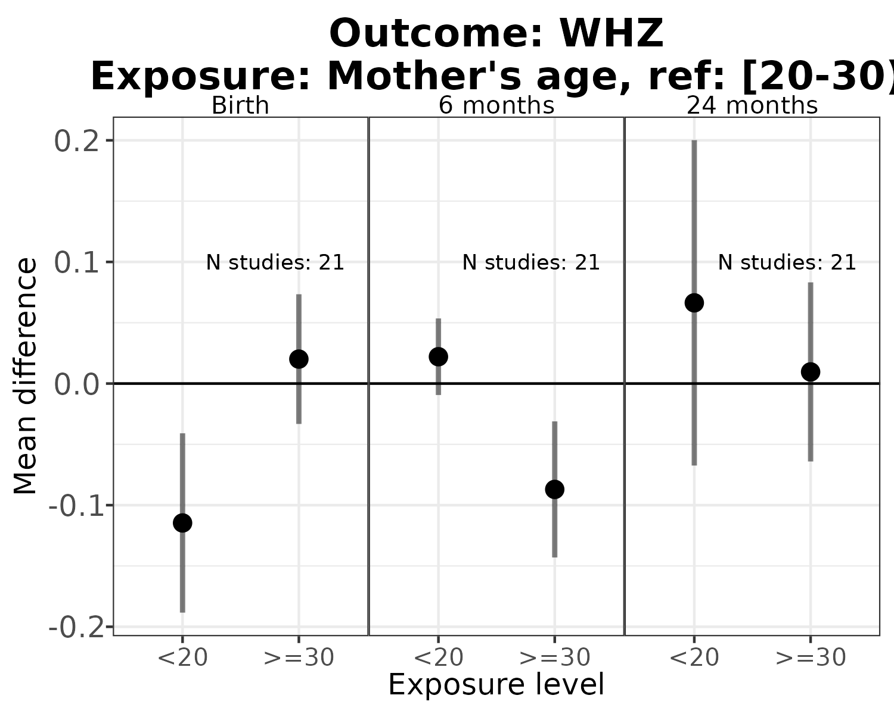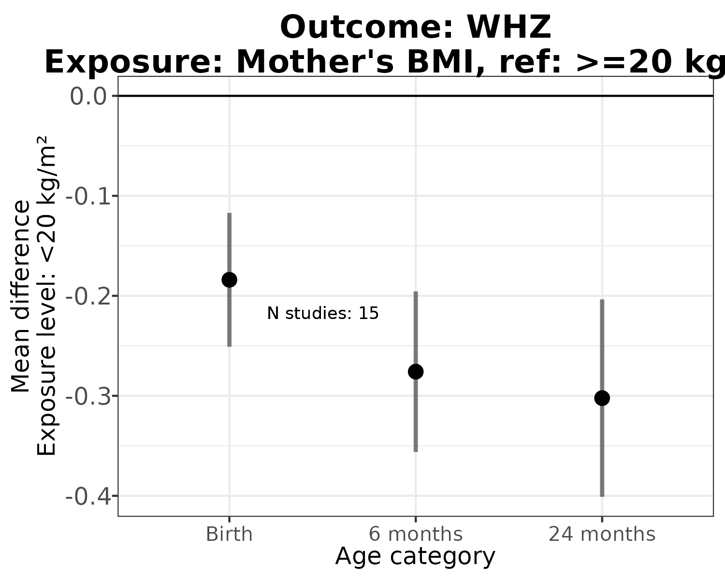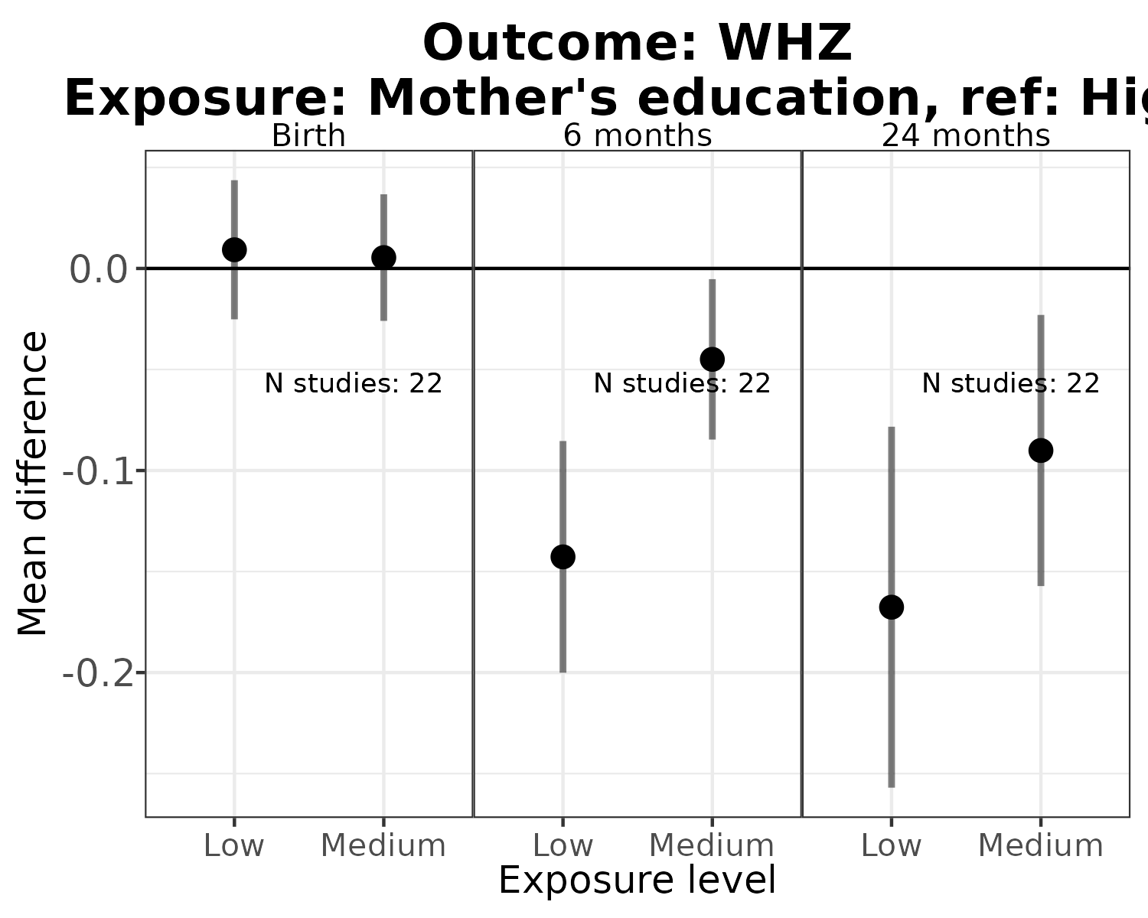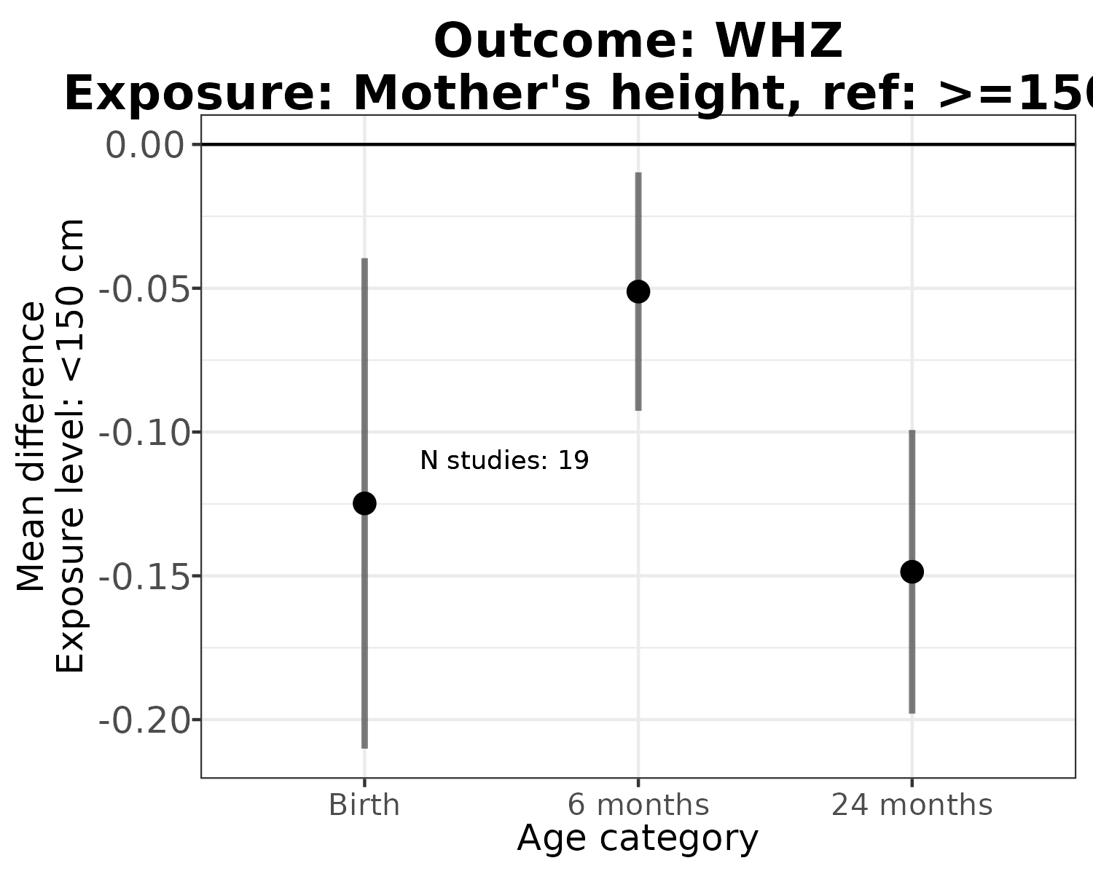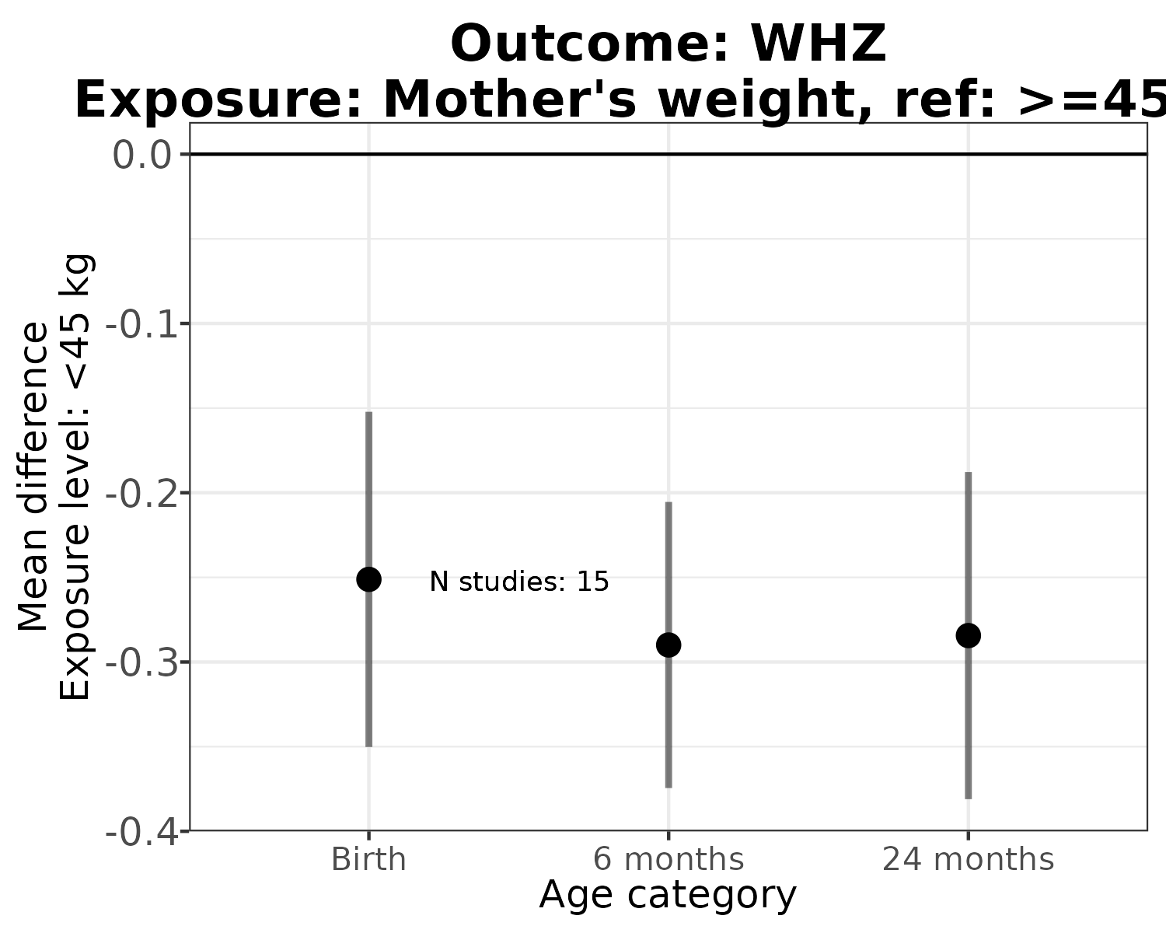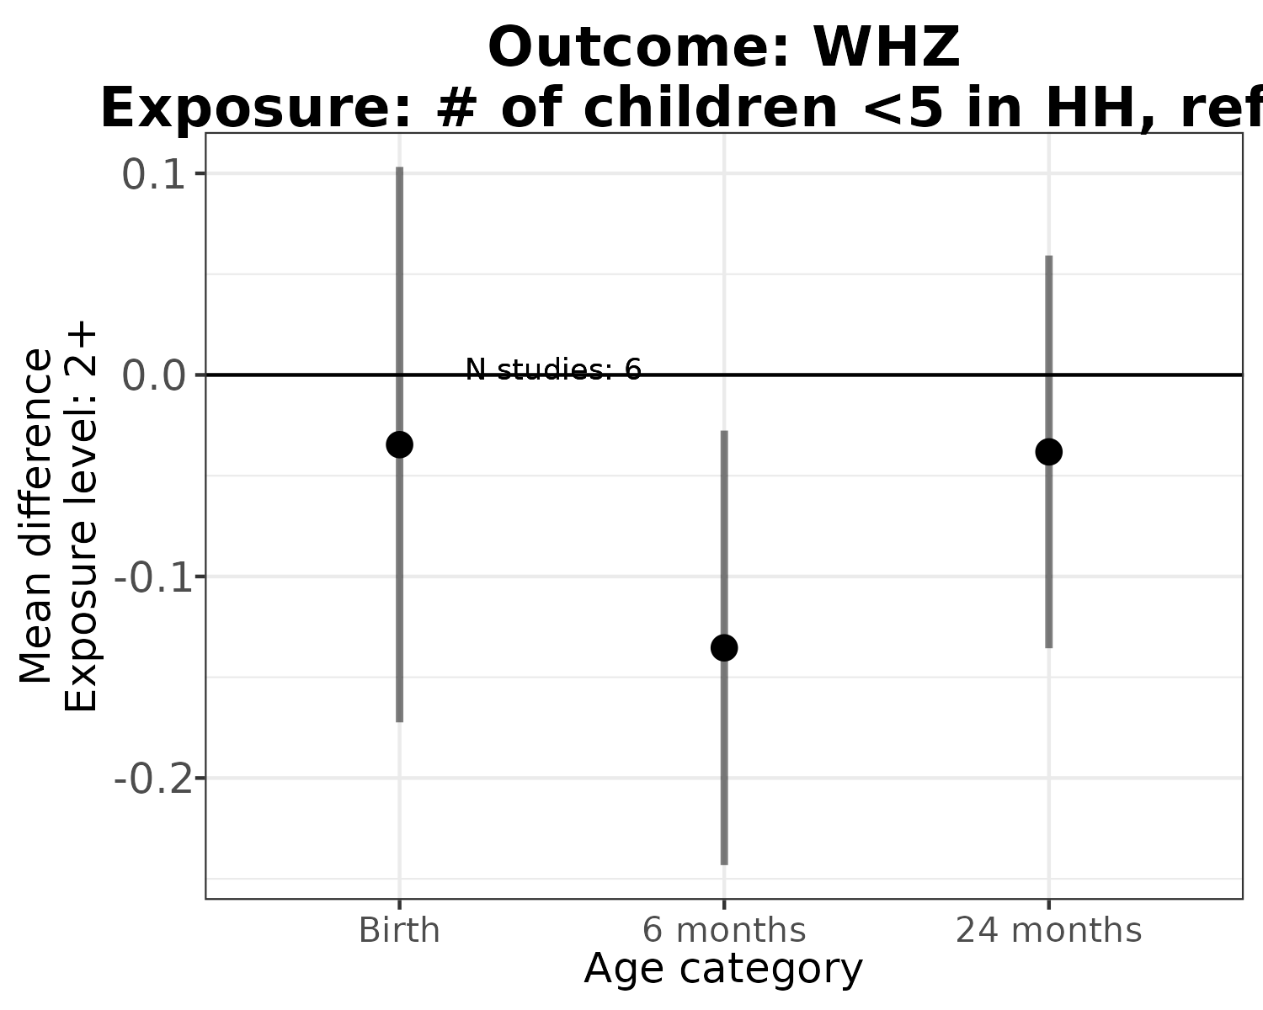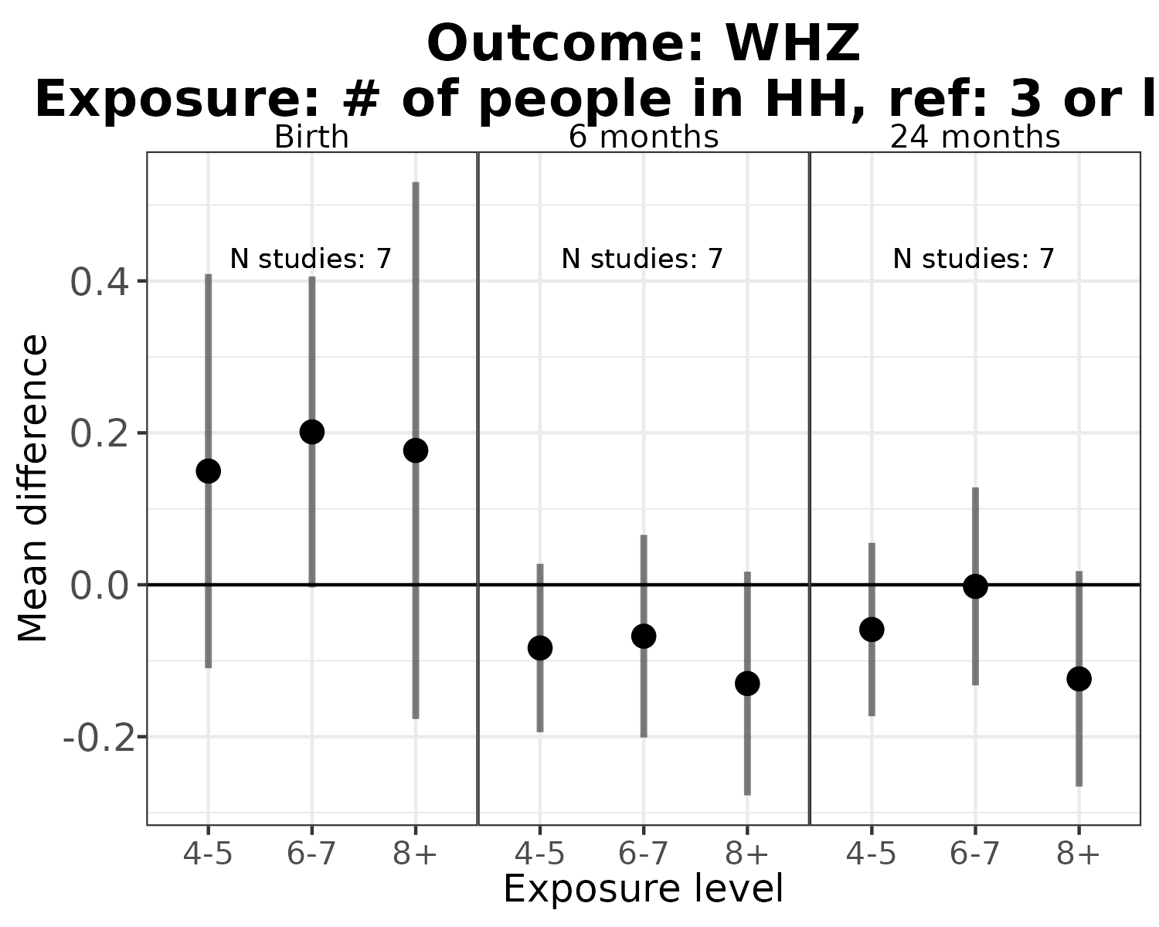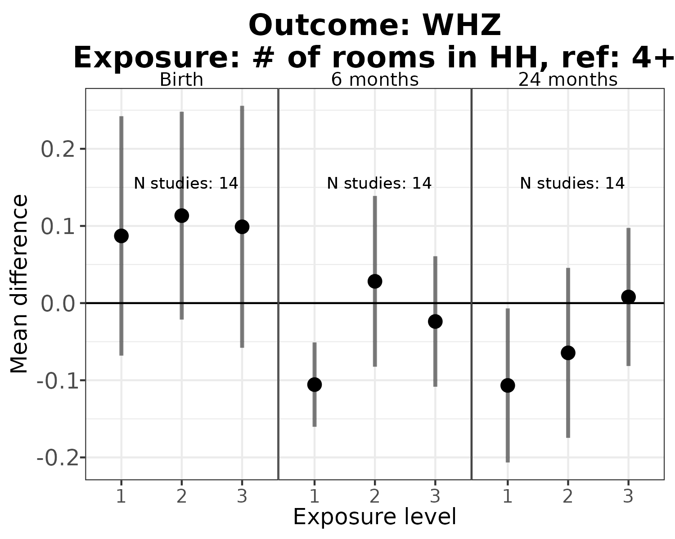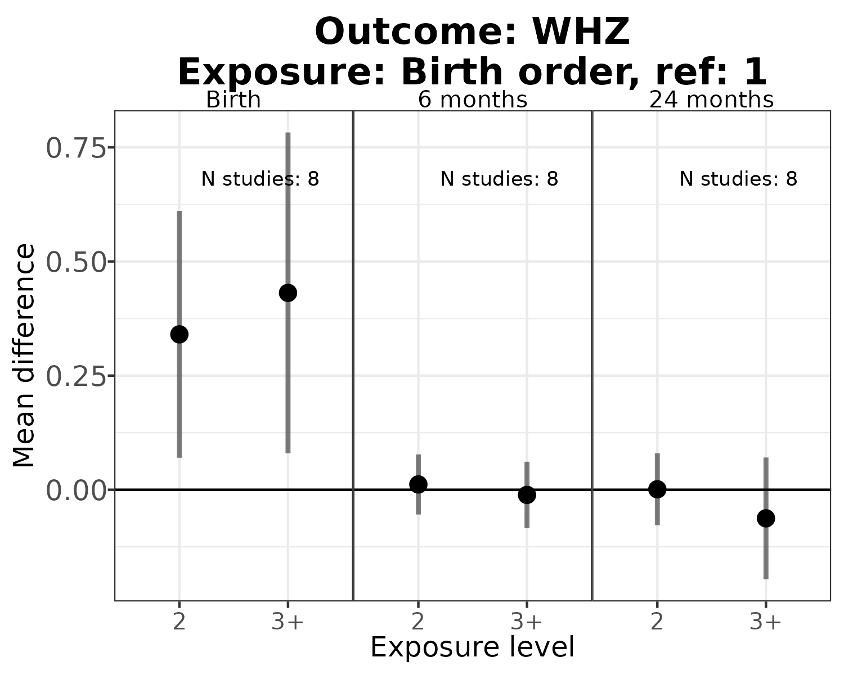

## Error in include_graphics(paste0(fig_dir, "/risk-factor/RR-plots/supplement/fig-Pooled-WHZ-perdiar6-ATE.png")) :   
## Cannot find the file(s): "figures//risk-factor/RR-plots/supplement/fig-Pooled-WHZ-perdiar6-ATE.png"

